Welcome To
Trinity Lutheran Church
Lutheran Church - Missouri Synod
A Stephen Ministry Congregation

1354 South Otsego Avenue
Gaylord, MI 49735
Church Phone: 989-732-4816

Church Email:
trinitygaylord-secretary@outlook.com
Web Page
www.trinitygaylord.com

Office Hours:
Monday through Friday 9am - 1pm

OUR PURPOSE

. . . is to LOVE GOD, LOVE OTHERS AND SERVE THE WORLD by worshiping the Lord Jesus, bringing our members into Christ-like maturity, and equipping them through Word and Sacrament for their mission and ministry. We go heart to heart into the world with Jesus, sharing His love, caring for one another, praying, and bringing the lost into a relationship with Christ, by the working of the Holy Spirit.

October 29, 2023
Twenty-Second Sunday after Pentecost
Reformation Sunday
Officiant: Rev. Ken Bernthal

ABOUT OUR WORSHIP

We welcome all who gather here today! We are blessed to celebrate together the mercy, grace and love we have from God through the death and resurrection of our Lord Jesus Christ.

Children: Families with children are very welcome here. Having children in church is important so they can begin to learn about their faith in Jesus, and it’s good for the whole congregation to see. Please feel comfortable keeping “squirmy” kids in the service. This is where they belong, too!

Pew cards: Guest and Members, please fill out a Guest/Member card located in the pew rack. The card can be placed in the offering plates at the back of the church.

If standing is difficult feel free to remain seated during any portion of the service. Please let an Elder or Usher know if you need communion in your pew seat.

About our celebration of Holy Communion
We celebrate The Lord's Supper in the confession and glad confidence that, as Jesus says, our Lord gives to us not only bread and wine, but also His very body and blood to eat and to drink for the forgiveness of sins and to strengthen our union with Him and with one another. Our Lord invites to His table those who trust His words, repent of all sin, and set aside any refusal to forgive and love as He forgives and loves us.
Because those who eat and drink our Lord's body and blood unworthily do so to their harm, and because Holy Communion is a confession of the faith which is confessed at this altar, any who are not baptized, instructed about communion in an LCMS congregation, or are in doubt and yet desire to receive Holy Communion, are asked to first speak with the Pastor or elder.
Those not communing are still invited to come forward for a blessing from Pastor, and you may indicate this by crossing your arms over your chest.
Grape juice is offered in the center of the trays. Gluten-free wafers are available.
For further study, see Matthew 5:23; 10:32; 18:15-35, 26:26-29, 1 Corinthians 10:16-17, 1 Corinthians 11:17-34.

Greeting
P Peace be with you.
C And also with you

Divine Service - Setting Four LSB 203

Opening Hymn

"The Church's One Foundation
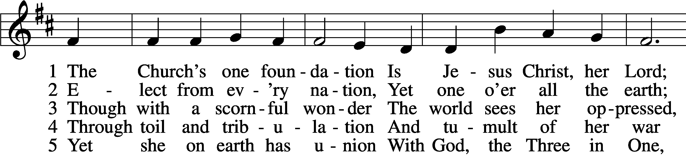
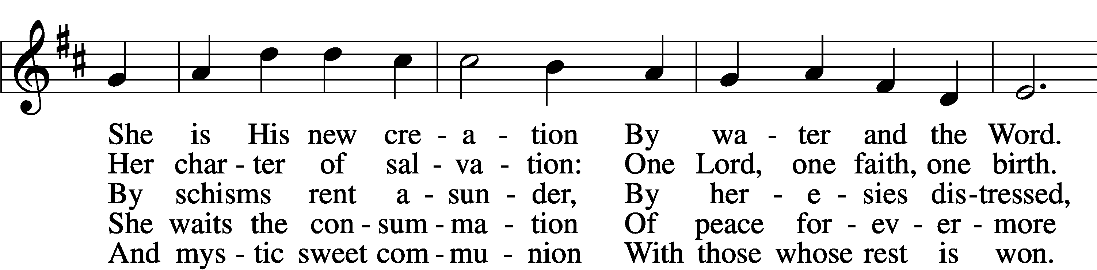
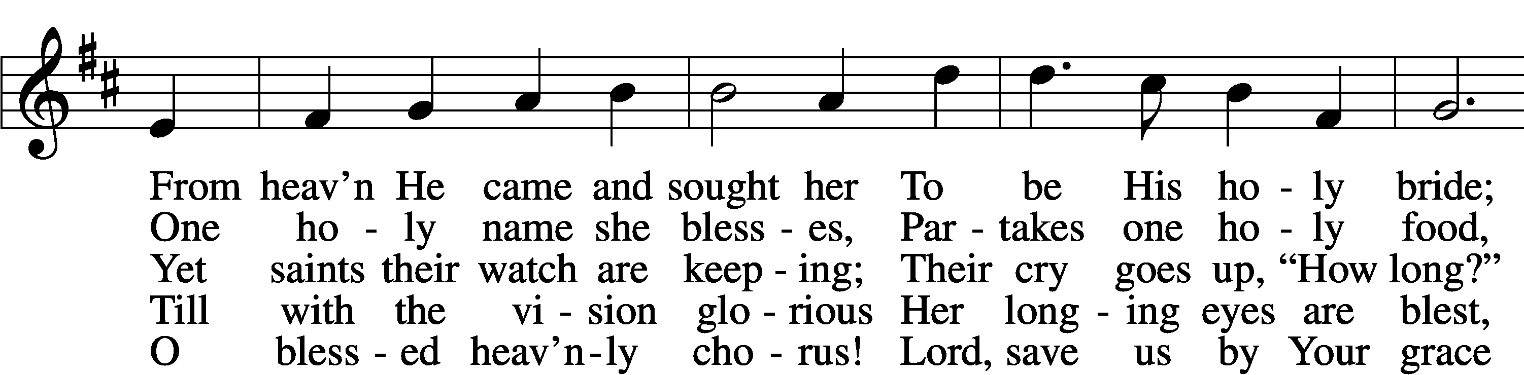
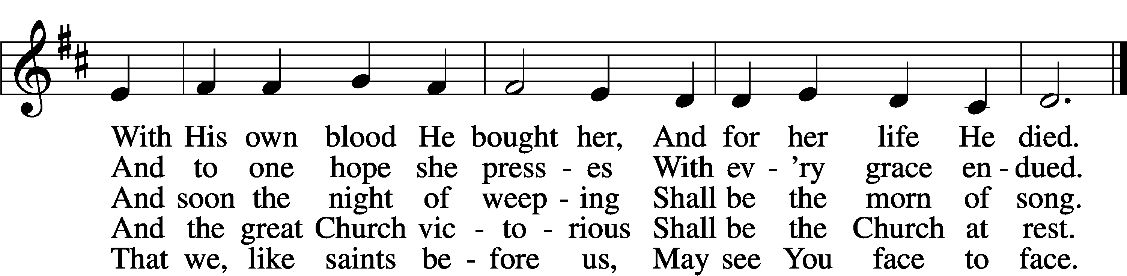
Stand

Confession and Absolution

The sign of the cross may be made by all in remembrance of their Baptism.

Invocation
P In the name of the Father and of the T Son and of the Holy Spirit.
C Amen.

Exhortation LSB 203
P Our help is in the name of the Lord,
C who made heaven and earth.

P If You, O Lord, kept a record of sins, O Lord, who could stand?
C But with You there is forgiveness; therefore You are feared.

P Since we are gathered to hear God’s Word, call upon Him in prayer and praise, and receive the body and blood of our Lord Jesus Christ in the fellowship of this altar, let us first consider our unworthiness and confess before God and one another that we have sinned in thought, word, and deed, and that we cannot free ourselves from our sinful condition. Together as His people let us take refuge in the infinite mercy of God, our heavenly Father, seeking His grace for the sake of Christ, and saying: God, be merciful to me, a sinner.

Confession of Sins LSB 203
C Almighty God, have mercy upon us, forgive us our sins, and lead us to everlasting life. Amen.

Prayer for Forgiveness
P Almighty God, merciful Father, in Holy Baptism You declared us to be Your children and gathered us into Your one, holy Church, in which You daily and richly forgive us our sins and grant us new life through Your Spirit. Be in our midst, enliven our faith, and graciously receive our prayer and praise; through Your Son, Jesus Christ, our Lord.
C Amen.

Service of the Word

Introit
P I will speak of your testimonies before kings, [O Lord,]
C and shall not be put to shame.
P I will bless the Lord at all times;
C his praise shall continually be in my mouth.
P My soul makes its boast in the Lord;
C let the humble hear and be glad.
P Come, O children, listen to me;
C I will teach you the fear of the Lord.
P The Lord redeems the life of his servants;
C none of those who take refuge in him will be condemned.

A Glory be to the Father and to the Son
and to the Holy Spirit;
as it was in the beginning,
is now, and will be forever. Amen.

P I will speak of your testimonies before kings, [O Lord,]
C and shall not be put to shame.

Kyrie LSB 204
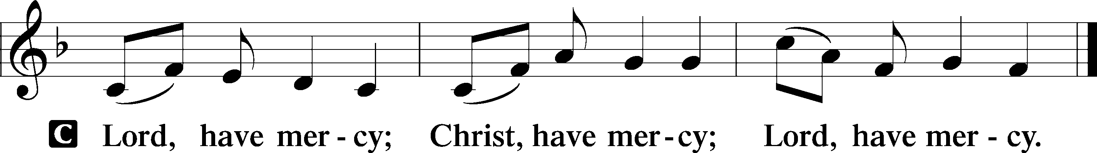

Gloria in Excelsis LSB 204
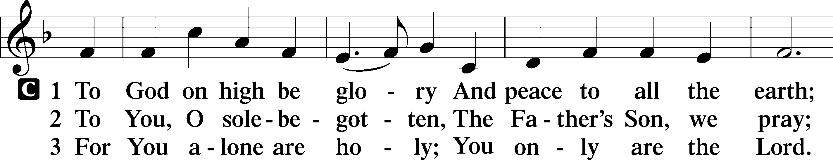
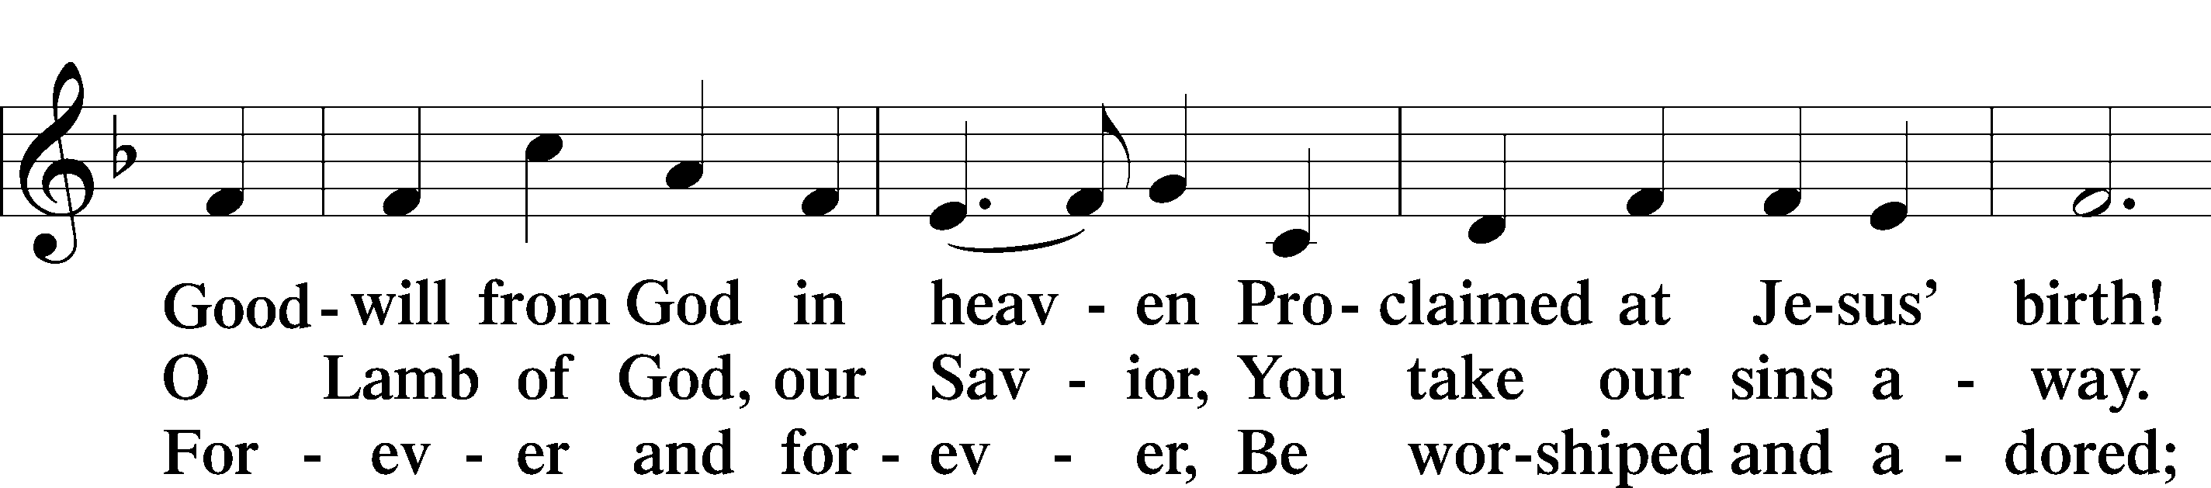
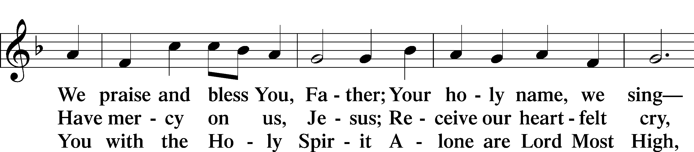
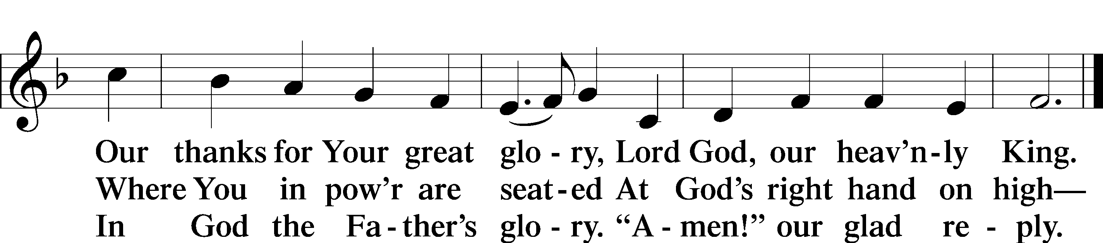

Salutation and Collect of the Day
P The Lord be with you.
C And also with you.

P Let us pray.
Almighty and gracious Lord, pour out Your Holy Spirit on Your faithful people. Keep us steadfast in Your grace and truth, protect and deliver us in times of temptation, defend us against all enemies, and grant to Your Church Your saving peace; through Jesus Christ, Your Son, our Lord, who lives and reigns with You and the Holy Spirit, one God, now and forever.
C Amen.

Sit

First Reading Revelation 14:6–7
6Then I saw another angel flying directly overhead, with an eternal gospel to proclaim to those who dwell on earth, to every nation and tribe and language and people. 7And he said with a loud voice, “Fear God and give him glory, because the hour of his judgment has come, and worship him who made heaven and earth, the sea and the springs of water.”

P This is the Word of the Lord.
C Thanks be to God.

Epistle Romans 3:19–28
19Now we know that whatever the law says it speaks to those who are under the law, so that every mouth may be stopped, and the whole world may be held accountable to God. 20For by works of the law no human being will be justified in his sight, since through the law comes knowledge of sin.
21But now the righteousness of God has been manifested apart from the law, although the Law and the Prophets bear witness to it— 22the righteousness of God through faith in Jesus Christ for all who believe. For there is no distinction: 23for all have sinned and fall short of the glory of God, 24and are justified by his grace as a gift, through the redemption that is in Christ Jesus, 25whom God put forward as a propitiation by his blood, to be received by faith. This was to show God’s righteousness, because in his divine forbearance he had passed over former sins. 26It was to show his righteousness at the present time, so that he might be just and the justifier of the one who has faith in Jesus.
27Then what becomes of our boasting? It is excluded. By what kind of law? By a law of works? No, but by the law of faith. 28For we hold that one is justified by faith apart from works of the law.

P This is the Word of the Lord.
C Thanks be to God.

Stand

Alleluia and Verse

Alleluia LSB 205
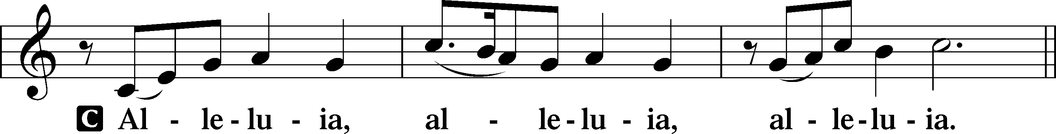

Verse LSB 205
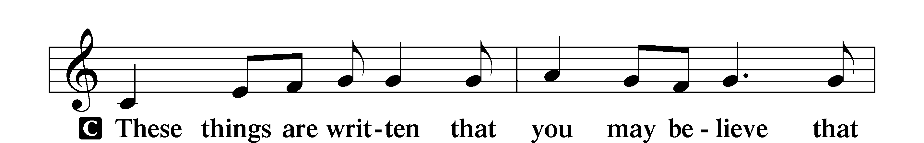
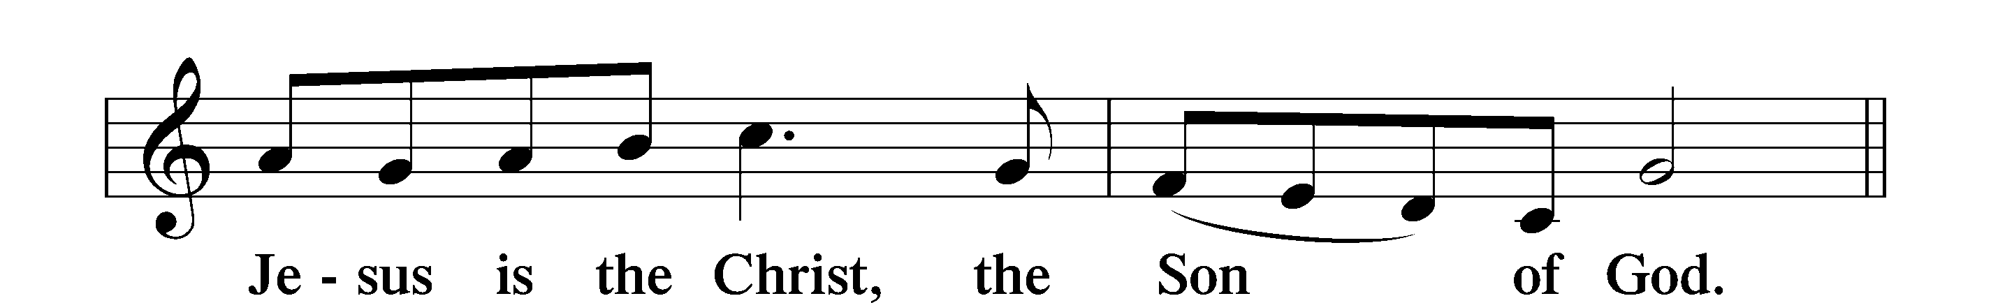

Alleluia LSB 205
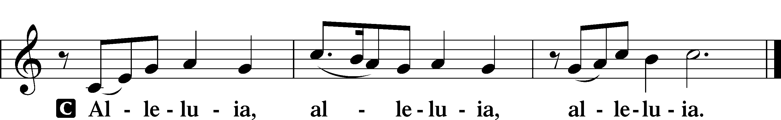

Holy Gospel John 8:31–36
P The Holy Gospel according to St. John, the eighth chapter.
C Glory to You, O Lord.

31So Jesus said to the Jews who had believed in him, “If you abide in my word, you are truly my disciples, 32and you will know the truth, and the truth will set you free.” 33They answered him, “We are offspring of Abraham and have never been enslaved to anyone. How is it that you say, ‘You will become free’?”
34Jesus answered them, “Truly, truly, I say to you, everyone who practices sin is a slave to sin. 35The slave does not remain in the house forever; the son remains forever. 36So if the Son sets you free, you will be free indeed.”

P This is the Gospel of the Lord.
C Praise to You, O Christ.

Nicene Creed
C I believe in one God,
the Father Almighty,
maker of heaven and earth
and of all things visible and invisible.

And in one Lord Jesus Christ,
the only-begotten Son of God,
begotten of His Father before all worlds,
God of God, Light of Light,
very God of very God,
begotten, not made,
being of one substance with the Father,
by whom all things were made;
who for us men and for our salvation came down from heaven
and was incarnate by the Holy Spirit of the virgin Mary
and was made man;
and was crucified also for us under Pontius Pilate.
He suffered and was buried.
And the third day He rose again according to the Scriptures
and ascended into heaven
and sits at the right hand of the Father.
And He will come again with glory to judge both the living and the dead,
whose kingdom will have no end.

And I believe in the Holy Spirit,
the Lord and giver of life,
who proceeds from the Father and the Son,
who with the Father and the Son together is worshiped and glorified,
who spoke by the prophets.
And I believe in one holy Christian and apostolic Church,
I acknowledge one Baptism for the remission of sins,
and I look for the resurrection of the dead
and the life T of the world to come. Amen.
Sit

Children's Talk

Sermon Hymn
657 A Mighty Fortress is Our God
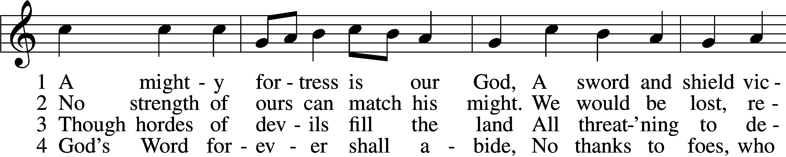
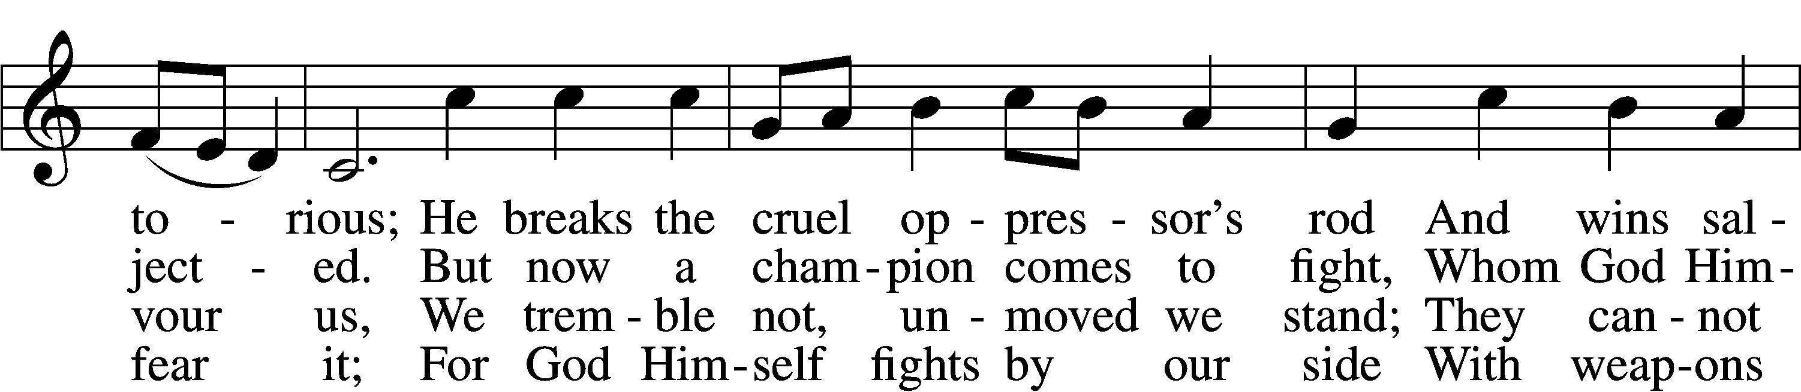
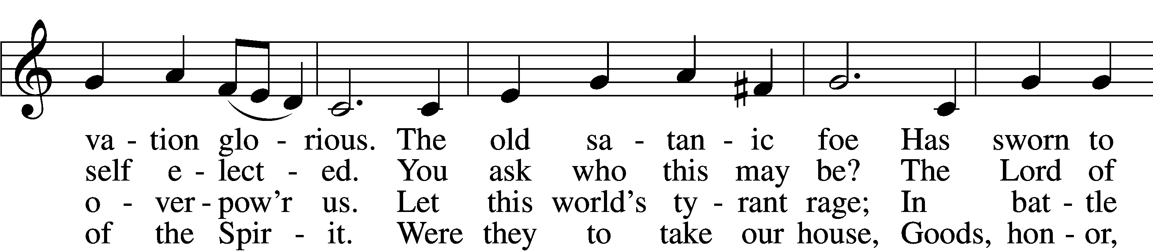
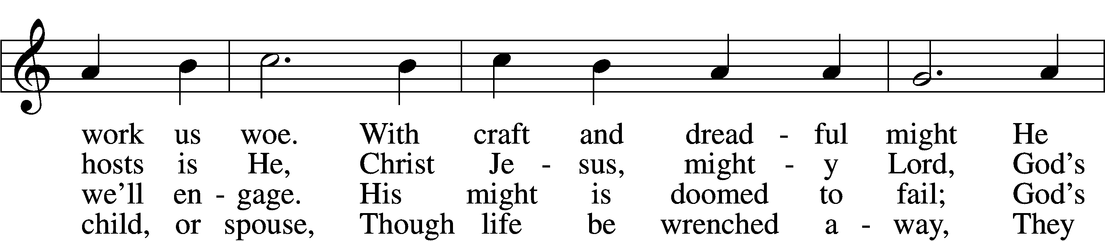
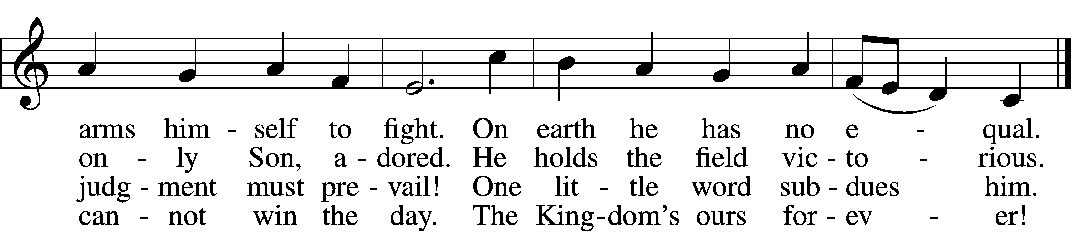
Sermon

Stand

Prayer of the Church

Prayer Response
After each segment:
P Lord, in Your mercy,
C hear our prayer.

After prayers:
P In Your Name we pray
C Amen.

Service of the Sacrament

Preface 208
P The Lord be with you.
C And also with you.

P Lift up your hearts.
C We lift them to the Lord.

P Let us give thanks to the Lord our God.
C It is right to give Him thanks and praise.

P It is truly good, right, and salutary that we should at all times and in all places give thanks to You, O Lord, holy Father, almighty and everlasting God, for the countless blessings You so freely bestow on us and all creation. Above all, we give thanks for Your boundless love shown to us when You sent Your only-begotten Son, Jesus Christ, into our flesh and laid on Him our sin, giving Him into death that we might not die eternally. Because He is now risen from the dead and lives and reigns to all eternity, all who believe in Him will overcome sin and death and will rise again to new life. Therefore with angels and archangels and with all the company of heaven we laud and magnify Your glorious name, evermore praising You and singing:

Sanctus LSB 208
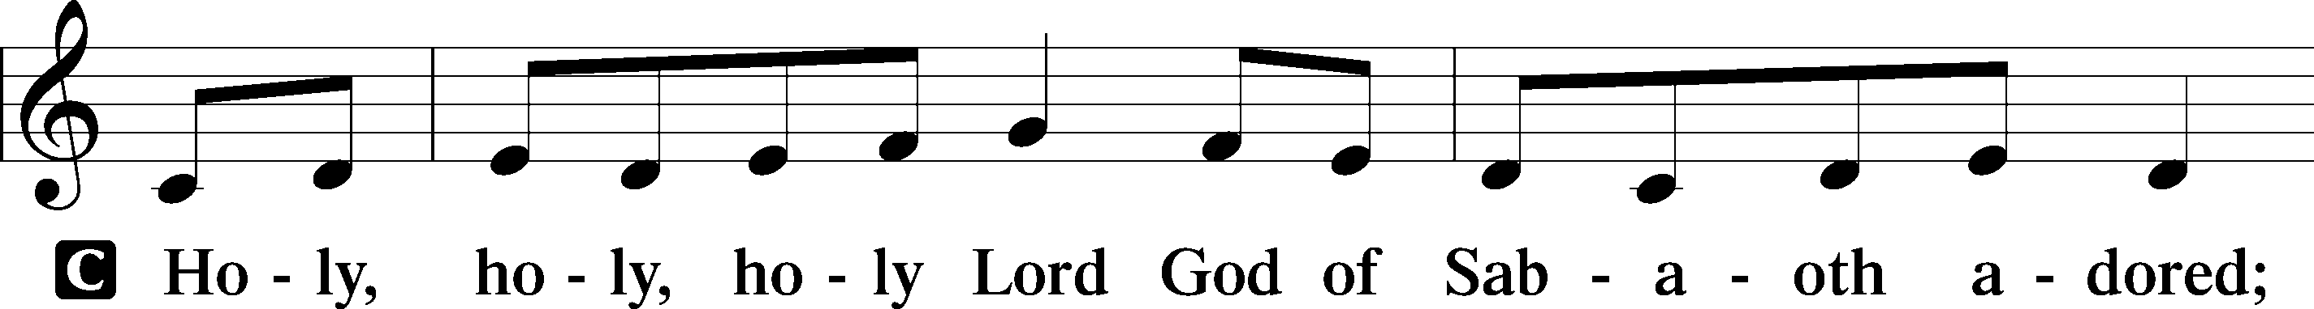
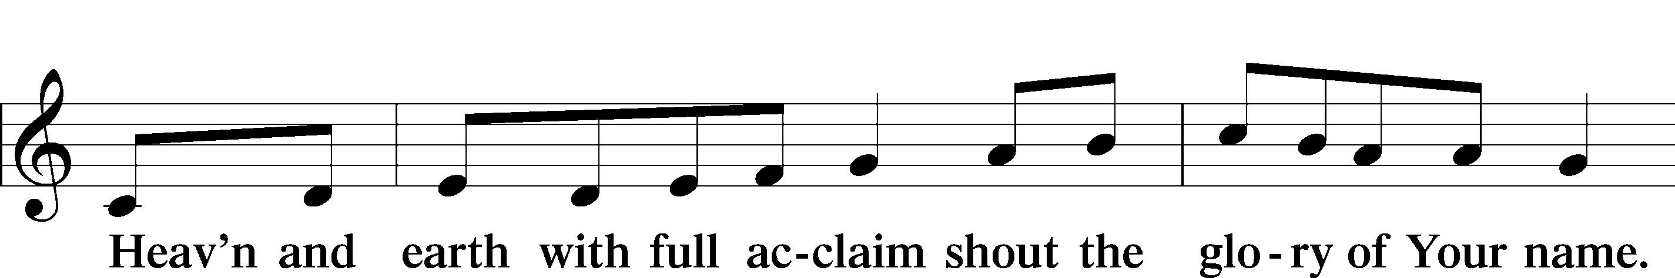
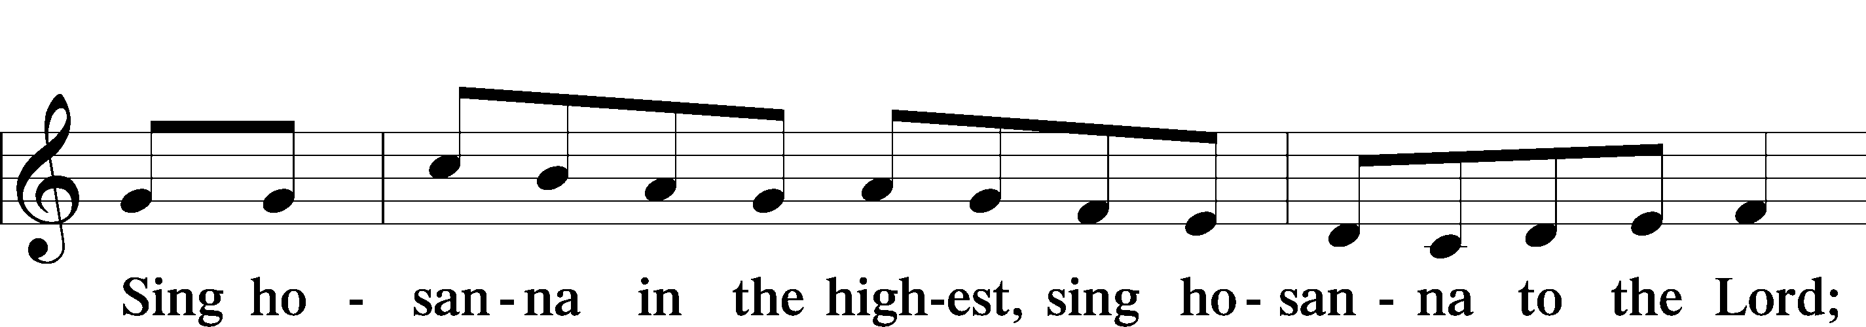
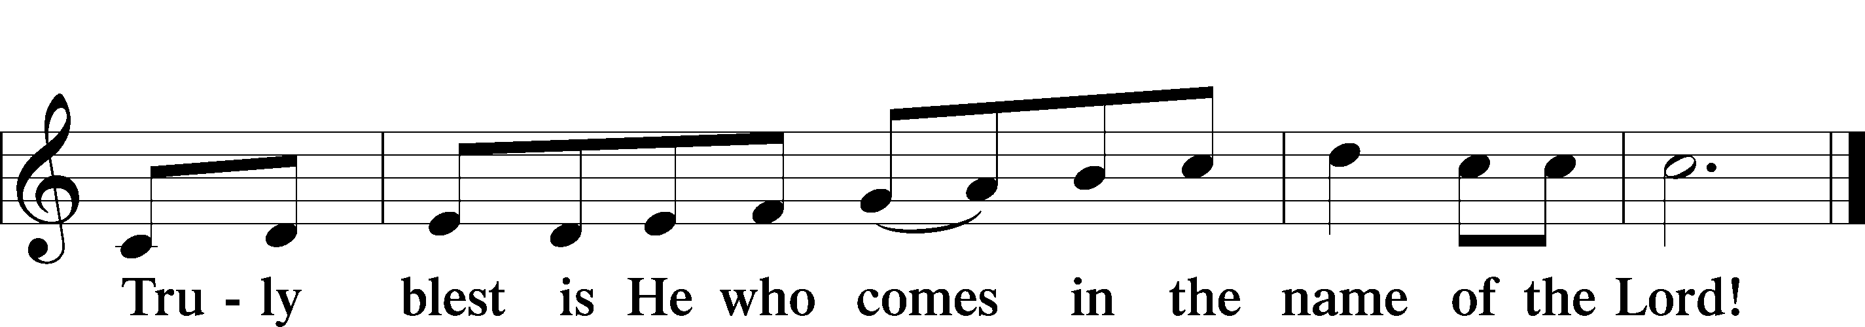

Prayer of Thanksgiving
P Blessed are You, O Lord our God, king of all creation, for You have had mercy on us and given Your only-begotten Son that whoever believes in Him should not perish but have eternal life.

In Your righteous judgment You condemned the sin of Adam and Eve, who ate the forbidden fruit, and You justly barred them and all their children from the tree of life. Yet, in Your great mercy, You promised salvation by a second Adam, Your Son, Jesus Christ, our Lord, and made His cross a life-giving tree for all who trust in Him.

We give You thanks for the redemption You have prepared for us through Jesus Christ. Grant us Your Holy Spirit that we may faithfully eat and drink of the fruits of His cross and receive the blessings of forgiveness, life, and salvation that come to us in His body and blood.

Hear us as we pray in His name and as He has taught us:

Lord’s Prayer
C Our Father who art in heaven,
hallowed be Thy name,
Thy kingdom come,
Thy will be done on earth
as it is in heaven;
give us this day our daily bread;
and forgive us our trespasses
as we forgive those
who trespass against us;
and lead us not into temptation,
but deliver us from evil.
For Thine is the kingdom
and the power and the glory
forever and ever. Amen.

The Words of Our Lord
P Our Lord Jesus Christ, on the night when He was betrayed, took bread, and when He had given thanks, He broke it and gave it to the disciples and said: “Take, eat; this is My T body, which is given for you. This do in remembrance of Me.”

In the same way also He took the cup after supper, and when He had given thanks, He gave it to them, saying: “Drink of it, all of you; this cup is the new testament in My T blood, which is shed for you for the forgiveness of sins. This do, as often as you drink it, in remembrance of Me.”

Pax Domini
P The peace of the Lord be with you always.
C Amen.

Agnus Dei LSB 210
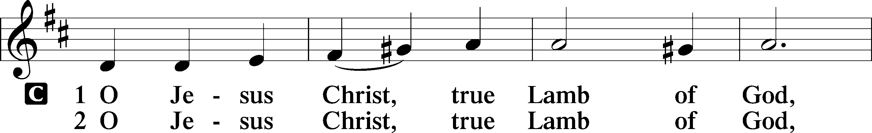
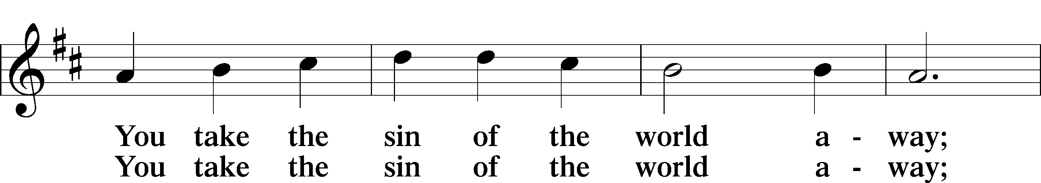
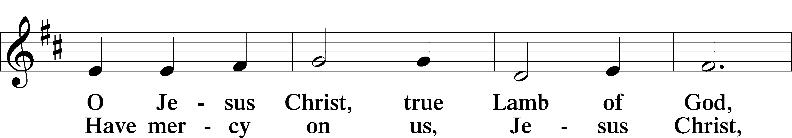
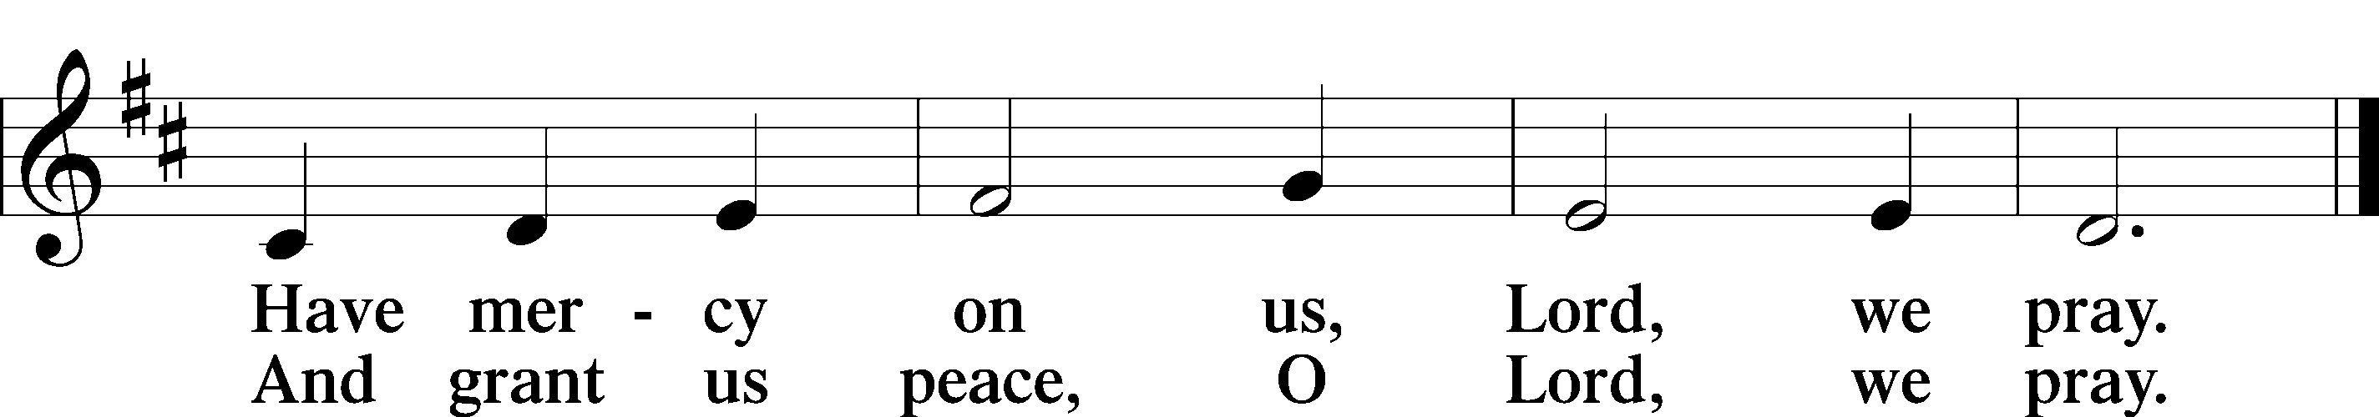

Sit

Distribution Hymns

618 I Come, O Savior, to Thy Table
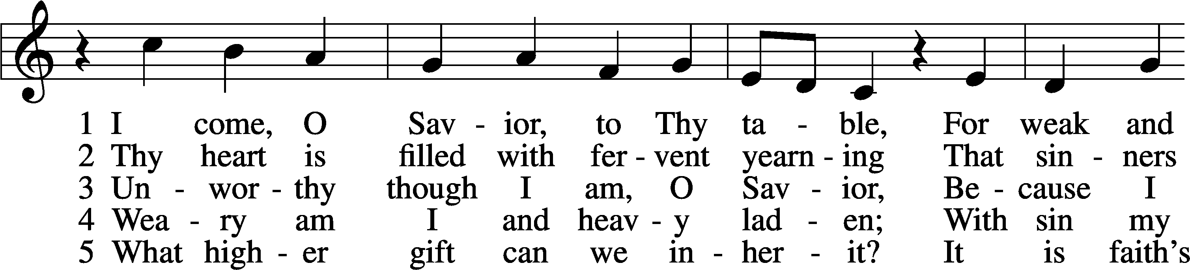
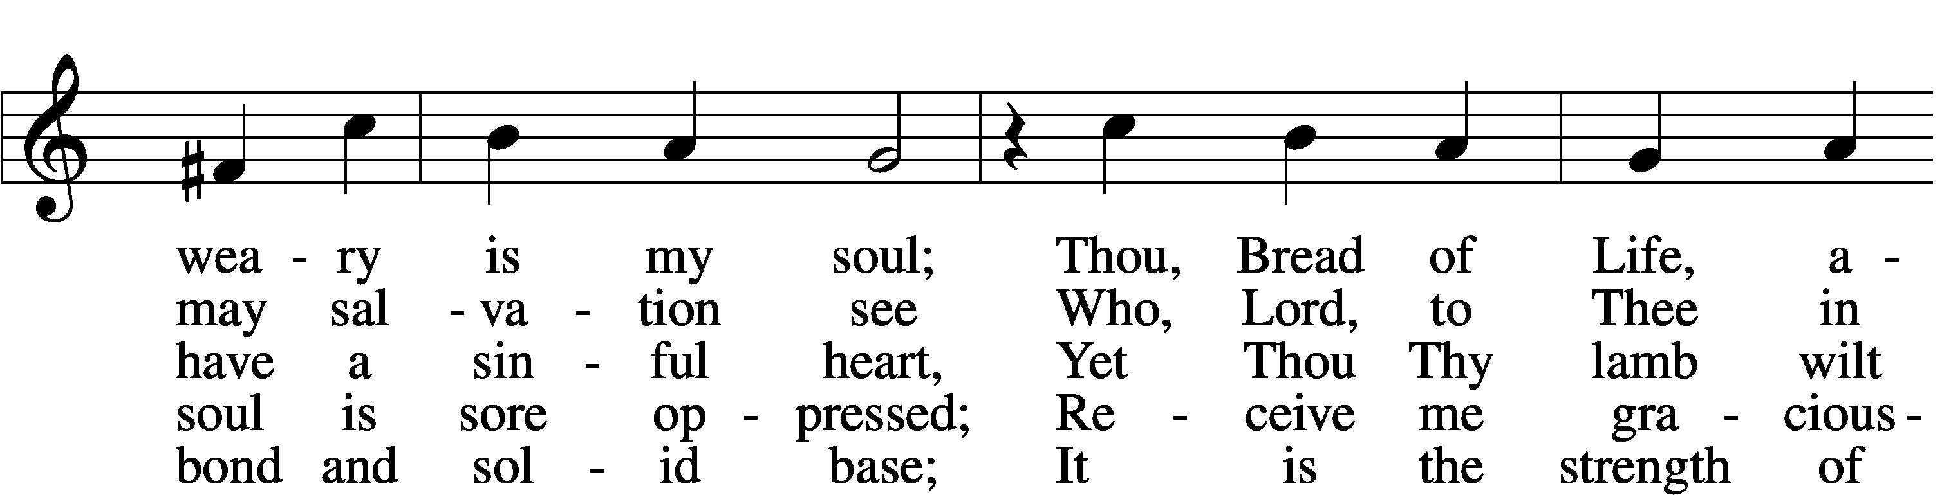
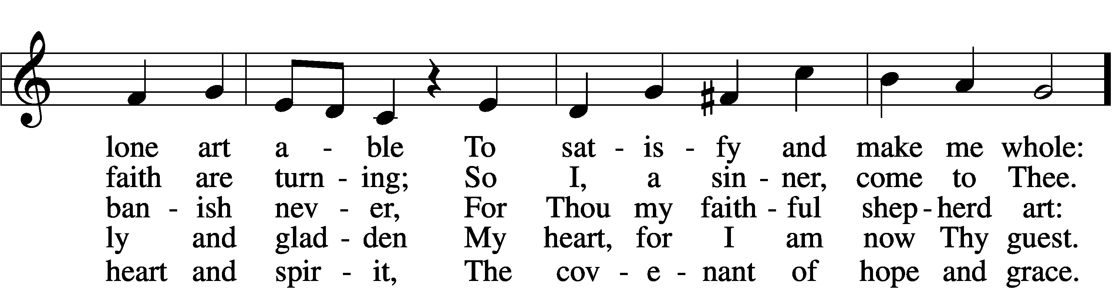
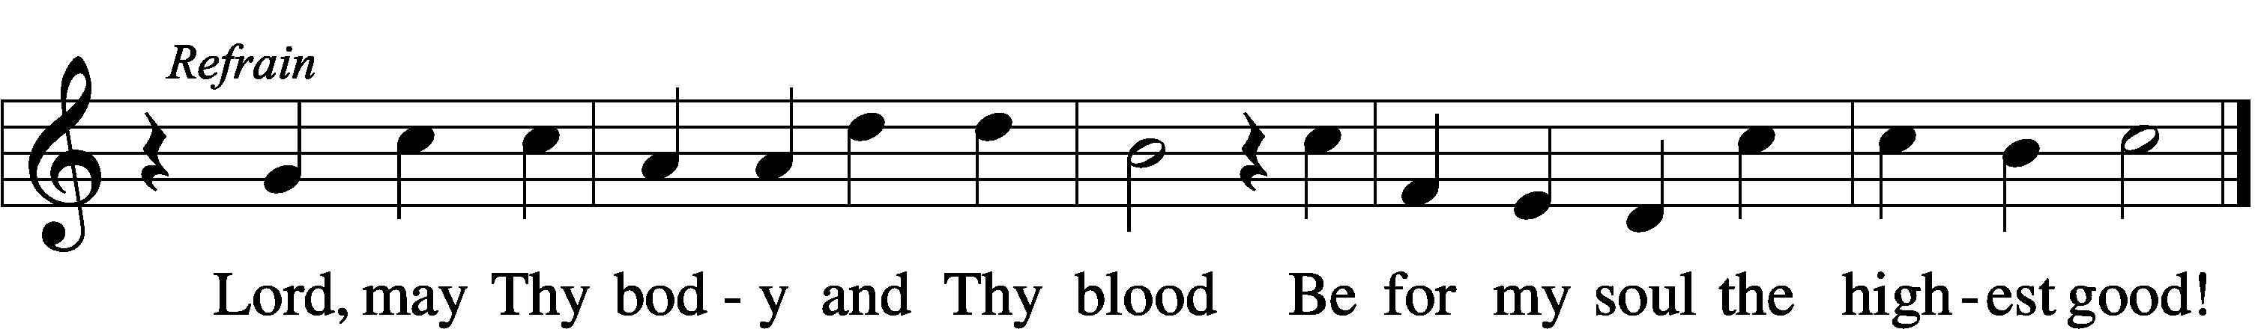

570 Just as I Am, without One Plea
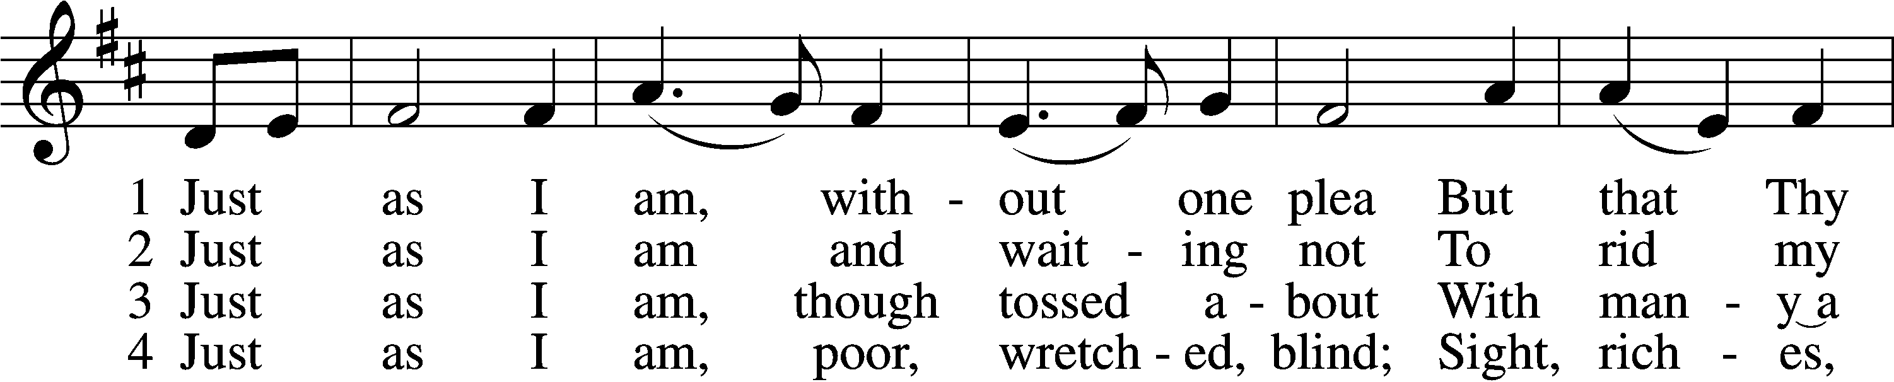
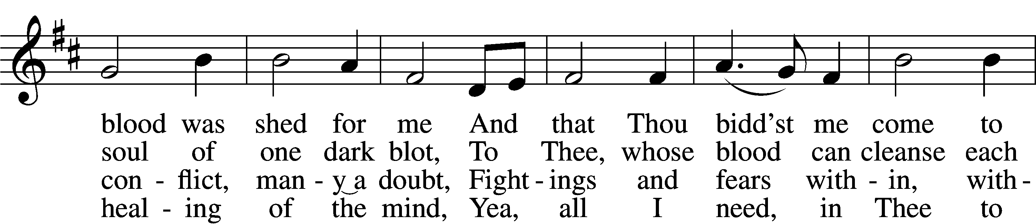
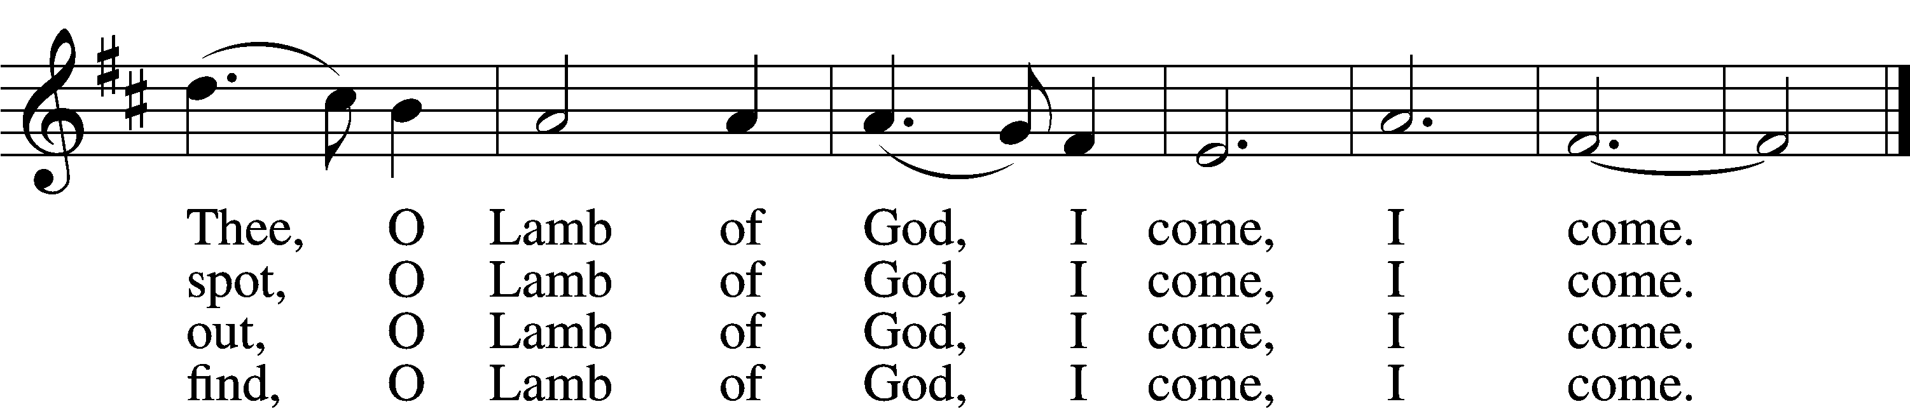

5 Just as I am, Thou wilt receive,
Wilt welcome, pardon, cleanse, relieve;
Because Thy promise I believe,
O Lamb of God, I come, I come.

6 Just as I am; Thy love unknown
Has broken ev’ry barrier down;
Now to be Thine, yea, Thine alone,
O Lamb of God, I come, I come.

Stand

Nunc Dimittis LSB 211
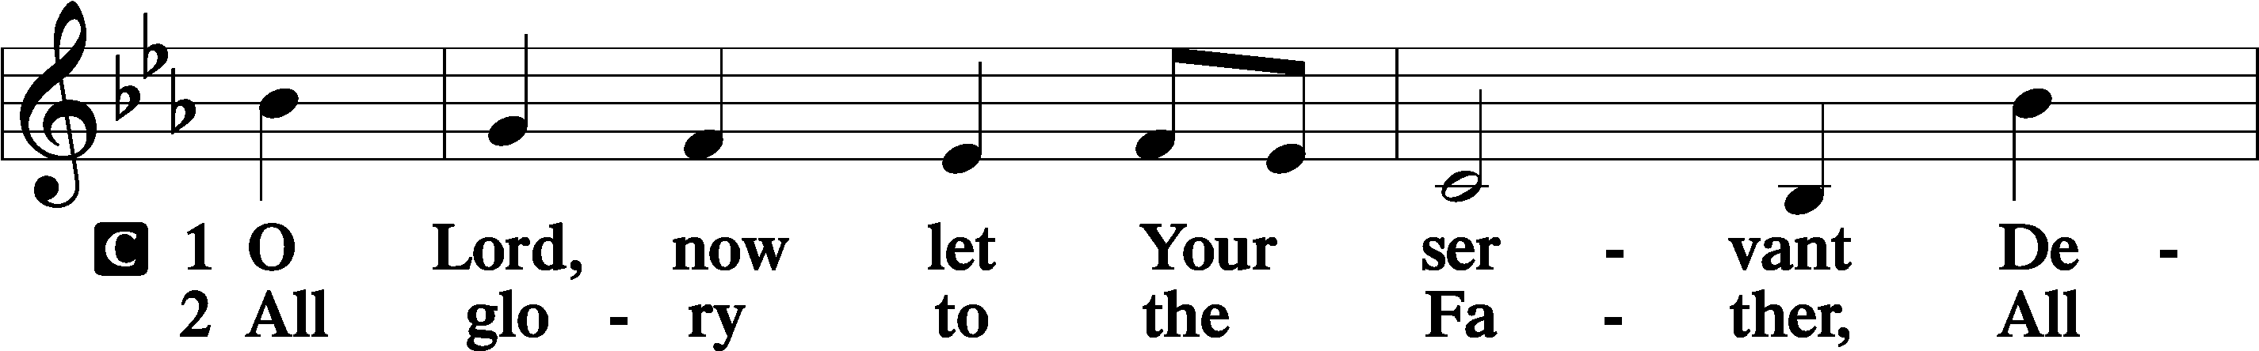
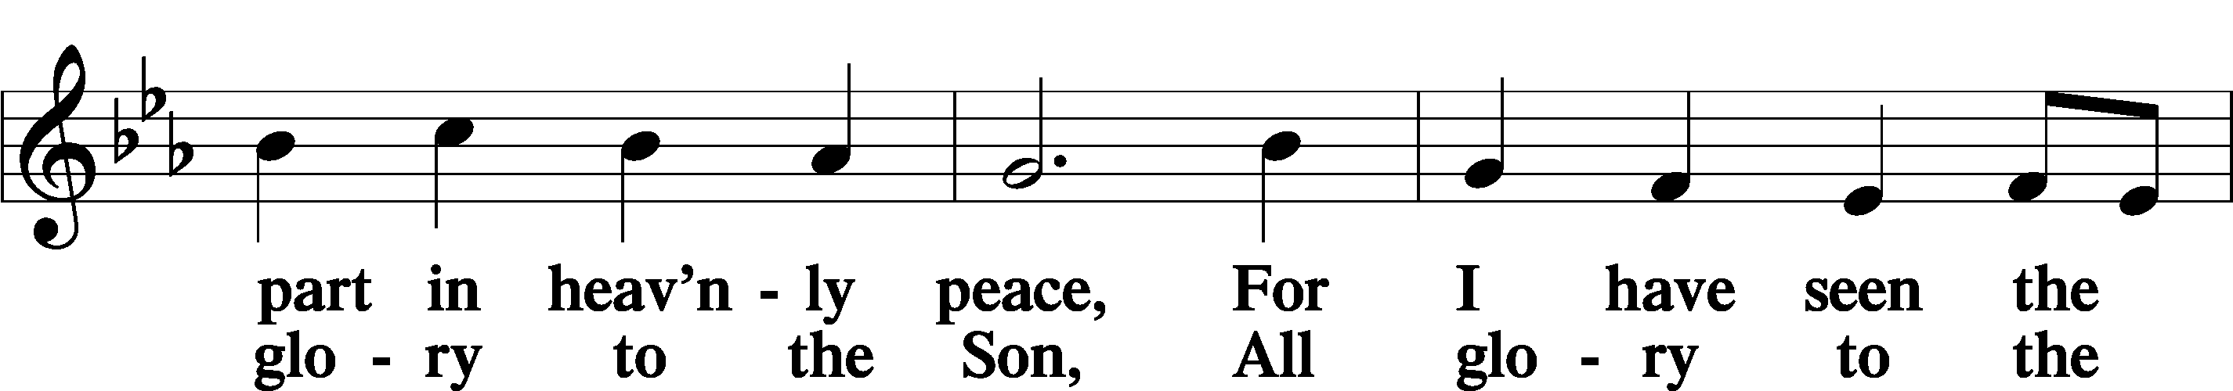
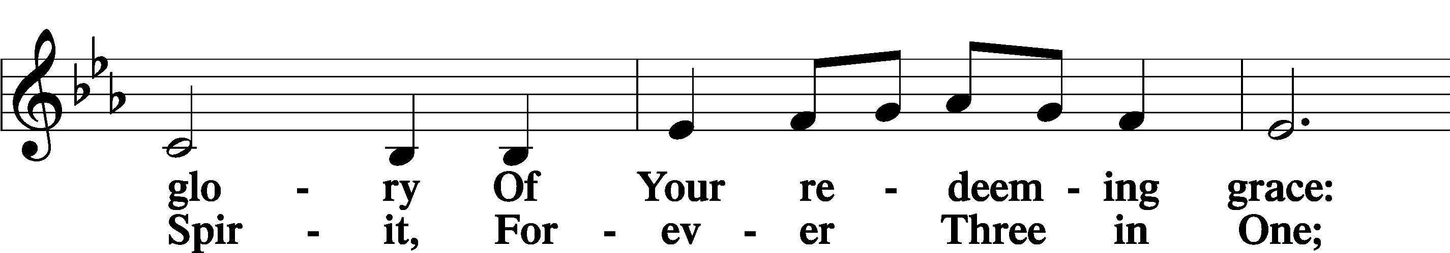
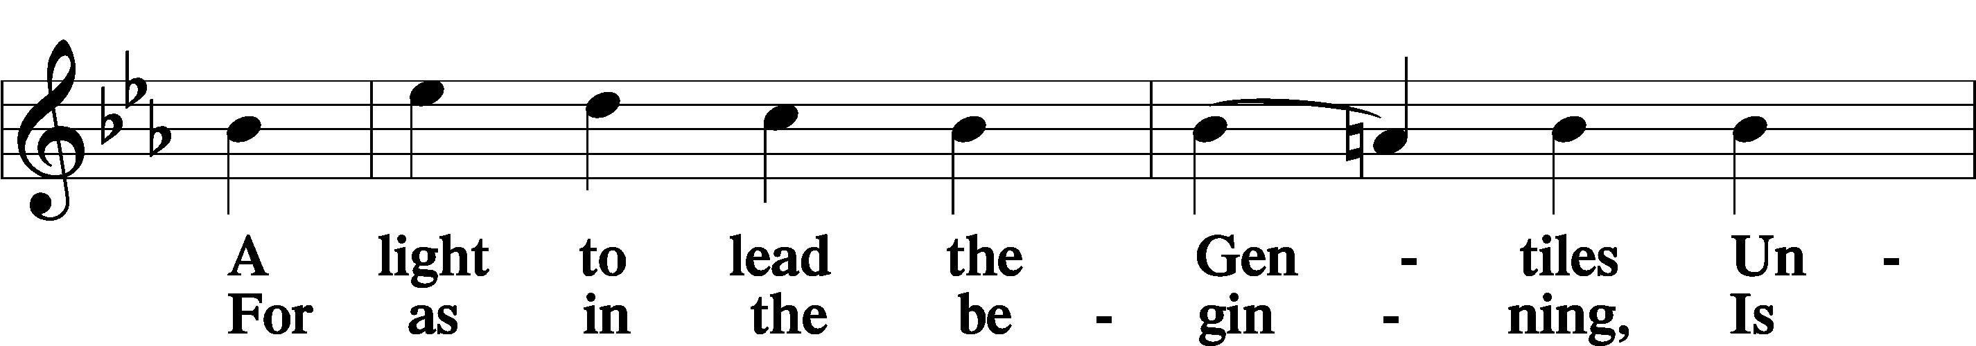
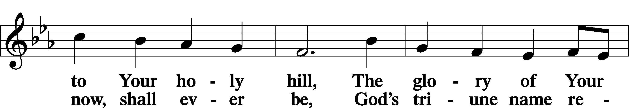
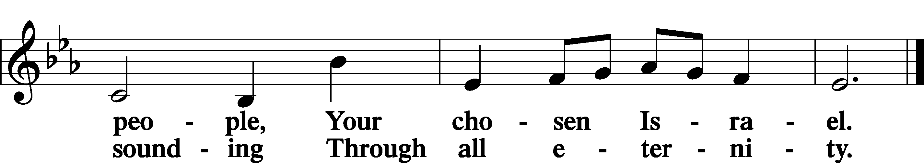

Post-Communion Collect
P Let us pray.

We give thanks to You, almighty God, that You have refreshed us through this salutary gift, and we implore You that of Your mercy You would strengthen us through the same in faith toward You and in fervent love toward one another; through Jesus Christ, Your Son, our Lord, who lives and reigns with You and the Holy Spirit, one God, now and forever.
C Amen.

Benedicamus 212
P Let us bless the Lord.
C Thanks be to God.

Benediction
P The Lord bless you and keep you.
The Lord make His face shine on you and be gracious to you.
The Lord look upon you with favor and T give you peace.
C Amen.

861 Christ Be My Leader
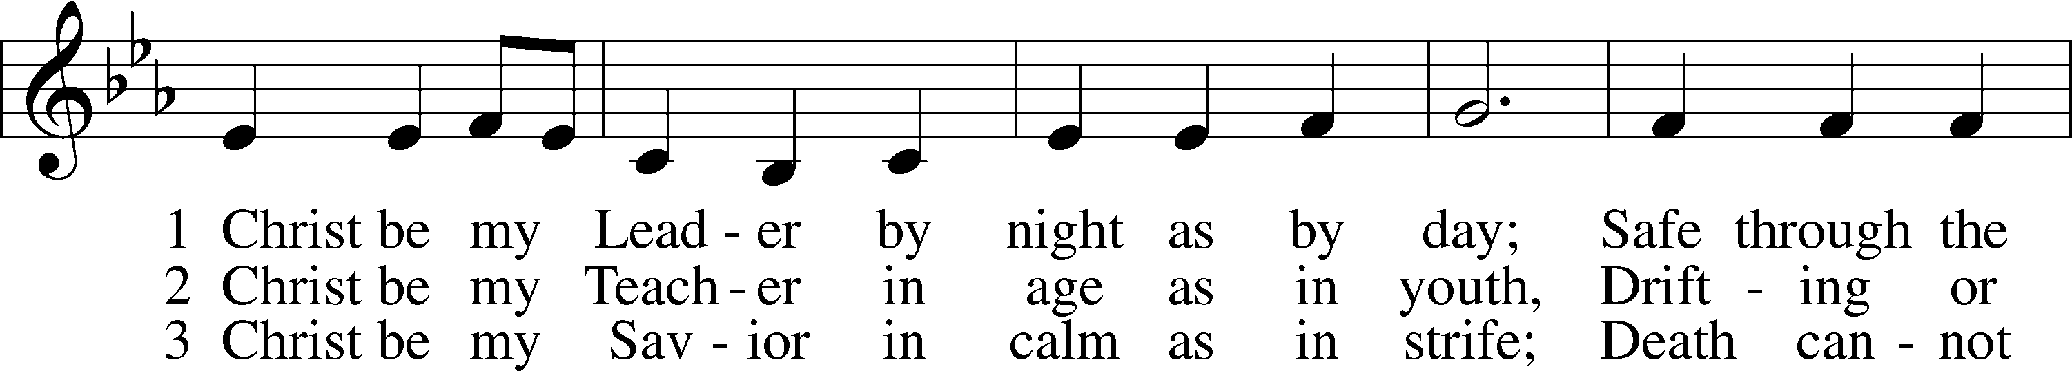
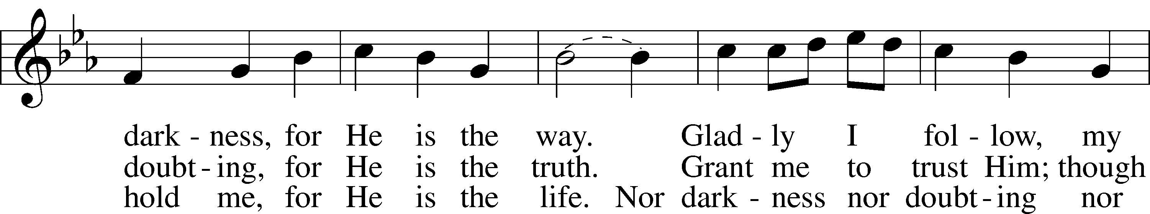
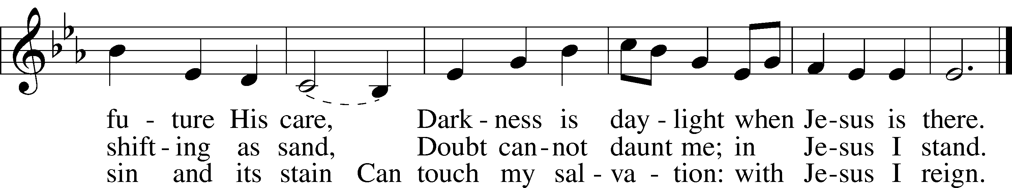

Closing Statement
P We go to live for Jesus.
C We go to share His love.

Acknowledgments
Unless otherwise indicated, Scripture quotations are from the ESV® Bible (The Holy Bible, English Standard Version®), copyright © 2001 by Crossway, a publishing ministry of Good News Publishers. Used by permission. All rights reserved.
Created by Lutheran Service Builder © 2023 Concordia Publishing House.

