Welcome To
Trinity Lutheran Church
Lutheran Church - Missouri Synod
A Stephen Ministry Congregation

1354 South Otsego Avenue
Gaylord, MI 49735
Church Phone: 989-732-4816

Church Email:
trinitygaylord-secretary@outlook.com
Web Page
www.trinitygaylord.com

Office Hours:
Monday through Friday 9am - 1pm

OUR PURPOSE

. . . is to LOVE GOD, LOVE OTHERS AND SERVE THE WORLD by worshiping the Lord Jesus, bringing our members into Christ-like maturity, and equipping them through Word and Sacrament for their mission and ministry. We go heart to heart into the world with Jesus, sharing His love, caring for one another, praying, and bringing the lost into a relationship with Christ, by the working of the Holy Spirit.

October 22, 2023
Twenty-First Sunday after Pentecost
(Stewardship Sunday Service 3)
Officiant: Rev. Paul H. Schneider

ABOUT OUR WORSHIP

We welcome all who gather here today! We are blessed to celebrate together the mercy, grace and love we have from God through the death and resurrection of our Lord Jesus Christ.

Children: Families with children are very welcome here. Having children in church is important so they can begin to learn about their faith in Jesus, and it’s good for the whole congregation to see. Please feel comfortable keeping “squirmy” kids in the service. This is where they belong, too!

Pew cards: Guest and Members, please fill out a Guest/Member card located in the pew rack. The card can be placed in the offering plates at the back of the church.

If standing is difficult feel free to remain seated during any portion of the service. Please let an Elder or Usher know if you need communion in your pew seat.

About our celebration of Holy Communion
We celebrate The Lord's Supper in the confession and glad confidence that, as Jesus says, our Lord gives to us not only bread and wine, but also His very body and blood to eat and to drink for the forgiveness of sins and to strengthen our union with Him and with one another. Our Lord invites to His table those who trust His words, repent of all sin, and set aside any refusal to forgive and love as He forgives and loves us.
Because those who eat and drink our Lord's body and blood unworthily do so to their harm, and because Holy Communion is a confession of the faith which is confessed at this altar, any who are not baptized, instructed about communion in an LCMS congregation, or are in doubt and yet desire to receive Holy Communion, are asked to first speak with the Pastor or elder.
Those not communing are still invited to come forward for a blessing from Pastor, and you may indicate this by crossing your arms over your chest.
Grape juice is offered in the center of the trays. Gluten-free wafers are available.
For further study, see Matthew 5:23; 10:32; 18:15-35, 26:26-29, 1 Corinthians 10:16-17, 1 Corinthians 11:17-34.

Greeting
P Peace be with you.
C And also with you

Divine Service - Setting Four LSB 203

Opening Hymn

807 When Morning Gilds the Skies
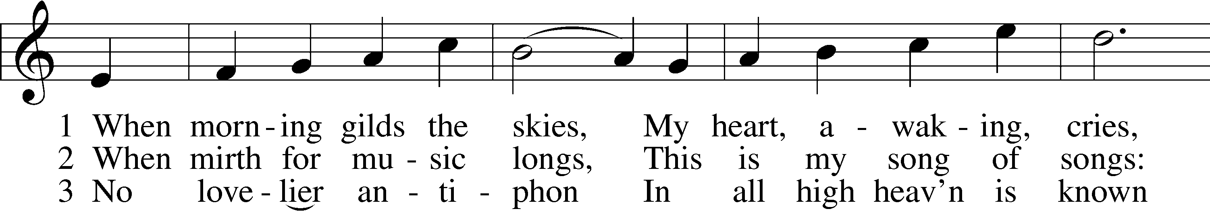
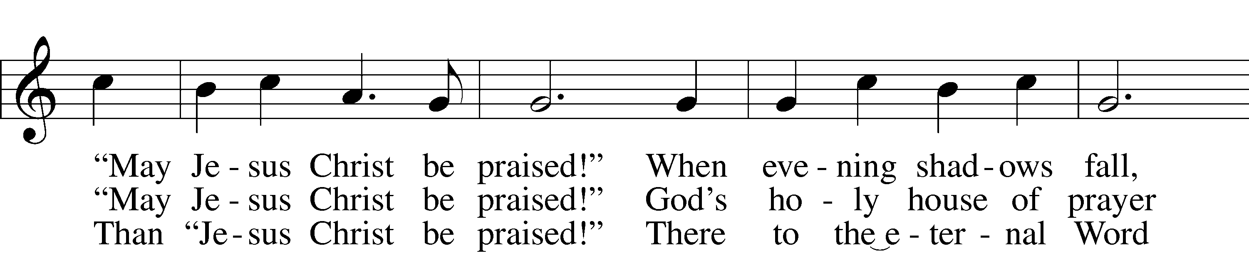
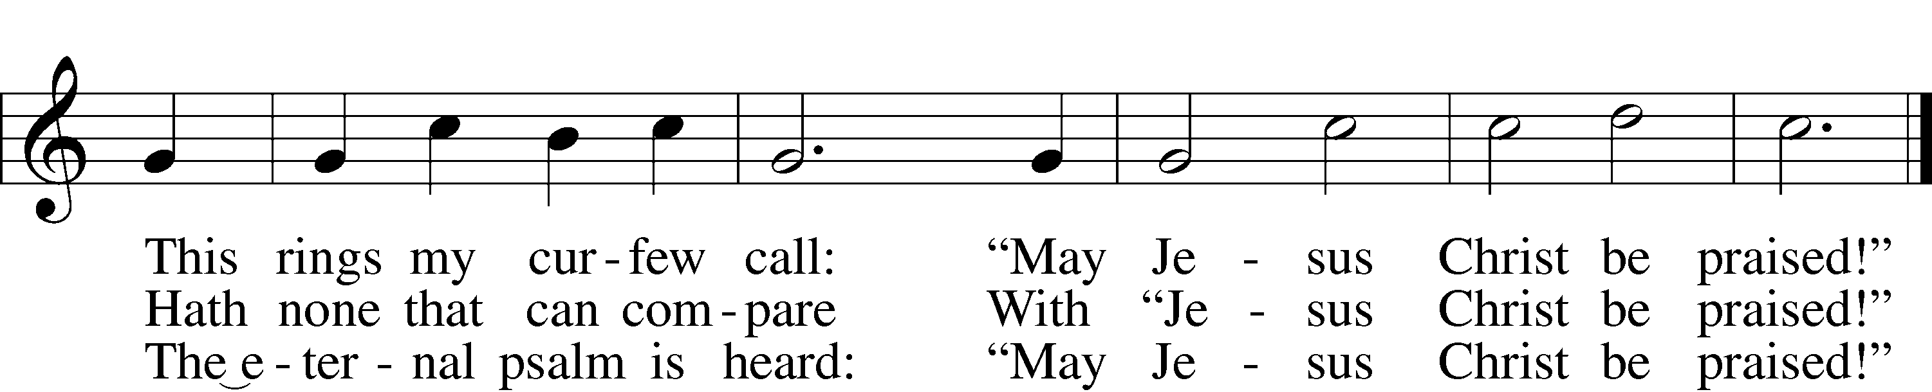

Stand

Confession and Absolution

The sign of the cross may be made by all in remembrance of their Baptism.

Invocation
P In the name of the Father and of the T Son and of the Holy Spirit.
C Amen.

Exhortation LSB 203
P Our help is in the name of the Lord,
C who made heaven and earth.

P If You, O Lord, kept a record of sins, O Lord, who could stand?
C But with You there is forgiveness; therefore You are feared.

P Since we are gathered to hear God’s Word, call upon Him in prayer and praise, and receive the body and blood of our Lord Jesus Christ in the fellowship of this altar, let us first consider our unworthiness and confess before God and one another that we have sinned in thought, word, and deed, and that we cannot free ourselves from our sinful condition. Together as His people let us take refuge in the infinite mercy of God, our heavenly Father, seeking His grace for the sake of Christ, and saying: God, be merciful to me, a sinner.

Confession of Sins LSB 203
C Almighty God, have mercy upon us, forgive us our sins, and lead us to everlasting life. Amen.

Prayer for Forgiveness
P Almighty God, merciful Father, in Holy Baptism You declared us to be Your children and gathered us into Your one, holy Church, in which You daily and richly forgive us our sins and grant us new life through Your Spirit. Be in our midst, enliven our faith, and graciously receive our prayer and praise; through Your Son, Jesus Christ, our Lord.
C Amen.

Service of the Word

Introit
P The Lord is your keeper;
C the Lord is your shade on your right hand.
P I lift up my eyes to the hills.
C From where does my help come?
P My help comes from the Lord,
C who made heaven and earth.

P He will not let your foot be moved;
C he who keeps you will not slumber.
P Behold, he who keeps Israel
C will neither slumber nor sleep.
P The Lord will keep you from all evil;
C he will keep your life.
P The Lord will keep your going out and your coming in
C from this time forth and forevermore.
A Glory be to the Father and to the Son
and to the Holy Spirit;
as it was in the beginning,
is now, and will be forever. Amen.
P The Lord is your keeper;
C the Lord is your shade on your right hand.

Kyrie LSB 204
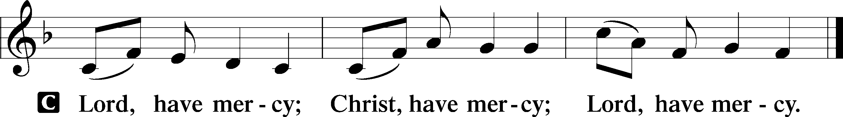

Gloria in Excelsis LSB 204
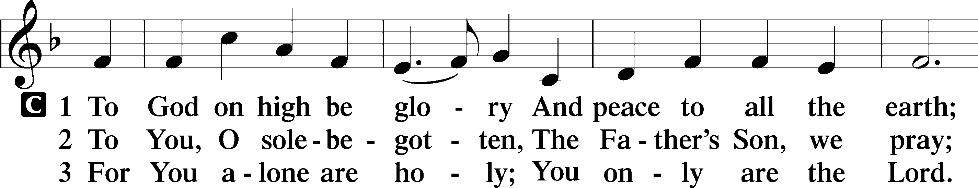
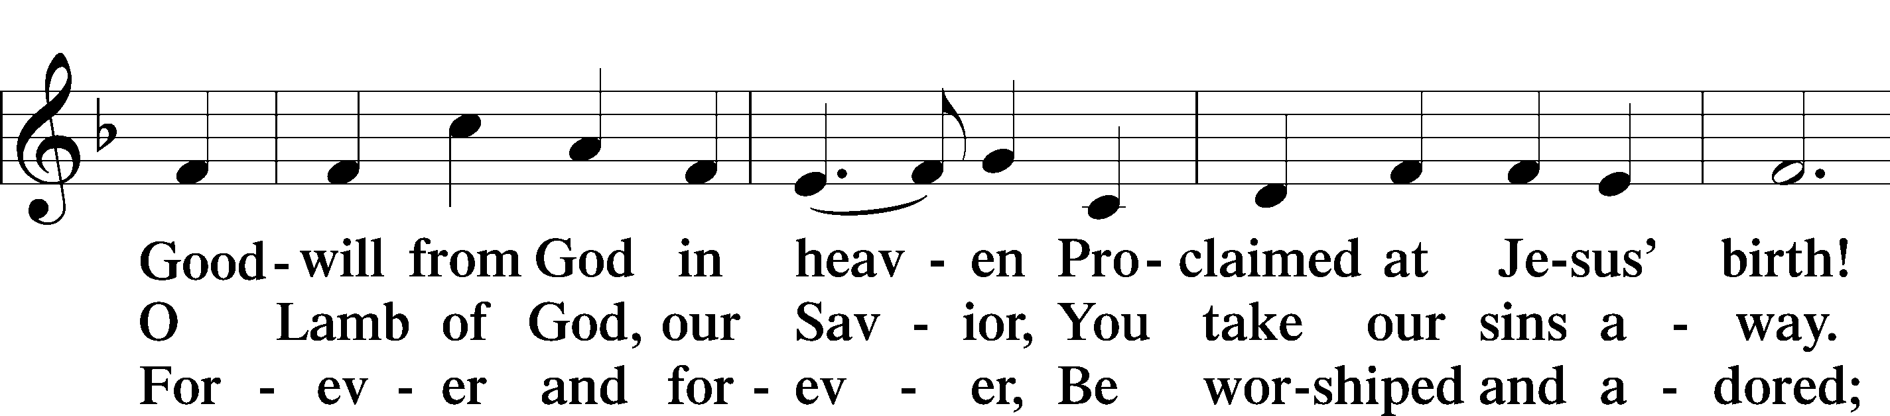
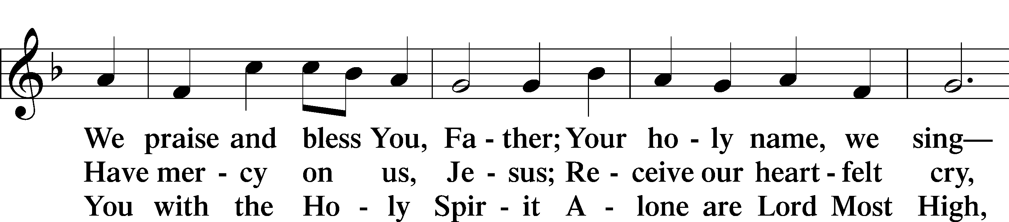
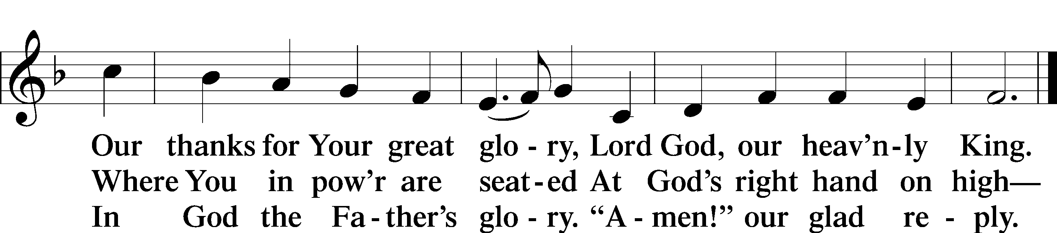

Salutation and Collect of the Day
P The Lord be with you.
C And also with you.

P Let us pray.
O God, the protector of all who trust in You, have mercy on us that with You as our ruler and guide we may so pass through things temporal that we lose not the things eternal; through Jesus Christ, Your Son, our Lord, who lives and reigns with You and the Holy Spirit, one God, now and forever.
C Amen.

Sit

First Reading Exodus 35:4–9, 3–7
4Moses said to all the congregation of the people of Israel, “This is the thing that the Lord has commanded. 5Take from among you a contribution to the Lord. Whoever is of a generous heart, let him bring the Lord’s contribution: gold, silver, and bronze; 6blue and purple and scarlet yarns and fine twined linen; goats’ hair, 7tanned rams’ skins, and goatskins; acacia wood, 8oil for the light, spices for the anointing oil and for the fragrant incense, 9and onyx stones and stones for setting, for the ephod and for the breastpiece.
3You shall kindle no fire in all your dwelling places on the Sabbath day.”
4Moses said to all the congregation of the people of Israel, “This is the thing that the Lord has commanded. 5Take from among you a contribution to the Lord. Whoever is of a generous heart, let him bring the Lord’s contribution: gold, silver, and bronze; 6blue and purple and scarlet yarns and fine twined linen; goats’ hair, 7tanned rams’ skins, and goatskins; acacia wood,

P This is the Word of the Lord.
C Thanks be to God.

Second Reading Malachi 3:6–12
6“For I the Lord do not change; therefore you, O children of Jacob, are not consumed. 7From the days of your fathers you have turned aside from my statutes and have not kept them. Return to me, and I will return to you, says the Lord of hosts. But you say, ‘How shall we return?’ 8Will man rob God? Yet you are robbing me. But you say, ‘How have we robbed you?’ In your tithes and contributions. 9You are cursed with a curse, for you are robbing me, the whole nation of you. 10Bring the full tithes into the storehouse, that there may be food in my house. And thereby put me to the test, says the Lord of hosts, if I will not open the windows of heaven for you and pour down for you a blessing until there is no more need. 11I will rebuke the devourer for you, so that it will not destroy the fruits of your soil, and your vine in the field shall not fail to bear, says the Lord of hosts. 12Then all nations will call you blessed, for you will be a land of delight, says the Lord of hosts.

P This is the Word of the Lord.
C Thanks be to God.

Stand

Alleluia and Verse

Alleluia LSB 205
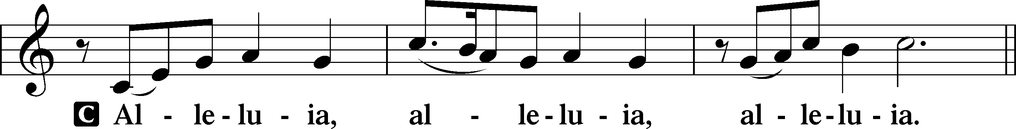

Verse LSB 205
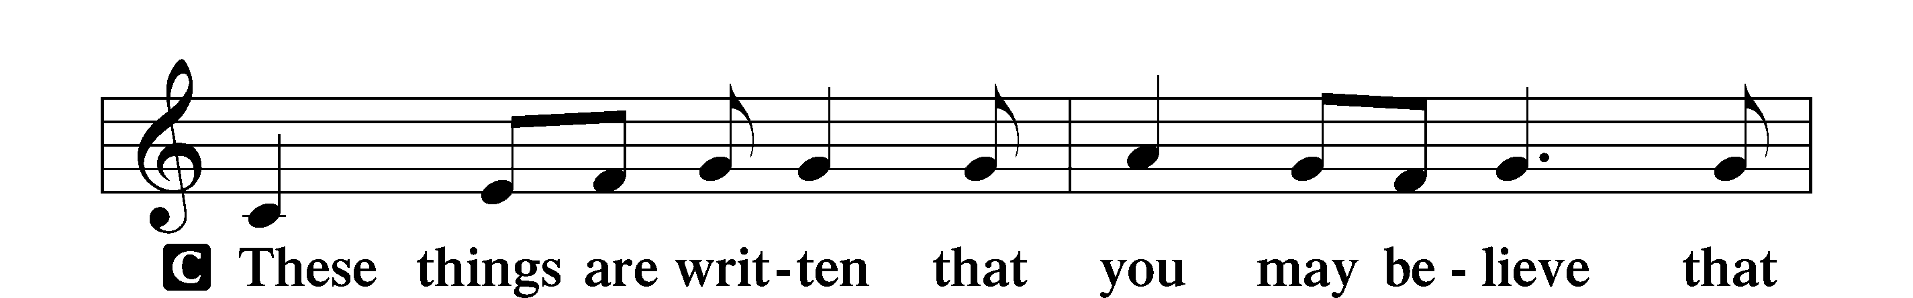
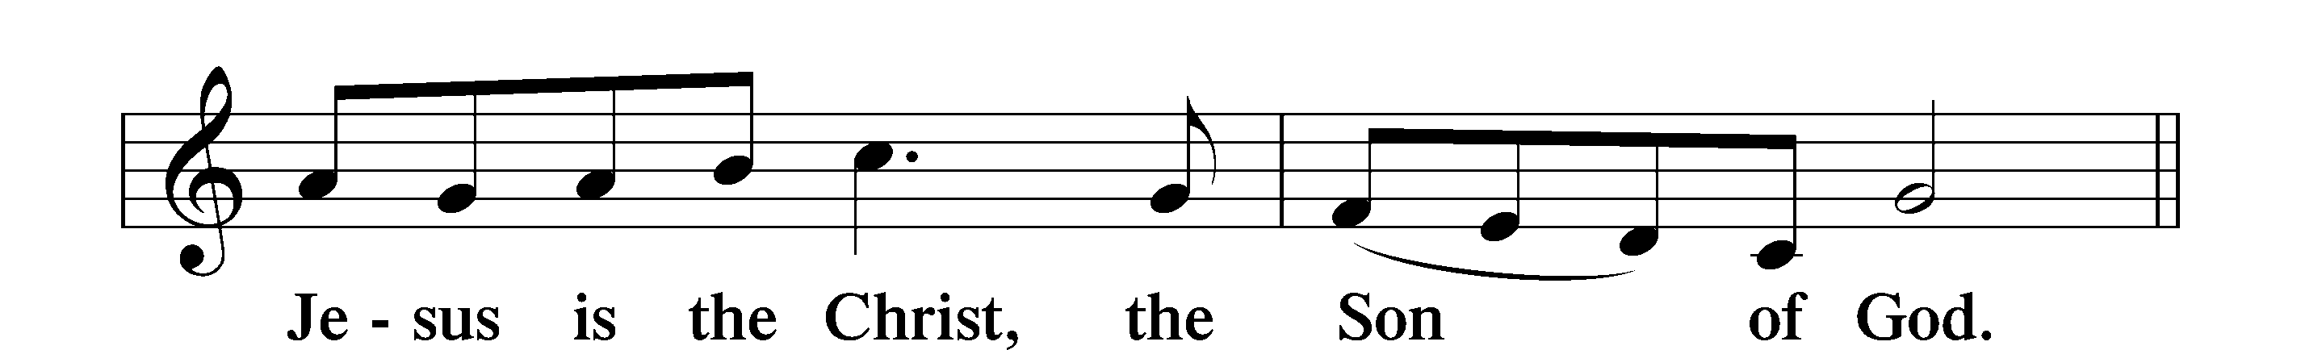

Alleluia LSB 205
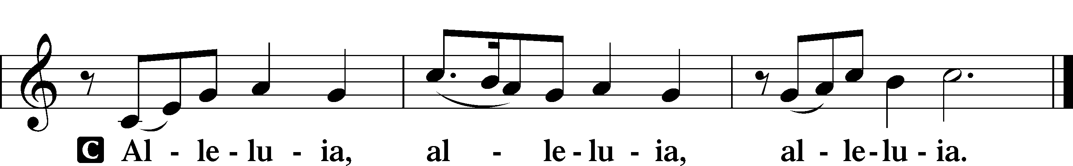

Holy Gospel 2 Corinthians 9:6–15
P The Holy Gospel according to St. 2 Corinthians, the ninth chapter.
C Glory to You, O Lord.

6The point is this: whoever sows sparingly will also reap sparingly, and whoever sows bountifully will also reap bountifully. 7Each one must give as he has made up his mind, not reluctantly or under compulsion, for God loves a cheerful giver. 8And God is able to make all grace abound to you, so that having all sufficiency in all things at all times, you may abound in every good work. 9As it is written,
“He has distributed freely, he has given to the poor;
his righteousness endures forever.”
10He who supplies seed to the sower and bread for food will supply and multiply your seed for sowing and increase the harvest of your righteousness. 11You will be enriched in every way for all your generosity, which through us will produce thanksgiving to God. 12For the ministry of this service is not only supplying the needs of the saints, but is also overflowing in many thanksgivings to God. 13By their approval of this service, they will glorify God because of your submission flowing from your confession of the gospel of Christ, and the generosity of your contribution for them and for all others, 14while they long for you and pray for you, because of the surpassing grace of God upon you. 15Thanks be to God for his inexpressible gift!

P This is the Gospel of the Lord.
C Praise to You, O Christ.

Apostles’ Creed
C I believe in God, the Father Almighty,
maker of heaven and earth.

And in Jesus Christ, His only Son, our Lord,
who was conceived by the Holy Spirit,
born of the virgin Mary,
suffered under Pontius Pilate,
was crucified, died and was buried.
He descended into hell.
The third day He rose again from the dead.
He ascended into heaven
and sits at the right hand of God the Father Almighty.
From thence He will come to judge the living and the dead.

I believe in the Holy Spirit,
the holy Christian Church,
the communion of saints,
the forgiveness of sins,
the resurrection of the body,
and the life T everlasting. Amen.

Sit

Children's Talk

Pre-Sermon Hymn

781 We Give Thee But Thine Own
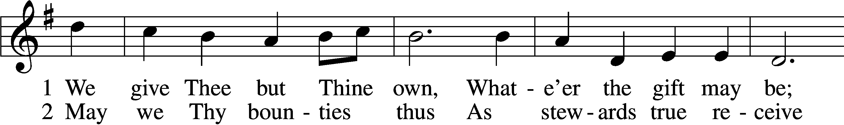
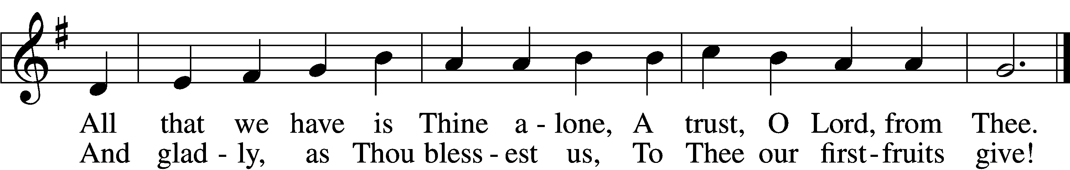

Sermon

Post-Sermon Hymn

781 We Give Thee But Thine Own
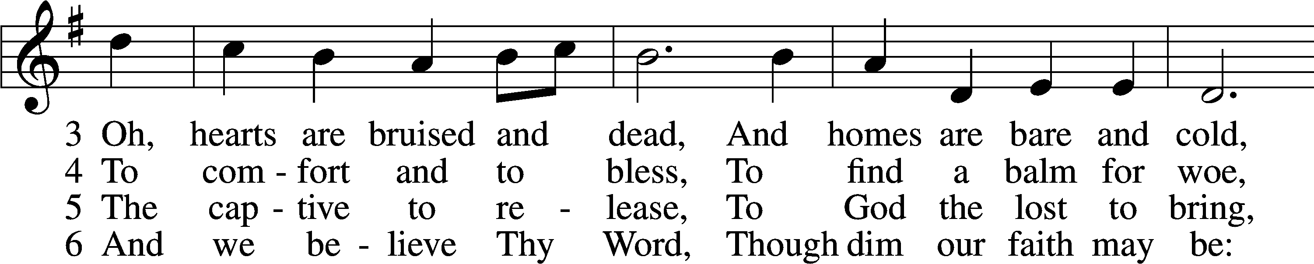
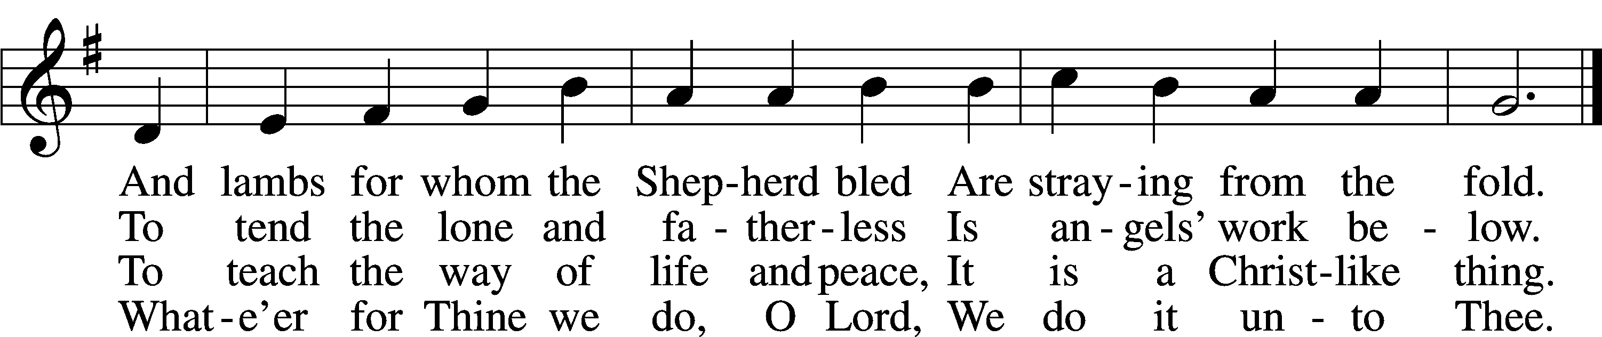

Stand

Prayer of the Church

Prayer Response

After each segment:
P Lord, in Your mercy,
C hear our prayer.

After prayers:
P In the name of Jesus we pray.
C Amen.

Service of the Sacrament

Preface 208
P The Lord be with you.
C And also with you.

P Lift up your hearts.
C We lift them to the Lord.

P Let us give thanks to the Lord our God.
C It is right to give Him thanks and praise.

P It is truly good, right, and salutary that we should at all times and in all places give thanks to You, O Lord, holy Father, almighty and everlasting God, for the countless blessings You so freely bestow on us and all creation. Above all, we give thanks for Your boundless love shown to us when You sent Your only-begotten Son, Jesus Christ, into our flesh and laid on Him our sin, giving Him into death that we might not die eternally. Because He is now risen from the dead and lives and reigns to all eternity, all who believe in Him will overcome sin and death and will rise again to new life. Therefore with angels and archangels and with all the company of heaven we laud and magnify Your glorious name, evermore praising You and singing:

Sanctus LSB 208
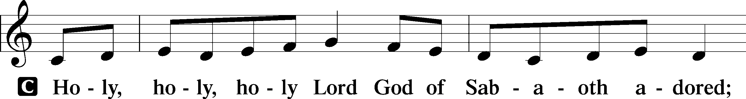
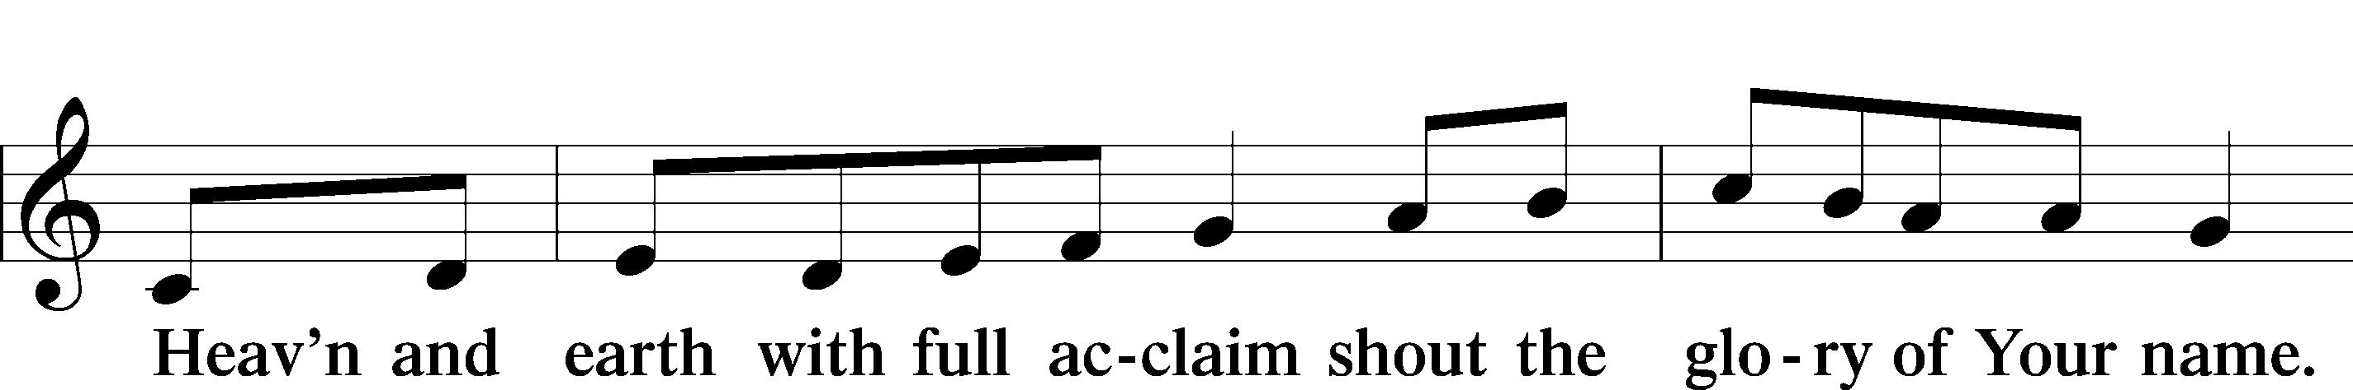
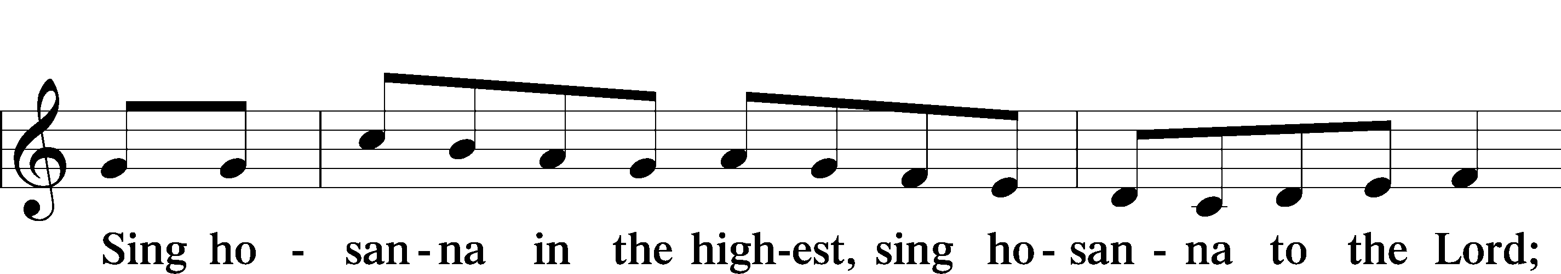
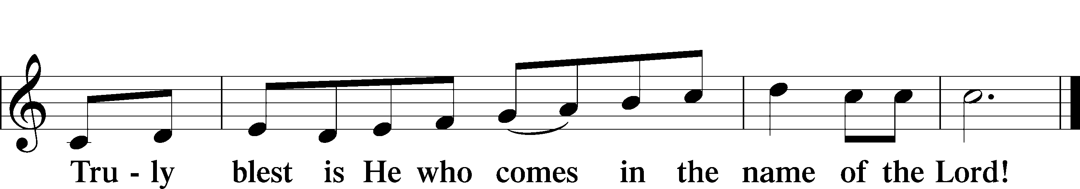

Prayer of Thanksgiving
P Blessed are You, O Lord our God, king of all creation, for You have had mercy on us and given Your only-begotten Son that whoever believes in Him should not perish but have eternal life.

In Your righteous judgment You condemned the sin of Adam and Eve, who ate the forbidden fruit, and You justly barred them and all their children from the tree of life. Yet, in Your great mercy, You promised salvation by a second Adam, Your Son, Jesus Christ, our Lord, and made His cross a life-giving tree for all who trust in Him.

We give You thanks for the redemption You have prepared for us through Jesus Christ. Grant us Your Holy Spirit that we may faithfully eat and drink of the fruits of His cross and receive the blessings of forgiveness, life, and salvation that come to us in His body and blood.

Hear us as we pray in His name and as He has taught us:

Lord’s Prayer
C Our Father who art in heaven,
hallowed be Thy name,
Thy kingdom come,
Thy will be done on earth
as it is in heaven;
give us this day our daily bread;
and forgive us our trespasses
as we forgive those
who trespass against us;
and lead us not into temptation,
but deliver us from evil.
For Thine is the kingdom
and the power and the glory
forever and ever. Amen.

The Words of Our Lord
P Our Lord Jesus Christ, on the night when He was betrayed, took bread, and when He had given thanks, He broke it and gave it to the disciples and said: “Take, eat; this is My T body, which is given for you. This do in remembrance of Me.”

In the same way also He took the cup after supper, and when He had given thanks, He gave it to them, saying: “Drink of it, all of you; this cup is the new testament in My T blood, which is shed for you for the forgiveness of sins. This do, as often as you drink it, in remembrance of Me.”

Pax Domini
P The peace of the Lord be with you always.
C Amen.

Agnus Dei LSB 210
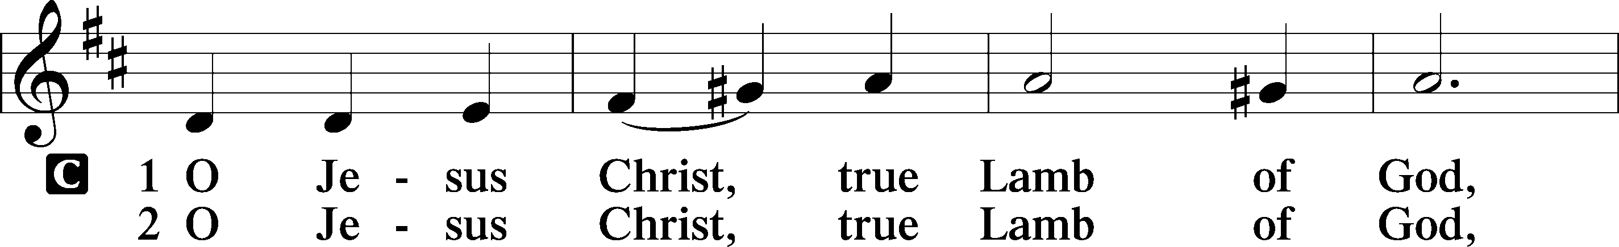
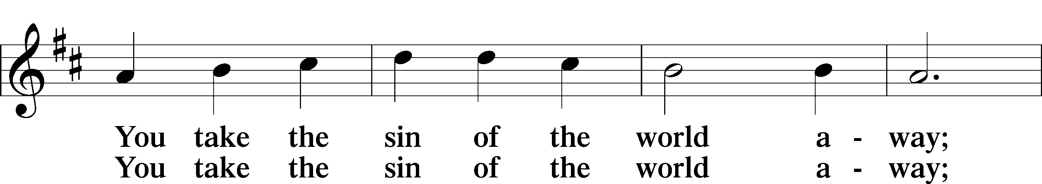
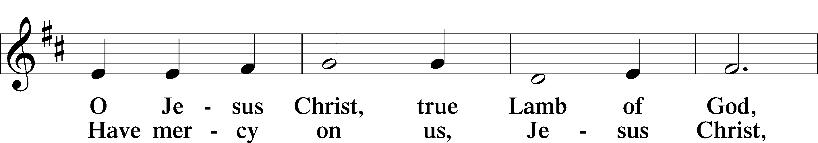
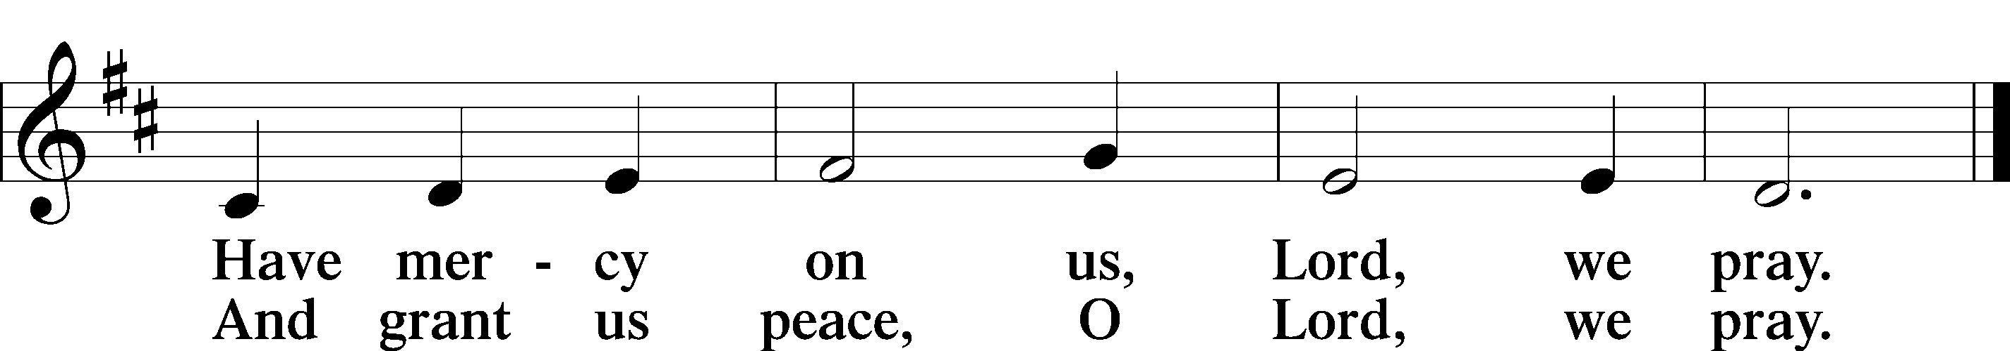

Sit

Distribution Hymns

717 Eternal Father, Strong to Save
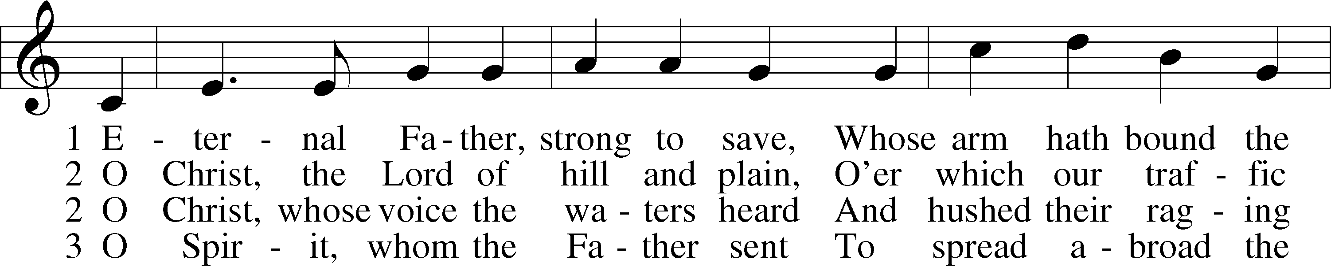
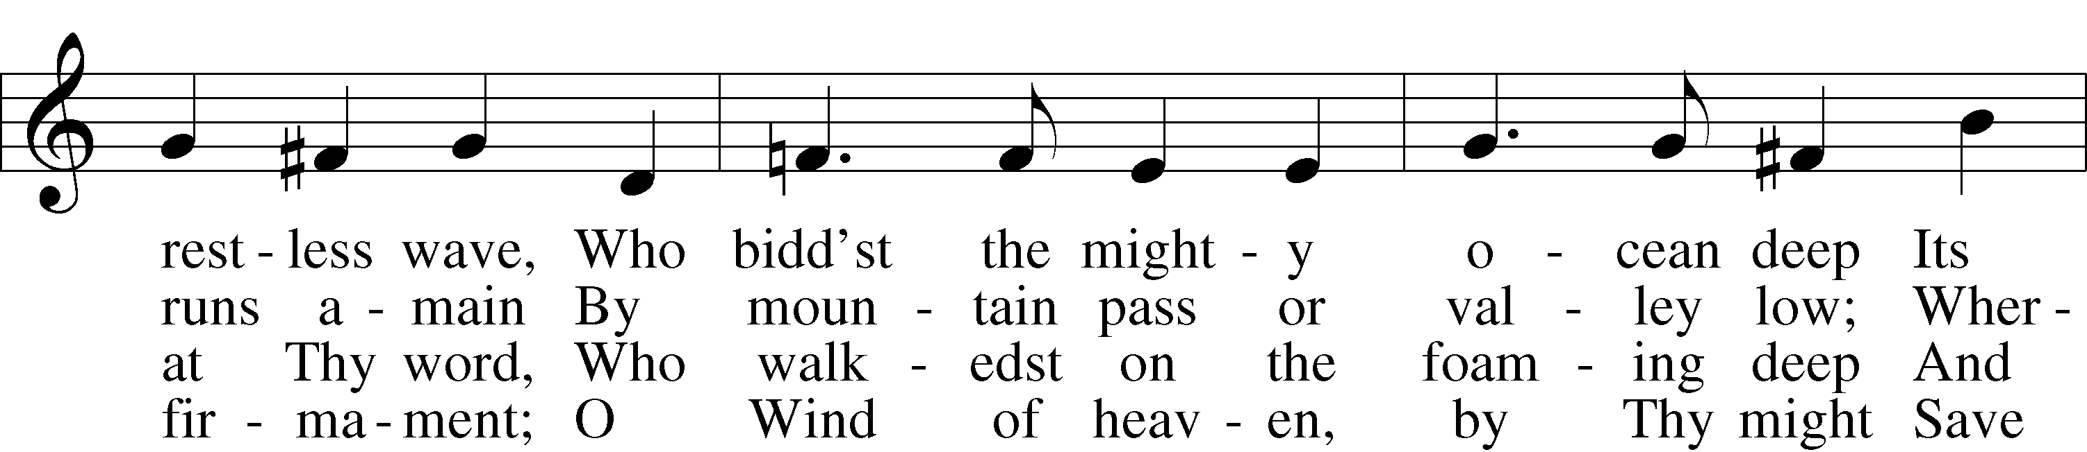
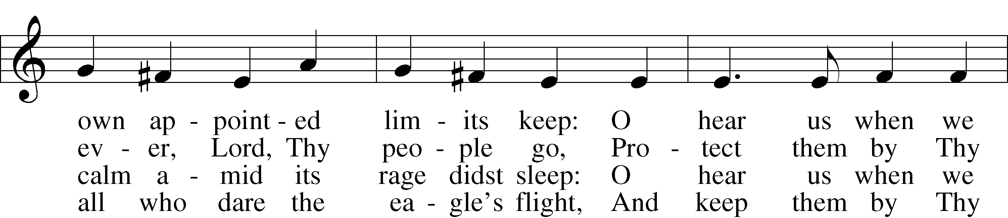

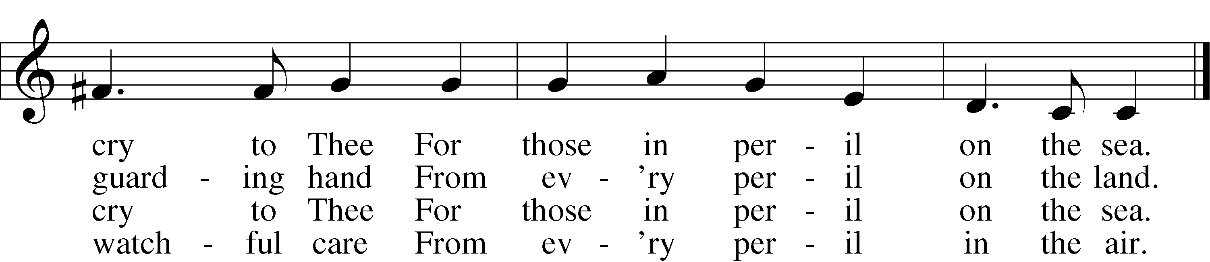

3a Most Holy Spirit, who didst brood
Upon the chaos dark and rude,
And bid its angry tumult cease,
And give, for wild confusion, peace:
O hear us when we cry to Thee
For those in peril on the sea.

4 O Trinity of love and pow’r,
Our people shield in danger’s hour;
From rock and tempest, fire and foe,
Protect them wheresoe’er they go;
Thus evermore shall rise to Thee
Glad praise from air and land and sea.

703 How Can I Thank You, Lord
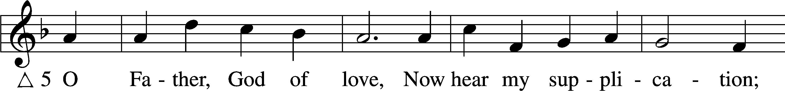
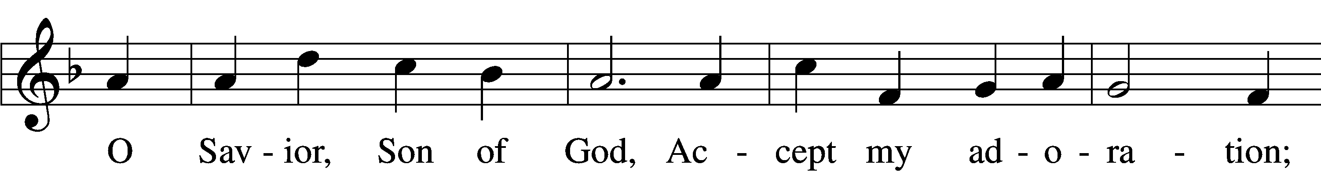
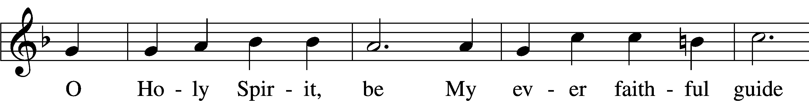
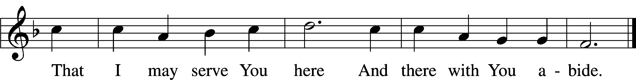
Stand

Nunc Dimittis LSB 211
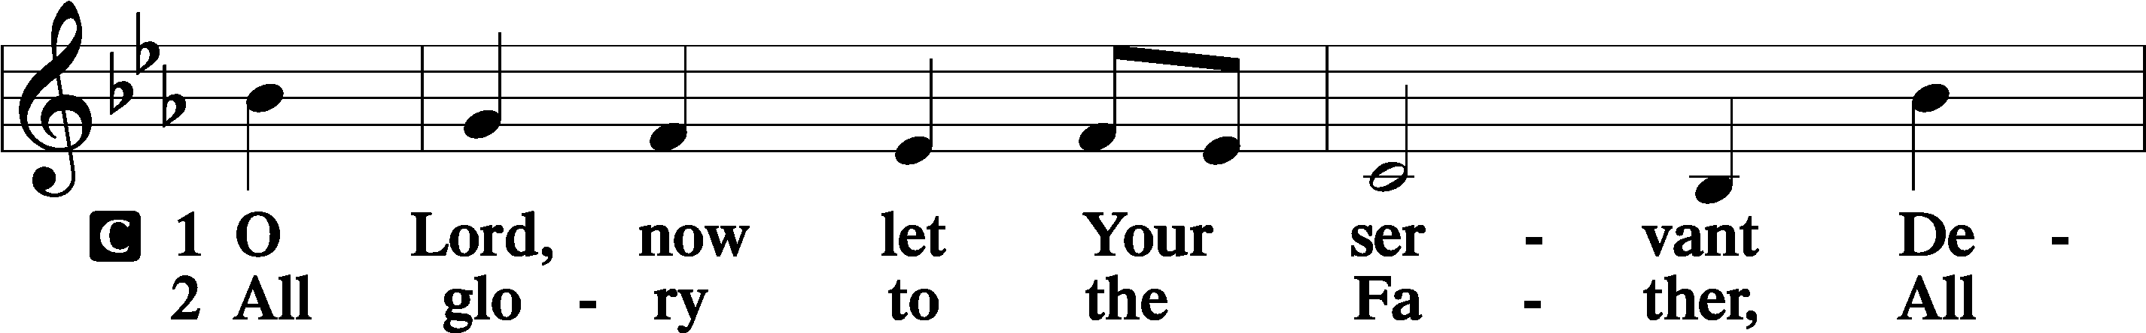
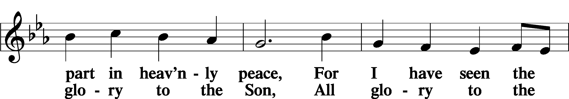
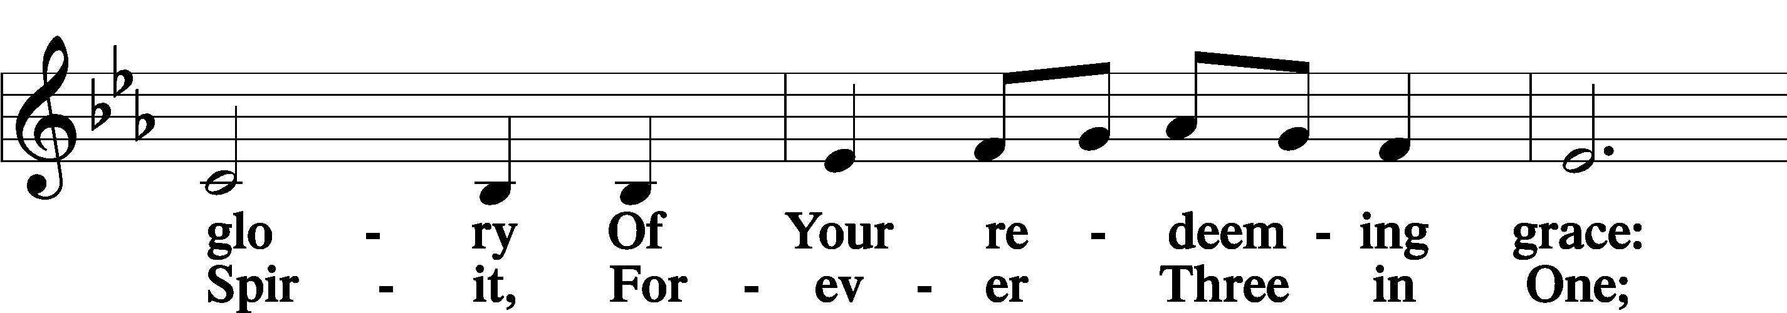
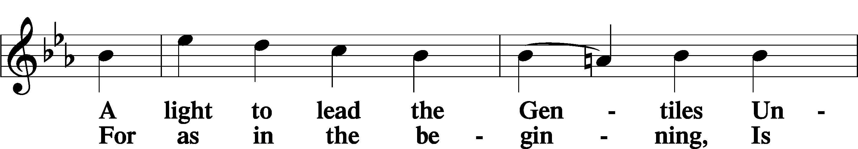
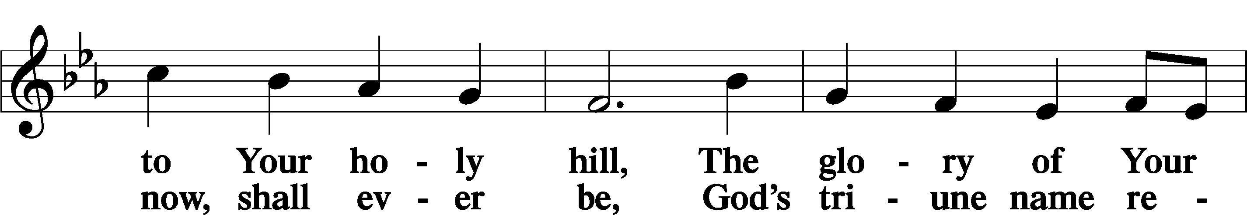
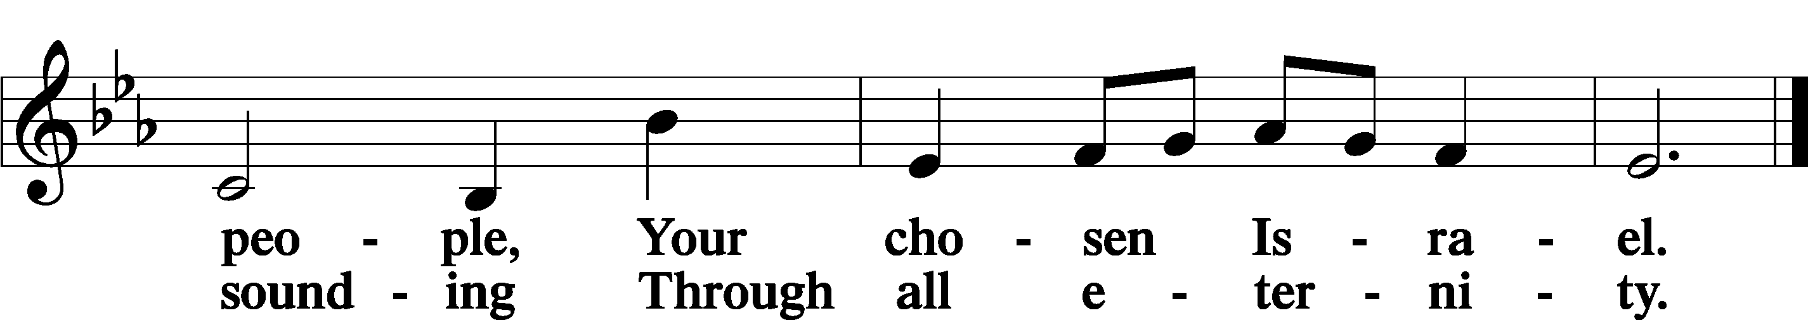

Post-Communion Collect
P Let us pray.

We give thanks to You, almighty God, that You have refreshed us through this salutary gift, and we implore You that of Your mercy You would strengthen us through the same in faith toward You and in fervent love toward one another; through Jesus Christ, Your Son, our Lord, who lives and reigns with You and the Holy Spirit, one God, now and forever.
C Amen.

Benedicamus 212
P Let us bless the Lord.
C Thanks be to God.

Benediction
P The Lord bless you and keep you.
The Lord make His face shine on you and be gracious to you.
The Lord look upon you with favor and T give you peace.
C Amen.

Sit

Closing Hymn

807 When Morning Gilds the Skies
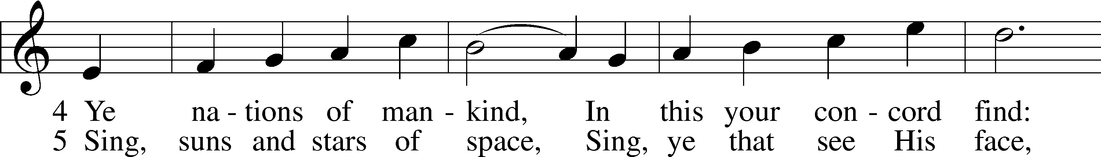
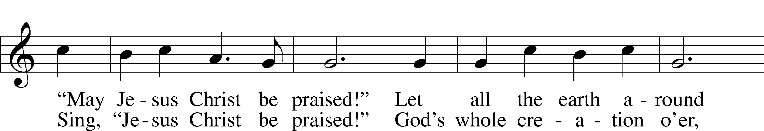
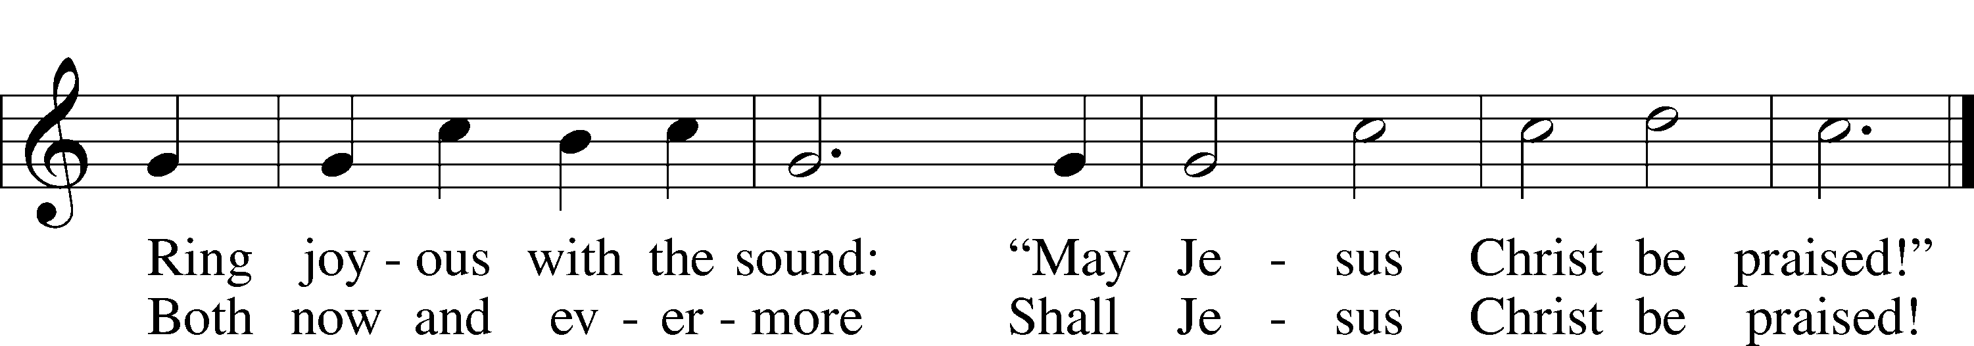

Closing Statement
P We go to live for Jesus.
C We go to share His love.

Acknowledgments
Unless otherwise indicated, Scripture quotations are from the ESV® Bible (The Holy Bible, English Standard Version®), copyright © 2001 by Crossway, a publishing ministry of Good News Publishers. Used by permission. All rights reserved.
Created by Lutheran Service Builder © 2023 Concordia Publishing House.

