Welcome To
Trinity Lutheran Church
Lutheran Church - Missouri Synod
A Stephen Ministry Congregation

1354 South Otsego Avenue
Gaylord, MI 49735
Church Phone: 989-732-4816

Church Email: secretary@trinitygaylord.com
www.trinitygaylord.com

Office Hours:
Monday through Friday 9am - 1pm

OUR PURPOSE

. . . is to LOVE GOD, LOVE OTHERS AND SERVE THE WORLD by worshiping the Lord Jesus, bringing our members into Christ-like maturity, and equipping them through Word and Sacrament for their mission and ministry. We go heart to heart into the world with Jesus, sharing His love, caring for one another, praying, and bringing the lost into a relationship with Christ, by the working of the Holy Spirit.

June 11, 2023
Second Sunday after Pentecost
Preacher: Rev. Ken Bernthal

ABOUT OUR WORSHIP

We welcome all who gather here today! We are blessed to celebrate together the mercy, grace and love we have from God through the death and resurrection of our Lord Jesus Christ.

Children: Families with children are very welcome here. Having children in church is important so they can begin to learn about their faith in Jesus, and it’s good for the whole congregation to see. Please feel comfortable keeping “squirmy” kids in the service. This is where they belong, too!

Pew cards: Guest and Members, please fill out a Guest/Member card located in the pew rack. The card can be placed in the offering plates at the back of the church.

If standing is difficult feel free to remain seated during any portion of the service. Please let an Elder or Usher know if you need communion in your pew seat.

About our celebration of Holy Communion: We celebrate the Lord’s Supper in the confession and glad confidence that, as he says, our Lord gives into our mouths not only bread and wine but his very body and blood to eat and drink for the forgiveness of sins and to strengthen our union with him and with one another. Our Lord invites to his table those who trust his words, repent of all sin and set aside any refusal to forgive and love as he forgives and loves us, that they may show forth his death until he comes.

Because those who eat and drink our Lord’s body and blood contrary to that which is stated above do so to their great harm, and because Holy Communion is a confession of the faith which is confessed at this altar. Anyone who is not yet instructed, in doubt, or who hold a confession differing from that of the Lutheran Church Missouri Synod, and yet desire to receive the sacrament, are asked to first speak with Pastor. Those not communing are still invited to come forward for a blessing from Pastor, and you may indicate this by crossing your arms over your chest.

Greeting
P Peace be with you.
C And also with you

Divine Service - Setting Four LSB 203

Opening Hymn

790 Praise to the Lord, the Almighty
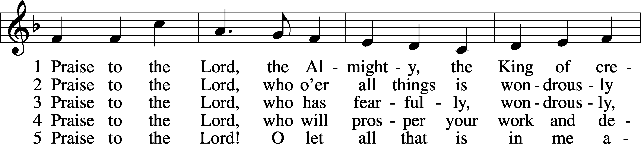
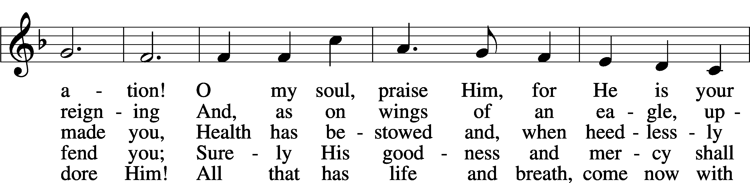
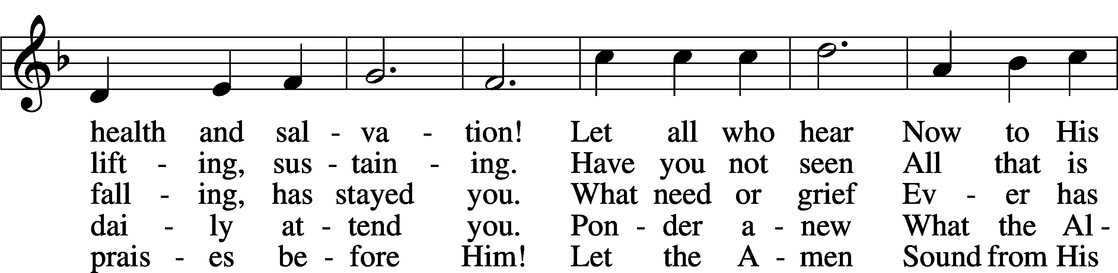
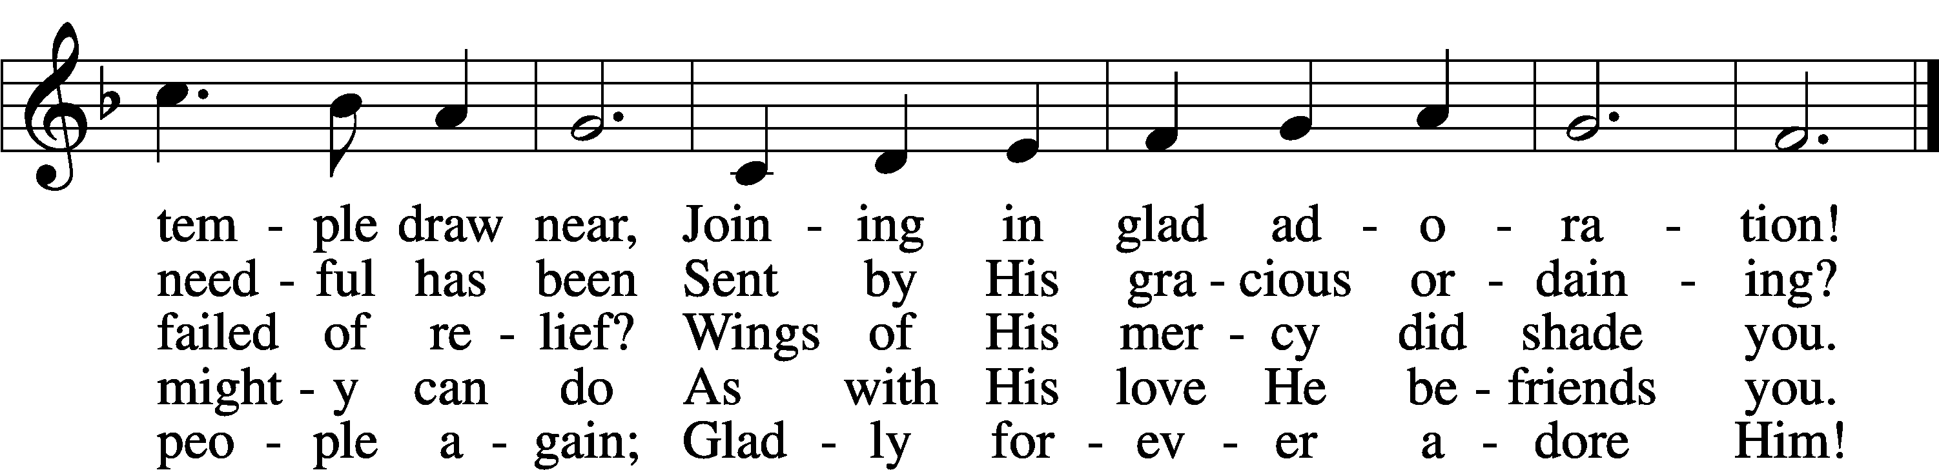
Stand

Confession and Absolution

The sign of the cross may be made by all in remembrance of their Baptism.

Invocation
P In the name of the Father and of the T Son and of the Holy Spirit.
C Amen.

Exhortation LSB 203
P Our help is in the name of the Lord,
C who made heaven and earth.

P If You, O Lord, kept a record of sins, O Lord, who could stand?
C But with You there is forgiveness; therefore You are feared.

P Since we are gathered to hear God’s Word, call upon Him in prayer and praise, and receive the body and blood of our Lord Jesus Christ in the fellowship of this altar, let us first consider our unworthiness and confess before God and one another that we have sinned in thought, word, and deed, and that we cannot free ourselves from our sinful condition. Together as His people let us take refuge in the infinite mercy of God, our heavenly Father, seeking His grace for the sake of Christ, and saying: God, be merciful to me, a sinner.

Confession of Sins LSB 203
C Almighty God, have mercy upon us, forgive us our sins, and lead us to everlasting life. Amen.

Prayer for Forgiveness
P Almighty God, merciful Father, in Holy Baptism You declared us to be Your children and gathered us into Your one, holy Church, in which You daily and richly forgive us our sins and grant us new life through Your Spirit. Be in our midst, enliven our faith, and graciously receive our prayer and praise; through Your Son, Jesus Christ, our Lord.
C Amen.

Service of the Word

Introit
P The Mighty One, God the Lord, speaks and summons the earth
C from the rising of the sun to its setting.
P Hear, O my people, and I will speak; O Israel, I will testify against you.
C I am God, your God.
P Not for your sacrifices do I rebuke you;
C your burnt offerings are continually before me.
P I will not accept a bull from your house
C or goats from your folds
P For every beast of the forest is mine,
C the cattle on a thousand hills.
A Glory be to the Father and to the Son
and to the Holy Spirit;
as it was in the beginning,
is now, and will be forever. Amen.
P The Mighty One, God the Lord, speaks and summons the earth
C from the rising of the sun to its setting.

Kyrie LSB 204
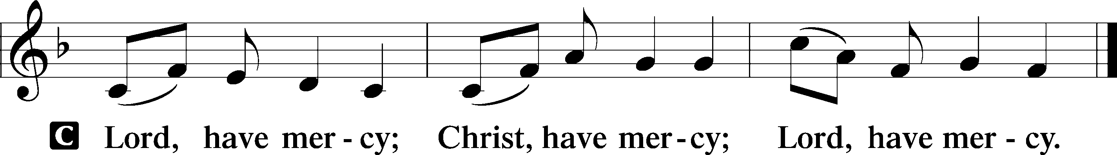

Gloria in Excelsis LSB 204
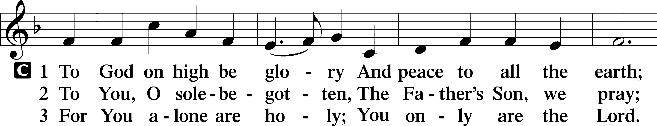
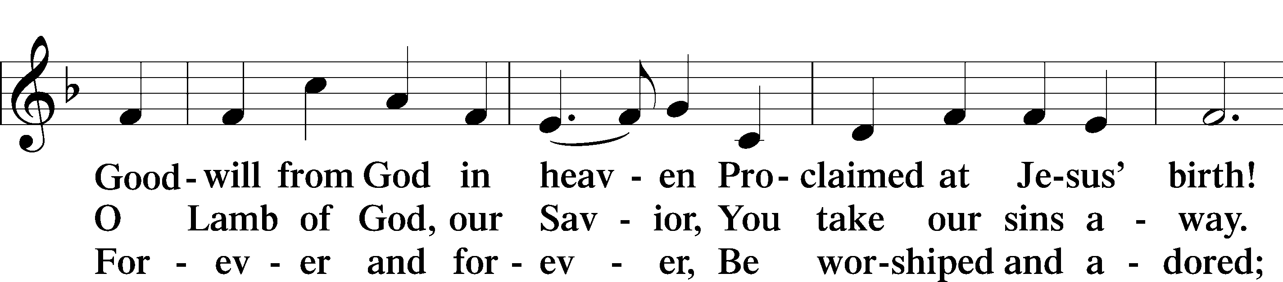
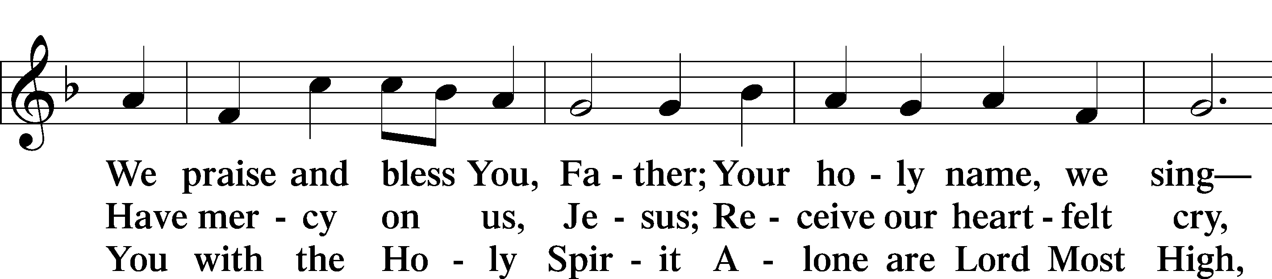
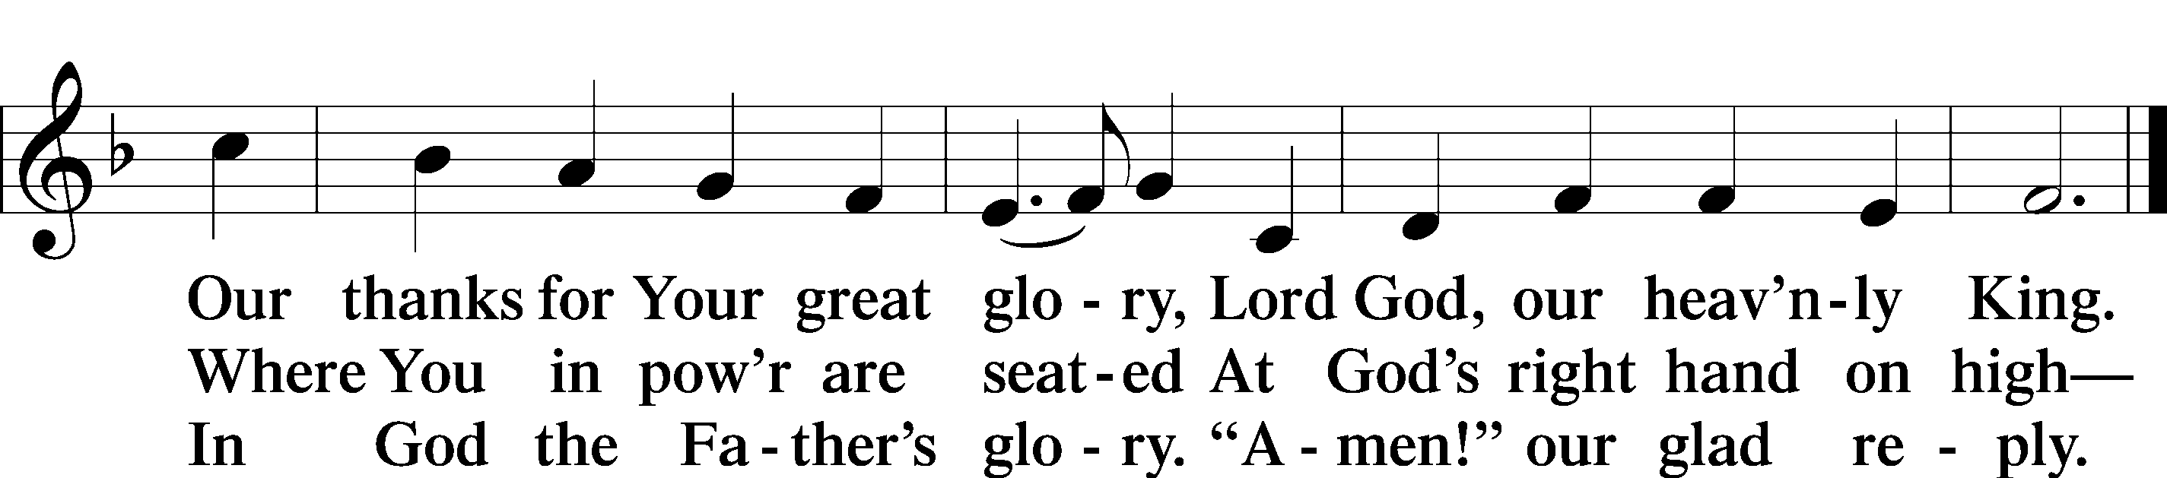

Salutation and Collect of the Day
P The Lord be with you.
C And also with you.

P Let us pray.
Almighty and most merciful God, You sent Your Son, Jesus Christ, to seek and to save the lost. Graciously open our ears and our hearts to hear His call and to follow Him by faith that we may feast with Him forever in His kingdom; through the same Jesus Christ, our Lord, who lives and reigns with You and the Holy Spirit, one God, now and forever.

C Amen.

Sit
First Reading Hosea 5:15—6:6
5:15I will return again to my place,
until they acknowledge their guilt and seek my face,
and in their distress earnestly seek me.
6:1 “Come, let us return to the Lord;
for he has torn us, that he may heal us;
he has struck us down, and he will bind us up.
2After two days he will revive us;
on the third day he will raise us up,
that we may live before him.
3Let us know; let us press on to know the Lord;
his going out is sure as the dawn;
he will come to us as the showers,
as the spring rains that water the earth.”
4What shall I do with you, O Ephraim?
What shall I do with you, O Judah?
Your love is like a morning cloud,
like the dew that goes early away.
5Therefore I have hewn them by the prophets;
I have slain them by the words of my mouth,
and my judgment goes forth as the light.
6For I desire steadfast love and not sacrifice,
the knowledge of God rather than burnt offerings.

P This is the Word of the Lord.
C Thanks be to God.

Epistle Romans 4:13–25
13The promise to Abraham and his offspring that he would be heir of the world did not come through the law but through the righteousness of faith. 14For if it is the adherents of the law who are to be the heirs, faith is null and the promise is void. 15For the law brings wrath, but where there is no law there is no transgression.
16That is why it depends on faith, in order that the promise may rest on grace and be guaranteed to all his offspring—not only to the adherent of the law but also to the one who shares the faith of Abraham, who is the father of us all, 17as it is written, “I have made you the father of many nations”—in the presence of the God in whom he believed, who gives life to the dead and calls into existence the things that do not exist. 18In hope he believed against hope, that he should become the father of many nations, as he had been told, “So shall your offspring be.” 19He did not weaken in faith when he considered his own body, which was as good as dead (since he was about a hundred years old), or when he considered the barrenness of Sarah’s womb. 20No distrust made him waver concerning the promise of God, but he grew strong in his faith as he gave glory to God, 21fully convinced that God was able to do what he had promised. 22That is why his faith was “counted to him as righteousness.” 23But the words “it was counted to him” were not written for his sake alone, 24but for ours also. It will be counted to us who believe in him who raised from the dead Jesus our Lord, 25who was delivered up for our trespasses and raised for our justification.

P This is the Word of the Lord.
C Thanks be to God.

Stand

Alleluia and Verse
Alleluia LSB 205
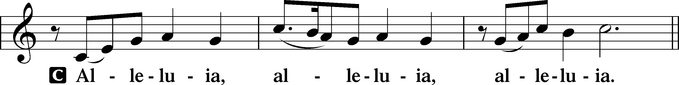

Verse LSB 205
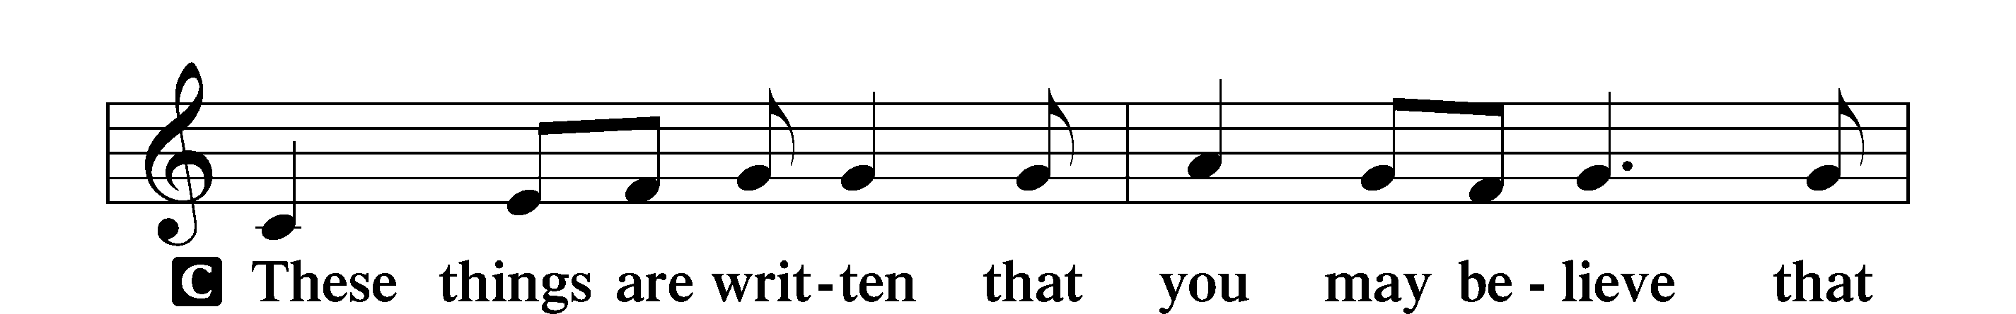
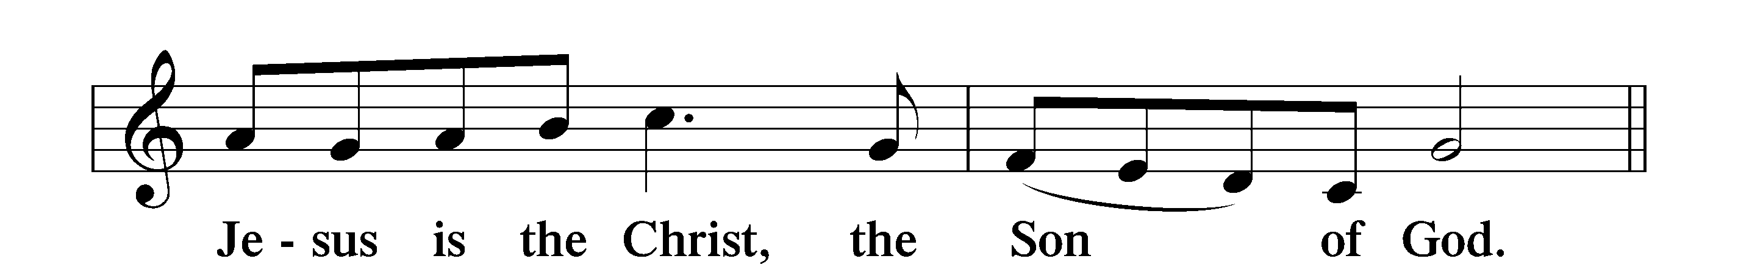

Alleluia LSB 205
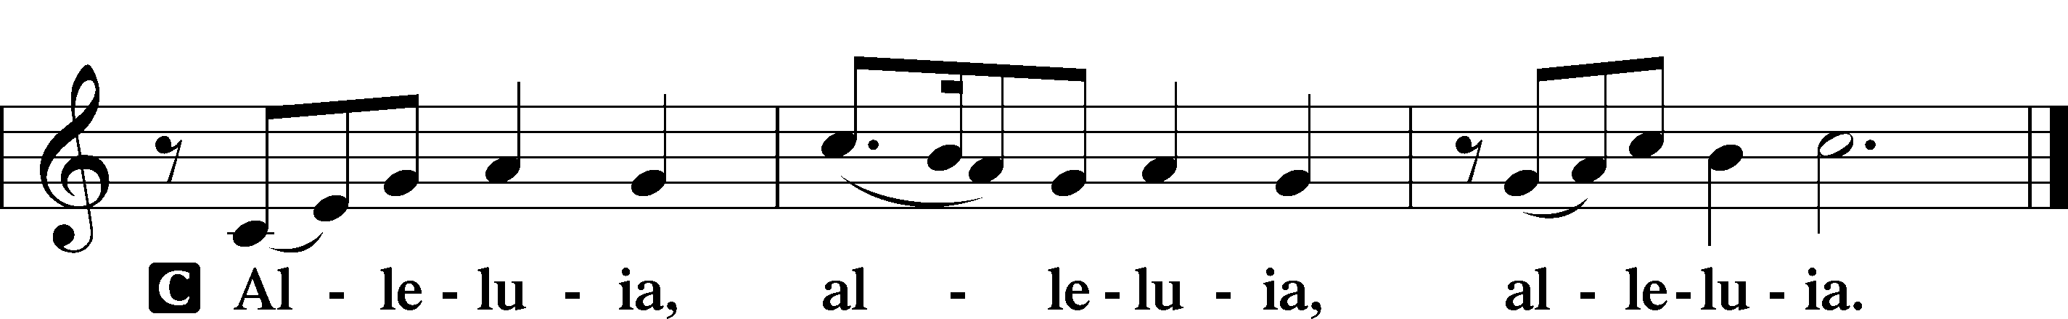

Holy Gospel Matthew 9:9–13
P The Holy Gospel according to St. Matthew, the ninth chapter.
C Glory to You, O Lord.

9As Jesus passed on from there, he saw a man called Matthew sitting at the tax booth, and he said to him, “Follow me.” And he rose and followed him.
10And as Jesus reclined at table in the house, behold, many tax collectors and sinners came and were reclining with Jesus and his disciples. 11And when the Pharisees saw this, they said to his disciples, “Why does your teacher eat with tax collectors and sinners?” 12But when he heard it, he said, “Those who are well have no need of a physician, but those who are sick. 13Go and learn what this means, ‘I desire mercy, and not sacrifice.’ For I came not to call the righteous, but sinners.”

P This is the Gospel of the Lord.
C Praise to You, O Christ.

Nicene Creed
C I believe in one God,
the Father Almighty,
maker of heaven and earth
and of all things visible and invisible.

And in one Lord Jesus Christ,
the only-begotten Son of God,
begotten of His Father before all worlds,
God of God, Light of Light,
very God of very God,
begotten, not made,
being of one substance with the Father,
by whom all things were made;
who for us men and for our salvation came down from heaven
and was incarnate by the Holy Spirit of the virgin Mary
and was made man;
and was crucified also for us under Pontius Pilate.
He suffered and was buried.
And the third day He rose again according to the Scriptures
and ascended into heaven
and sits at the right hand of the Father.
And He will come again with glory to judge both the living and the dead,
whose kingdom will have no end.

And I believe in the Holy Spirit,
the Lord and giver of life,
who proceeds from the Father and the Son,
who with the Father and the Son together is worshiped and glorified,
who spoke by the prophets.
And I believe in one holy Christian and apostolic Church,
I acknowledge one Baptism for the remission of sins,
and I look for the resurrection of the dead
and the life T of the world to come. Amen.

Sit

Children's Talk

Sermon Hymn

806 Give Thanks with a Grateful Heart
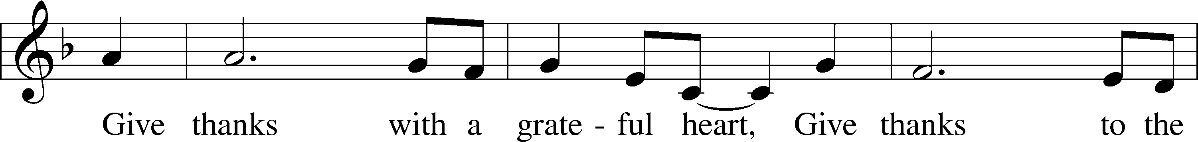
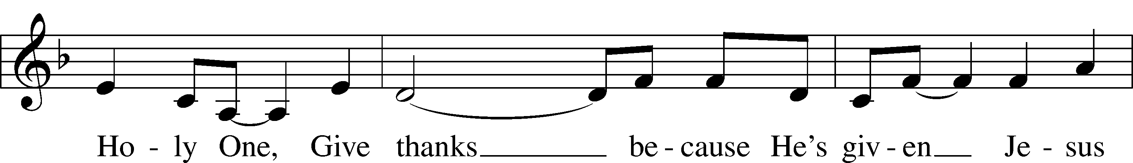
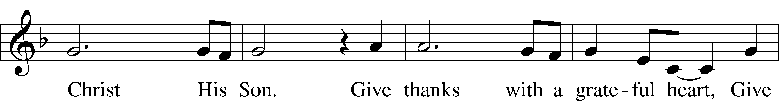
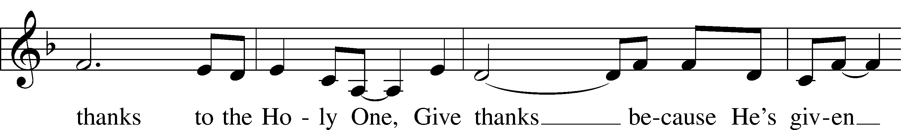
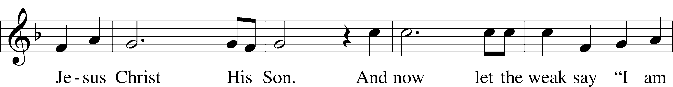
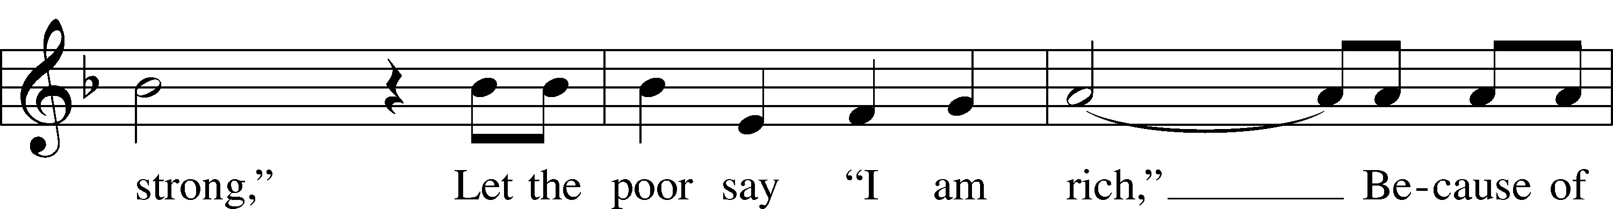
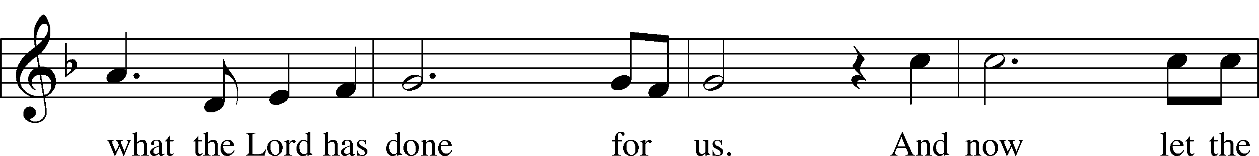
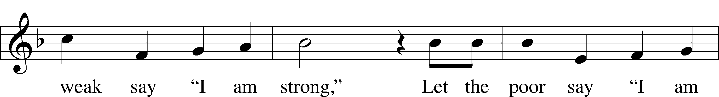
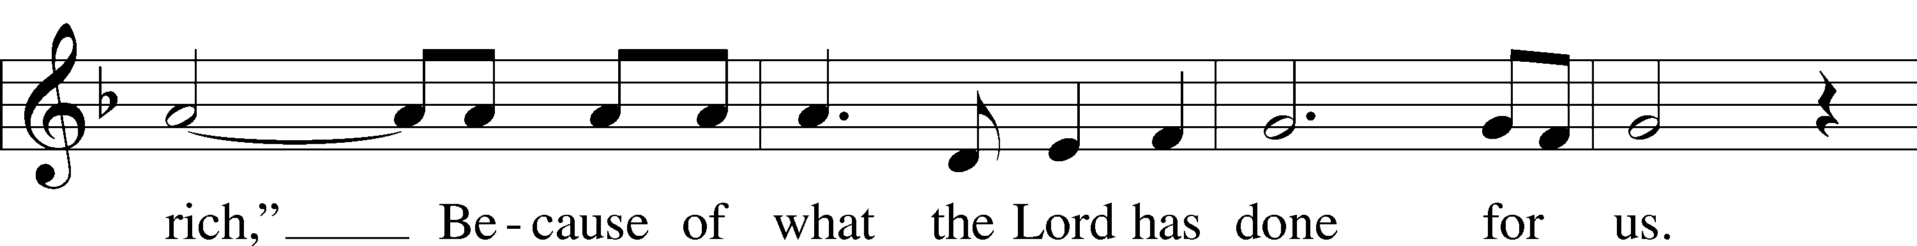
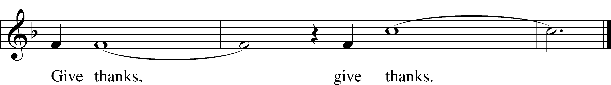

Sermon

Stand

Prayer of the Church
Prayer Response
After each segment:
P Lord, in Your mercy,
C hear our prayer.

After prayers:
P In the name of Jesus we pray.
C Amen
Service of the Sacrament

Preface 208
P The Lord be with you.
C And also with you.

P Lift up your hearts.
C We lift them to the Lord.

P Let us give thanks to the Lord our God.
C It is right to give Him thanks and praise.

P It is truly good, right, and salutary that we should at all times and in all places give thanks to You, O Lord, holy Father, almighty and everlasting God, for the countless blessings You so freely bestow on us and all creation. Above all, we give thanks for Your boundless love shown to us when You sent Your only-begotten Son, Jesus Christ, into our flesh and laid on Him our sin, giving Him into death that we might not die eternally. Because He is now risen from the dead and lives and reigns to all eternity, all who believe in Him will overcome sin and death and will rise again to new life. Therefore with angels and archangels and with all the company of heaven we laud and magnify Your glorious name, evermore praising You and singing:

Sanctus LSB 208
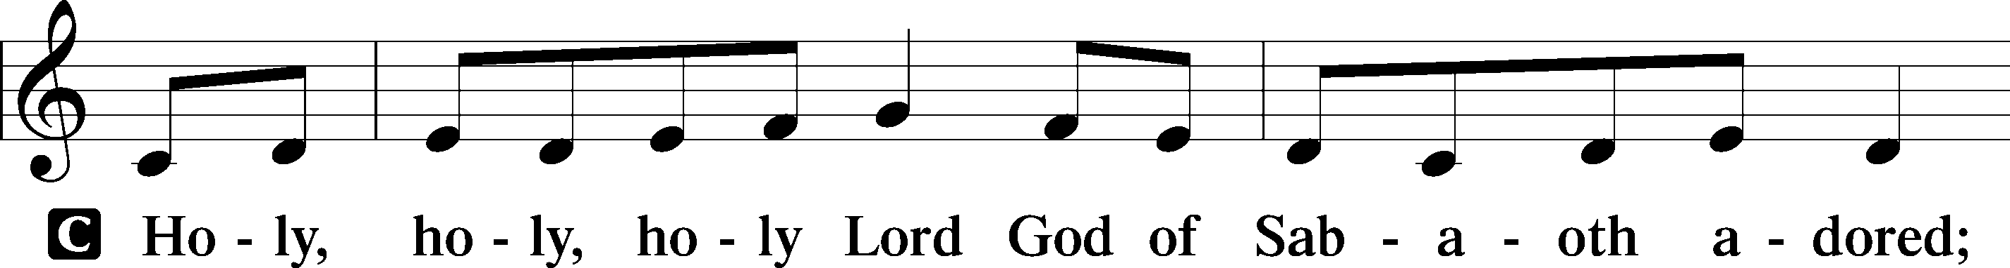
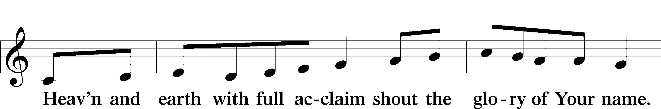
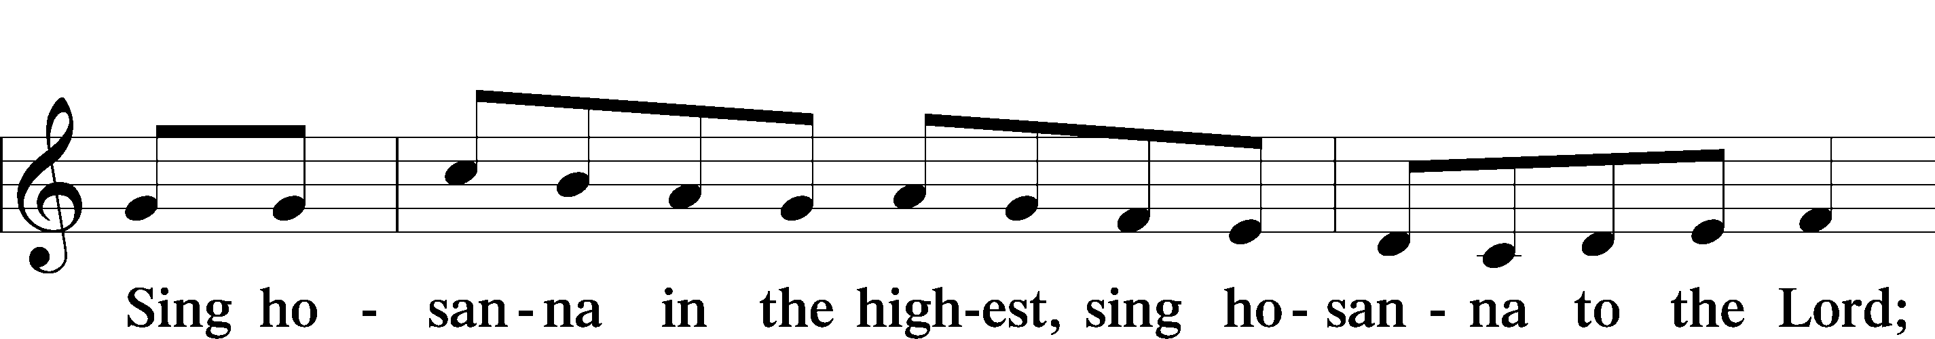
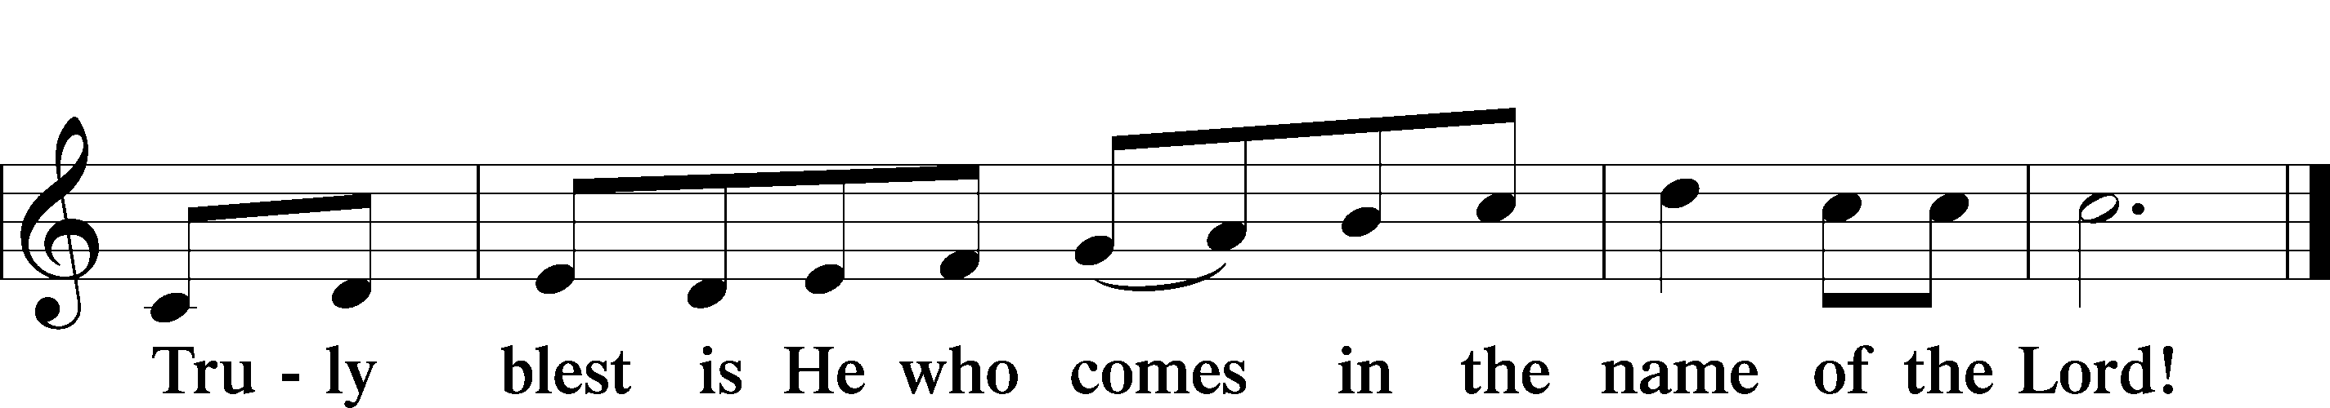

Prayer of Thanksgiving
P Blessed are You, O Lord our God, king of all creation, for You have had mercy on us and given Your only-begotten Son that whoever believes in Him should not perish but have eternal life.

In Your righteous judgment You condemned the sin of Adam and Eve, who ate the forbidden fruit, and You justly barred them and all their children from the tree of life. Yet, in Your great mercy, You promised salvation by a second Adam, Your Son, Jesus Christ, our Lord, and made His cross a life-giving tree for all who trust in Him.

We give You thanks for the redemption You have prepared for us through Jesus Christ. Grant us Your Holy Spirit that we may faithfully eat and drink of the fruits of His cross and receive the blessings of forgiveness, life, and salvation that come to us in His body and blood.

Hear us as we pray in His name and as He has taught us:

Lord’s Prayer
C Our Father who art in heaven,
hallowed be Thy name,
Thy kingdom come,
Thy will be done on earth
as it is in heaven;
give us this day our daily bread;
and forgive us our trespasses
as we forgive those
who trespass against us;
and lead us not into temptation,
but deliver us from evil.
For Thine is the kingdom
and the power and the glory
forever and ever. Amen.

The Words of Our Lord
P Our Lord Jesus Christ, on the night when He was betrayed, took bread, and when He had given thanks, He broke it and gave it to the disciples and said: “Take, eat; this is My T body, which is given for you. This do in remembrance of Me.”

In the same way also He took the cup after supper, and when He had given thanks, He gave it to them, saying: “Drink of it, all of you; this cup is the new testament in My T blood, which is shed for you for the forgiveness of sins. This do, as often as you drink it, in remembrance of Me.”

Pax Domini
P The peace of the Lord be with you always.
C Amen.

Agnus Dei LSB 210
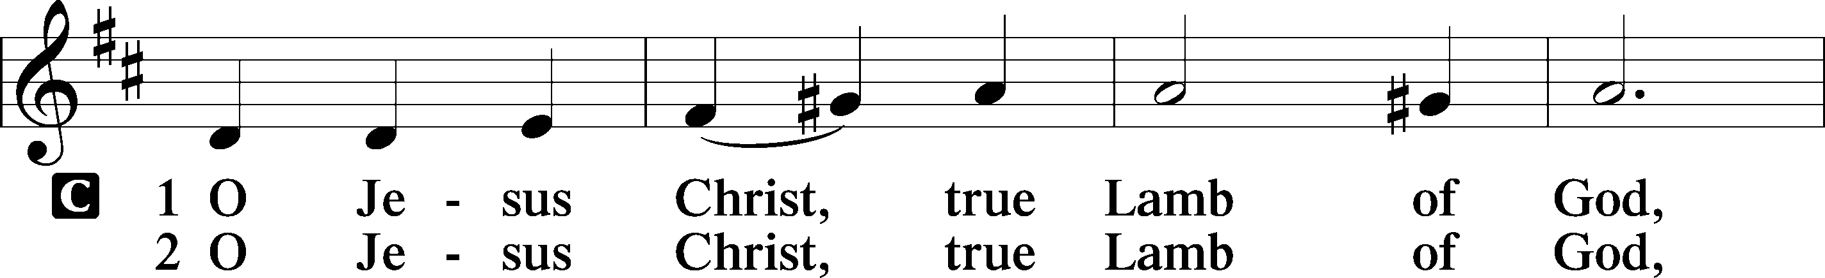
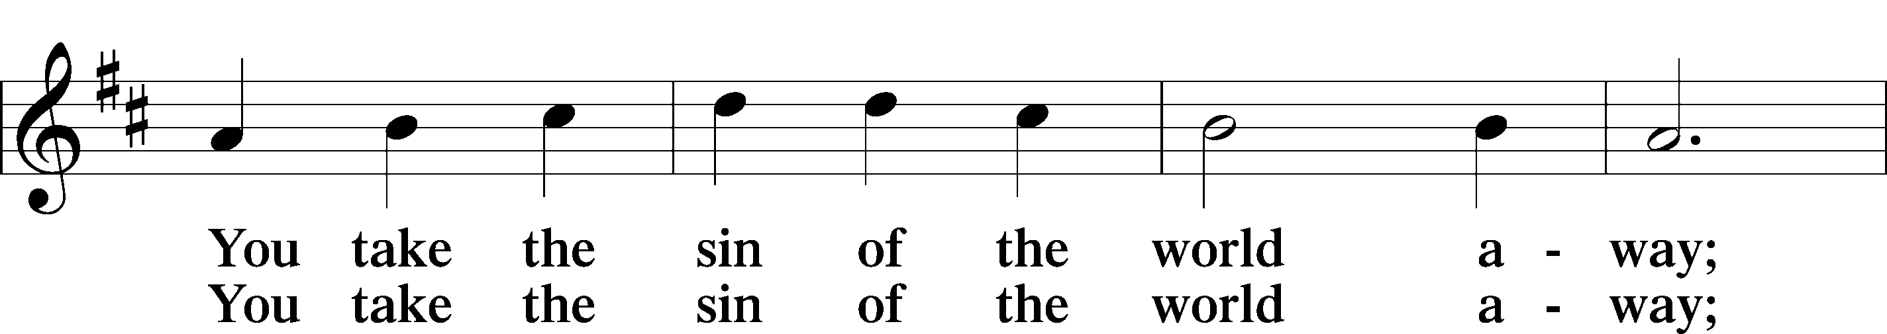
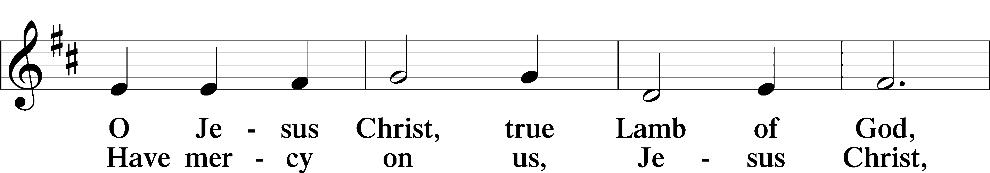
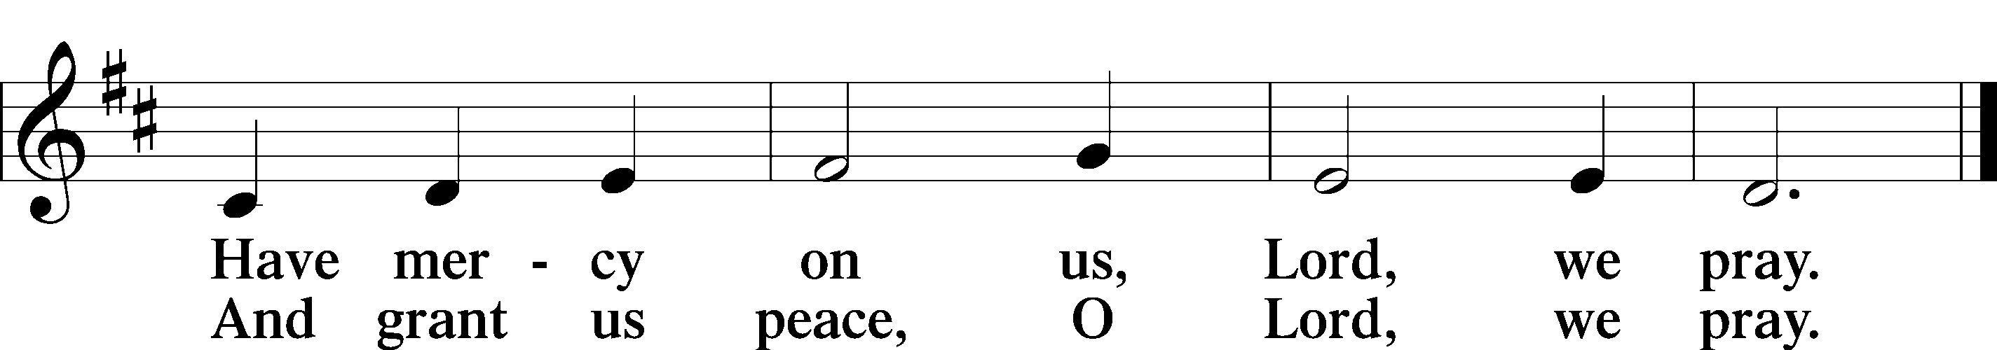

Sit

Distribution Hymn
636 Soul, Adorn Yourself with Gladness
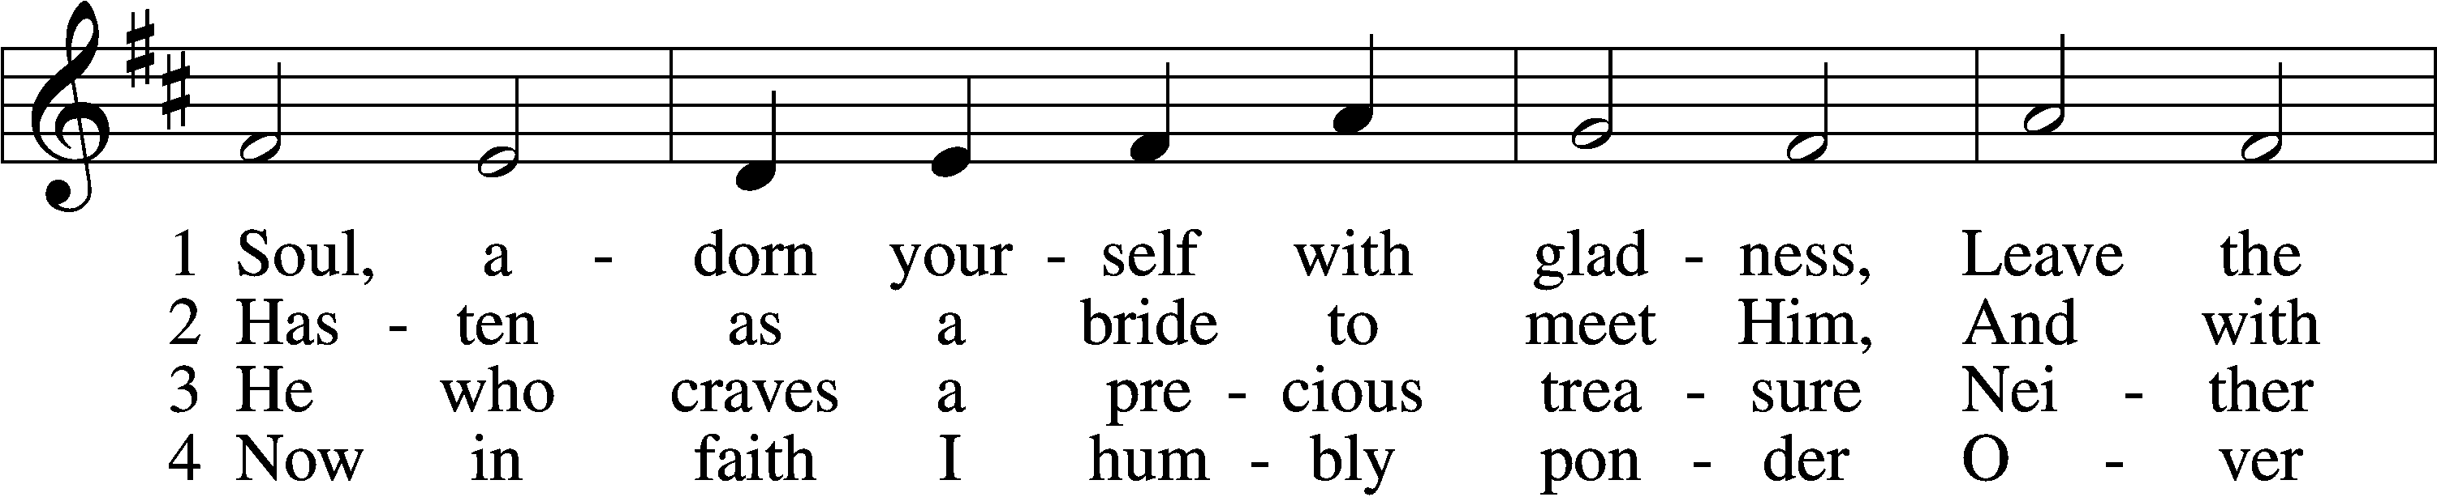
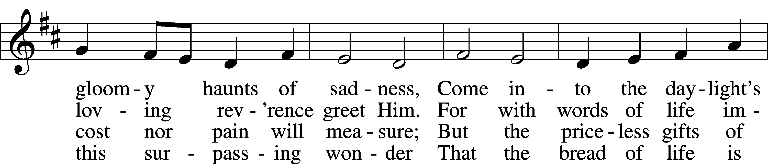
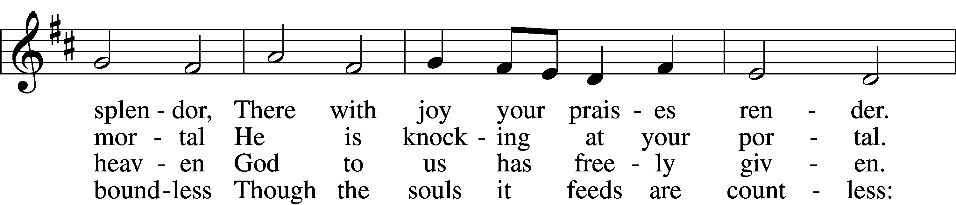
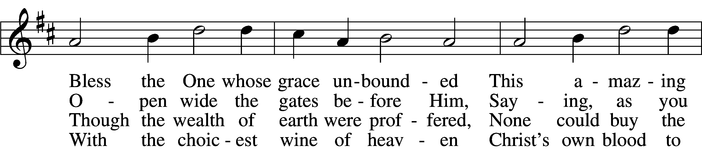
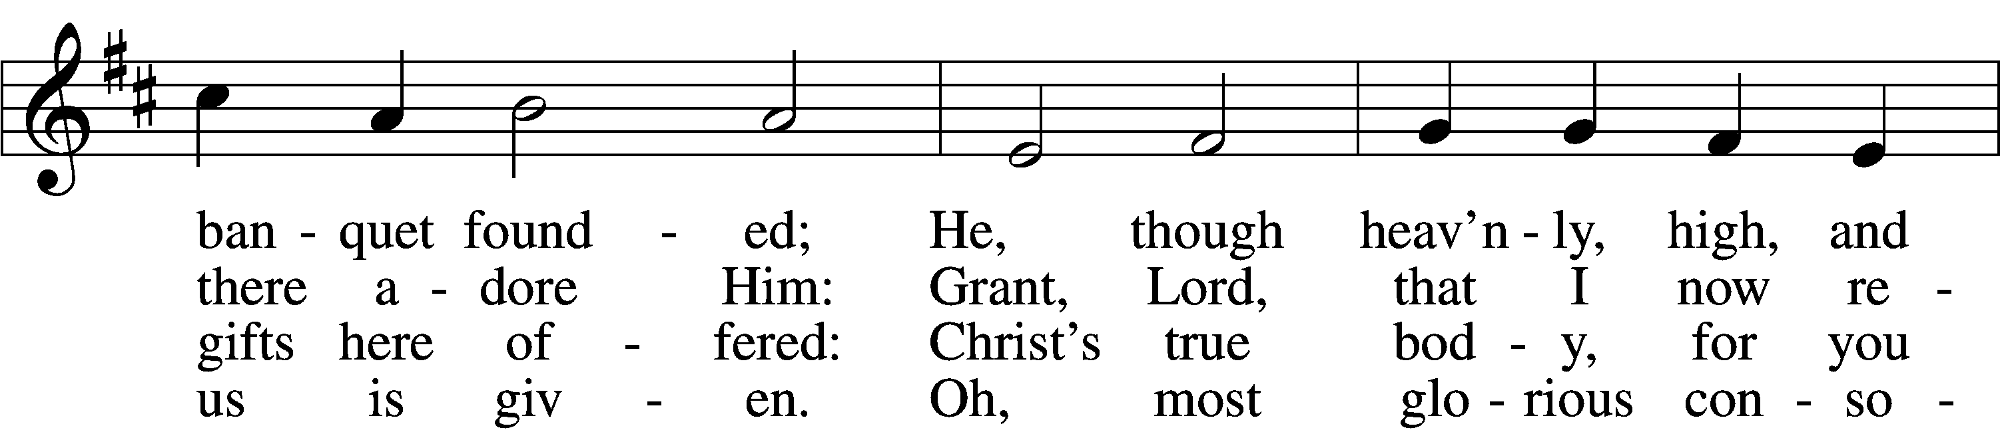
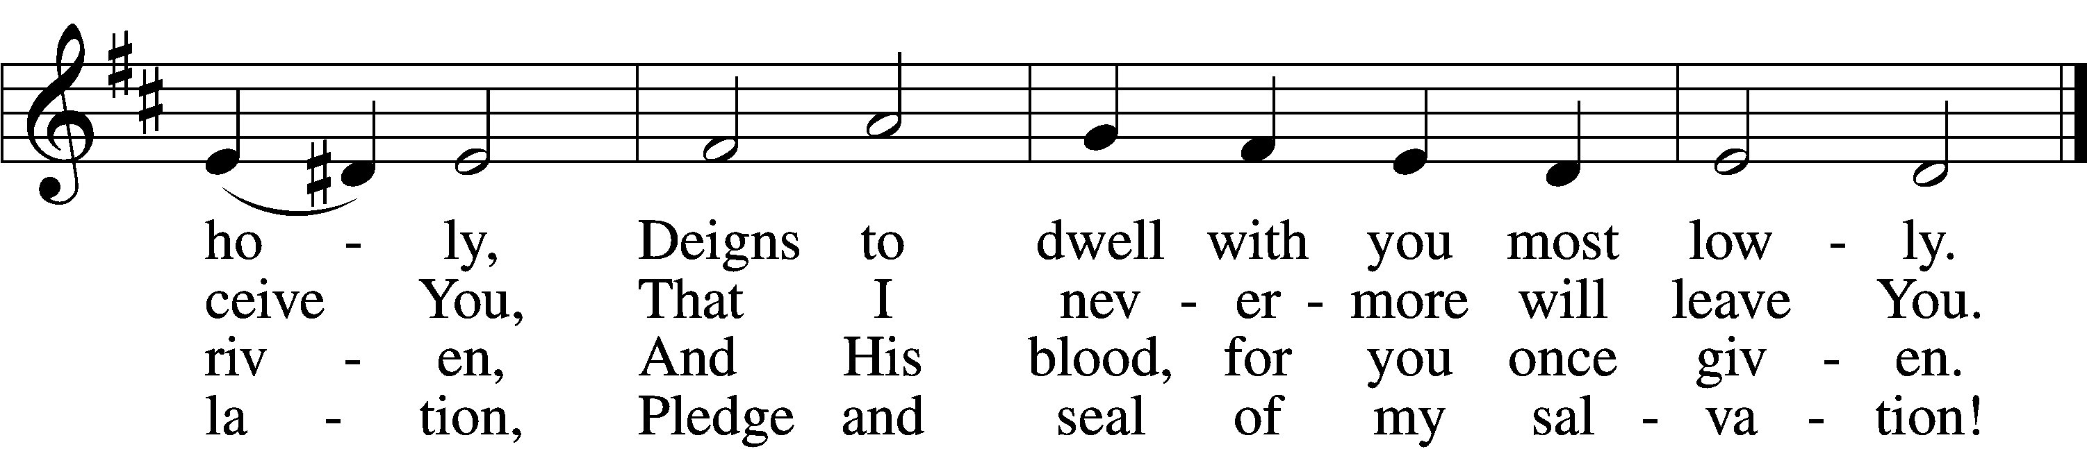

5 Jesus, source of lasting pleasure,
Truest friend, and dearest treasure,
Peace beyond all understanding,
Joy into all life expanding:
Humbly now, I bow before You;
Love incarnate, I adore You;
Worthily let me receive You
And, so favored, never leave You.

6 Jesus, sun of life, my splendor,
Jesus, friend of friends, most tender,
Jesus, joy of my desiring,
Fount of life, my soul inspiring:
At Your feet I cry, my maker,
Let me be a fit partaker
Of this blessèd food from heaven,
For our good, Your glory, given.

7 Lord, by love and mercy driven,
You once left Your throne in heaven
On the cross for me to languish And to die in bitter anguish,
To forego all joy and gladness
And to shed Your blood in sadness.
By this blood redeemed and living,
Lord, I praise You with thanksgivi

8 Jesus, bread of life, I pray You,
Let me gladly here obey You.
By Your love I am invited,
Be Your love with love requited;
By this Supper let me measure,
Lord, how vast and deep love’s treasure.
Through the gift of grace You give me
As Your guest in heav’n receive me

Stand

Nunc Dimittis LSB 211
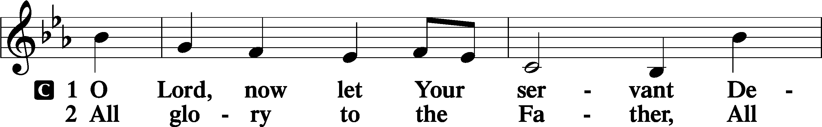
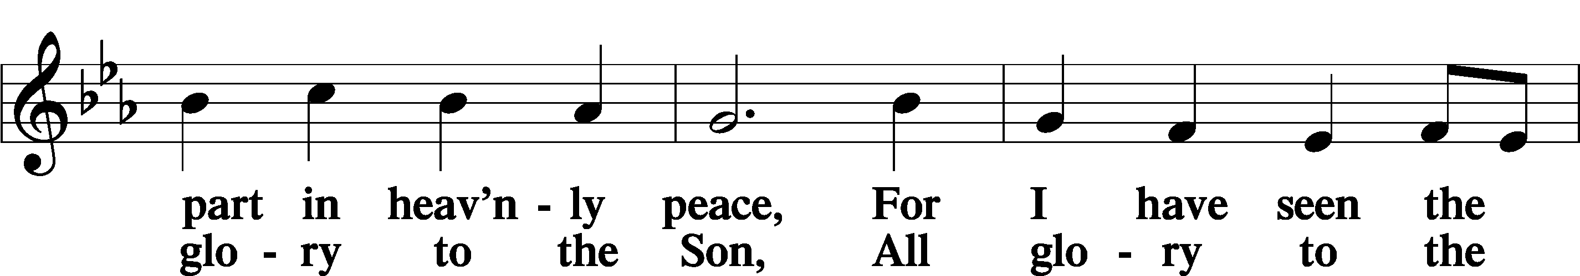
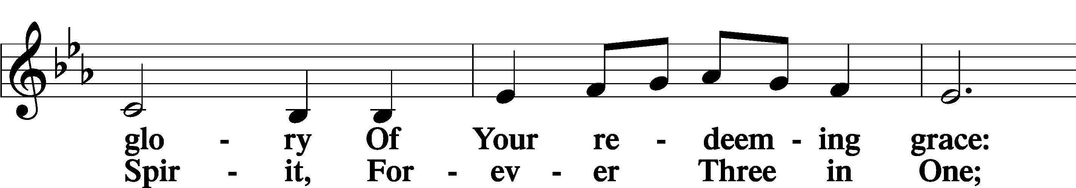
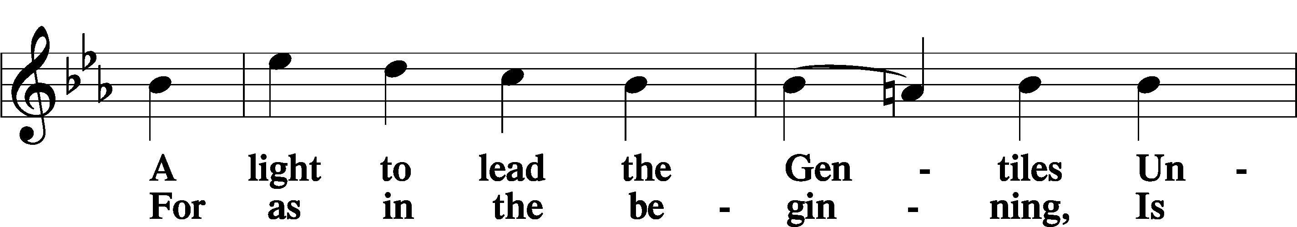
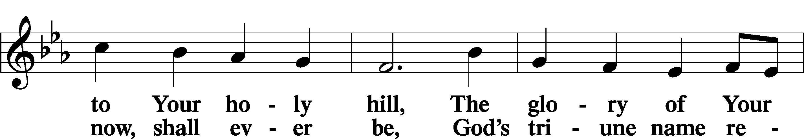
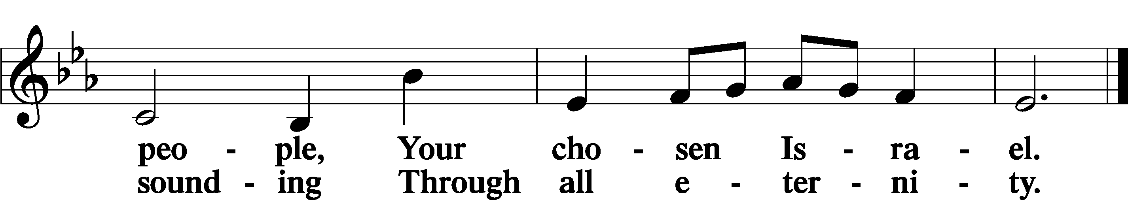

Post-Communion Collect
P Let us pray.

We give thanks to You, almighty God, that You have refreshed us through this salutary gift, and we implore You that of Your mercy You would strengthen us through the same in faith toward You and in fervent love toward one another; through Jesus Christ, Your Son, our Lord, who lives and reigns with You and the Holy Spirit, one God, now and forever.
C Amen.

Benedicamus 212
P Let us bless the Lord.
C Thanks be to God.

Benediction
P The Lord bless you and keep you.
The Lord make His face shine on you and be gracious to you.
The Lord look upon you with favor and T give you peace.
C Amen.

Sit

687 Thine Forever, God of Love
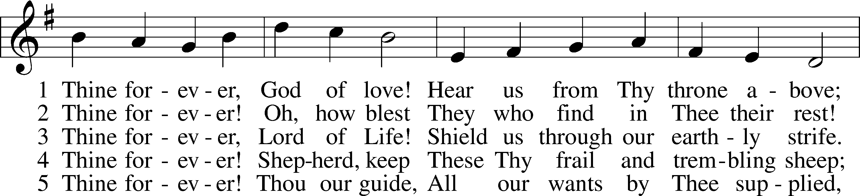
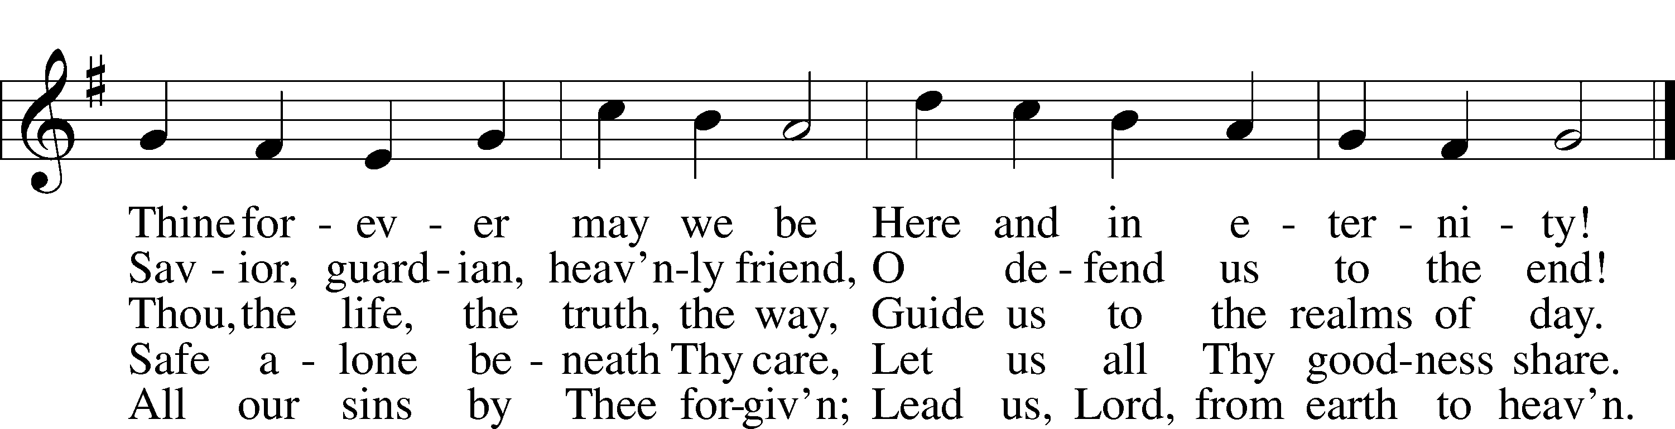
Announcements

Closing Statement

P We go to live for Jesus.
C We go to share His love.

Acknowledgments
Unless otherwise indicated, Scripture quotations are from the ESV® Bible (The Holy Bible, English Standard Version®), copyright © 2001 by Crossway, a publishing ministry of Good News Publishers. Used by permission. All rights reserved.
Created by Lutheran Service Builder © 2023 Concordia Publishing House.

