Welcome To
Trinity Lutheran Church
Lutheran Church - Missouri Synod
A Stephen Ministry Congregation

1354 South Otsego Avenue
Gaylord, MI 49735
Church Phone: 989-732-4816

Church Email: secretary@trinitygaylord.com
www.trinitygaylord.com

Office Hours:
Monday through Friday 9am - 1pm

OUR PURPOSE

. . . is to LOVE GOD, LOVE OTHERS AND SERVE THE WORLD by worshiping the Lord Jesus, bringing our members into Christ-like maturity, and equipping them through Word and Sacrament for their mission and ministry. We go heart to heart into the world with Jesus, sharing His love, caring for one another, praying, and bringing the lost into a relationship with Christ, by the working of the Holy Spirit.

May 28, 2023
The Day of Pentecost
Preacher: Rev. Ken Bernthal

ABOUT OUR WORSHIP

We welcome all who gather here today! We are blessed to celebrate together the mercy, grace and love we have from God through the death and resurrection of our Lord Jesus Christ.

Children: Families with children are very welcome here. Having children in church is important so they can begin to learn about their faith in Jesus, and it’s good for the whole congregation to see. Please feel comfortable keeping “squirmy” kids in the service. This is where they belong, too!

Pew cards: Guest and Members, please fill out a Guest/Member card located in the pew rack. The card can be placed in the offering plates at the back of the church.

If standing is difficult feel free to remain seated during any portion of the service. Please let an Elder or Usher know if you need communion in your pew seat.

About our celebration of Holy Communion: We celebrate the Lord’s Supper in the confession and glad confidence that, as he says, our Lord gives into our mouths not only bread and wine but his very body and blood to eat and drink for the forgiveness of sins and to strengthen our union with him and with one another. Our Lord invites to his table those who trust his words, repent of all sin and set aside any refusal to forgive and love as he forgives and loves us, that they may show forth his death until he comes.

Because those who eat and drink our Lord’s body and blood contrary to that which is stated above do so to their great harm, and because Holy Communion is a confession of the faith which is confessed at this altar. Anyone who is not yet instructed, in doubt, or who hold a confession differing from that of the Lutheran Church Missouri Synod, and yet desire to receive the sacrament, are asked to first speak with Pastor. Those not communing are still invited to come forward for a blessing from Pastor, and you may indicate this by crossing your arms over your chest.

Greeting
P Peace be with you.
C And also with you

Divine Service - Setting Four LSB 203

Opening Hymn

496 Holy Spirit, Light Divine
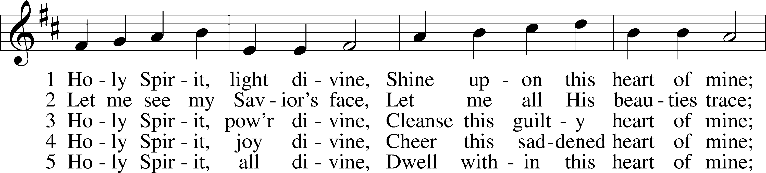
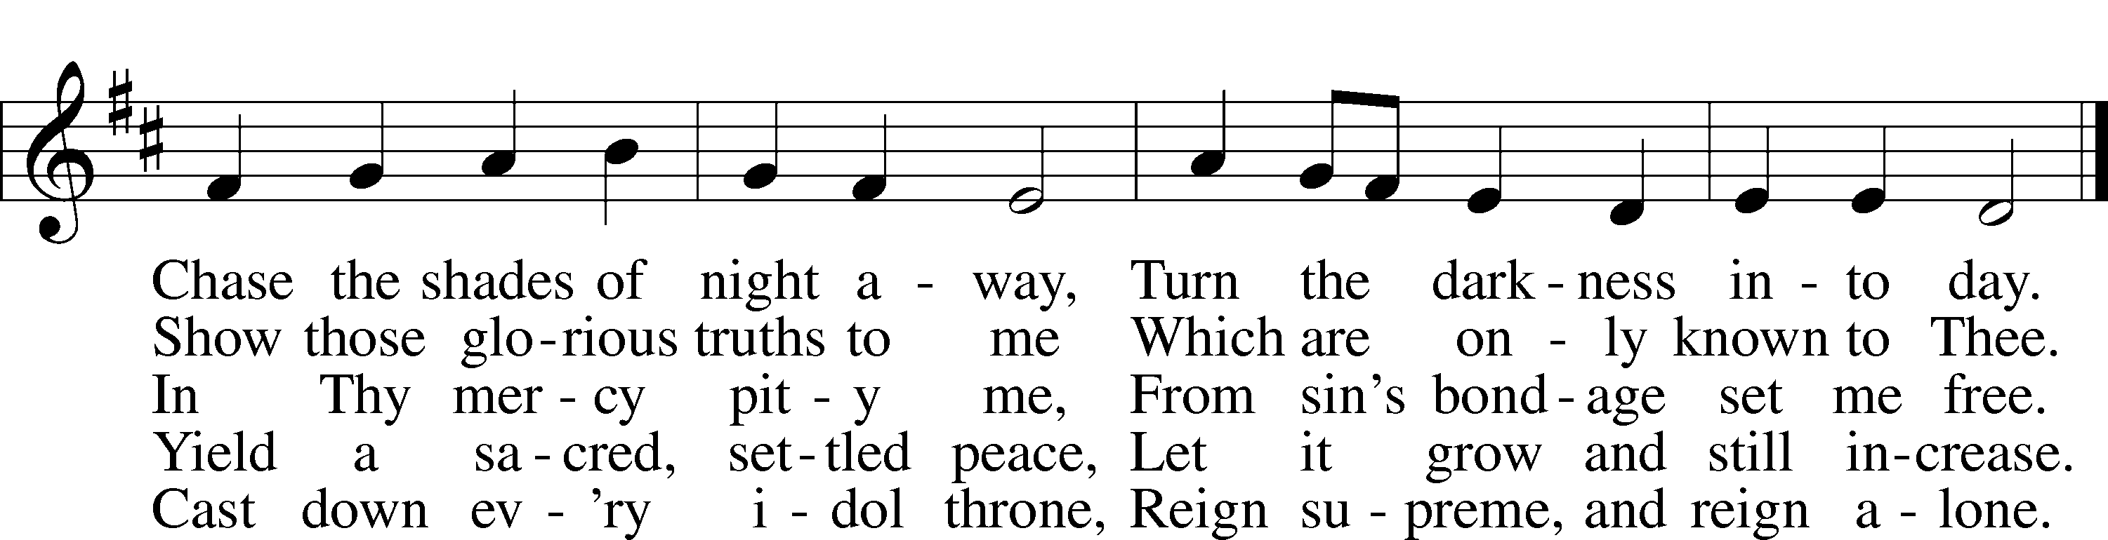

Stand

Confession and Absolution

The sign of the cross may be made by all in remembrance of their Baptism.

Invocation
P In the name of the Father and of the T Son and of the Holy Spirit.
C Amen.

Exhortation LSB 203
P Our help is in the name of the Lord,
C who made heaven and earth.

P If You, O Lord, kept a record of sins, O Lord, who could stand?
C But with You there is forgiveness; therefore You are feared.

P Since we are gathered to hear God’s Word, call upon Him in prayer and praise, and receive the body and blood of our Lord Jesus Christ in the fellowship of this altar, let us first consider our unworthiness and confess before God and one another that we have sinned in thought, word, and deed, and that we cannot free ourselves from our sinful condition. Together as His people let us take refuge in the infinite mercy of God, our heavenly Father, seeking His grace for the sake of Christ, and saying: God, be merciful to me, a sinner.

Confession of Sins LSB 203
C Almighty God, have mercy upon us, forgive us our sins, and lead us to everlasting life. Amen.

Prayer for Forgiveness
P Almighty God, merciful Father, in Holy Baptism You declared us to be Your children and gathered us into Your one, holy Church, in which You daily and richly forgive us our sins and grant us new life through Your Spirit. Be in our midst, enliven our faith, and graciously receive our prayer and praise; through Your Son, Jesus Christ, our Lord.
C Amen.

Service of the Word

Introit
P Come, Holy Spirit, fill the hearts of the faithful,
C and kindle in them the fire of your love. Alleluia.
P O Lord, how manifold are your works! In wisdom have you made them all;
C the earth is full of your creatures.
P These all look to you,
C to give them their food in due season.
P When you give it to them, they gather it up;
C when you open your hand, they are filled with good things.
P When you send forth your Spirit, they are created,
C and you renew the face of the ground.

A Glory be to the Father and to the Son
and to the Holy Spirit;
as it was in the beginning,
is now, and will be forever. Amen.

P Come, Holy Spirit, fill the hearts of the faithful,
C and kindle in them the fire of your love. Alleluia.

Kyrie LSB 204
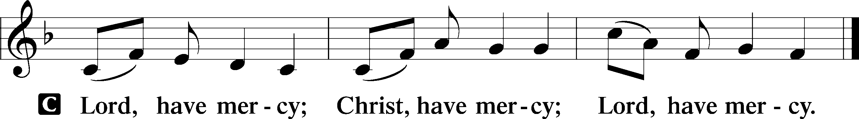

Gloria in Excelsis LSB 204
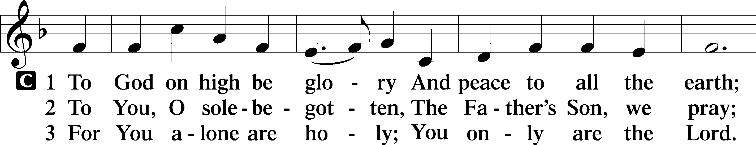
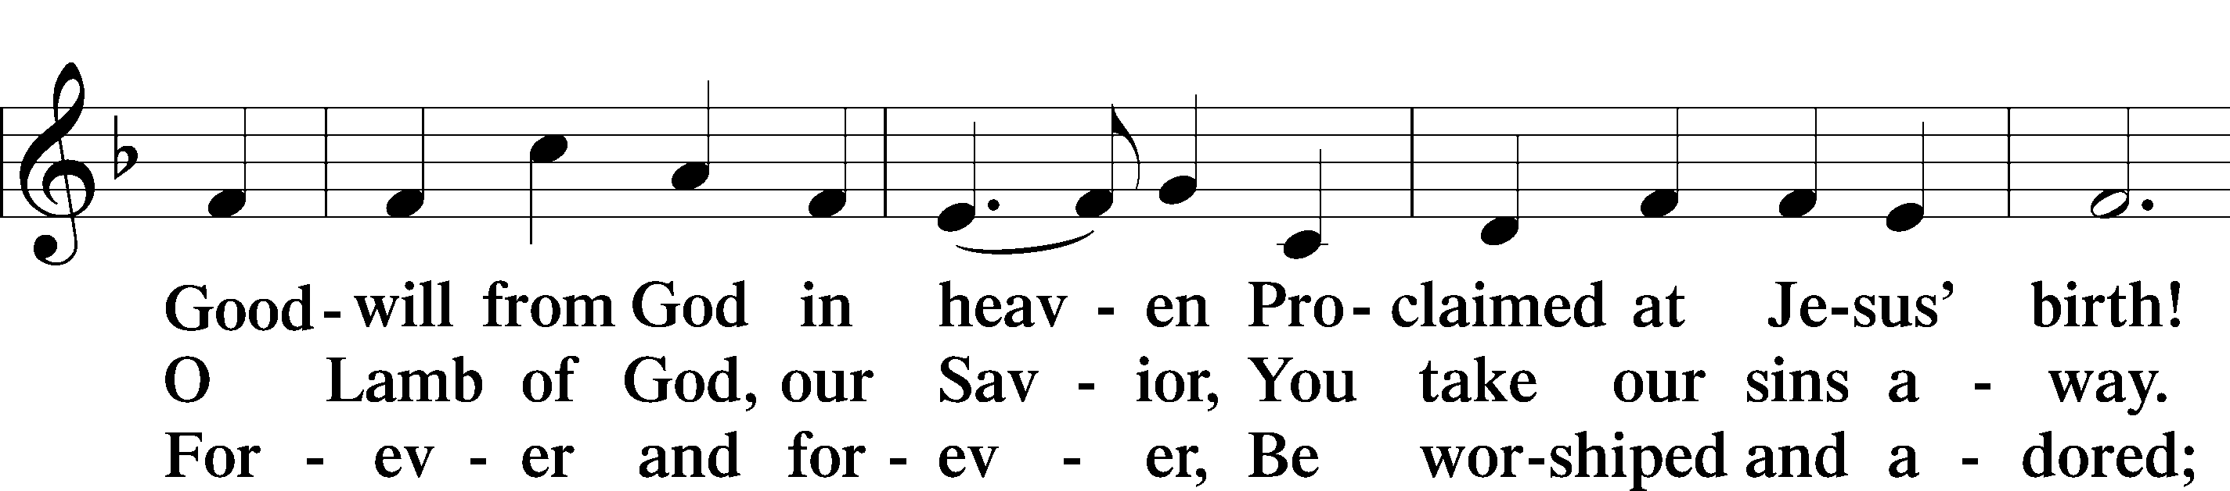
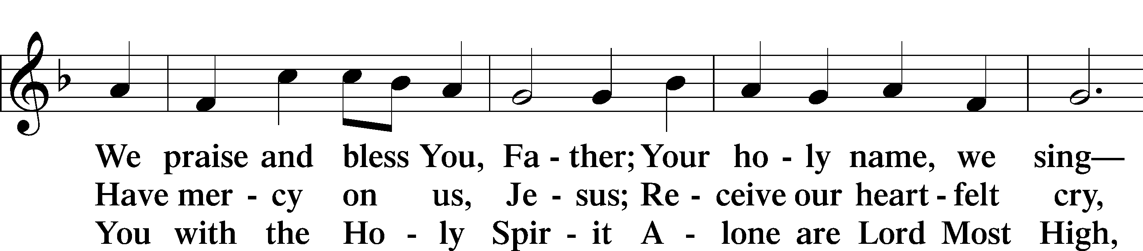
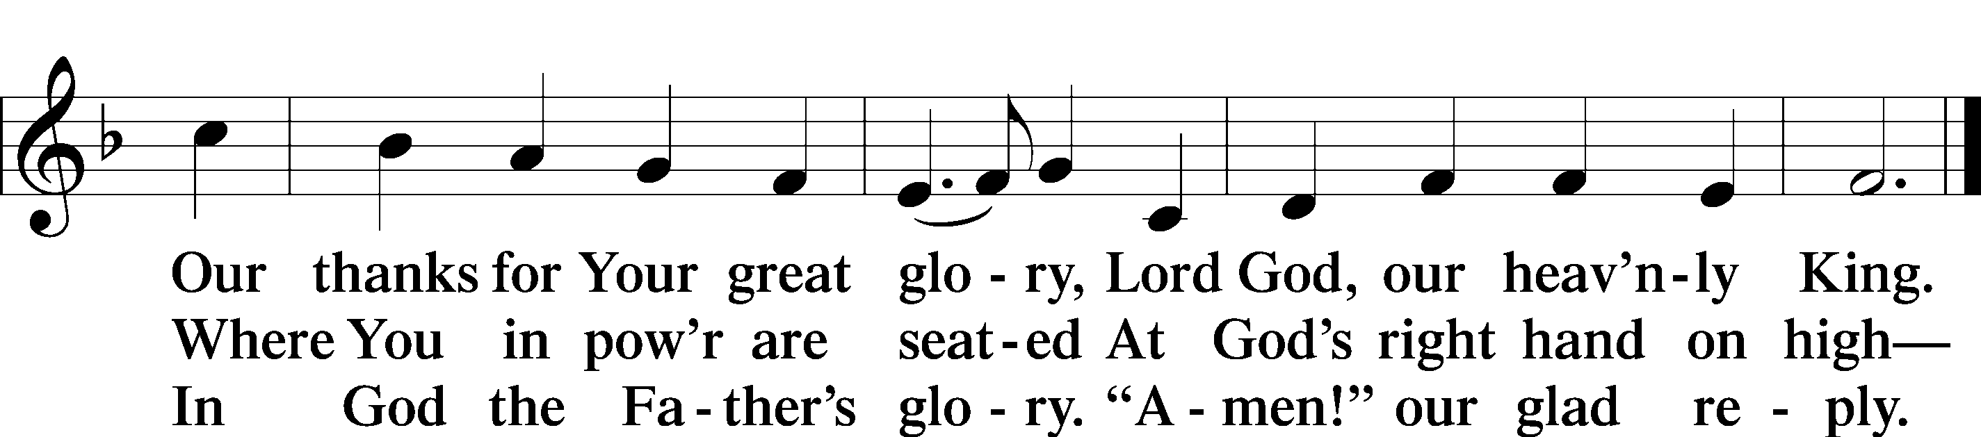

Salutation and Collect of the Day
P The Lord be with you.
C And also with you.

P Let us pray.
O God, on this day You once taught the hearts of Your faithful people by sending them the light of Your Holy Spirit. Grant us in our day by the same Spirit to have a right understanding in all things and evermore to rejoice in His holy consolation; through Jesus Christ, Your Son, our Lord, who lives and reigns with You and the Holy Spirit, one God, now and forever.

C Amen.

Sit

First Reading Numbers 11:24–30
24Moses went out and told the people the words of the Lord. And he gathered seventy men of the elders of the people and placed them around the tent. 25Then the Lord came down in the cloud and spoke to him, and took some of the Spirit that was on him and put it on the seventy elders. And as soon as the Spirit rested on them, they prophesied. But they did not continue doing it.
26Now two men remained in the camp, one named Eldad, and the other named Medad, and the Spirit rested on them. They were among those registered, but they had not gone out to the tent, and so they prophesied in the camp. 27And a young man ran and told Moses, “Eldad and Medad are prophesying in the camp.” 28And Joshua the son of Nun, the assistant of Moses from his youth, said, “My lord Moses, stop them.” 29But Moses said to him, “Are you jealous for my sake? Would that all the Lord’s people were prophets, that the Lord would put his Spirit on them!” 30And Moses and the elders of Israel returned to the camp.

P This is the Word of the Lord.
C Thanks be to God.

Choir Anthem "O, That I Had A Thousand Voices"

Second Reading Acts 2:1–21
1When the day of Pentecost arrived, they were all together in one place. 2And suddenly there came from heaven a sound like a mighty rushing wind, and it filled the entire house where they were sitting. 3And divided tongues as of fire appeared to them and rested on each one of them. 4And they were all filled with the Holy Spirit and began to speak in other tongues as the Spirit gave them utterance.
5Now there were dwelling in Jerusalem Jews, devout men from every nation under heaven. 6And at this sound the multitude came together, and they were bewildered, because each one was hearing them speak in his own language. 7And they were amazed and astonished, saying, “Are not all these who are speaking Galileans? 8And how is it that we hear, each of us in his own native language? 9Parthians and Medes and Elamites and residents of Mesopotamia, Judea and Cappadocia, Pontus and Asia, 10Phrygia and Pamphylia, Egypt and the parts of Libya belonging to Cyrene, and visitors from Rome, 11both Jews and proselytes, Cretans and Arabians—we hear them telling in our own tongues the mighty works of God.” 12And all were amazed and perplexed, saying to one another, “What does this mean?” 13But others mocking said, “They are filled with new wine.”
14But Peter, standing with the eleven, lifted up his voice and addressed them, “Men of Judea and all who dwell in Jerusalem, let this be known to you, and give ear to my words. 15For these men are not drunk, as you suppose, since it is only the third hour of the day. 16But this is what was uttered through the prophet Joel:
17“‘And in the last days it shall be, God declares,
that I will pour out my Spirit on all flesh,
and your sons and your daughters shall prophesy,
and your young men shall see visions,
and your old men shall dream dreams;
18even on my male servants and female servants
in those days I will pour out my Spirit, and they shall prophesy.
19And I will show wonders in the heavens above
and signs on the earth below,
blood, and fire, and vapor of smoke;
20the sun shall be turned to darkness
and the moon to blood,
before the day of the Lord comes, the great and magnificent day.
21And it shall come to pass that everyone who calls upon the name of the Lord shall be saved.’”

P This is the Word of the Lord.
C Thanks be to God.

Stand

Alleluia and Verse

Alleluia LSB 205
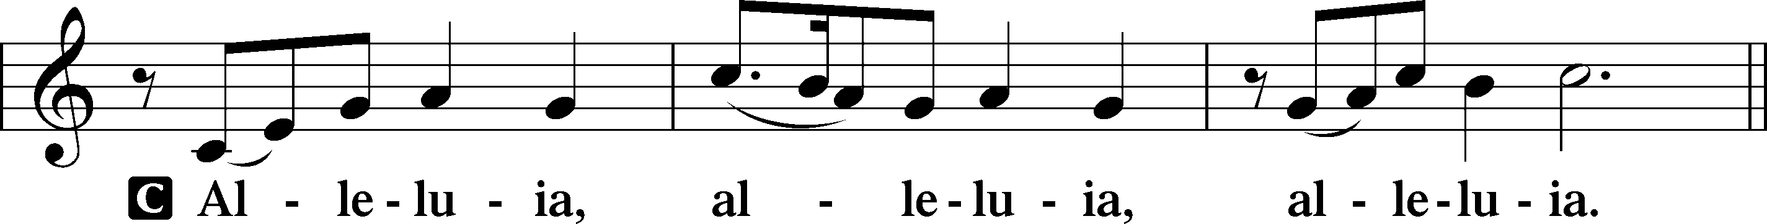

Verse LSB 205
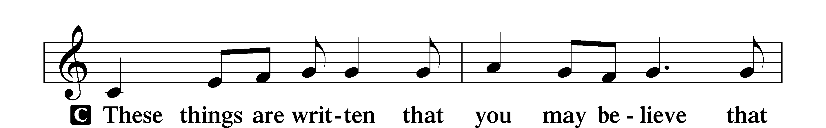
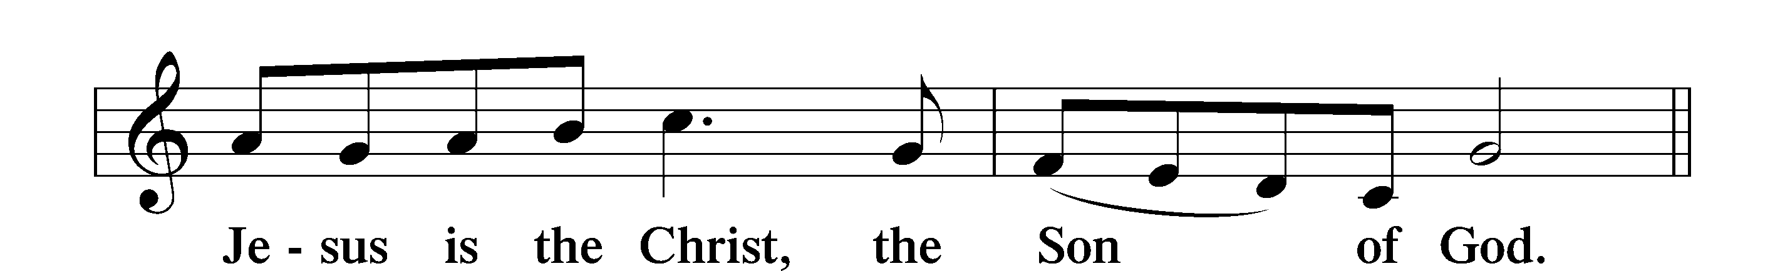

Alleluia LSB 205
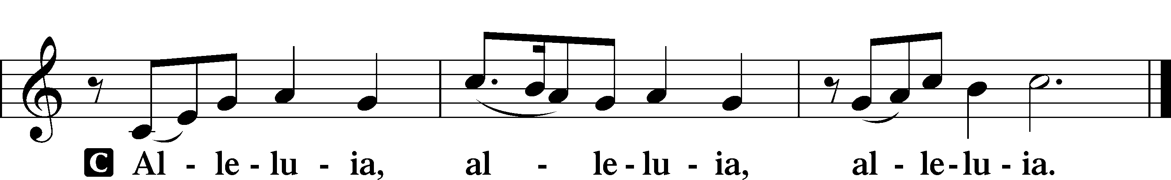

Holy Gospel John 7:37–39
P The Holy Gospel according to St. John, the seventh chapter.
C Glory to You, O Lord.

37On the last day of the feast, the great day, Jesus stood up and cried out, “If anyone thirsts, let him come to me and drink. 38Whoever believes in me, as the Scripture has said, ‘Out of his heart will flow rivers of living water.’” 39Now this he said about the Spirit, whom those who believed in him were to receive, for as yet the Spirit had not been given, because Jesus was not yet glorified.

P This is the Gospel of the Lord.
C Praise to You, O Christ.

Nicene Creed
C I believe in one God,
the Father Almighty,
maker of heaven and earth
and of all things visible and invisible.

And in one Lord Jesus Christ,
the only-begotten Son of God,
begotten of His Father before all worlds,
God of God, Light of Light,
very God of very God,
begotten, not made,
being of one substance with the Father,
by whom all things were made;
who for us men and for our salvation came down from heaven
and was incarnate by the Holy Spirit of the virgin Mary
and was made man;
and was crucified also for us under Pontius Pilate.
He suffered and was buried.
And the third day He rose again according to the Scriptures
and ascended into heaven
and sits at the right hand of the Father.
And He will come again with glory to judge both the living and the dead,
whose kingdom will have no end.

And I believe in the Holy Spirit,
the Lord and giver of life,
who proceeds from the Father and the Son,
who with the Father and the Son together is worshiped and glorified,
who spoke by the prophets.
And I believe in one holy Christian and apostolic Church,
I acknowledge one Baptism for the remission of sins,
and I look for the resurrection of the dead
and the life T of the world to come. Amen.

Sit

Children's Talk

Sermon Hymn

832 Jesus Shall Reign
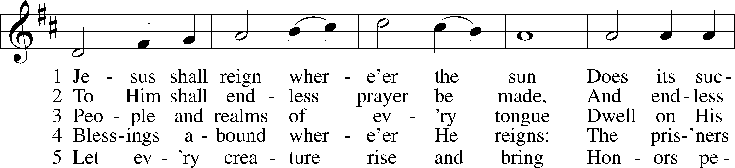
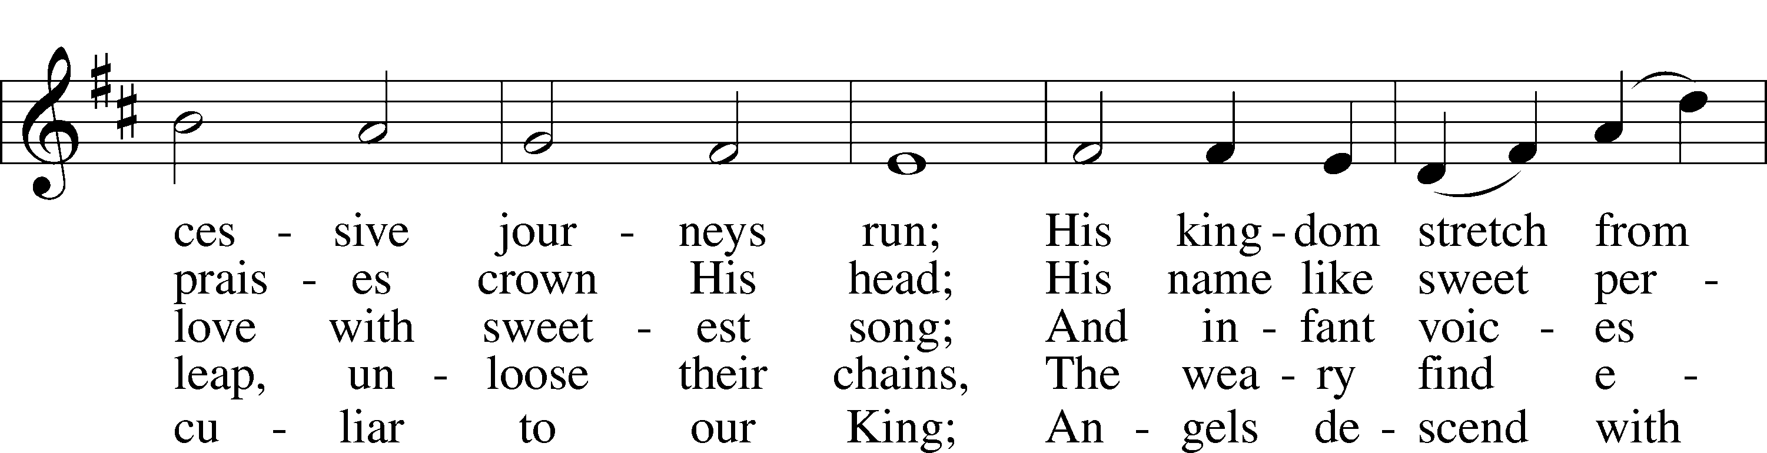
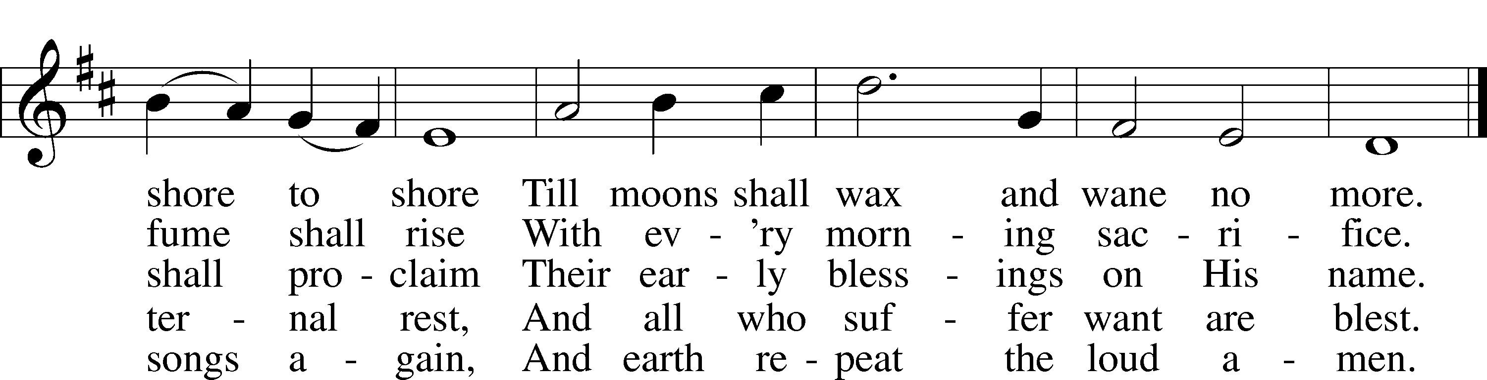

Sermon

Stand

Prayer of the Church

Prayer Response
After each segment:
P Lord, in Your mercy,
C hear our prayer.

After prayers:
P In the name of Jesus we pray.
C Amen.

Service of the Sacrament

Preface 208
P The Lord be with you.
C And also with you.

P Lift up your hearts.
C We lift them to the Lord.

P Let us give thanks to the Lord our God.
C It is right to give Him thanks and praise.

P It is truly good, right, and salutary that we should at all times and in all places give thanks to You, O Lord, holy Father, almighty and everlasting God, for the countless blessings You so freely bestow on us and all creation. Above all, we give thanks for Your boundless love shown to us when You sent Your only-begotten Son, Jesus Christ, into our flesh and laid on Him our sin, giving Him into death that we might not die eternally. Because He is now risen from the dead and lives and reigns to all eternity, all who believe in Him will overcome sin and death and will rise again to new life. Therefore with angels and archangels and with all the company of heaven we laud and magnify Your glorious name, evermore praising You and singing:

Sanctus LSB 208
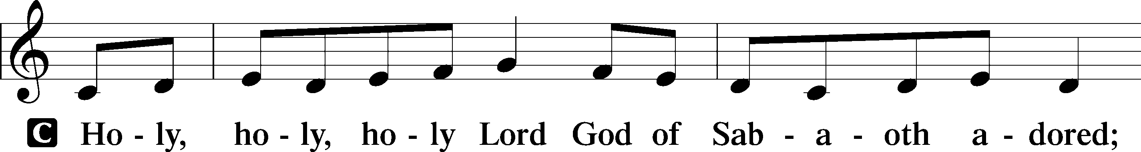
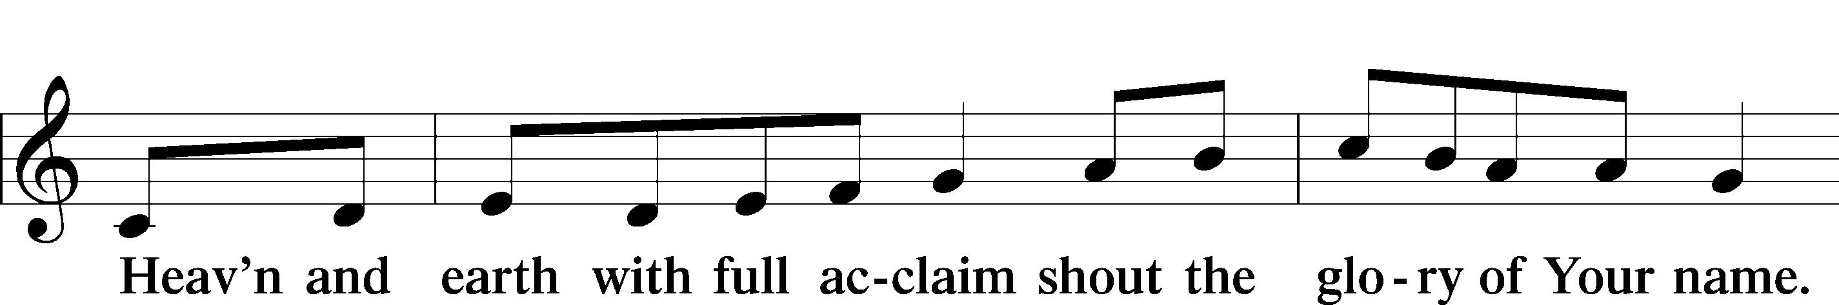
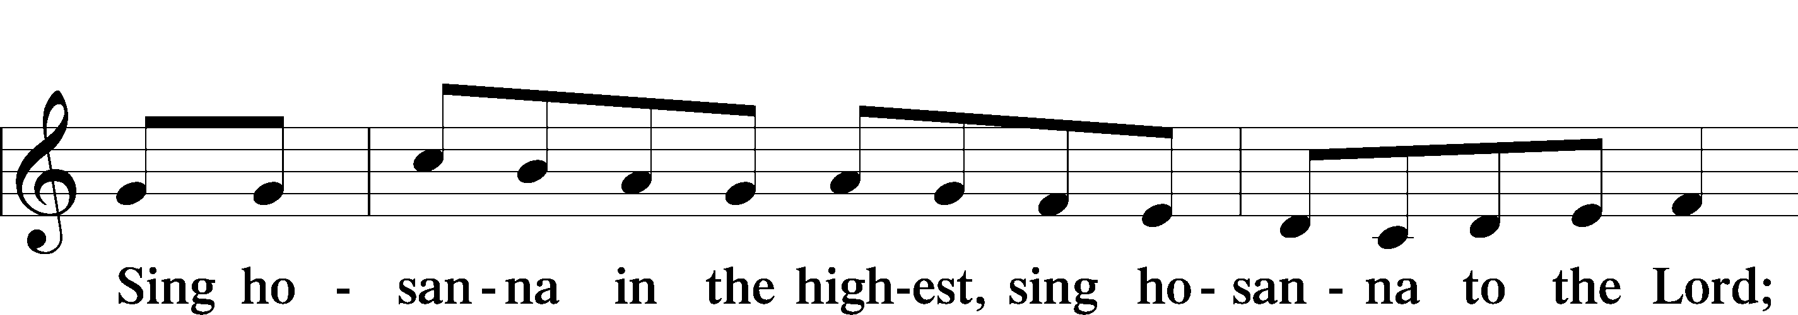
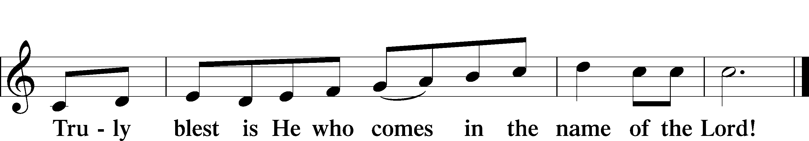

Prayer of Thanksgiving
P Blessed are You, O Lord our God, king of all creation, for You have had mercy on us and given Your only-begotten Son that whoever believes in Him should not perish but have eternal life.

In these last days, You have poured out Your Holy Spirit on Your Church that Your sons and daughters might proclaim the wonders of Your salvation in Christ Jesus, our Lord.

Pour out Your Holy Spirit upon Your gathered people that, faithfully eating and drinking the body and blood of Your Son, we may go forth to proclaim His salvation to the ends of the earth.

Hear us as we pray in His name and as He has taught us:

Lord’s Prayer
Our Father, Who art in heaven,
hallowed be Thy name,
Thy kingdom come,
Thy will be done, on earth as it is in heaven.
Give us this day our daily bread;
and forgive us our trespasses, as we forgive those who trespass against us;
and lead us not into temptation,
but deliver us from evil.
For Thine is the kingdom, and the power, and the glory, forever and ever. Amen.

The Words of Our Lord
P Our Lord Jesus Christ, on the night when He was betrayed, took bread, and when He had given thanks, He broke it and gave it to the disciples and said: “Take, eat; this is My T body, which is given for you. This do in remembrance of Me.”

In the same way also He took the cup after supper, and when He had given thanks, He gave it to them, saying: “Drink of it, all of you; this cup is the new testament in My T blood, which is shed for you for the forgiveness of sins. This do, as often as you drink it, in remembrance of Me.”

Pax Domini
P The peace of the Lord be with you always.
C Amen.

Agnus Dei LSB 210
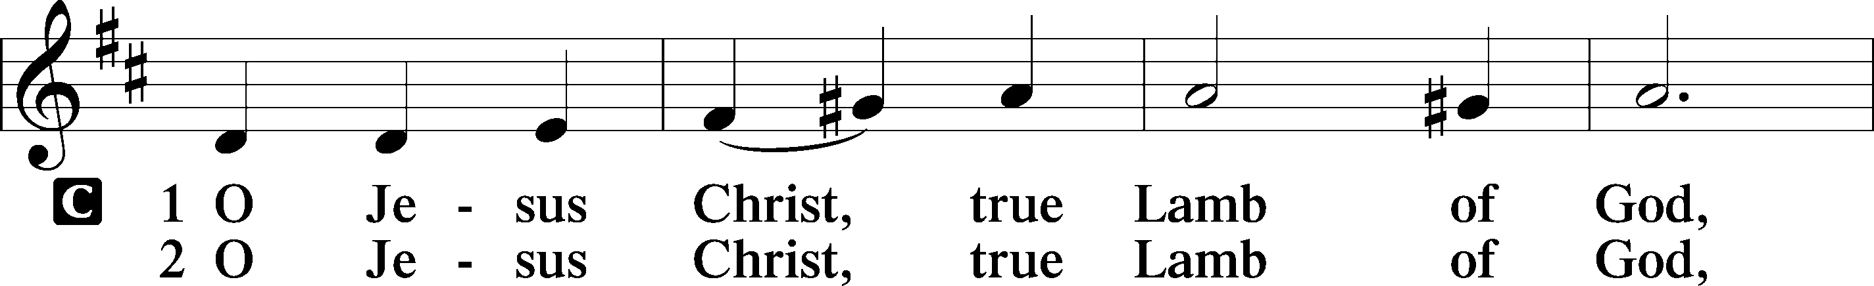
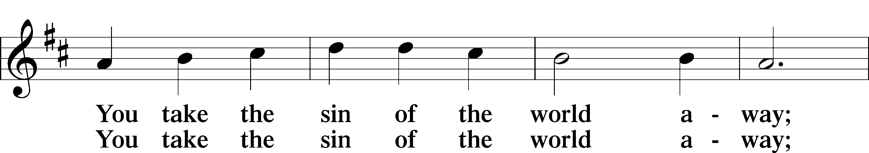
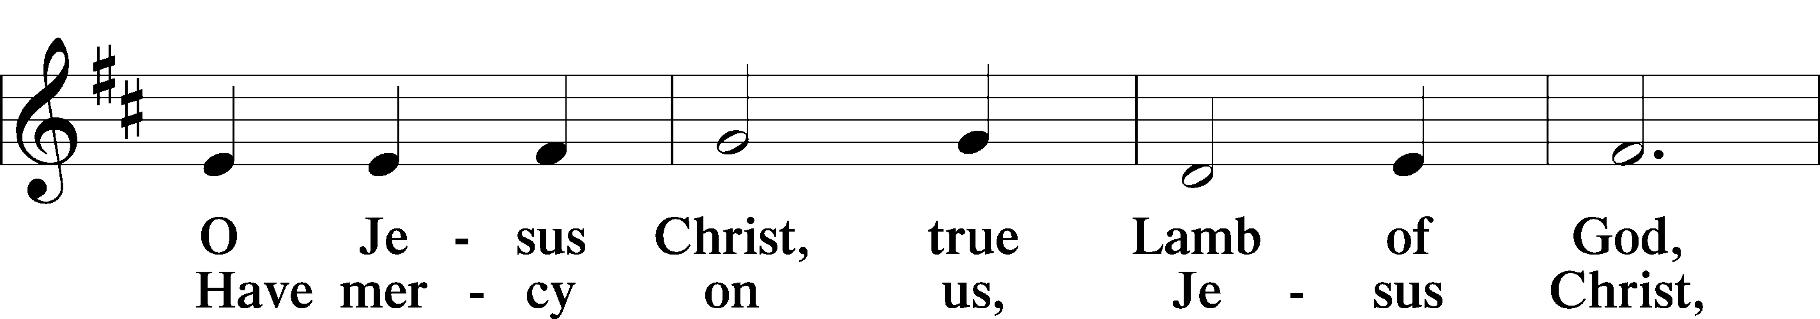
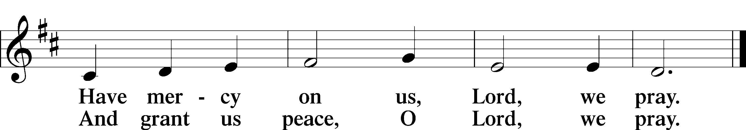

Sit

Distribution Hymns

621 Let All Mortal Flesh Keep Silence
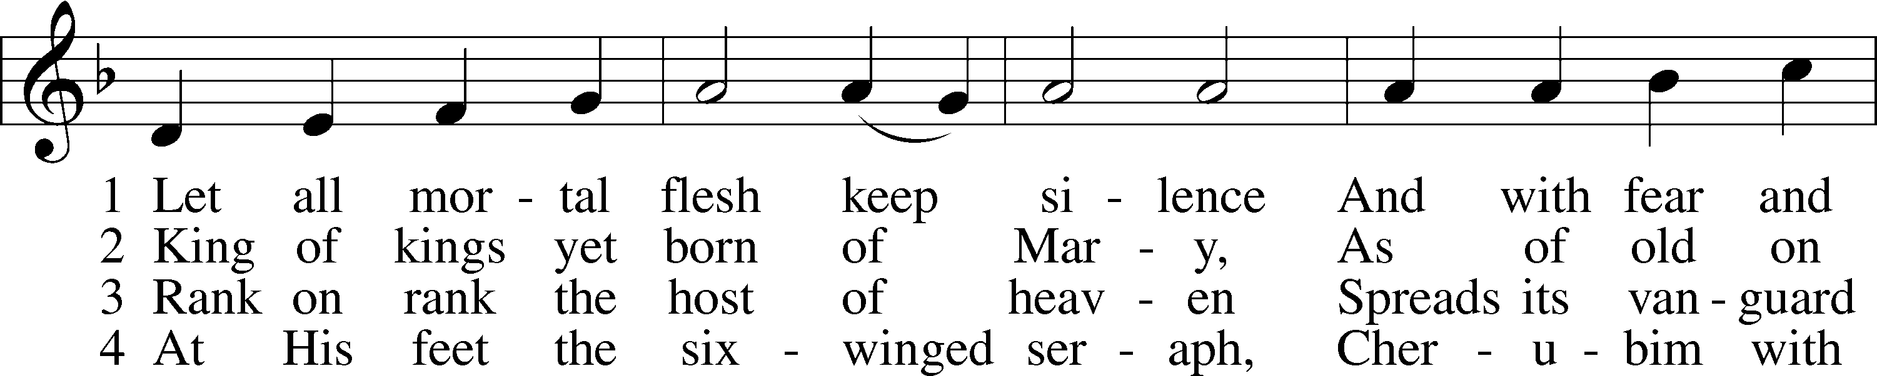
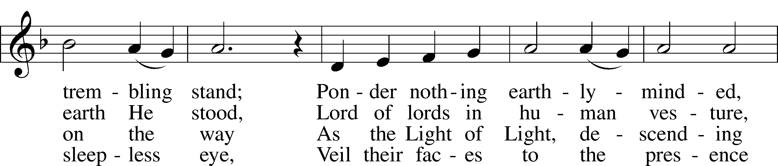
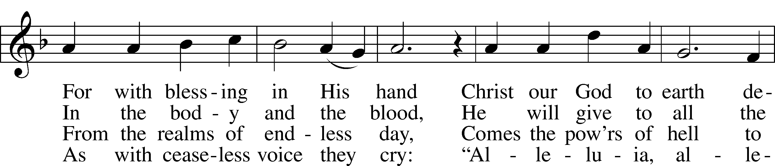
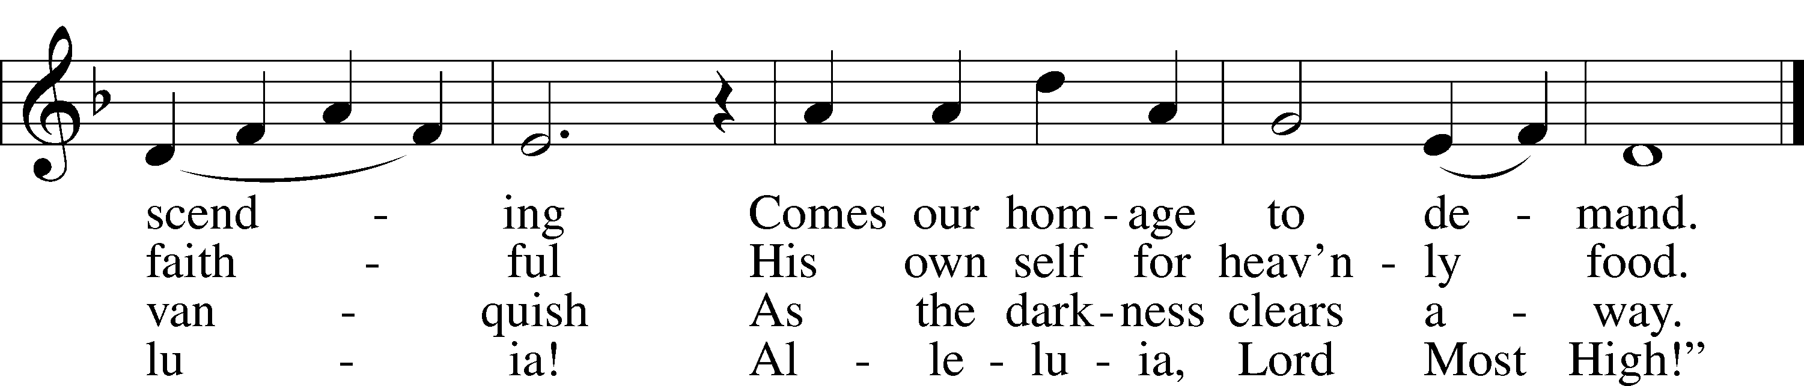

830 Spread the Reign of God the Lord
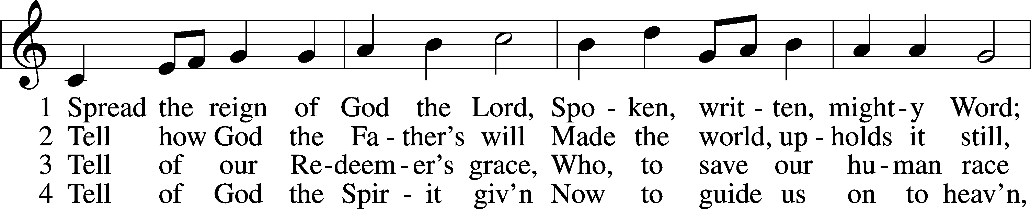
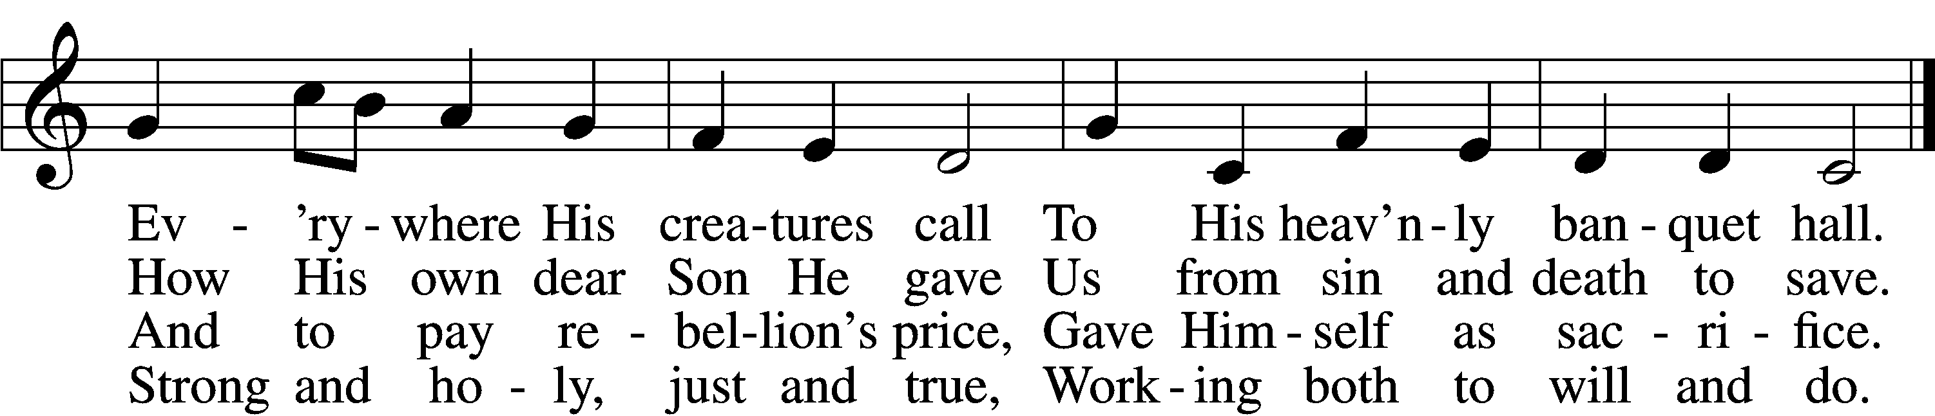

5 Enter, mighty Word, the field;
Ripe the promise of its yield.
But the reapers, oh, how few
For the work there is to do!

6 Lord of harvest, great and kind,
Rouse to action heart and mind;
Let the gath’ring nations all
See Your light and heed Your call.

Stand

Nunc Dimittis LSB 211
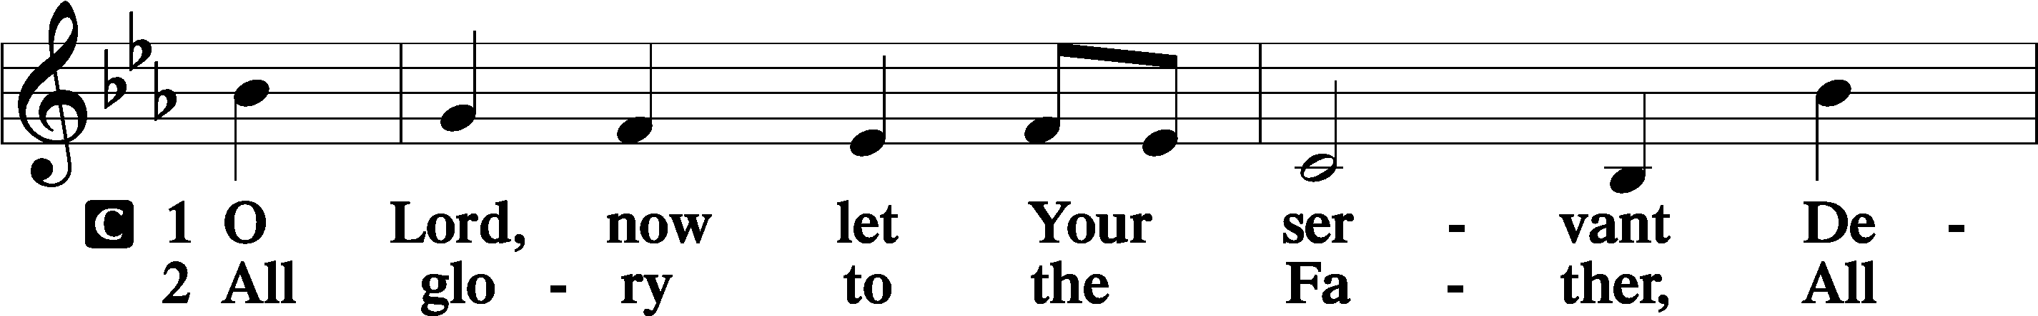
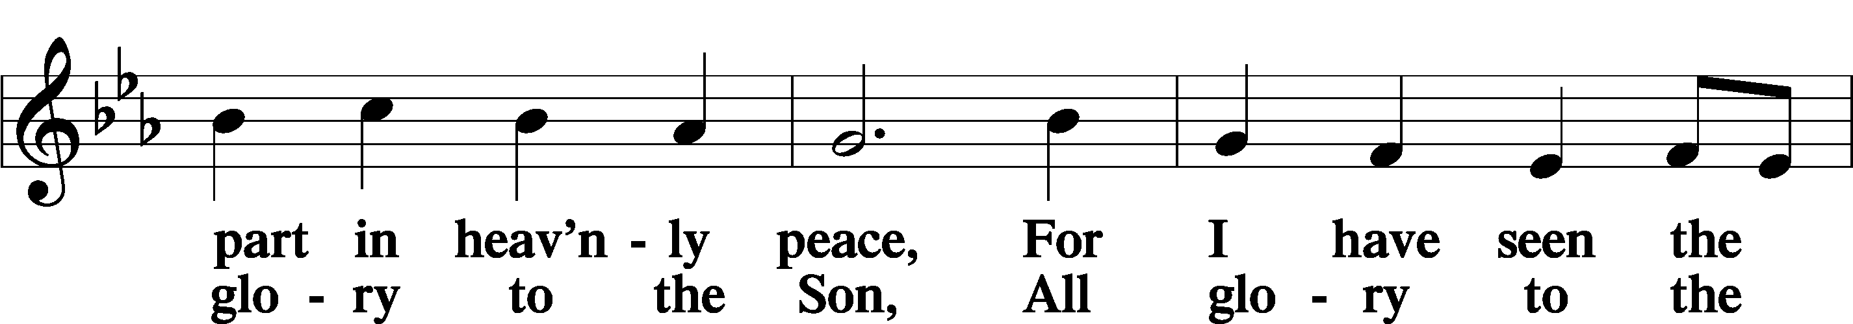
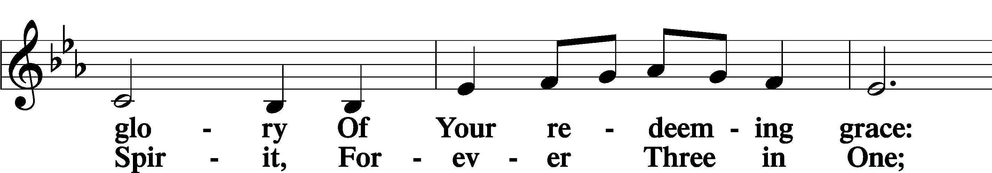
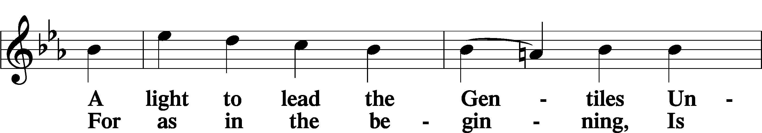
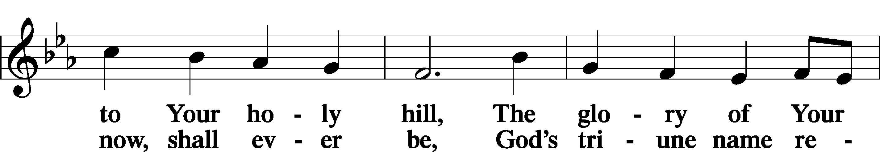
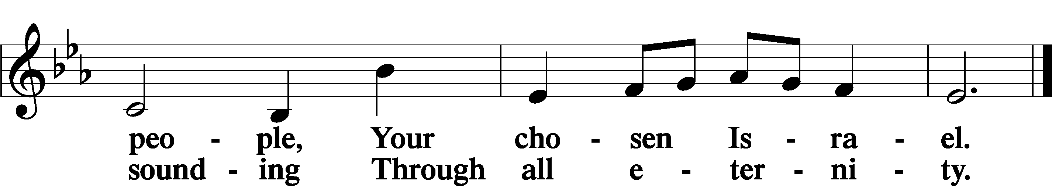

Post-Communion Collect
P Let us pray.

We give thanks to You, almighty God, that You have refreshed us through this salutary gift, and we implore You that of Your mercy You would strengthen us through the same in faith toward You and in fervent love toward one another; through Jesus Christ, Your Son, our Lord, who lives and reigns with You and the Holy Spirit, one God, now and forever.
C Amen.

Baptism of Gracie and Braxton Fults

Benedicamus 212
P Let us bless the Lord.
C Thanks be to God.

Benediction
P The Lord bless you and keep you.
The Lord make His face shine on you and be gracious to you.
The Lord look upon you with favor and T give you peace.
C Amen.

Sit

861 Christ Be My Leader
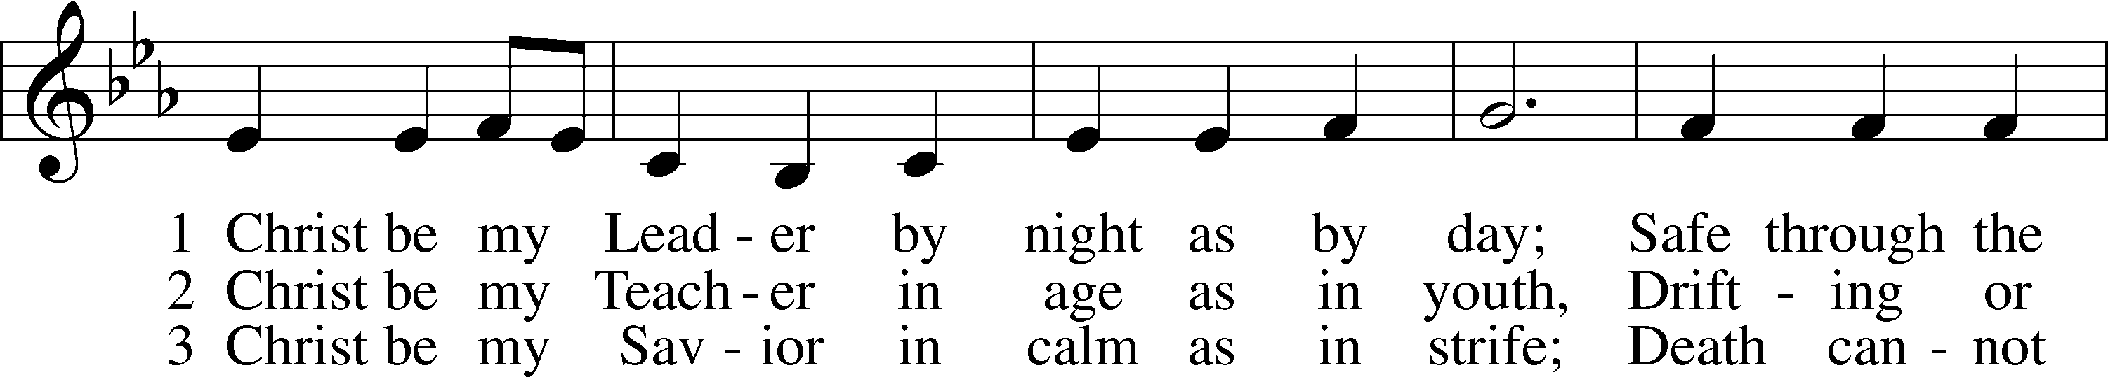
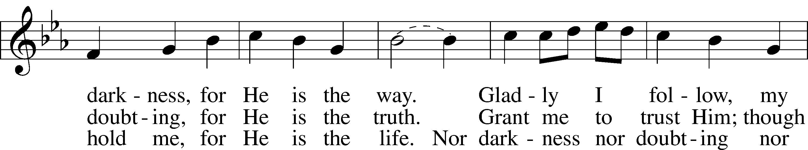
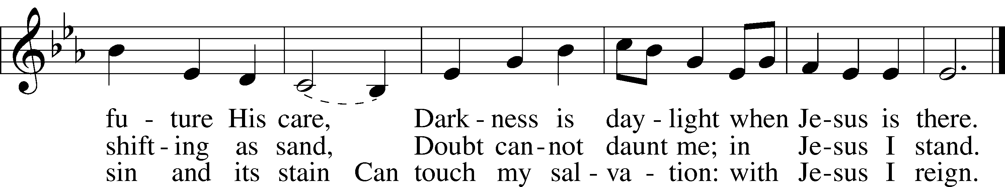

Closing Statement
P We go to live for Jesus.
C We go to share His love.

Acknowledgments
Unless otherwise indicated, Scripture quotations are from the ESV® Bible (The Holy Bible, English Standard Version®), copyright © 2001 by Crossway, a publishing ministry of Good News Publishers. Used by permission. All rights reserved.
Created by Lutheran Service Builder © 2023 Concordia Publishing House.

