Welcome To
Trinity Lutheran Church
Lutheran Church - Missouri Synod
A Stephen Ministry Congregation

1354 South Otsego Avenue
Gaylord, MI 49735
Church Phone: 989-732-4816

Church Email: secretary@trinitygaylord.com
www.trinitygaylord.com

Office Hours:
Monday through Friday 9am - 1pm

OUR PURPOSE

. . . is to LOVE GOD, LOVE OTHERS AND SERVE THE WORLD by worshiping the Lord Jesus, bringing our members into Christ-like maturity, and equipping them through Word and Sacrament for their mission and ministry. We go heart to heart into the world with Jesus, sharing His love, caring for one another, praying, and bringing the lost into a relationship with Christ, by the working of the Holy Spirit.

May 14, 2023
Sixth Sunday of Easter
“Mothers’ Day”
Preacher: Rev. Ken Bernthal

ABOUT OUR WORSHIP

We welcome all who gather here today! We are blessed to celebrate together the mercy, grace and love we have from God through the death and resurrection of our Lord Jesus Christ.

Children: Families with children are very welcome here. Having children in church is important so they can begin to learn about their faith in Jesus, and it’s good for the whole congregation to see. Please feel comfortable keeping “squirmy” kids in the service. This is where they belong, too!

Pew cards: Guest and Members, please fill out a Guest/Member card located in the pew rack. The card can be placed in the offering plates at the back of the church.

If standing is difficult feel free to remain seated during any portion of the service. Please let an Elder or Usher know if you need communion in your pew seat.

About our celebration of Holy Communion: We celebrate the Lord’s Supper in the confession and glad confidence that, as he says, our Lord gives into our mouths not only bread and wine but his very body and blood to eat and drink for the forgiveness of sins and to strengthen our union with him and with one another. Our Lord invites to his table those who trust his words, repent of all sin and set aside any refusal to forgive and love as he forgives and loves us, that they may show forth his death until he comes.

Because those who eat and drink our Lord’s body and blood contrary to that which is stated above do so to their great harm, and because Holy Communion is a confession of the faith which is confessed at this altar. Anyone who is not yet instructed, in doubt, or who hold a confession differing from that of the Lutheran Church Missouri Synod, and yet desire to receive the sacrament, are asked to first speak with Pastor. Those not communing are still invited to come forward for a blessing from Pastor, and you may indicate this by crossing your arms over your chest.

Greeting
P Peace be with you.
C And also with you

Divine Service - Setting Four LSB 203

Opening Hymn

837 Lift High the Cross
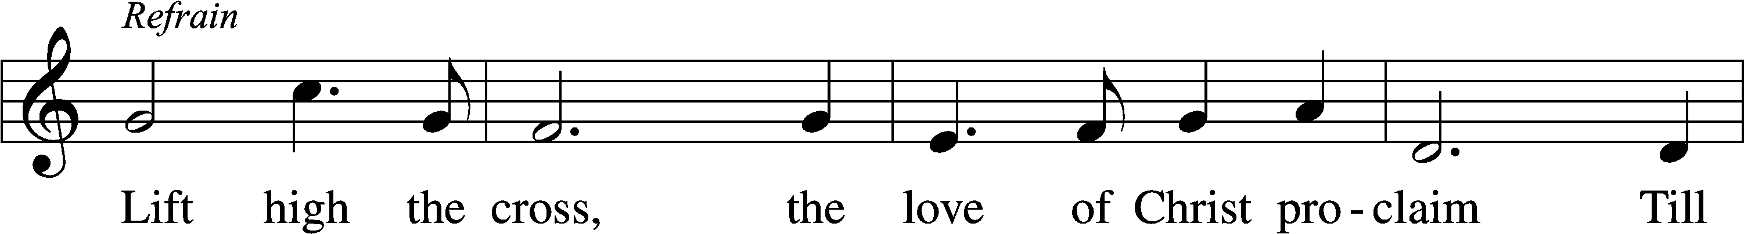
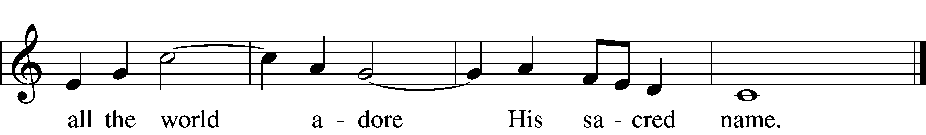
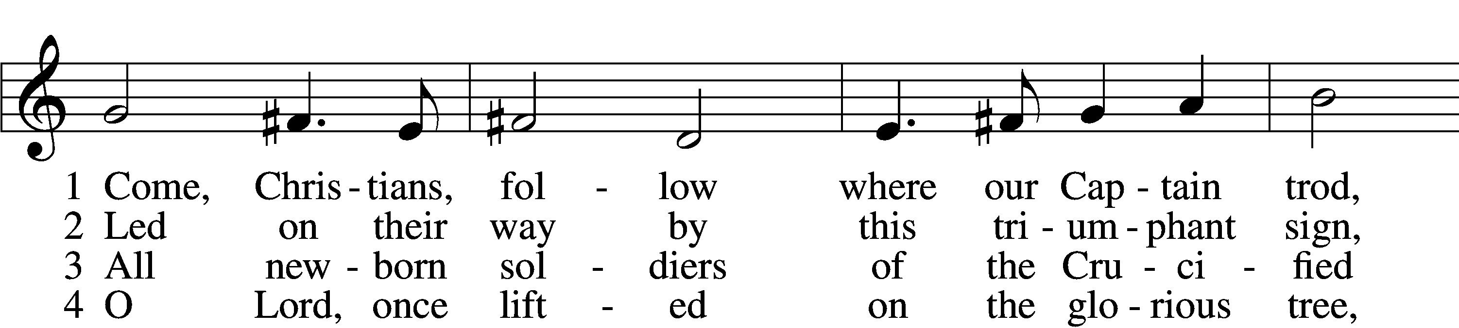
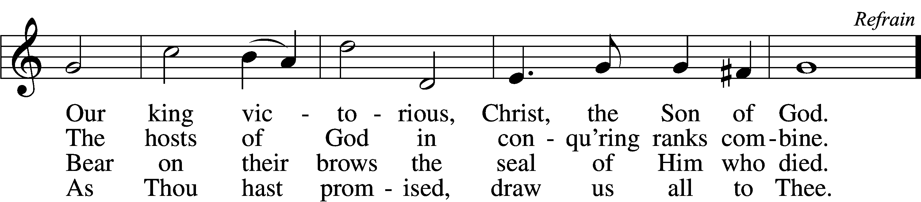

Stand

Confession and Absolution

The sign of the cross may be made by all in remembrance of their Baptism.

Invocation
P In the name of the Father and of the T Son and of the Holy Spirit.
C Amen.

Exhortation LSB 203
P Our help is in the name of the Lord,
C who made heaven and earth.

P If You, O Lord, kept a record of sins, O Lord, who could stand?
C But with You there is forgiveness; therefore You are feared.

P Since we are gathered to hear God’s Word, call upon Him in prayer and praise, and receive the body and blood of our Lord Jesus Christ in the fellowship of this altar, let us first consider our unworthiness and confess before God and one another that we have sinned in thought, word, and deed, and that we cannot free ourselves from our sinful condition. Together as His people let us take refuge in the infinite mercy of God, our heavenly Father, seeking His grace for the sake of Christ, and saying: God, be merciful to me, a sinner.

Confession of Sins LSB 203
C Almighty God, have mercy upon us, forgive us our sins, and lead us to everlasting life. Amen.

Prayer for Forgiveness
P Almighty God, merciful Father, in Holy Baptism You declared us to be Your children and gathered us into Your one, holy Church, in which You daily and richly forgive us our sins and grant us new life through Your Spirit. Be in our midst, enliven our faith, and graciously receive our prayer and praise; through Your Son, Jesus Christ, our Lord.
C Amen.

Service of the Word

Introit
P Your word is a lamp to my feet
C and a light to my path.
P Forever, O Lord, your word
C is firmly fixed in the heavens.
P Your faithfulness endures to all generations;
C you have established the earth, and it stands fast.
P By your appointment they stand this day,
C for all things are your servants.
P If your law had not been my delight,
C I would have perished in my affliction.
P I will never forget your precepts,
C for by them you have given me life.

A Glory be to the Father and to the Son
and to the Holy Spirit;
as it was in the beginning,
is now, and will be forever. Amen.

P Your word is a lamp to my feet
C and a light to my path.

Kyrie LSB 204
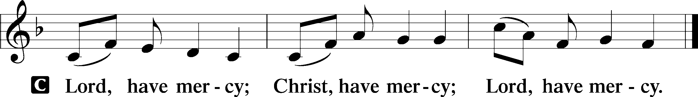

Gloria in Excelsis LSB 204
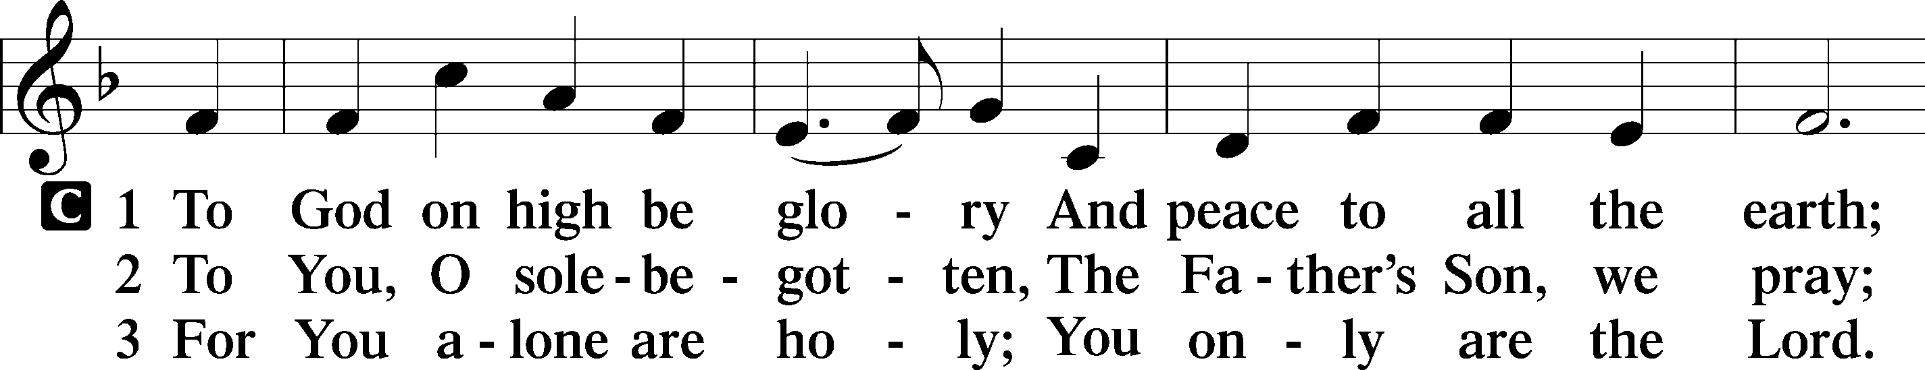
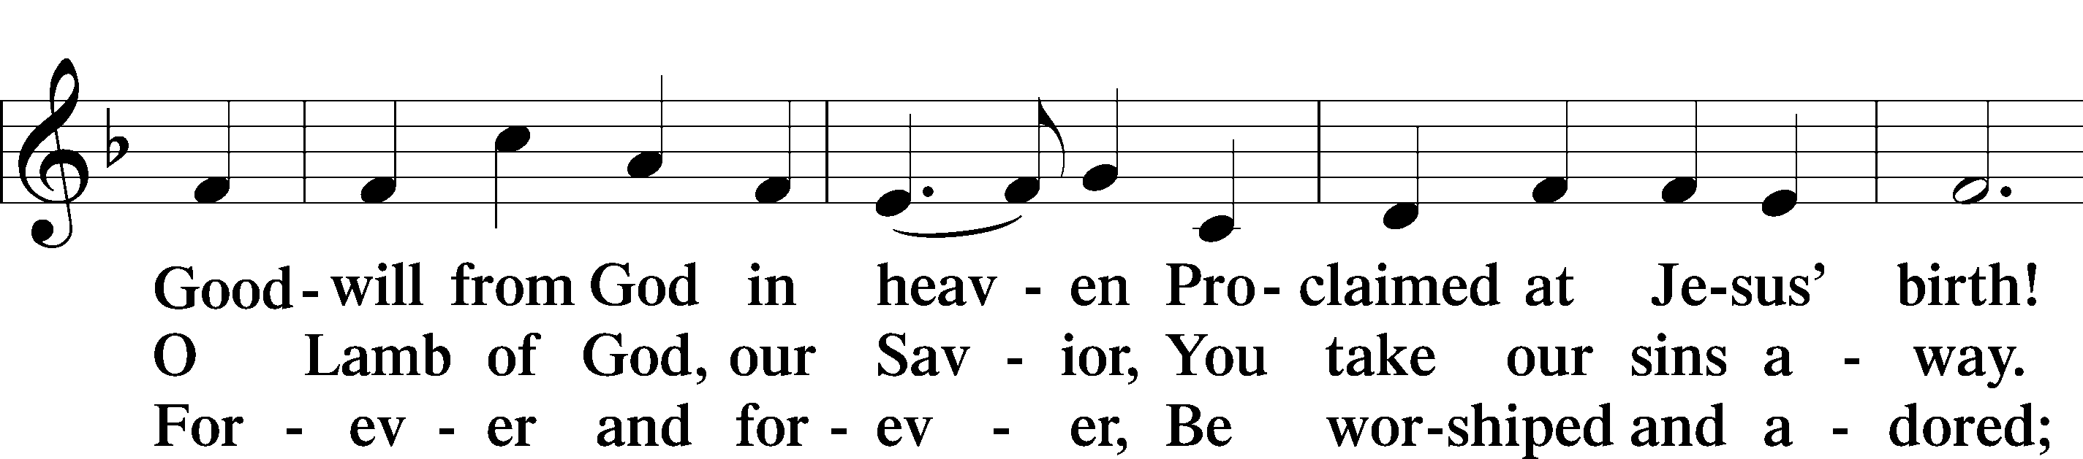
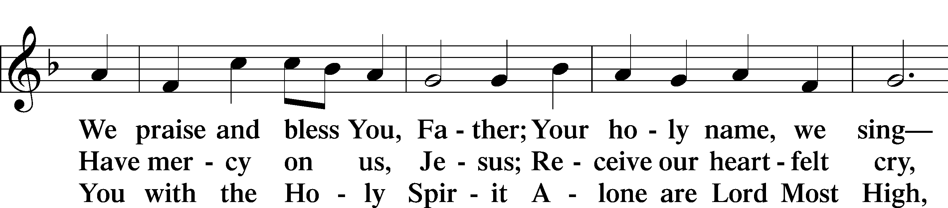
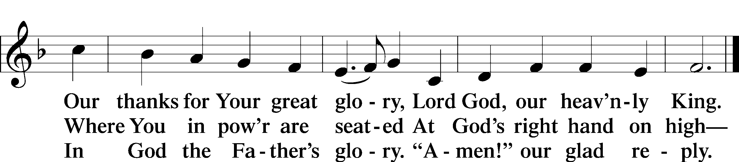

Salutation and Collect of the Day
P The Lord be with you.
C And also with you.

P Let us pray.
O God, the giver of all that is good, by Your holy inspiration grant that we may think those things that are right and by Your merciful guiding accomplish them; through Jesus Christ, Your Son, our Lord, who lives and reigns with You and the Holy Spirit, one God, now and forever.

C Amen.

Sit

Old Testament Acts 17:16–31
16While Paul was waiting for them at Athens, his spirit was provoked within him as he saw that the city was full of idols. 17So he reasoned in the synagogue with the Jews and the devout persons, and in the marketplace every day with those who happened to be there. 18Some of the Epicurean and Stoic philosophers also conversed with him. And some said, “What does this babbler wish to say?” Others said, “He seems to be a preacher of foreign divinities”—because he was preaching Jesus and the resurrection. 19And they took hold of him and brought him to the Areopagus, saying, “May we know what this new teaching is that you are presenting? 20For you bring some strange things to our ears. We wish to know therefore what these things mean.” 21Now all the Athenians and the foreigners who lived there would spend their time in nothing except telling or hearing something new.
22So Paul, standing in the midst of the Areopagus, said: “Men of Athens, I perceive that in every way you are very religious. 23For as I passed along and observed the objects of your worship, I found also an altar with this inscription, ‘To the unknown god.’ What therefore you worship as unknown, this I proclaim to you. 24The God who made the world and everything in it, being Lord of heaven and earth, does not live in temples made by man, 25nor is he served by human hands, as though he needed anything, since he himself gives to all mankind life and breath and everything. 26And he made from one man every nation of mankind to live on all the face of the earth, having determined allotted periods and the boundaries of their dwelling place, 27that they should seek God, in the hope that they might feel their way toward him and find him. Yet he is actually not far from each one of us, 28for
“‘In him we live and move and have our being’;
as even some of your own poets have said,
“‘For we are indeed his offspring.’
29Being then God’s offspring, we ought not to think that the divine being is like gold or silver or stone, an image formed by the art and imagination of man. 30The times of ignorance God overlooked, but now he commands all people everywhere to repent, 31because he has fixed a day on which he will judge the world in righteousness by a man whom he has appointed; and of this he has given assurance to all by raising him from the dead.”

P This is the Word of the Lord.
C Thanks be to God.

Epistle 1 Peter 3:13–22
13Now who is there to harm you if you are zealous for what is good? 14But even if you should suffer for righteousness’ sake, you will be blessed. Have no fear of them, nor be troubled, 15but in your hearts regard Christ the Lord as holy, always being prepared to make a defense to anyone who asks you for a reason for the hope that is in you; 16yet do it with gentleness and respect, having a good conscience, so that, when you are slandered, those who revile your good behavior in Christ may be put to shame. 17For it is better to suffer for doing good, if that should be God’s will, than for doing evil.
18For Christ also suffered once for sins, the righteous for the unrighteous, that he might bring us to God, being put to death in the flesh but made alive in the spirit, 19in which he went and proclaimed to the spirits in prison, 20because they formerly did not obey, when God’s patience waited in the days of Noah, while the ark was being prepared, in which a few, that is, eight persons, were brought safely through water. 21Baptism, which corresponds to this, now saves you, not as a removal of dirt from the body but as an appeal to God for a good conscience, through the resurrection of Jesus Christ, 22who has gone into heaven and is at the right hand of God, with angels, authorities, and powers having been subjected to him.

P This is the Word of the Lord.
C Thanks be to God.

Stand

Alleluia and Verse

Alleluia LSB 205
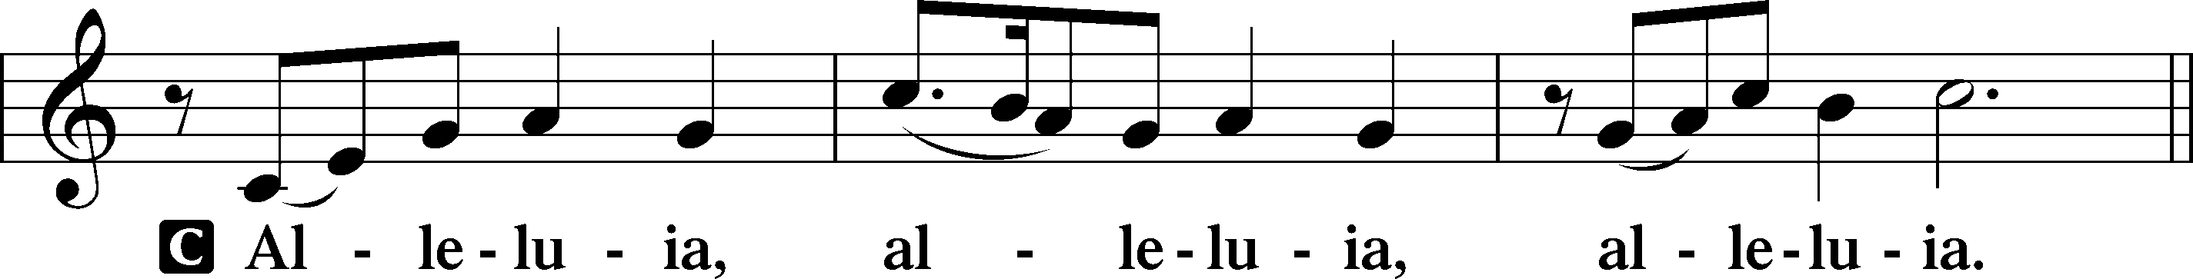

Verse LSB 205
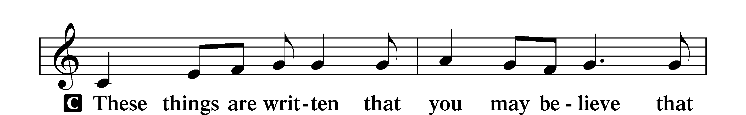
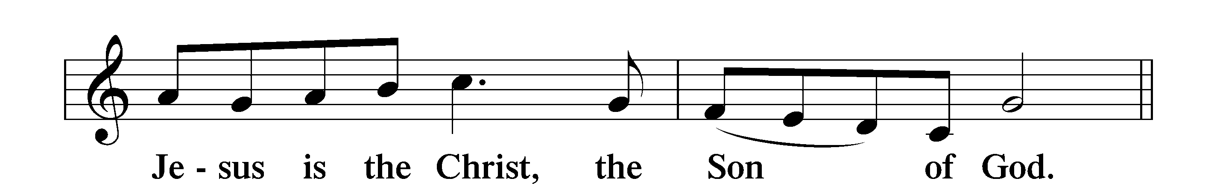

Alleluia LSB 205
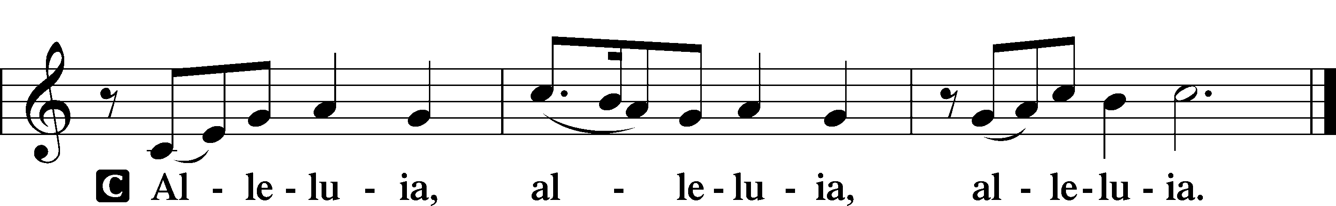

Holy Gospel John 14:15–21
P The Holy Gospel according to St. John, the fourteenth chapter.
C Glory to You, O Lord.

15[Jesus said:] “If you love me, you will keep my commandments. 16And I will ask the Father, and he will give you another Helper, to be with you forever, 17even the Spirit of truth, whom the world cannot receive, because it neither sees him nor knows him. You know him, for he dwells with you and will be in you.
18“I will not leave you as orphans; I will come to you. 19Yet a little while and the world will see me no more, but you will see me. Because I live, you also will live. 20In that day you will know that I am in my Father, and you in me, and I in you. 21Whoever has my commandments and keeps them, he it is who loves me. And he who loves me will be loved by my Father, and I will love him and manifest myself to him.”

P This is the Gospel of the Lord.
C Praise to You, O Christ.

Nicene Creed
C I believe in one God,
the Father Almighty,
maker of heaven and earth
and of all things visible and invisible.

And in one Lord Jesus Christ,
the only-begotten Son of God,
begotten of His Father before all worlds,
God of God, Light of Light,
very God of very God,
begotten, not made,
being of one substance with the Father,
by whom all things were made;
who for us men and for our salvation came down from heaven
and was incarnate by the Holy Spirit of the virgin Mary
and was made man;
and was crucified also for us under Pontius Pilate.
He suffered and was buried.
And the third day He rose again according to the Scriptures
and ascended into heaven
and sits at the right hand of the Father.
And He will come again with glory to judge both the living and the dead,
whose kingdom will have no end.

And I believe in the Holy Spirit,
the Lord and giver of life,
who proceeds from the Father and the Son,
who with the Father and the Son together is worshiped and glorified,
who spoke by the prophets.
And I believe in one holy Christian and apostolic Church,
I acknowledge one Baptism for the remission of sins,
and I look for the resurrection of the dead
and the life T of the world to come. Amen.

Sit

Children's Talk

Sermon Hymn
833 Listen, God Is Calling
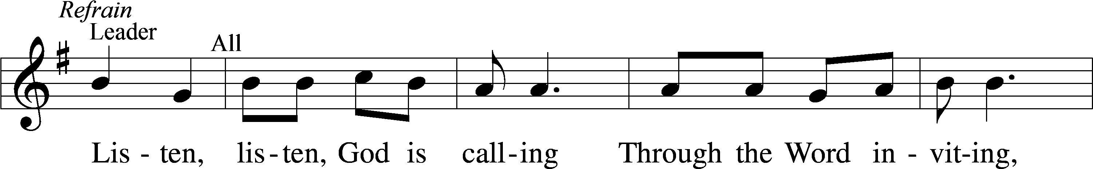
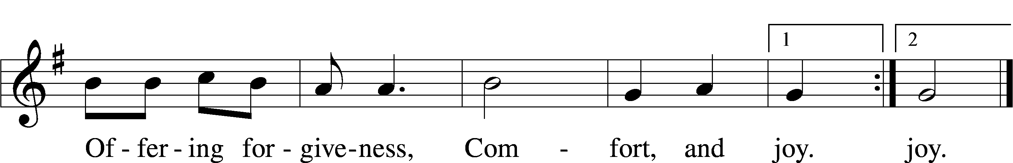
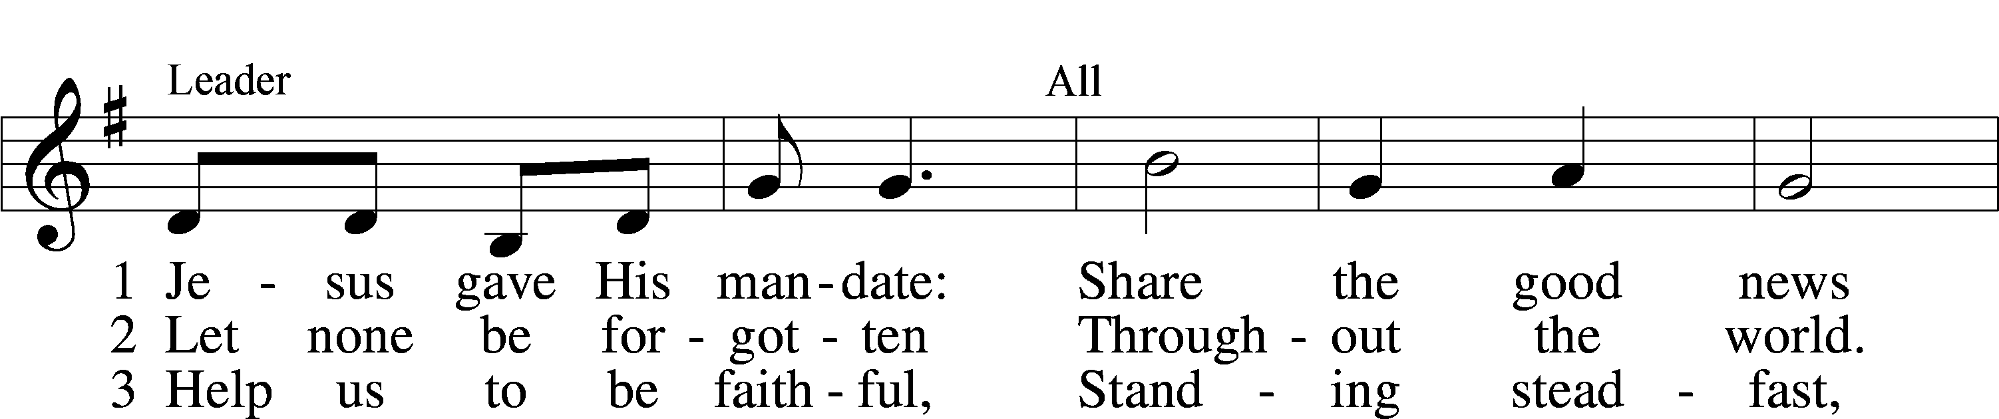
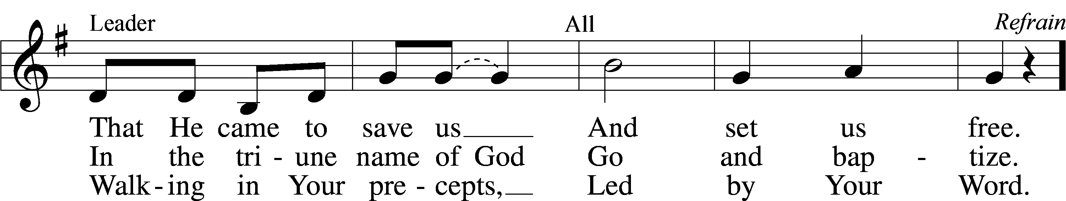

Sermon

Stand

Prayer of the Church
Prayer Response
After each segment:
P Lord, in Your mercy,
C hear our prayer.

After prayers:
P In the name of Jesus we pray.
C Amen.

Service of the Sacrament

Preface 208
P The Lord be with you.
C And also with you.

P Lift up your hearts.
C We lift them to the Lord.

P Let us give thanks to the Lord our God.
C It is right to give Him thanks and praise.

P It is truly good, right, and salutary that we should at all times and in all places give thanks to You, O Lord, holy Father, almighty and everlasting God, for the countless blessings You so freely bestow on us and all creation. Above all, we give thanks for Your boundless love shown to us when You sent Your only-begotten Son, Jesus Christ, into our flesh and laid on Him our sin, giving Him into death that we might not die eternally. Because He is now risen from the dead and lives and reigns to all eternity, all who believe in Him will overcome sin and death and will rise again to new life. Therefore with angels and archangels and with all the company of heaven we laud and magnify Your glorious name, evermore praising You and singing:

Sanctus LSB 208
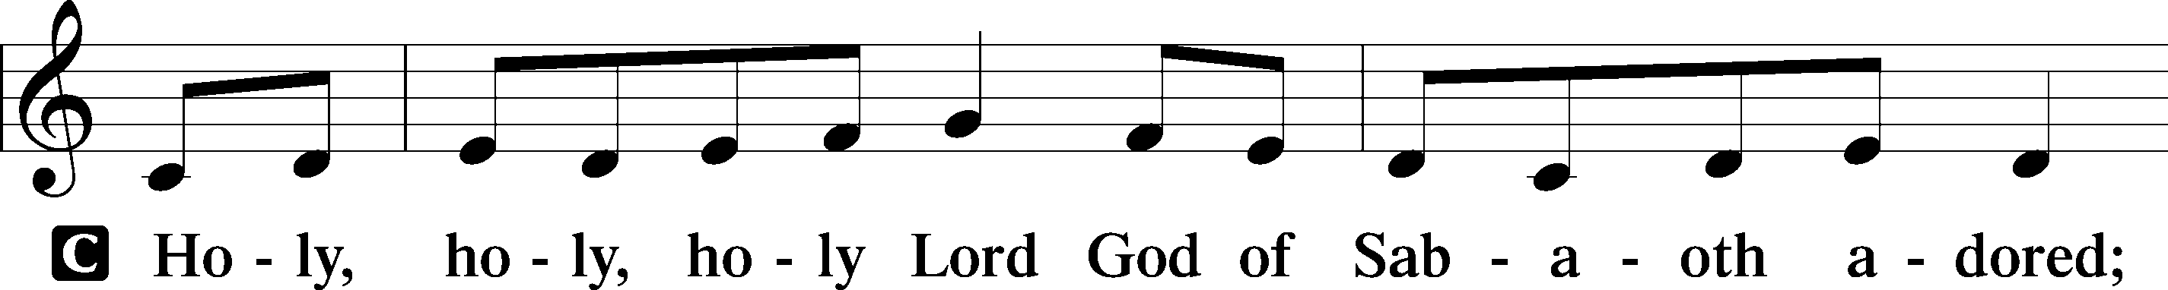
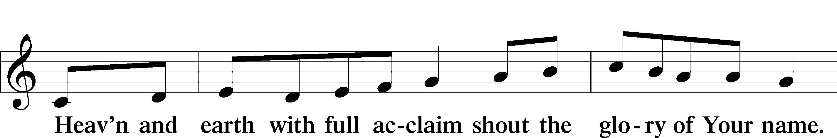
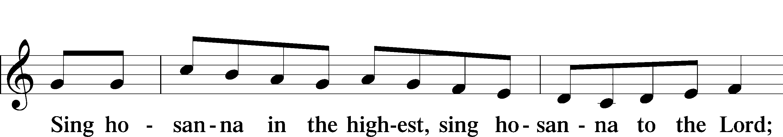
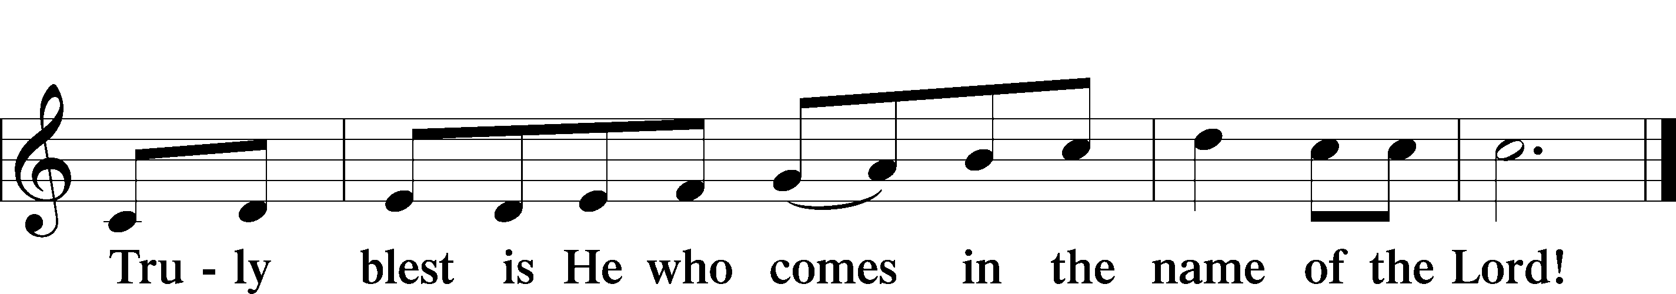

Prayer of Thanksgiving
P Blessed are You, O Lord our God, king of all creation, for You have had mercy on us and given Your only-begotten Son that whoever believes in Him should not perish but have eternal life.

For Christ, our Passover Lamb, has been sacrificed. By His death, He has redeemed us from bondage to sin and death, and by His resurrection, He has delivered us into new life in Him.

Grant us to keep the Feast in sincerity and truth, faithfully eating His body given into death and drinking His life’s blood poured out for our salvation until we pass through death to the promised land of life eternal.

Hear us as we pray in His name and as He has taught us:

Lord’s Prayer
Our Father, Who art in heaven,
hallowed be Thy name,
Thy kingdom come,
Thy will be done, on earth as it is in heaven.
Give us this day our daily bread;
and forgive us our trespasses, as we forgive those who trespass against us;
and lead us not into temptation,
but deliver us from evil.
For Thine is the kingdom, and the power, and the glory, forever and ever. Amen.

The Words of Our Lord
P Our Lord Jesus Christ, on the night when He was betrayed, took bread, and when He had given thanks, He broke it and gave it to the disciples and said: “Take, eat; this is My T body, which is given for you. This do in remembrance of Me.”

In the same way also He took the cup after supper, and when He had given thanks, He gave it to them, saying: “Drink of it, all of you; this cup is the new testament in My T blood, which is shed for you for the forgiveness of sins. This do, as often as you drink it, in remembrance of Me.”

Pax Domini
P The peace of the Lord be with you always.
C Amen.

Agnus Dei LSB 210
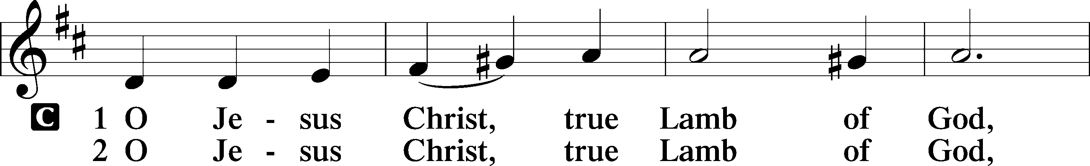
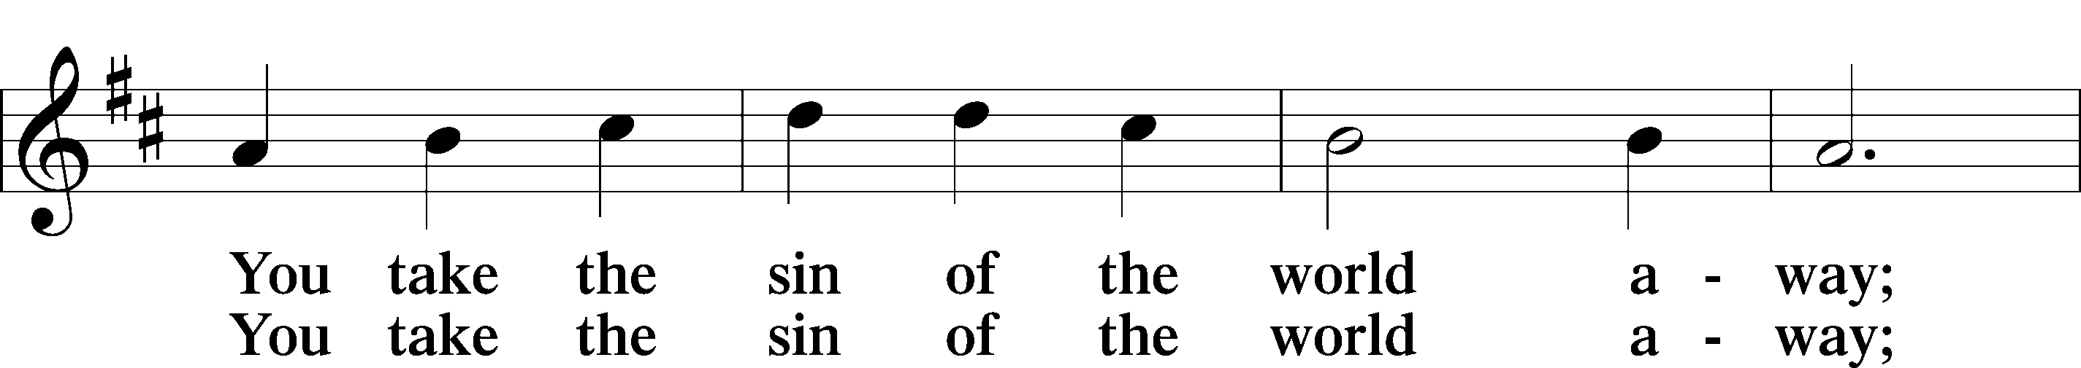
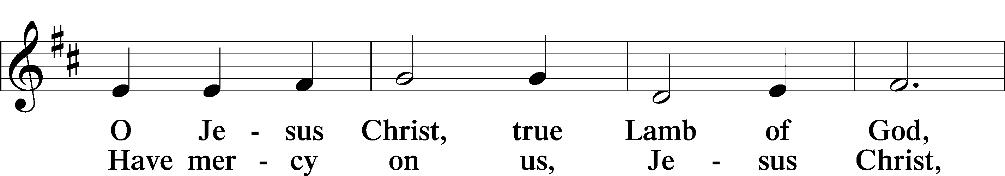
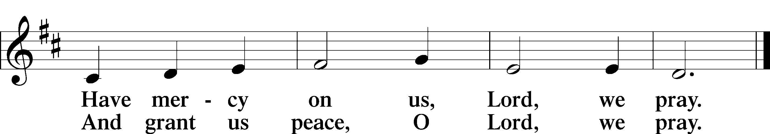

Sit

Distribution Hymns

744 Amazing Grace
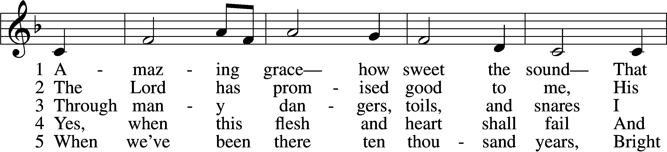
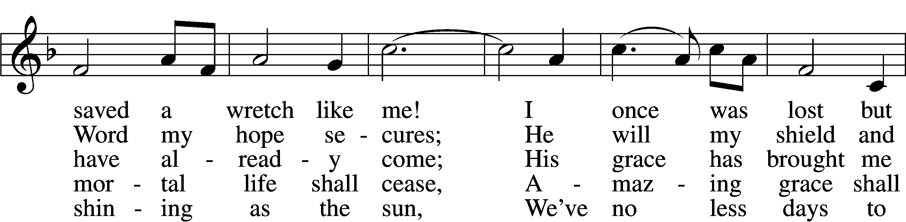
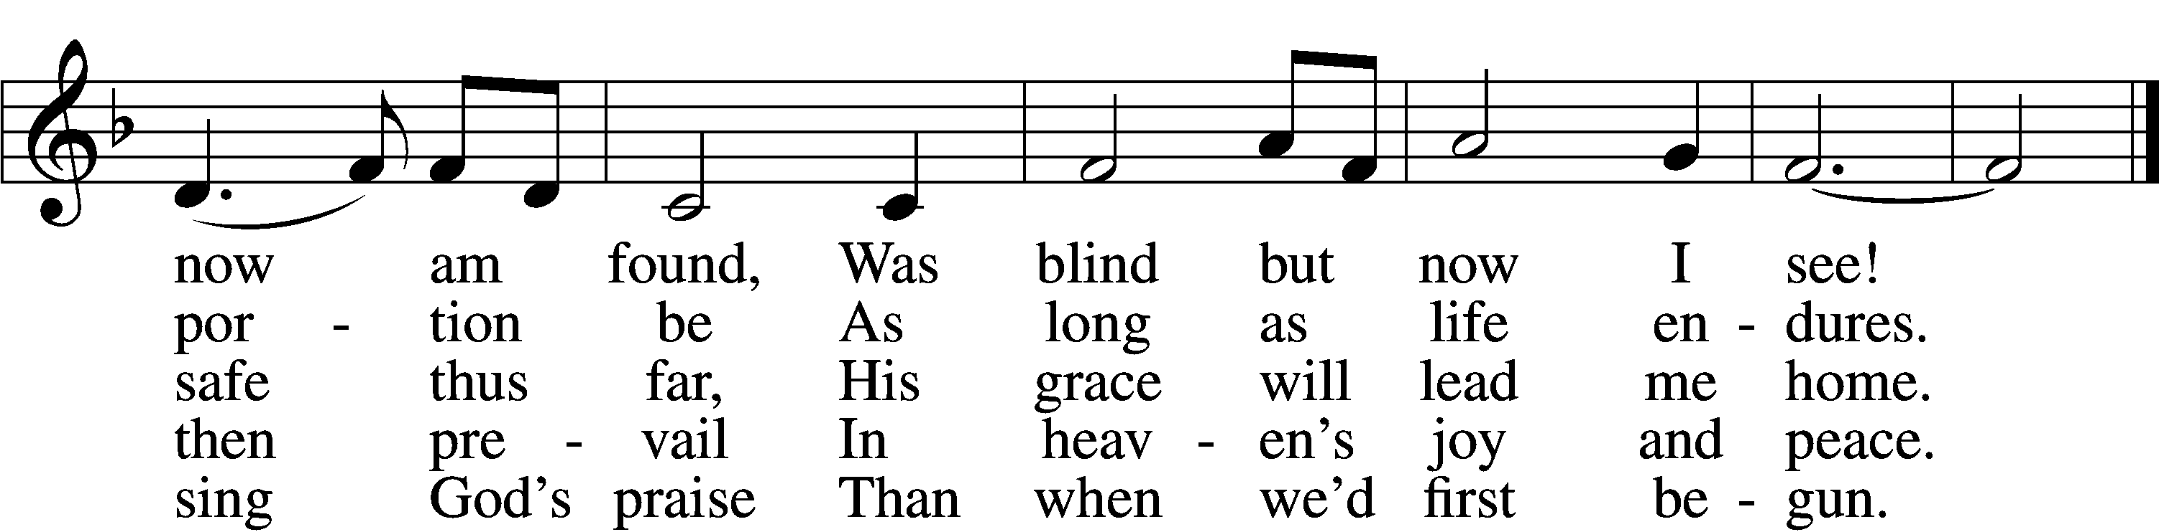

550 Lamb of God
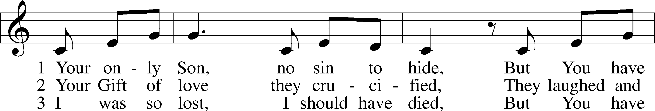
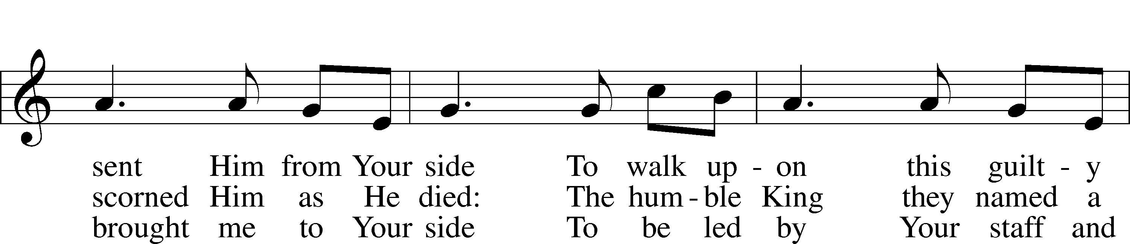
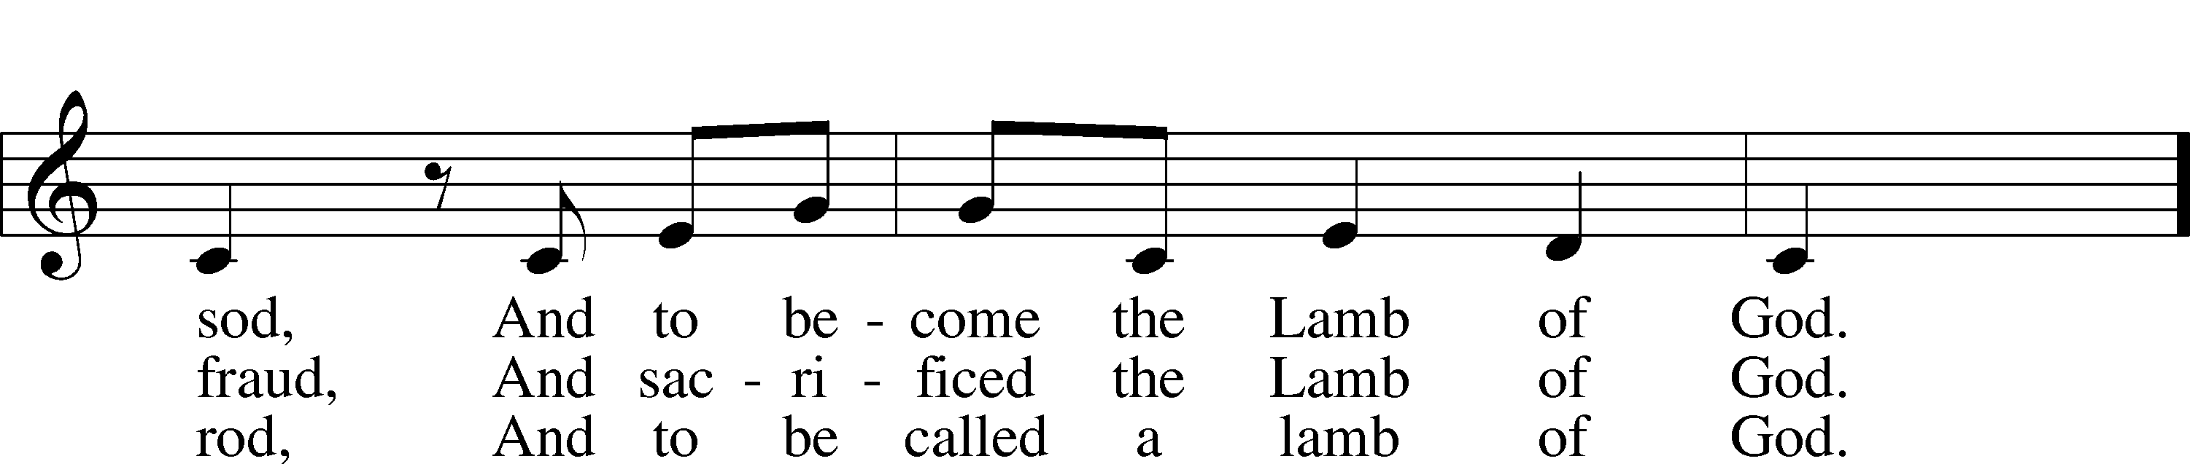
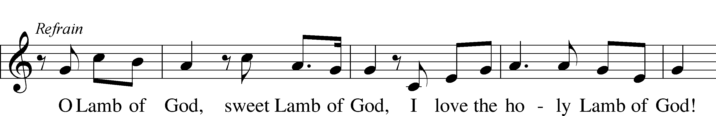
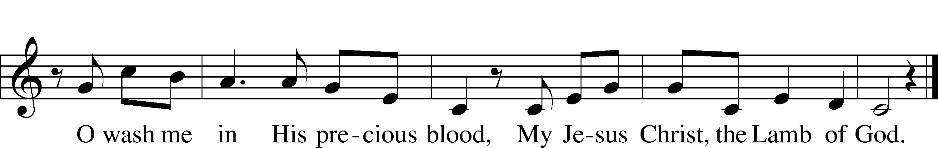

Stand

Nunc Dimittis LSB 211
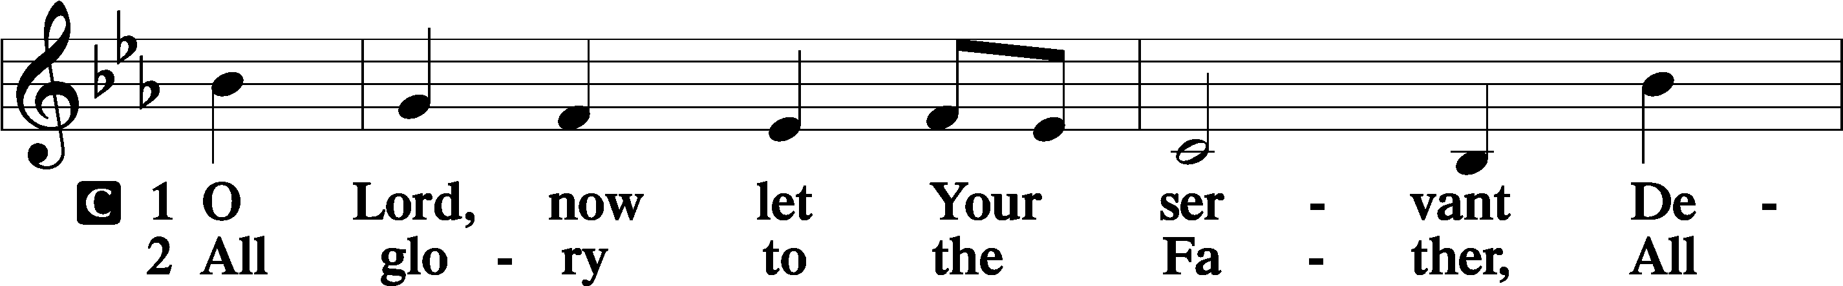
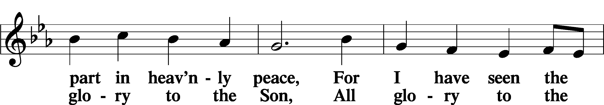
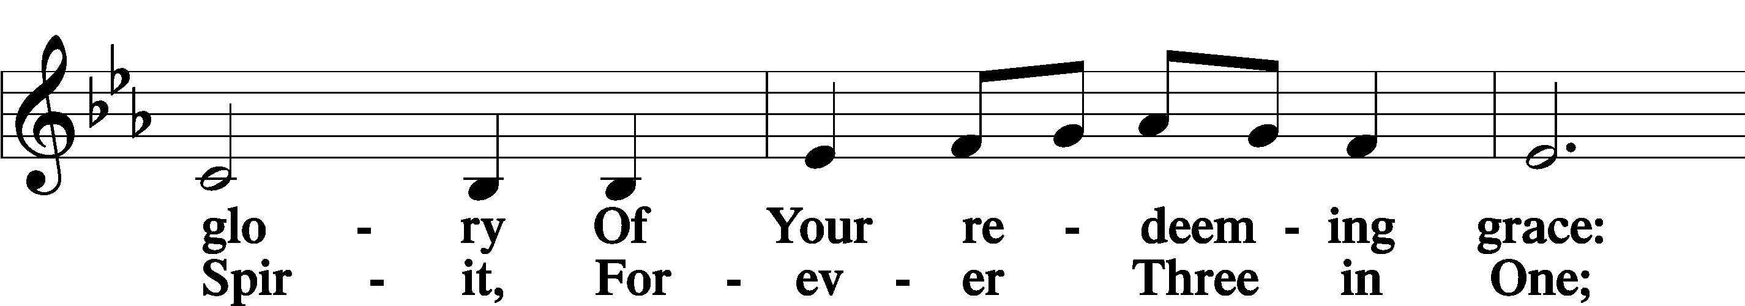
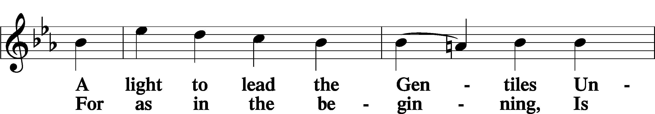
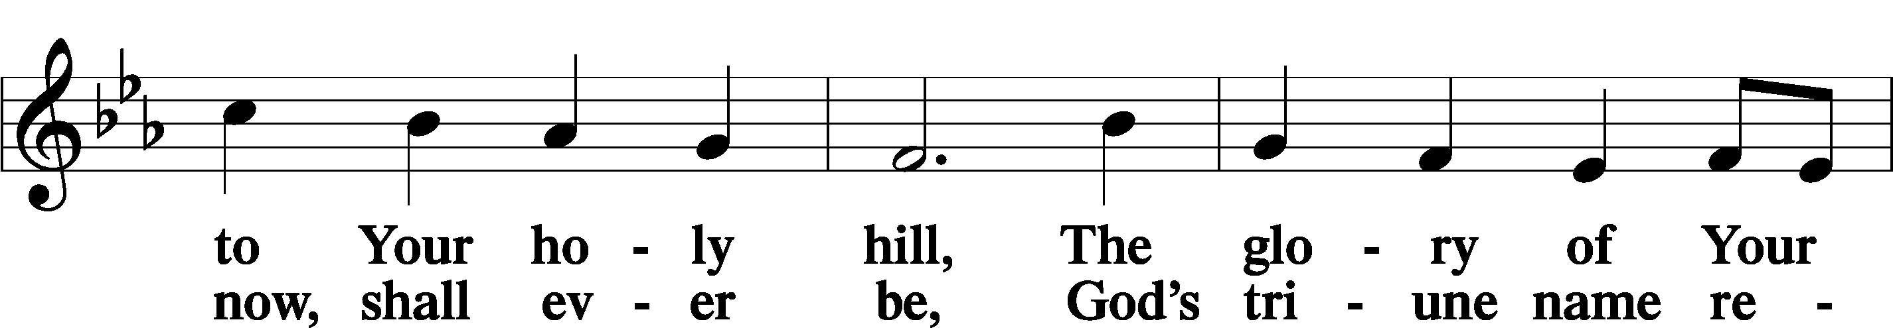
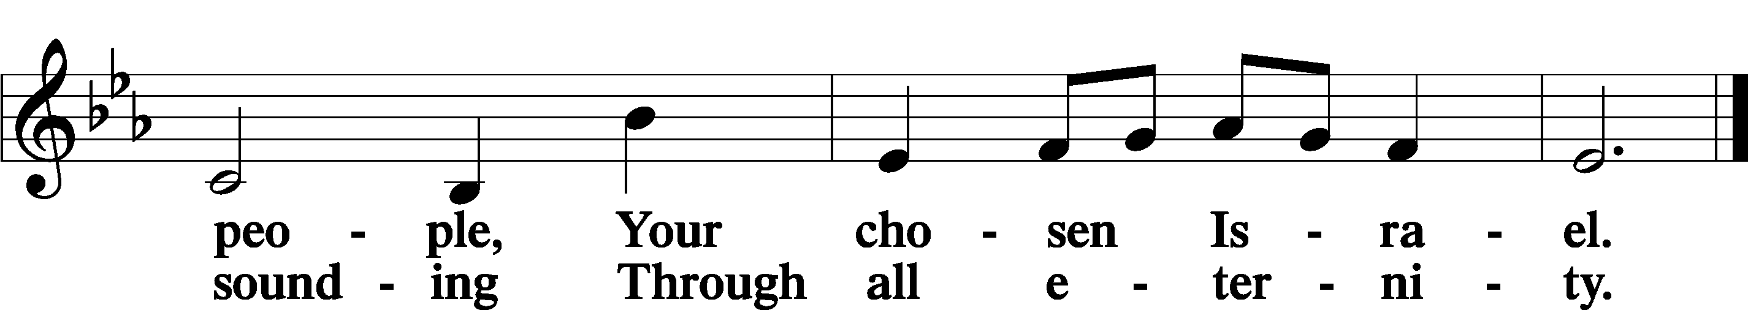

Post-Communion Collect
P Let us pray.

We give thanks to You, almighty God, that You have refreshed us through this salutary gift, and we implore You that of Your mercy You would strengthen us through the same in faith toward You and in fervent love toward one another; through Jesus Christ, Your Son, our Lord, who lives and reigns with You and the Holy Spirit, one God, now and forever.
C Amen.

Benedicamus 212
P Let us bless the Lord.
C Thanks be to God.

Benediction
P The Lord bless you and keep you.
The Lord make His face shine on you and be gracious to you.
The Lord look upon you with favor and T give you peace.
C Amen.

Sit

Closing Hymn

837 Lift High the Cross
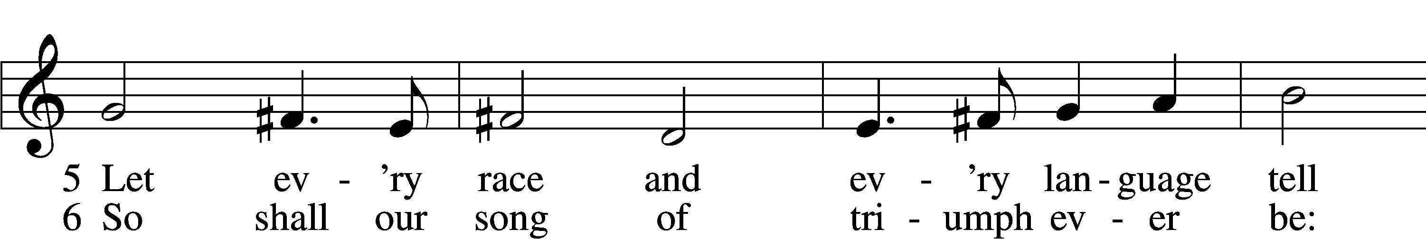
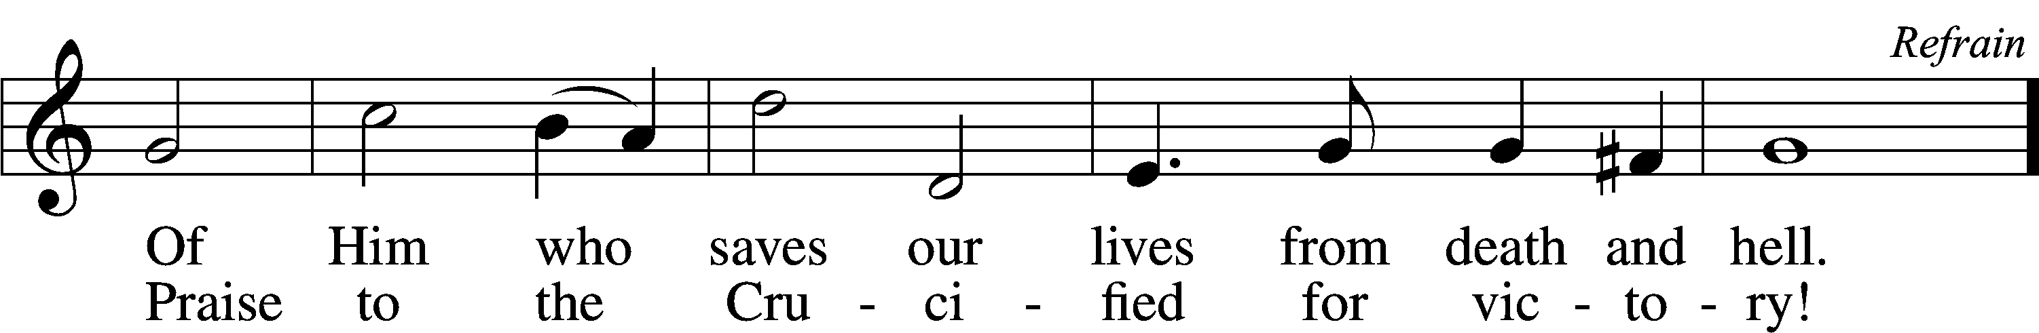

Closing Statement
P We go to live for Jesus.
C We go to share His love.

Acknowledgments
Unless otherwise indicated, Scripture quotations are from the ESV® Bible (The Holy Bible, English Standard Version®), copyright 2001 by Crossway, a publishing ministry of Good News Publishers. Used by permission. All rights reserved. Created by Lutheran Service Builder. Music reproduced in this service is used with permission through: CCLI License No.1776588 and CPH – LSB Service Builder.

