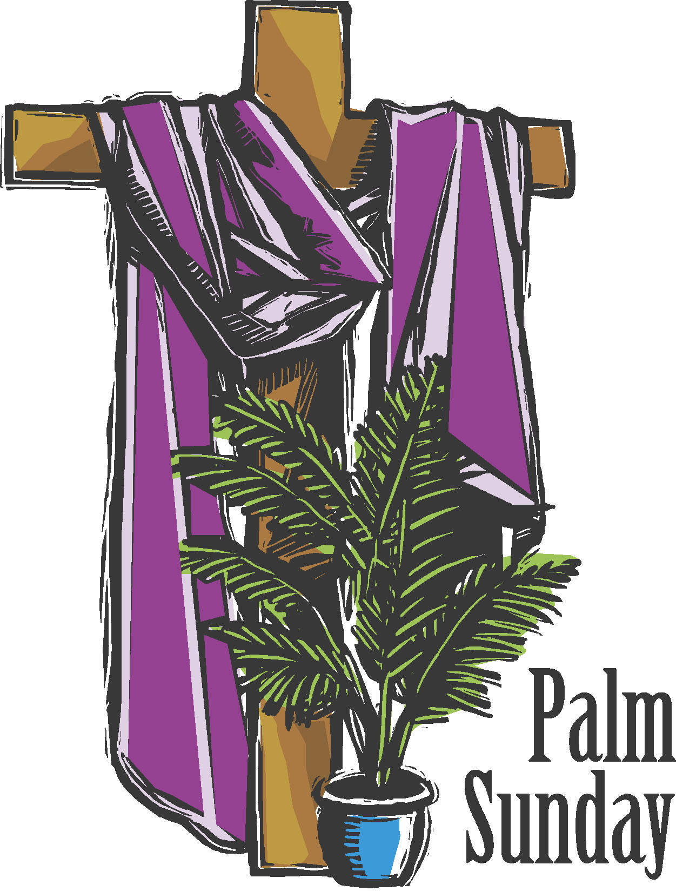

Welcome To
Trinity Lutheran Church
Lutheran Church—Missouri Synod
A Stephen Ministry Congregation

1354 South Otsego Avenue
Gaylord, Michigan 49735
Church Phone: (989) 732-4816

Church Email: secretary@trinitygaylord.com
www.trinitygaylord.com

Office Hours: Monday through Friday 9am – 1pm

OUR PURPOSE
…is to LOVE GOD, LOVE OTHERS, AND SERVE THE WORLD by worshiping the Lord Jesus, bringing our members into Christ-like maturity, and equipping them through Word and Sacrament for their mission and ministry. We go heart to heart into the world with Jesus, sharing His love, caring for one another, praying, and bringing the lost into a relationship with Christ, by the working of the Holy Spirit.

April 2, 2023
Palm Sunday
Preacher: Rev. Ken Bernthal

ABOUT OUR WORSHIP
We welcome all who gather here today! We are blessed to celebrate together the mercy, grace, and love we have from God through the death and resurrection of our Lord Jesus Christ.

Children: Families with children are very welcome here. Having children in church is important so they can begin to learn about their faith in Jesus, and it’s good for the whole congregation to see. Please feel comfortable keeping “squirmy” kids in the service. This is where they belong, too!

Pew Cards: Guests and Members, please fill out the Guest/Member card located on the back of the pew in front of you and pass it to the end of the aisle. If you forget you can put it in the offering plate on your way out.

If standing is difficult: Please feel free to remain seated during any portion of the service. Please let an Elder or Usher know if you need communion in your pew seat.

About our celebration of Holy Communion: We celebrate the Lord’s Supper in the confession and glad confidence that, as he says, our Lord gives into our mouths not only bread and wine but his very body and blood to eat and to drink for the forgiveness of sins and to strengthen our union with him and with one another. Our Lord invites to his table those who trust his words, repent of all sin, and set aside any refusal to forgive and love as he forgives and loves us, that they may show forth his death until he comes.

Because those who eat and drink our Lord’s body and blood contrary to that which is stated above do so to their great harm, and also because Holy Communion is a confession of the faith which is confessed at this altar. Anyone who is not yet instructed, in doubt, or who hold a confession differing from that of the Lutheran Church—Missouri Synod, and yet desire to receive the sacrament, are asked first to speak with Pastor. Those not communing are still invited to come forward for a blessing from Pastor, and you may indicate this by crossing your arms over your chest.
TTTTTT
GREETING

P Peace be with you.
C And also with you.

T ORDER OF SERVICE T
(The liturgy is from Divine Service Setting four LSB pg. 203ff)

Opening Hymn
443 Hosanna, Loud Hosanna
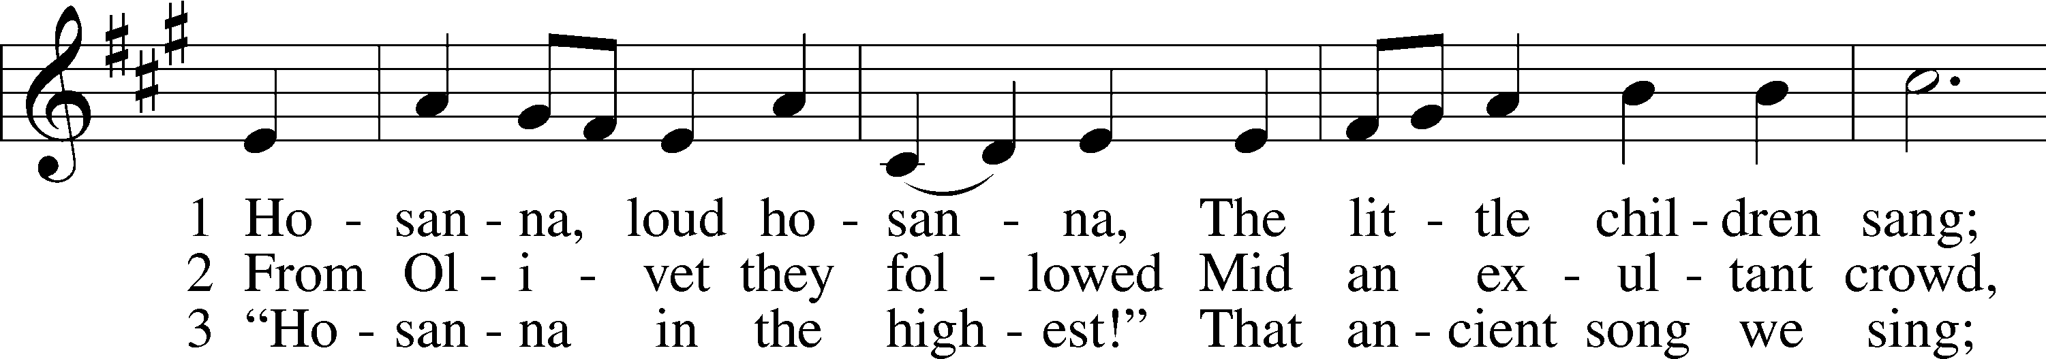
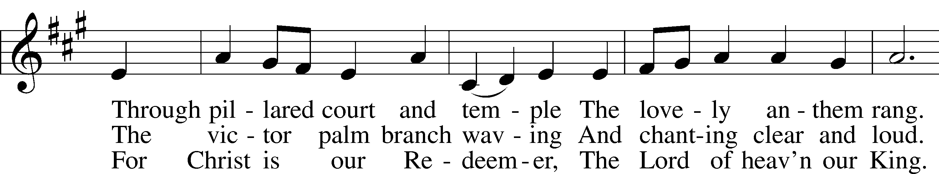
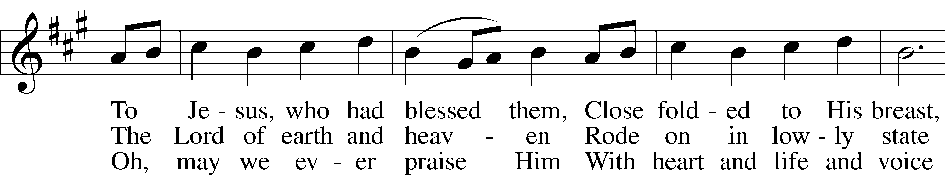
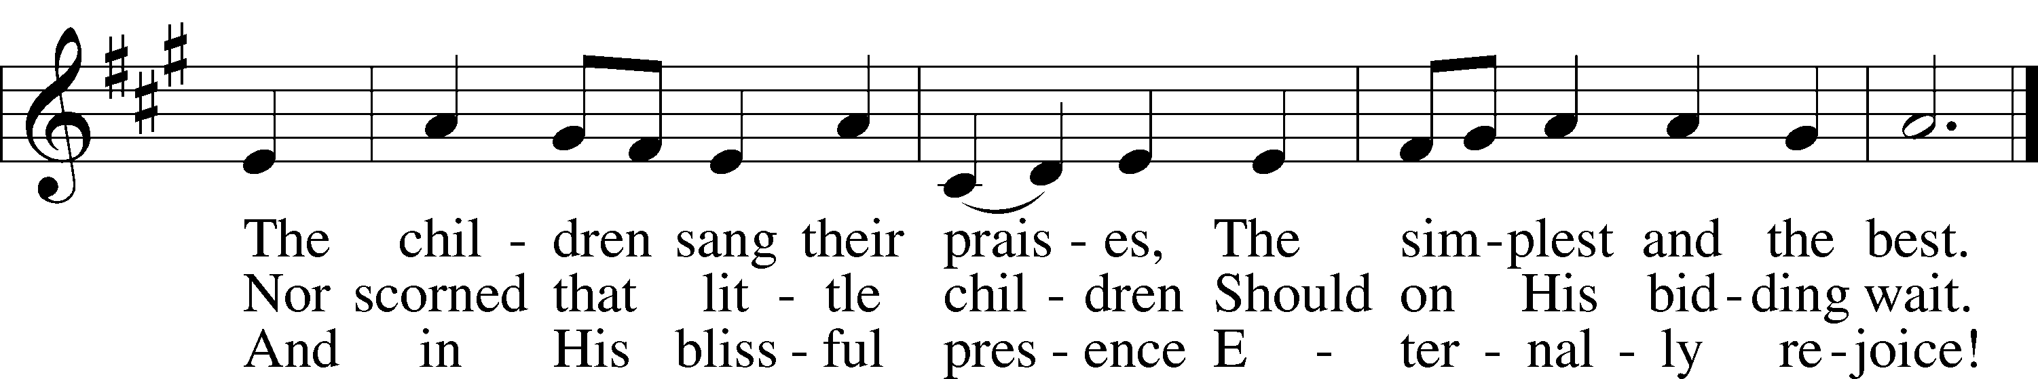

Confession and Absolution
Stand

The sign of the cross may be made by all in remembrance of their Baptism.

Invocation
P In the name of the Father and of the T Son and of the Holy Spirit.
C Amen.

Exhortation LSB 203
P Our help is in the name of the Lord,
C who made heaven and earth.

P If You, O Lord, kept a record of sins, O Lord, who could stand?
C But with You there is forgiveness; therefore You are feared.

P Since we are gathered to hear God’s Word, call upon Him in prayer and praise, and receive the body and blood of our Lord Jesus Christ in the fellowship of this altar, let us first consider our unworthiness and confess before God and one another that we have sinned in thought, word, and deed, and that we cannot free ourselves from our sinful condition. Together as His people let us take refuge in the infinite mercy of God, our heavenly Father, seeking His grace for the sake of Christ, and saying: God, be merciful to me, a sinner.

Confession of Sins LSB 203
C Almighty God, have mercy upon us, forgive us our sins, and lead us to everlasting life. Amen.

Prayer for Forgiveness
P Almighty God, merciful Father, in Holy Baptism You declared us to be Your children and gathered us into Your one, holy Church, in which You daily and richly forgive us our sins and grant us new life through Your Spirit. Be in our midst, enliven our faith, and graciously receive our prayer and praise; through Your Son, Jesus Christ, our Lord.
C Amen.

Service of the Word

Introit
P Blessèd is he who comes in the name of the Lord!
C We bless you from the house of the Lord.
P Lift up your heads, O gates! And be lifted up, O ancient doors,
C that the King of glory may come in.
P Who is this King of glory?
C The Lord, strong and mighty, the Lord, mighty in battle!
P Lift up your heads, O gates! And lift them up, O ancient doors,
C that the King of glory may come in.
P Who is this King of glory?
C The Lord of hosts, he is the King of glory!
P Blessèd is he who comes in the name of the Lord!
C We bless you from the house of the Lord.

Kyrie LSB 204
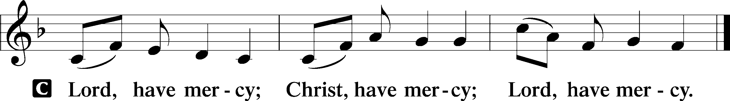

Salutation and Collect of the Day
P The Lord be with you.
C And also with you.
P Let us pray.
Almighty and everlasting God, You sent Your Son, our Savior Jesus Christ, to take upon Himself our flesh and to suffer death upon the cross. Mercifully grant that we may follow the example of His great humility and patience and be made partakers of His resurrection; through the same Jesus Christ, our Lord, who lives and reigns with You and the Holy Spirit, one God, now and forever.
C Amen.
Old Testament Reading Isaiah 50:4–9a
4The Lord God has given me
the tongue of those who are taught,
that I may know how to sustain with a word
him who is weary.
Morning by morning he awakens;
he awakens my ear
to hear as those who are taught.
5The Lord God has opened my ear,
and I was not rebellious;
I turned not backward.
6I gave my back to those who strike,
and my cheeks to those who pull out the beard;
I hid not my face
from disgrace and spitting.
7But the Lord God helps me;
therefore I have not been disgraced;
therefore I have set my face like a flint,
and I know that I shall not be put to shame.
8He who vindicates me is near.
Who will contend with me?
Let us stand up together.
Who is my adversary?
Let him come near to me.
9Behold, the Lord God helps me;
who will declare me guilty?

A This is the Word of the Lord.
C Thanks be to God.

Epistle Philippians 2:5–11
5Have this mind among yourselves, which is yours in Christ Jesus, 6who, though he was in the form of God, did not count equality with God a thing to be grasped, 7but made himself nothing, taking the form of a servant, being born in the likeness of men. 8And being found in human form, he humbled himself by becoming obedient to the point of death, even death on a cross. 9Therefore God has highly exalted him and bestowed on him the name that is above every name, 10so that at the name of Jesus

every knee should bow, in heaven and on earth and under the earth, 11and every tongue confess that Jesus Christ is Lord, to the glory of God the Father.

A This is the Word of the Lord.
C Thanks be to God.

Stand
Verse LSB 205
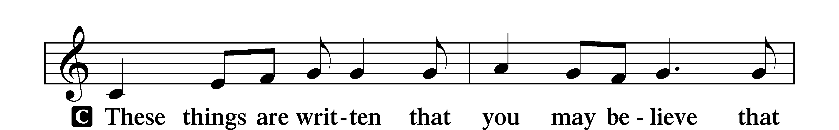
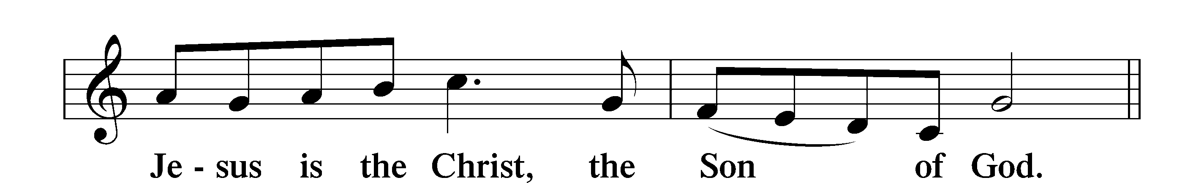

Holy Gospel John 12:12–19; 11:38–44
P The Holy Gospel according to St. John, the twelfth chapter.
C Glory to You, O Lord.

^{12:}12The next day the large crowd that had come to the feast heard that Jesus was coming to Jerusalem. 13So they took branches of palm trees and went out to meet him, crying out, “Hosanna! Blessed is he who comes in the name of the Lord, even the King of Israel!” 14And Jesus found a young donkey and sat on it, just as it is written,
15“Fear not, daughter of Zion;
behold, your king is coming,
sitting on a donkey’s colt!”
16His disciples did not understand these things at first, but when Jesus was glorified, then they remembered that these things had been written about him and had been done to him. 17The crowd that had been with him when he called Lazarus out of the tomb and raised him from the dead continued to bear witness. 18The reason why the crowd went to meet him was that they heard he had done this sign. 19So the Pharisees said to one another, “You see that you are gaining nothing. Look, the world has gone after him.”
^{11:}38Then Jesus, deeply moved again, came to the tomb. It was a cave, and a stone lay against it. 39Jesus said, “Take away the stone.” Martha, the sister of the dead man, said to him, “Lord, by this time there will be an odor, for he has been dead four days.” 40Jesus said to her, “Did I not tell you that if you believed you would see the glory of God?” 41So they took away the stone. And Jesus lifted up his eyes and said, “Father, I thank you that you have heard me. 42I knew that you always hear me, but I said this on account of the people standing around, that they may believe that you sent me.” 43When he had said these things, he cried out with a loud voice, “Lazarus, come out.” 44The man who had died came out, his hands and feet bound with linen strips, and his face wrapped with a cloth. Jesus said to them, “Unbind him, and let him go.”

P This is the Gospel of the Lord.
C Praise to You, O Christ.

Nicene Creed
C I believe in one God,
the Father Almighty,
maker of heaven and earth
and of all things visible and invisible.

And in one Lord Jesus Christ,
the only-begotten Son of God,
begotten of His Father before all worlds,
God of God, Light of Light,
very God of very God,
begotten, not made,
being of one substance with the Father,
by whom all things were made;
who for us men and for our salvation came down from heaven
and was incarnate by the Holy Spirit of the virgin Mary
and was made man;
and was crucified also for us under Pontius Pilate.
He suffered and was buried.
And the third day He rose again according to the Scriptures
and ascended into heaven
and sits at the right hand of the Father.
And He will come again with glory to judge both the living and the dead,
whose kingdom will have no end.
And I believe in the Holy Spirit,
the Lord and giver of life,
who proceeds from the Father and the Son,
who with the Father and the Son together is worshiped and glorified,
who spoke by the prophets.
And I believe in one holy Christian and apostolic Church,
I acknowledge one Baptism for the remission of sins,
and I look for the resurrection of the dead
and the life T of the world to come. Amen.

Sit

Children’s Message

Sermon Hymn
490 Jesus Lives! The Victory's Won
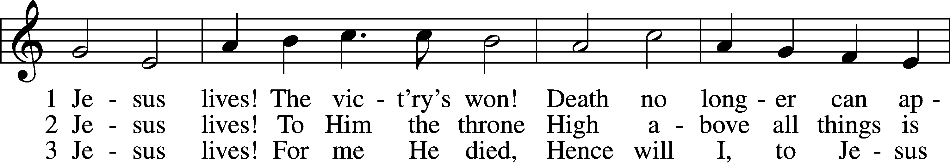
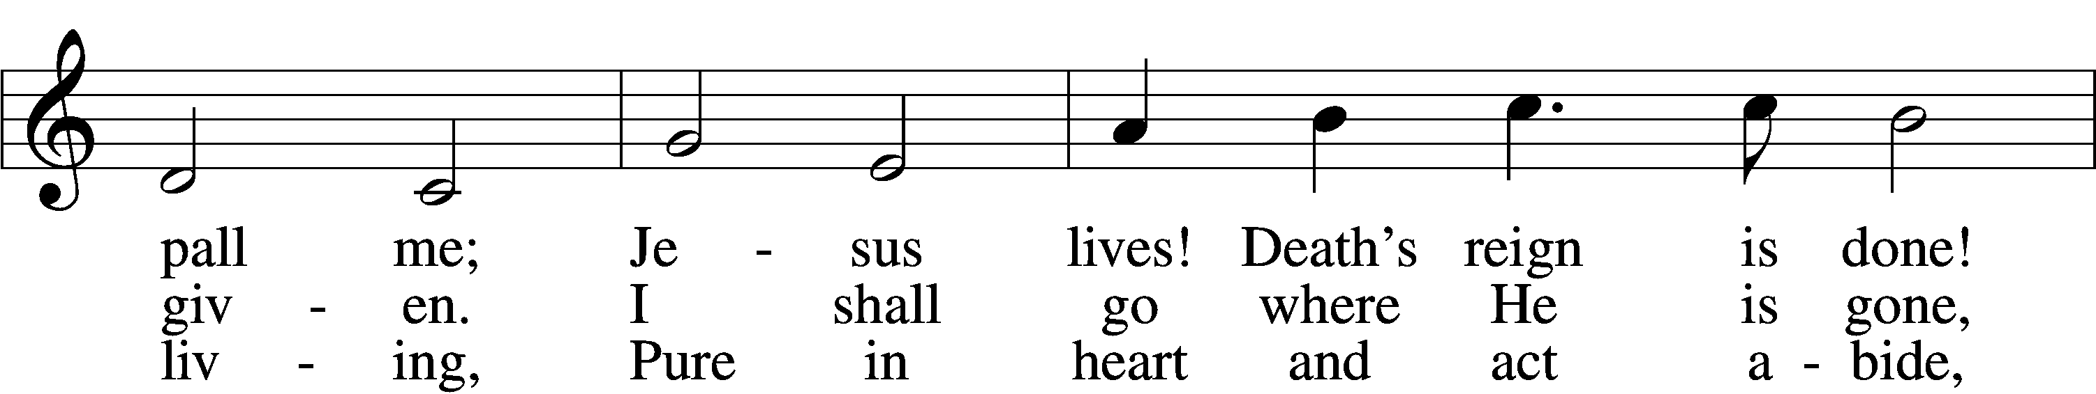
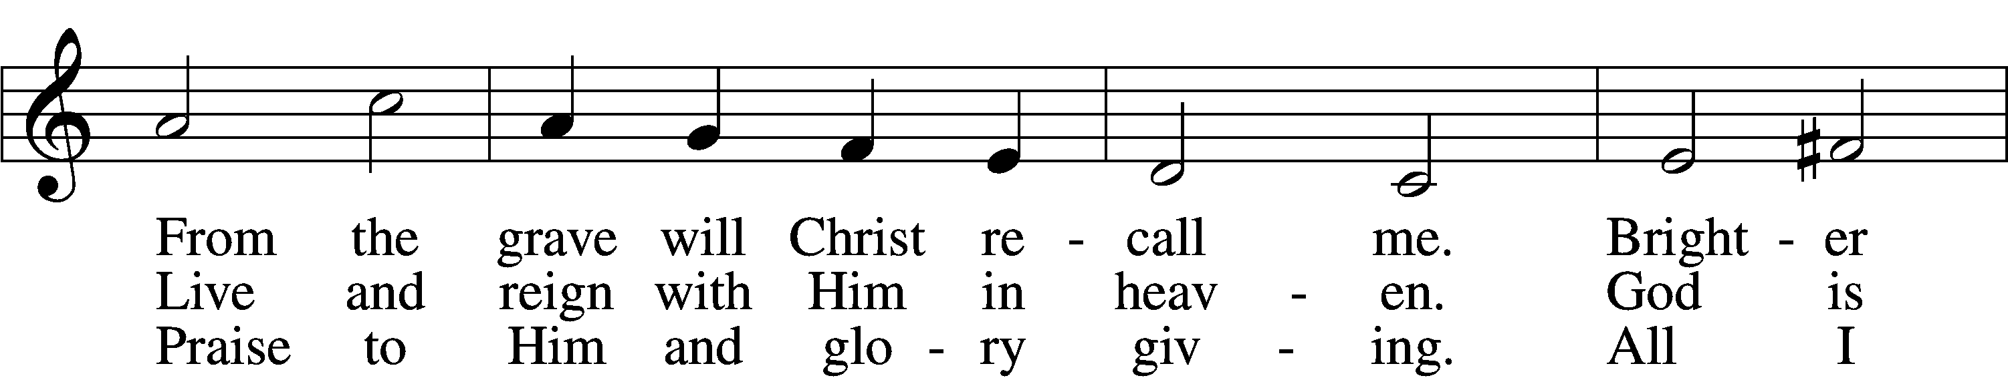
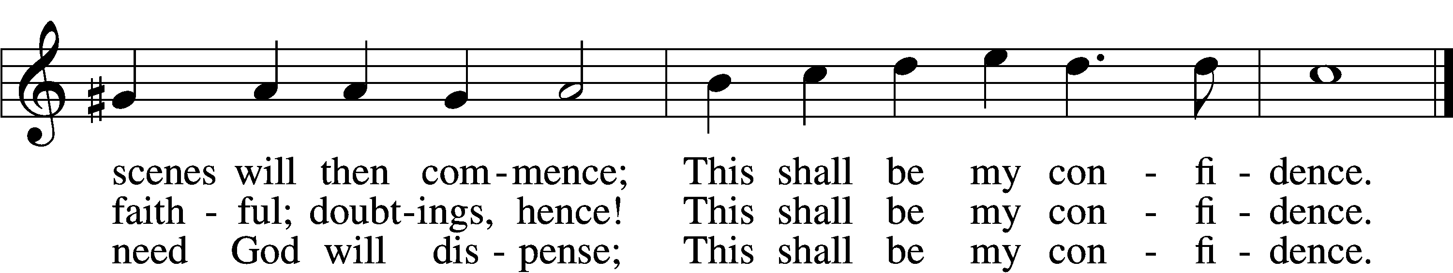

Sermon Lazarus, Were You There?

Stand

Prayer of the Church
After each Segment:
P Lord, in Your Mercy,
C Hear our Prayer.
P In Your Name we Pray
C Amen

Service of the Sacrament LSB 208

P The Lord be with you.
C And also with you.

P Lift up your hearts.
C We lift them to the Lord.

P Let us give thanks to the Lord our God.
C It is right to give Him thanks and praise.

P It is truly good, right, and salutary that we should at all times and in all places give thanks to You, O Lord, holy Father, almighty and everlasting God, for the countless blessings You so freely bestow on us and all creation. Above all, we give thanks for Your boundless love shown to us when You sent Your only-

begotten Son, Jesus Christ, into our flesh and laid on Him our sin, giving Him into death that we might not die eternally. Because He is now risen from the dead and lives and reigns to all eternity, all who believe in Him will overcome sin and death and will rise again to new life. Therefore with angels and archangels and with all the company of heaven we laud and magnify Your glorious name, evermore praising You and singing

Sanctus LSB 208
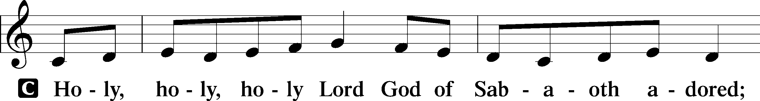
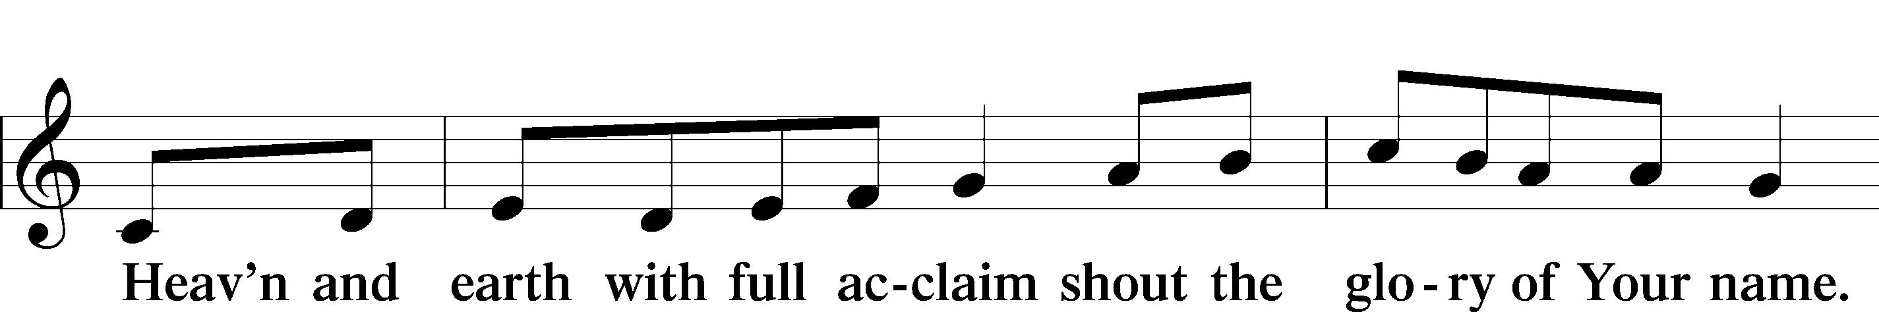
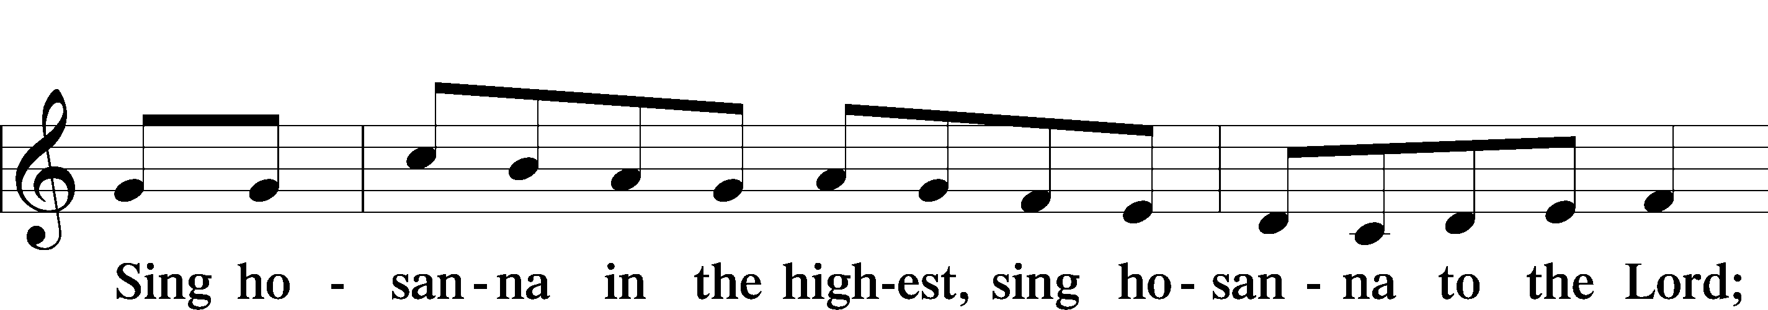
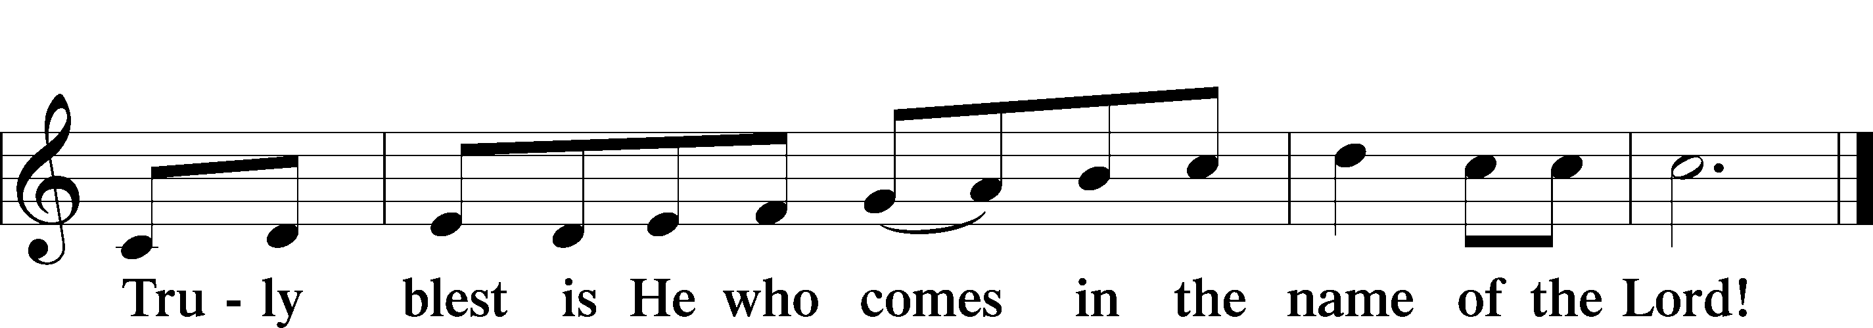

Prayer of Thanksgiving
P Blessed are You, O Lord our God, king of all creation, for You have had mercy on us and given Your only-begotten Son that whoever believes in Him should not perish but have eternal life.

At Your command, Abraham prepared to offer his son Isaac as a sacrifice on the mountain; yet, in mercy You provided a ram as a substitute. We give You thanks that on Calvary You spared not Your only Son but sent Him to offer His life as a ransom for many.

As we eat and drink His body and blood, grant us, like Abraham our father, to trust in Your promise now fulfilled in Christ, the Lamb of God, who takes away the sin of the world.

Hear us as we pray in Your name and as He has taught us:

Lord’s Prayer
C Our Father who art in heaven,
hallowed be Thy name,
Thy kingdom come,
Thy will be done on earth
as it is in heaven;
give us this day our daily bread;
and forgive us our trespasses
as we forgive those
who trespass against us;
and lead us not into temptation,
but deliver us from evil.
For Thine is the kingdom
and the power and the glory
forever and ever. Amen.

The Words of Our Lord
P Our Lord Jesus Christ, on the night when He was betrayed, took bread, and when He had given thanks, He broke it and gave it to the disciples and said: “Take, eat; this is My T body, which is given for you. This do in remembrance of Me.”

In the same way also He took the cup after supper, and when He had given thanks, He gave it to them, saying: “Drink of it, all of you; this cup is the new testament in My T blood, which is shed for you for the forgiveness of sins. This do, as often as you drink it, in remembrance of Me.”

Pax Domini
P The peace of the Lord be with you always.
C Amen.
Agnus Dei LSB 210
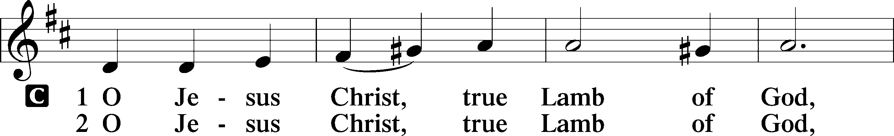
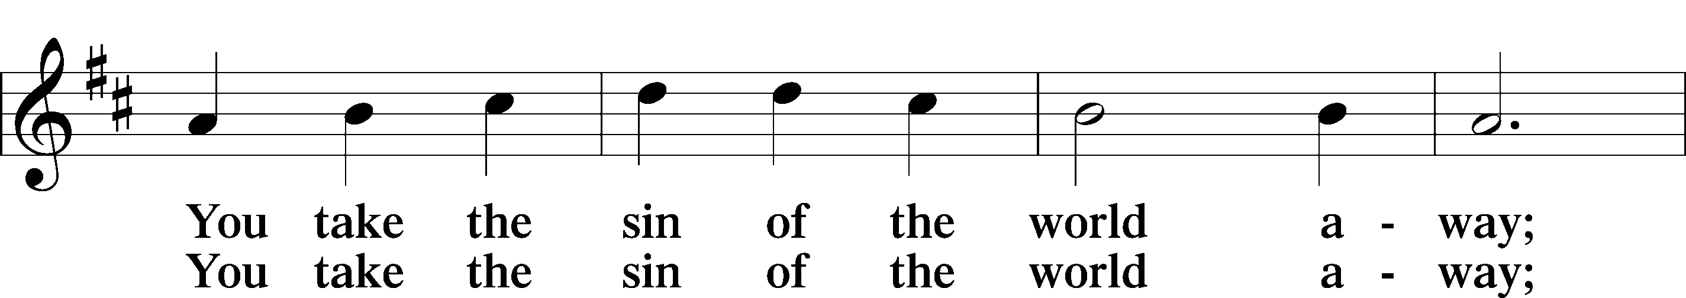
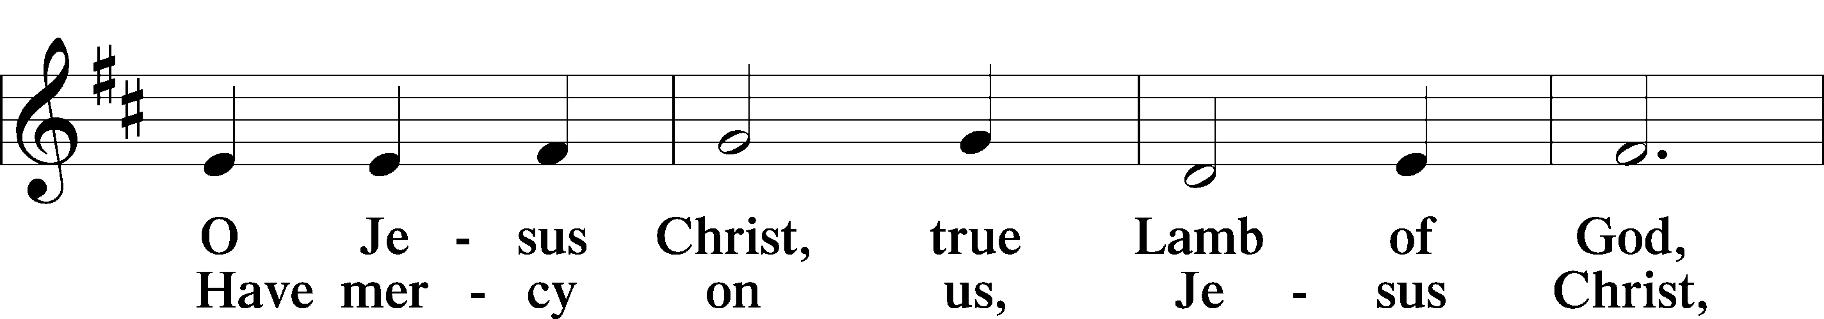
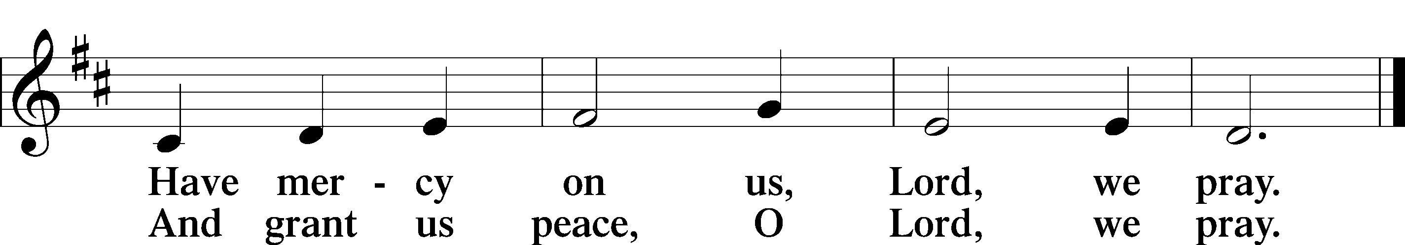

Sit
Distribution

543 What Wondrous Love Is This
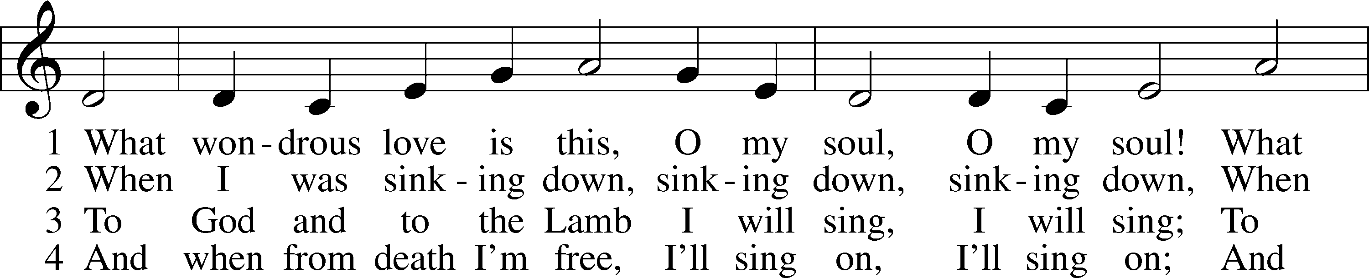

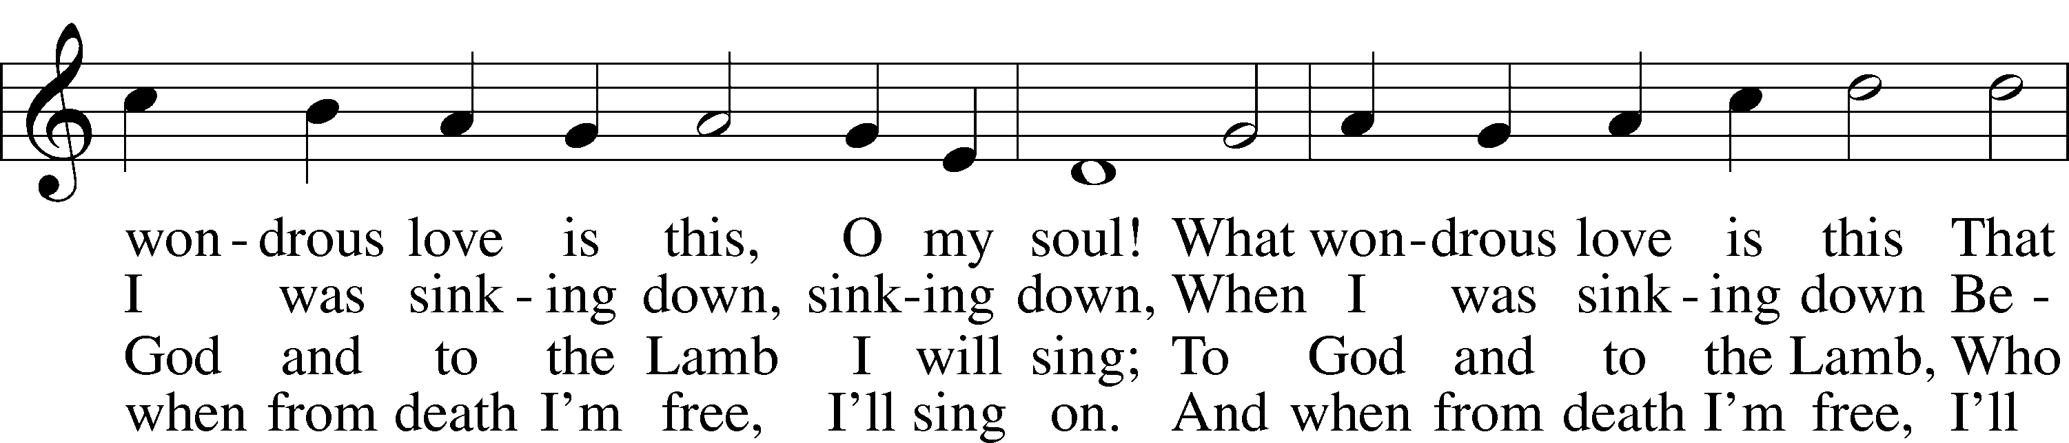
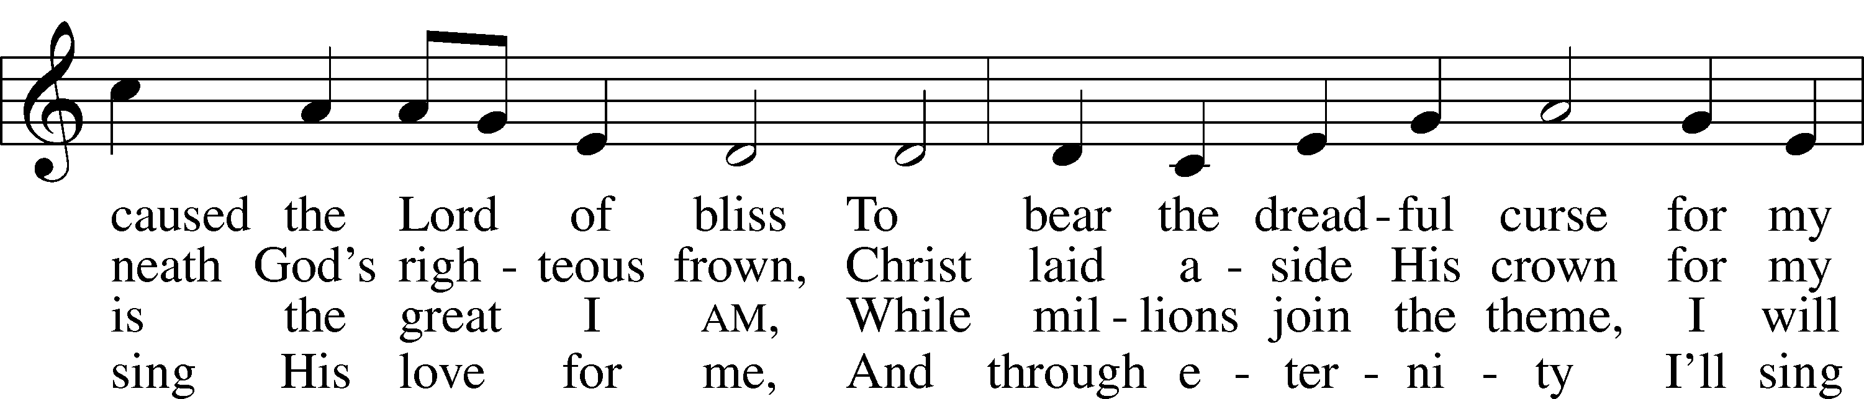
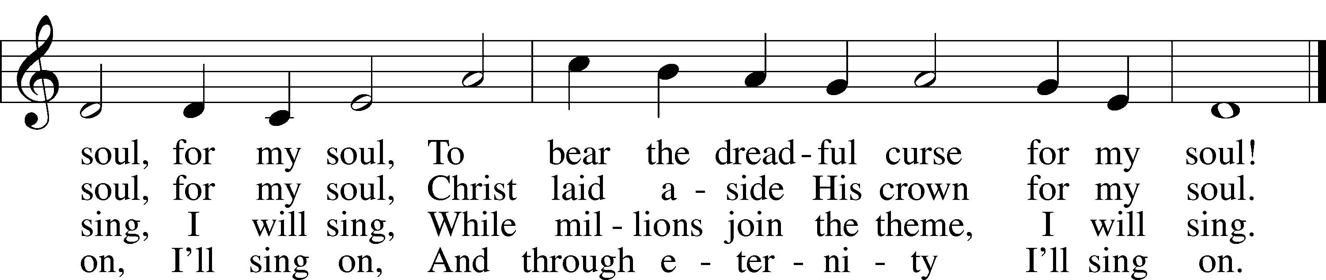

684 Come unto Me, Ye Weary
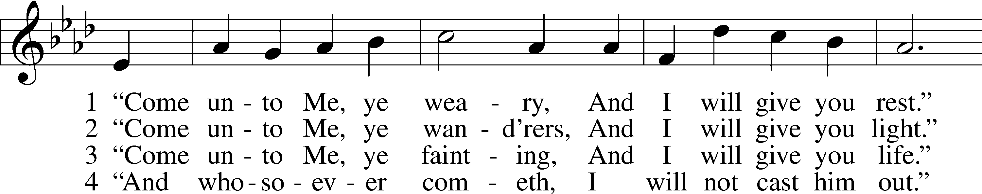
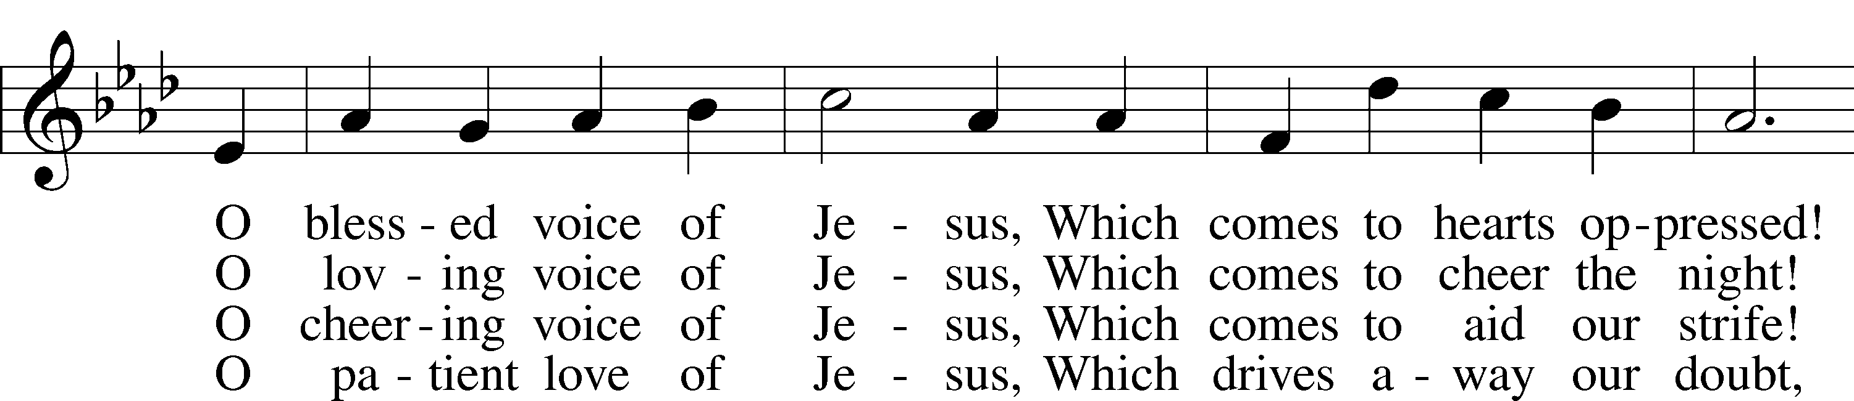
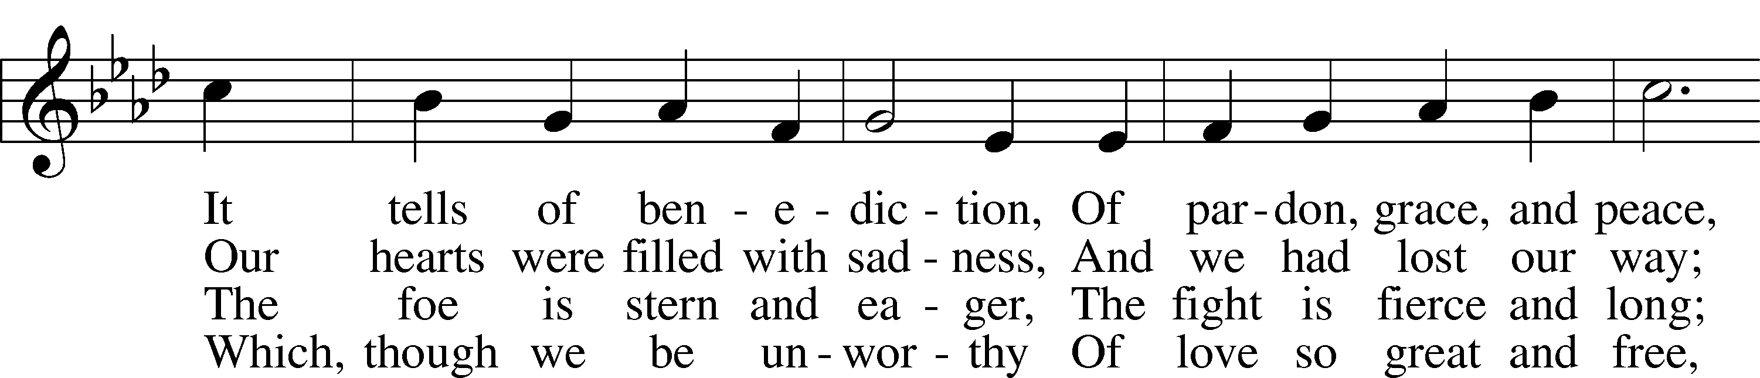
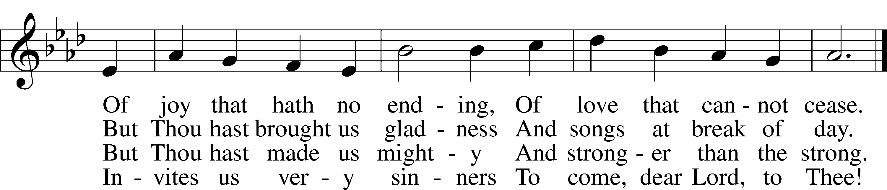

Stand

Nunc Dimittis LSB 211
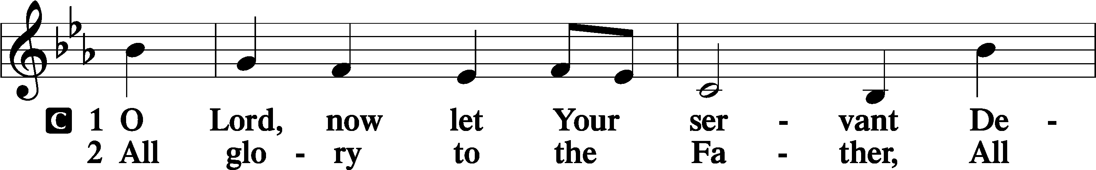
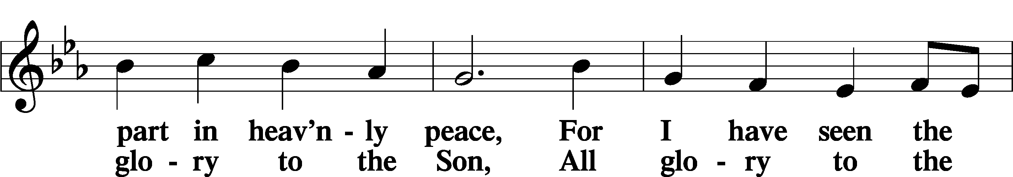
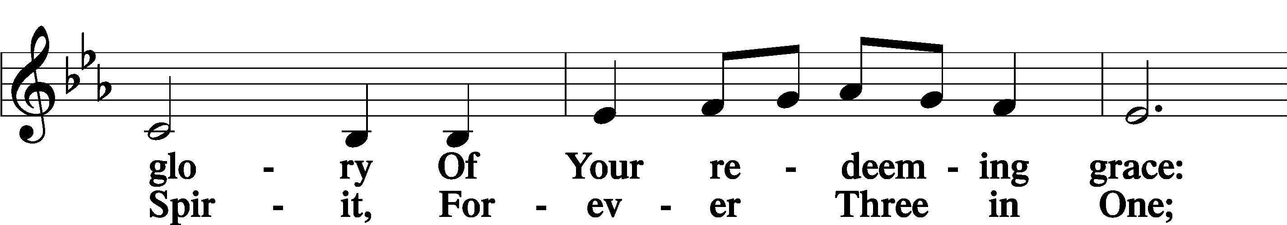
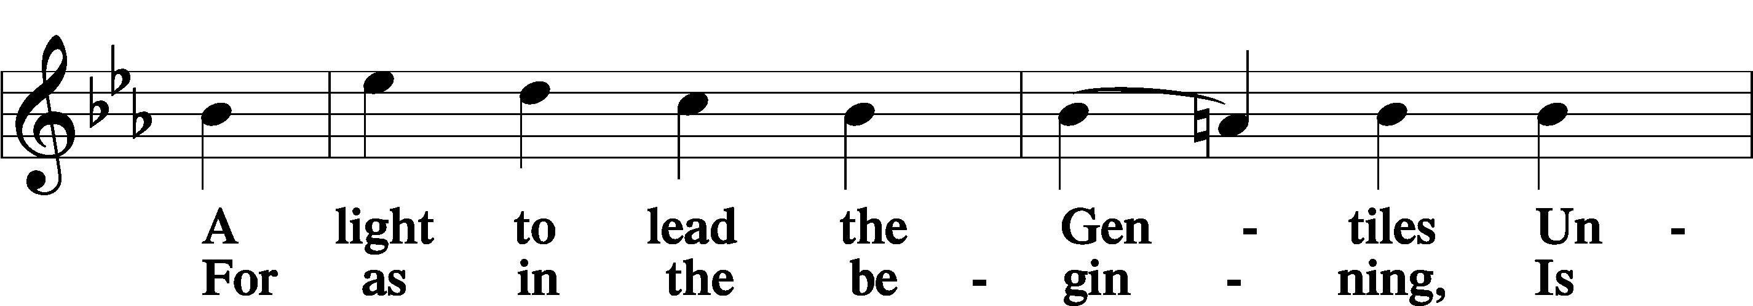
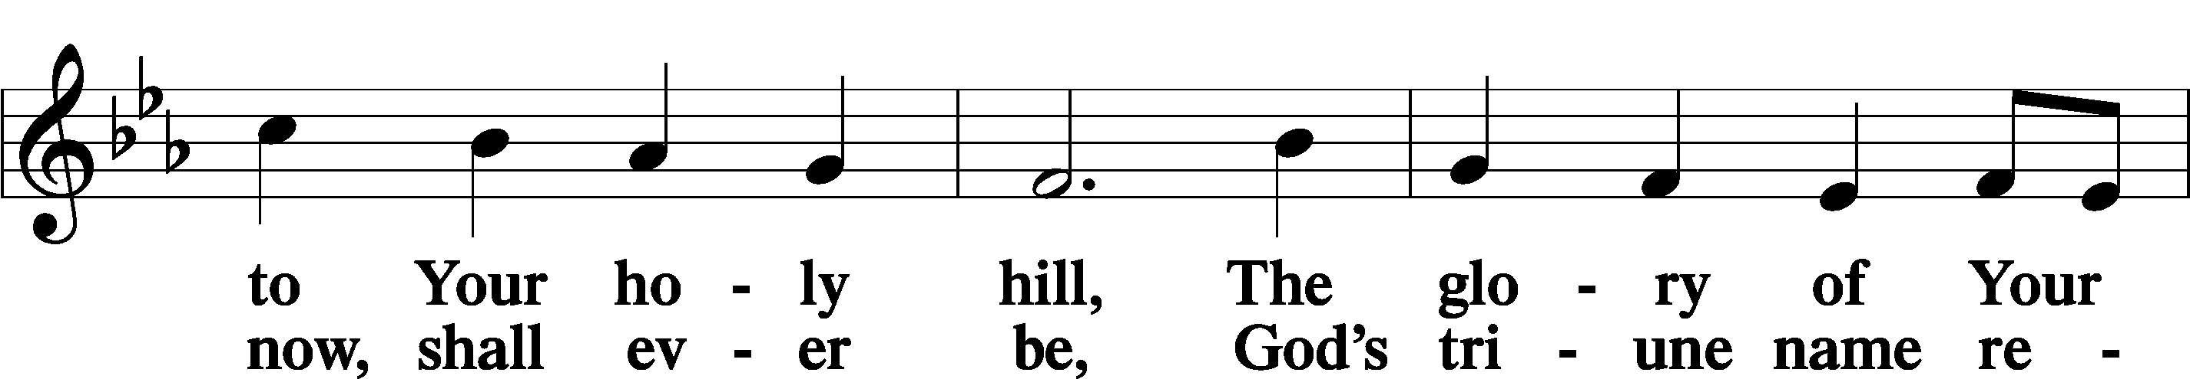
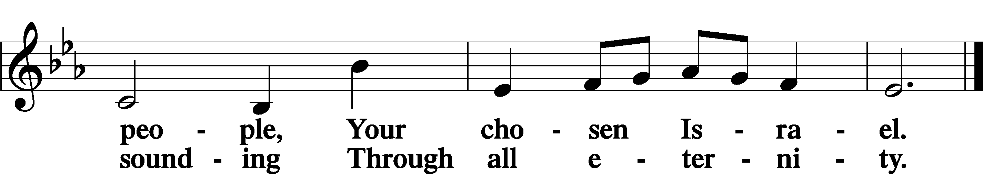

Post-Communion Collect
A Let us pray.
We give thanks to You, almighty God, that You have refreshed us through this salutary gift, and we implore You that of Your mercy You would strengthen us through the same in faith toward You and in fervent love toward one another; through Jesus Christ, Your Son, our Lord, who lives and reigns with You and the Holy Spirit, one God, now and forever.
C Amen.

Benedicamus LSB 212
A Let us bless the Lord.
C Thanks be to God.

Benediction
P The Lord bless you and keep you.
The Lord make His face shine on you and be gracious to you.
The Lord look upon you with favor and T give you peace.
C Amen.

Sit

Closing Hymn
490 Jesus Lives The Victory's won
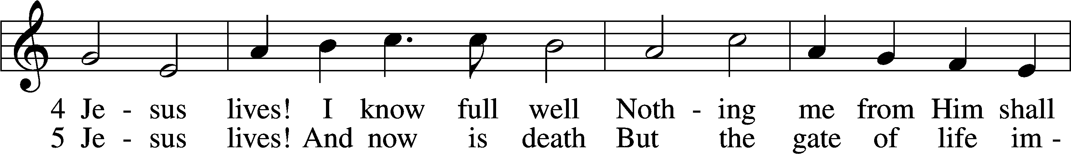
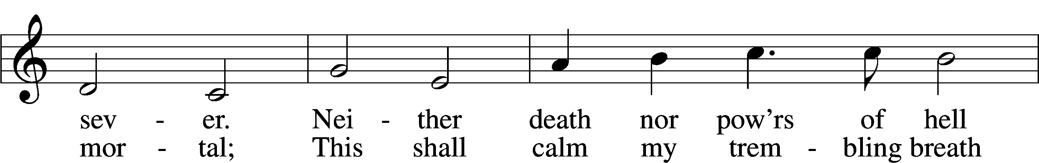
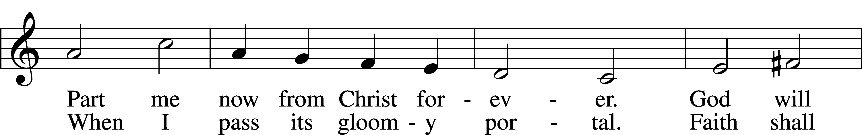
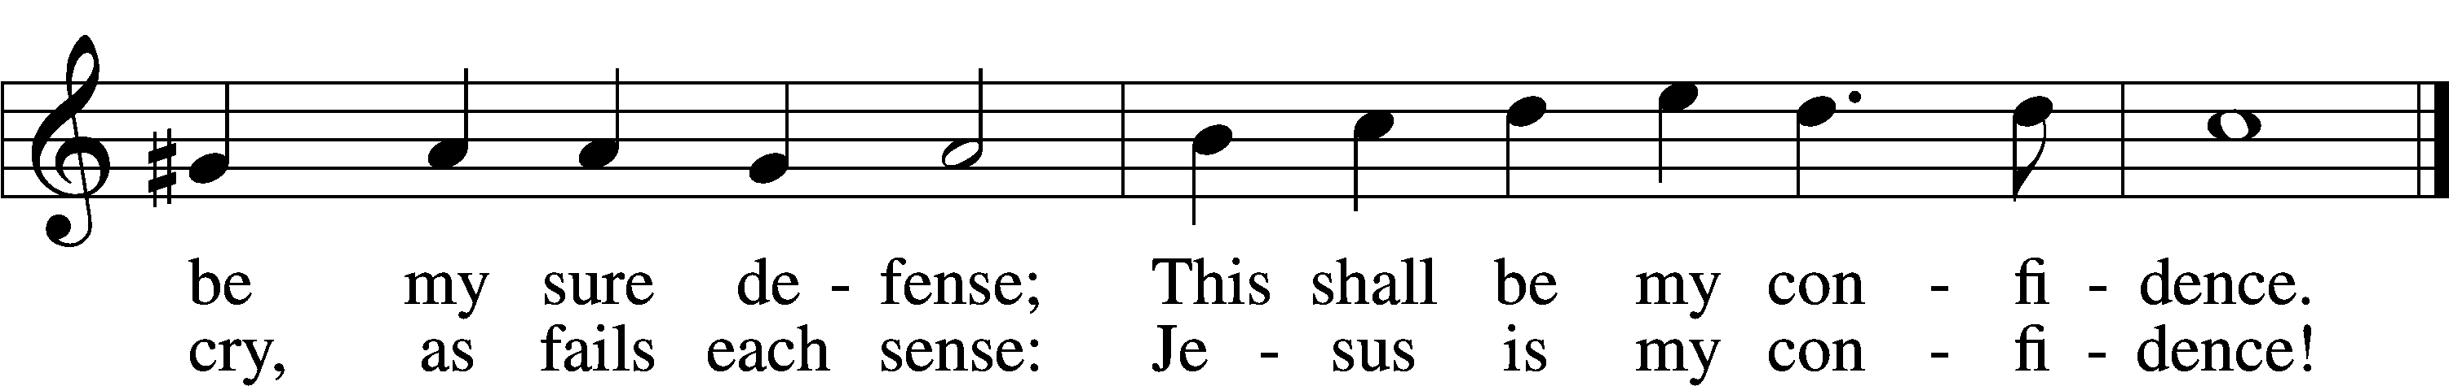

Acknowledgments
Unless otherwise indicated, Scripture quotations are from the ESV® Bible (The Holy Bible, English Standard Version®), copyright 2001 by Crossway, a publishing ministry of Good News Publishers. Used by permission. All rights reserved. Created by Lutheran Service Builder. Music reproduced in this service is used with permission through: CCLI License No.1776588 and CPH – LSB Service Builder.

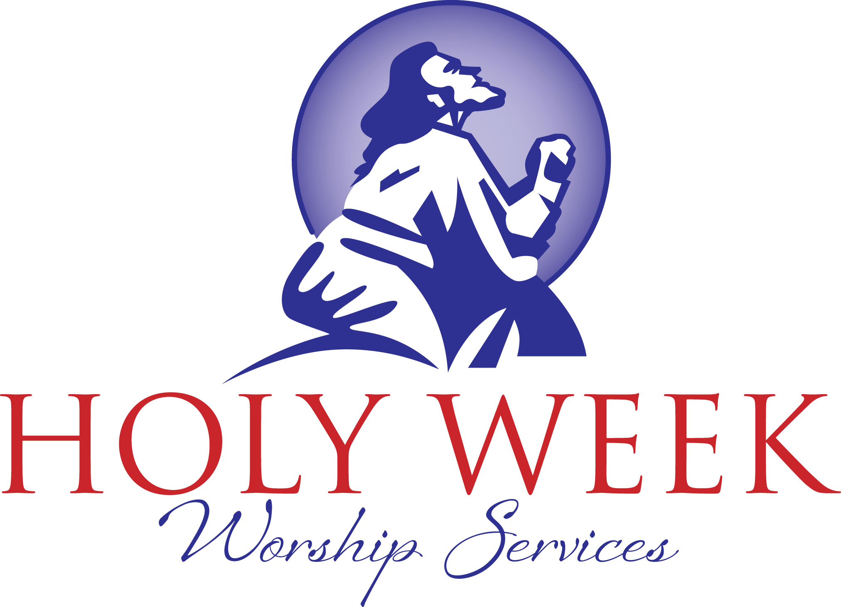

Maundy Thursday Service
7:00pm

Good Friday Service
7:00pm

Easter Sunday Service
9:00am

