Welcome To
Trinity Lutheran Church
Lutheran Church—Missouri Synod
A Stephen Ministry Congregation

1354 South Otsego Avenue
Gaylord, Michigan 49735
Church Phone: (989) 732-4816

Church Email: secretary@trinitygaylord.com
www.trinitygaylord.com

Office Hours: Monday through Friday 9am – 1pm

OUR PURPOSE
…is to LOVE GOD, LOVE OTHERS, AND SERVE THE WORLD by worshiping the Lord Jesus, bringing our members into Christ-like maturity, and equipping them through Word and Sacrament for their mission and ministry. We go heart to heart into the world with Jesus, sharing His love, caring for one another, praying, and bringing the lost into a relationship with Christ, by the working of the Holy Spirit.

January 22, 2023
Third Sunday after Epiphany
Preacher: Rev. Ken Bernthal

ABOUT OUR WORSHIP
We welcome all who gather here today! We are blessed to celebrate together the mercy, grace, and love we have from God through the death and resurrection of our Lord Jesus Christ.

Children: Families with children are very welcome here. Having children in church is important so they can begin to learn about their faith in Jesus, and it’s good for the whole congregation to see. Please feel comfortable keeping “squirmy” kids in the service. This is where they belong, too!

Pew Cards: Guests and Members, please fill out the Guest/Member card located on the back of the pew in front of you and pass it to the end of the aisle. If you forget you can put it in the offering plate on your way out.

If standing is difficult: Please feel free to remain seated during any portion of the service. Please let an Elder or Usher know if you need communion in your pew seat.

About our celebration of Holy Communion: We celebrate the Lord’s Supper in the confession and glad confidence that, as he says, our Lord gives into our mouths not only bread and wine but his very body and blood to eat and to drink for the forgiveness of sins and to strengthen our union with him and with one another. Our Lord invites to his table those who trust his words, repent of all sin, and set aside any refusal to forgive and love as he forgives and loves us, that they may show forth his death until he comes.

Because those who eat and drink our Lord’s body and blood contrary to that which is stated above do so to their great harm, and also because Holy Communion is a confession of the faith which is confessed at this altar. Anyone who is not yet instructed, in doubt, or who hold a confession differing from that of the Lutheran Church—Missouri Synod, and yet desire to receive the sacrament, are asked first to speak with Pastor. Those not communing are still invited to come forward for a blessing from Pastor, and you may indicate this by crossing your arms over your chest.
TTTTTT
GREETING

P Peace be with you.
C And also with you.

T ORDER OF SERVICE T
(The liturgy is from Divine Service Setting four LSB pg. 203ff)

OPENING HYMN
From All That Dwell Below the Skies Please stand on v. 3 LSB 816
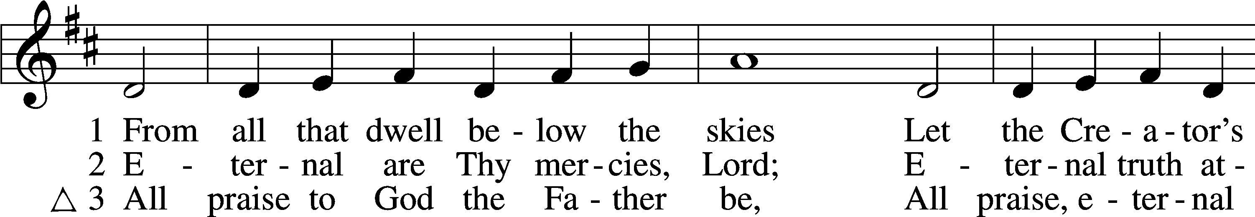
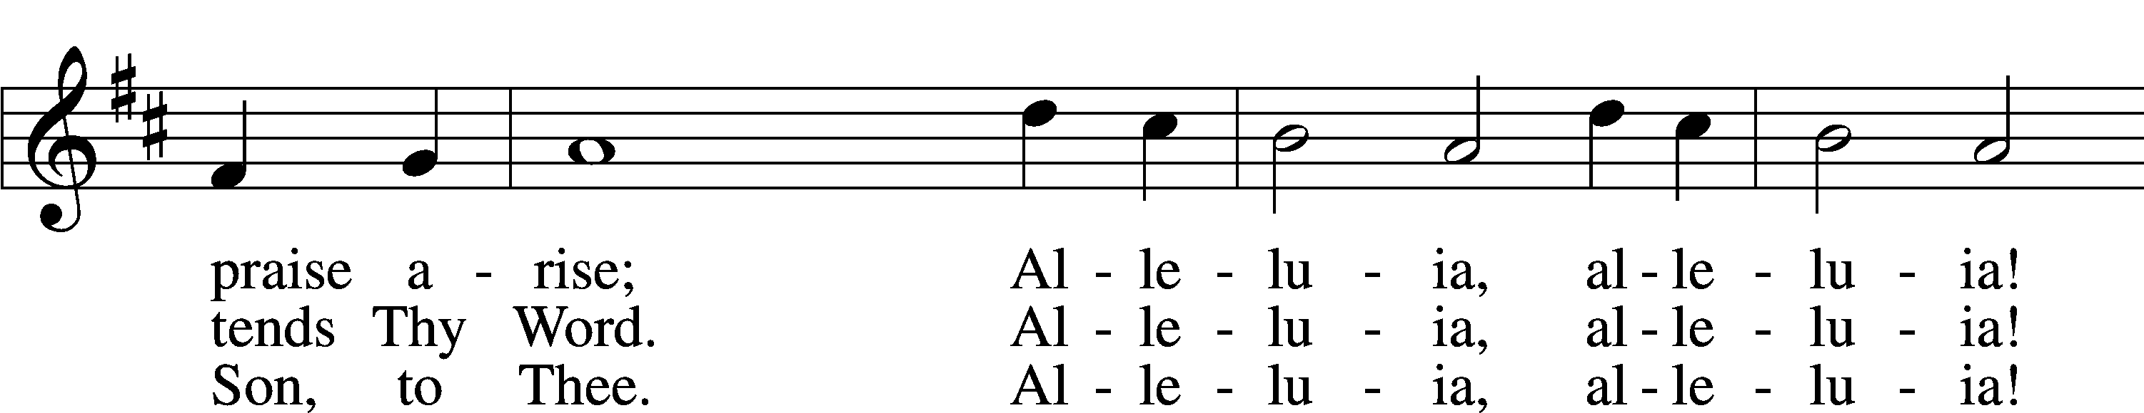
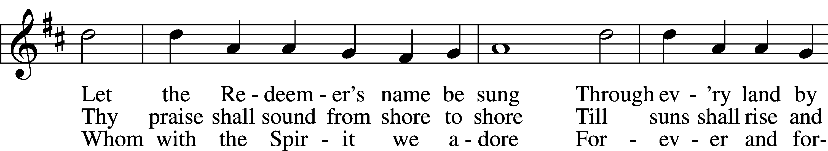
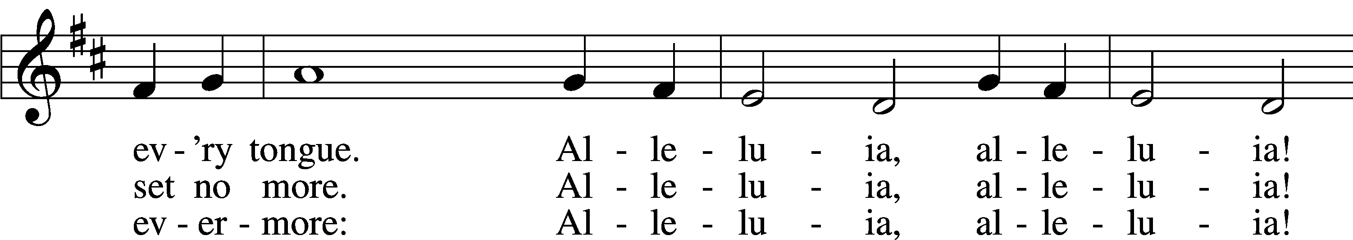
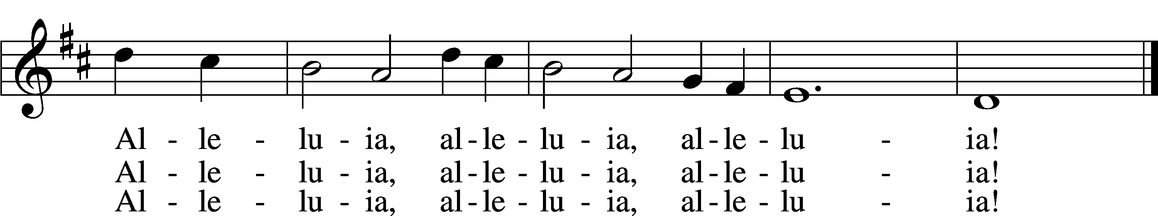

CONFESSION and ABSOLUTION
The sign of the cross may be made by all in remembrance of their Baptism.
P In the name of the Father and of the T Son and of the Holy Spirit.
C Amen.
P Our help is in the name of the Lord,
C who made heaven and earth.
P If You, O Lord, kept a record of sins, O Lord, who could stand?
C But with You there is forgiveness; therefore You are feared.
P Since we are gathered to hear God’s Word, call upon Him in prayer and praise, and receive the body and blood of our Lord Jesus Christ in the fellowship of this altar, let us first consider our unworthiness and confess before God and one another that we have sinned in thought, word, and deed, and that we cannot free ourselves from our sinful condition. Together as His people let us take refuge in the infinite mercy of God, our heavenly Father, seeking His grace for the sake of Christ, and saying: God, be merciful to me, a sinner.
C Almighty God, have mercy upon us, forgive us our sins, and lead us to everlasting life. Amen.
P Almighty God, merciful Father, in Holy Baptism You declared us to be Your
children and gathered us into Your one, holy Church, in which You daily and richly forgive us our sins and grant us new life through Your Spirit. Be in our midst, enliven our faith, and graciously receive our prayer and praise; through Your Son, Jesus Christ, our Lord.
C Amen.
T SERVICE OF THE WORD T
INTROIT Psalm 22:27–31; antiphon: v. 22
P I will tell of your name to my brothers;
in the midst of the congregation I will praise you.
C All the ends of the earth shall remember and turn to the Lord,
and all the families of the nations shall worship before you.
P For kingship belongs to the Lord,
and he rules over the nations.
C All the prosperous of the earth eat and worship;
before him shall bow all who go down to the dust, even the one who could not keep himself alive,
P Posterity shall serve him;
it shall be told of the Lord to the coming generation;
C they shall come and proclaim his righteousness to a people yet unborn,
that he has done it.
A Glory be to the Father and to the Son
and to the Holy Spirit;
as it was in the beginning,
is now, and will be forever. Amen.
P I will tell of your name to my brothers;
in the midst of the congregation I will praise you.
KYRIE LSB 204
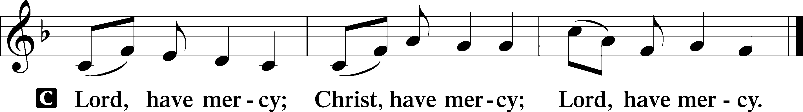

HYMN OF PRAISE
GLORIA IN EXCELSIS LSB 204
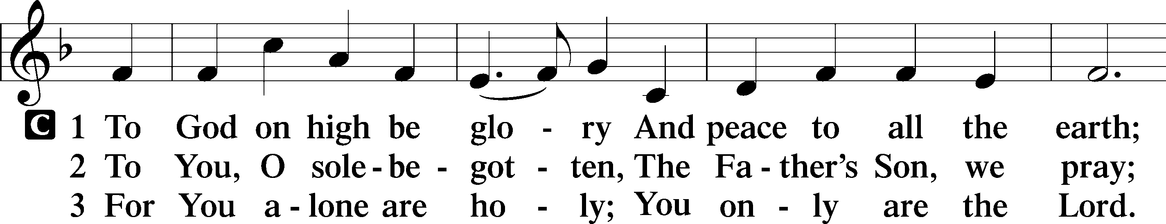
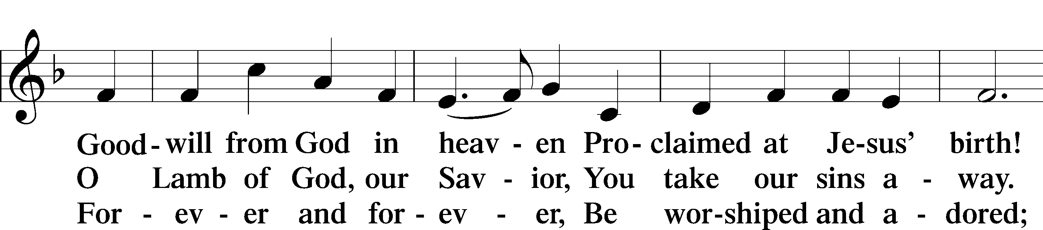
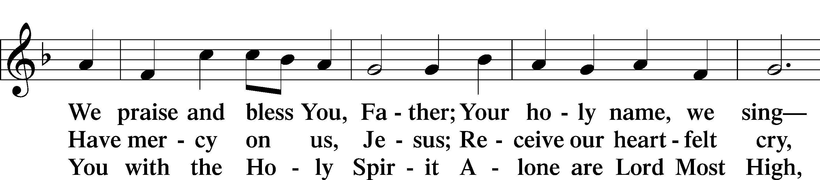
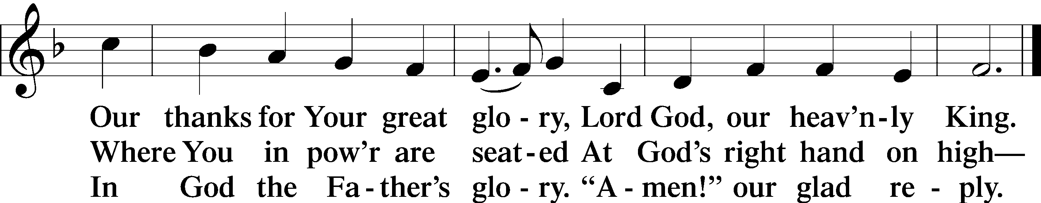

SALUTATION AND COLLECT OF THE DAY
P The Lord be with you.
C And also with you.
P Let us pray.
Almighty and everlasting God, mercifully look upon our infirmities and stretch forth the hand of Your majesty to heal and defend us; through Jesus Christ, Your Son, our Lord, who lives and reigns with You and the Holy Spirit, one God, now and forever.
C Amen.
Please be seated

OLD TESTAMENT READING Isaiah 9:1–4
¹ There will be no gloom for her who was in anguish. In the former time he brought into contempt the land of Zebulun and the land of Naphtali, but in the latter time he has made glorious the way of the sea, the land beyond the Jordan, Galilee of the nations.
² The people who walked in darkness
have seen a great light;
those who dwelt in a land of deep darkness,
on them has light shined.
³You have multiplied the nation;
you have increased its joy;
they rejoice before you
as with joy at the harvest,
as they are glad when they divide the spoil.
⁴For the yoke of his burden,
and the staff for his shoulder,
the rod of his oppressor,
you have broken as on the day of Midian.
P This is the Word of the Lord.
C Thanks be to God.

EPISTLE READING 1 Corinthians 1:10–18
¹⁰I appeal to you, brothers, by the name of our Lord Jesus Christ, that all of you agree and that there be no divisions among you, but that you be united in the same mind and the same judgment. ¹¹For it has been reported to me by Chloe’s people that there is quarreling among you, my brothers. ¹²What I mean is that each one of you says, “I follow Paul,” or “I follow Apollos,” or “I follow Cephas,” or “I follow Christ.” ¹³Is Christ divided? Was Paul crucified for you? Or were you baptized in the name of Paul? ¹⁴I thank God that I baptized none of you except Crispus and Gaius, ¹⁵so that no one may say that you were baptized in my name. ¹⁶(I did baptize also the household of Stephanas. Beyond that, I do not know whether I baptized anyone else.) ¹⁷For Christ did not send me to baptize but to preach the gospel, and not with words of eloquent wisdom, lest the cross of Christ be emptied of its power.
¹⁸For the word of the cross is folly to those who are perishing, but to us who are being saved it is the power of God.

P This is the Word of the Lord.
C Thanks be to God.

Please stand as able

ALLELUIA AND VERSE
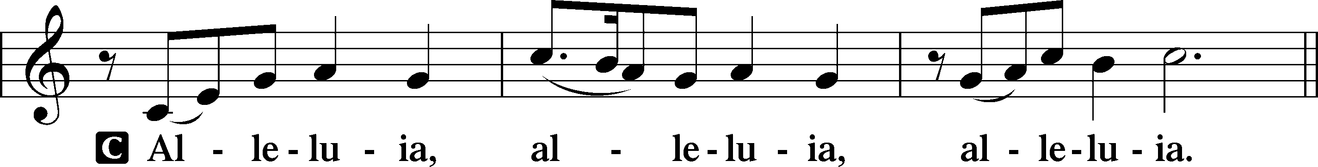
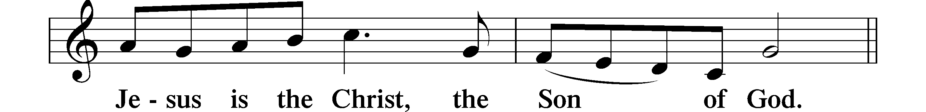
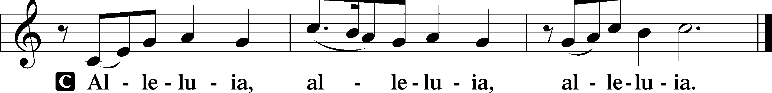

HOLY GOSPEL Matthew 4:12–25
P The Holy Gospel according to St. Matthew, the fourth chapter.
C Glory to You, O Lord.

¹²When [Jesus] heard that John had been arrested, he withdrew into Galilee. ¹³And leaving Nazareth he went and lived in Capernaum by the sea, in the territory of Zebulun and Naphtali, ¹⁴so that what was spoken by the prophet Isaiah might be fulfilled:
¹⁵“The land of Zebulun and the land of Naphtali,
the way of the sea, beyond the Jordan, Galilee of the Gentiles—
¹⁶the people dwelling in darkness
have seen a great light,
and for those dwelling in the region and shadow of death,
on them a light has dawned.”
¹⁷From that time Jesus began to preach, saying, “Repent, for the kingdom of heaven is at hand.”
¹⁸While walking by the Sea of Galilee, he saw two brothers, Simon (who is called Peter) and Andrew his brother, casting a net into the sea, for they were fishermen. ¹⁹And he said to them, “Follow me, and I will make you fishers of men.” ²⁰Immediately they left their nets and followed him. ²¹And going on from there he saw two other brothers, James the son of Zebedee and John his brother, in the boat with Zebedee their father, mending their nets, and he called them. ²²Immediately they left the boat and their father and followed him.
²³And he went throughout all Galilee, teaching in their synagogues and proclaiming the gospel of the kingdom and healing every disease and every affliction among the people. ²⁴So his fame spread throughout all Syria, and they brought him all the sick, those afflicted with various diseases and pains, those oppressed by demons, epileptics, and paralytics, and he healed them. ²⁵And great crowds followed him from Galilee and the Decapolis, and from Jerusalem and Judea, and from beyond the Jordan.

P This is the Gospel of the Lord.
C Praise to You, O Christ.

NICENE CREED
C I believe in one God,
the Father Almighty,
maker of heaven and earth
and of all things visible and invisible.

And in one Lord Jesus Christ,
the only-begotten Son of God,
begotten of His Father before all worlds,
God of God, Light of Light,
very God of very God,
begotten, not made,
being of one substance with the Father,
by whom all things were made;
who for us men and for our salvation came down from heaven
and was incarnate by the Holy Spirit of the virgin Mary
and was made man;
and was crucified also for us under Pontius Pilate.
He suffered and was buried.
And the third day He rose again according to the Scriptures
and ascended into heaven
and sits at the right hand of the Father.
And He will come again with glory to judge both the living and the dead,
whose kingdom will have no end.
And I believe in the Holy Spirit,
the Lord and giver of life,
who proceeds from the Father and the Son,
who with the Father and the Son together is worshiped and glorified,
who spoke by the prophets.
And I believe in one holy Christian and apostolic Church,
I acknowledge one Baptism for the remission of sins,
and I look for the resurrection of the dead
and the life T of the world to come. Amen.

Please be seated

ALL GOD’S CHILDREN – TALK

SEERMON HYMN
I Love Your Kingdom, Lord LSB 651
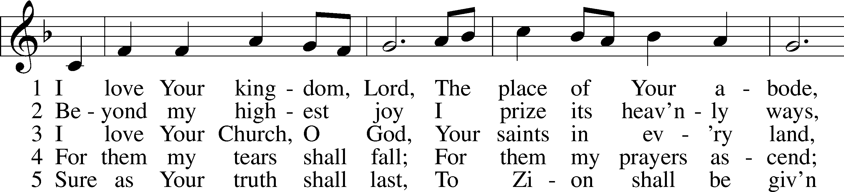
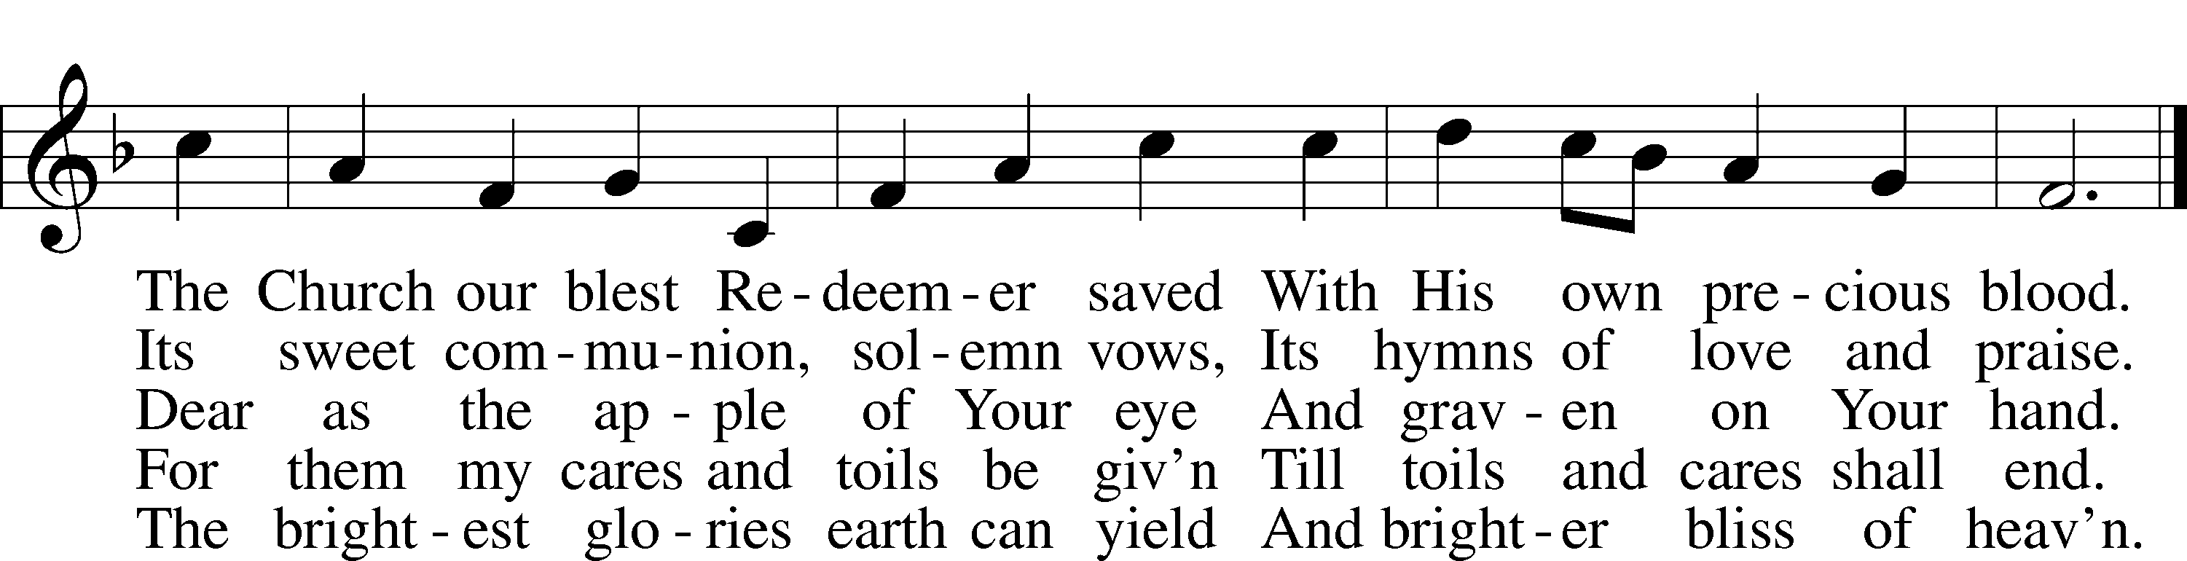

SERMON
Please stand as able for prayers
PRAYER of the CHURCH
After each Segment:
P Lord, in Your Mercy,
C Hear our Prayer.
After Final Segment:
P Hear us as we pray in His name and as He has taught us:
LORD’S PRAYER
Our Father, Who art in heaven, hallowed be Thy name,
Thy kingdom come, Thy will be done, on earth as it is in heaven.
Give us this day our daily bread;
and forgive us our trespasses, as we forgive those who trespass against us;
and lead us not into temptation,
but deliver us from evil.
For Thine is the kingdom, and the power, and the glory, forever and ever. Amen.
PREFACE LSB 208
P The Lord be with you.
C And also with you.
P Lift up your hearts.
C We lift them to the Lord.
P Let us give thanks to the Lord our God.
C It is right to give Him thanks and praise.
P It is truly good, right, and salutary that we should at all times and in all places give thanks to You, O Lord, holy Father, almighty and everlasting God, for the countless blessings You so freely bestow on us and all creation. Above all, we give thanks for Your boundless love shown to us when You sent Your only-begotten Son, Jesus Christ, into our flesh and laid on Him our sin, giving Him into death that we might not die eternally. Because He is now risen from the dead and lives and reigns to all eternity, all who believe in Him will overcome sin and death and will rise again to new life. Therefore with angels and archangels and with all the company of heaven we laud and magnify Your glorious name, evermore praising You and singing:

SANCTUS LSB 208
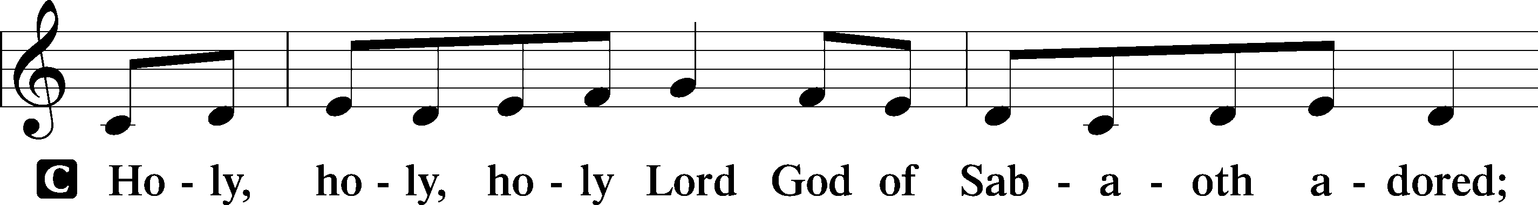
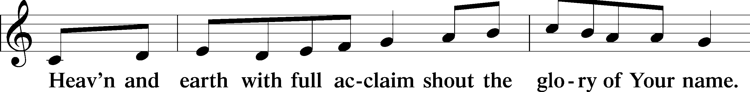
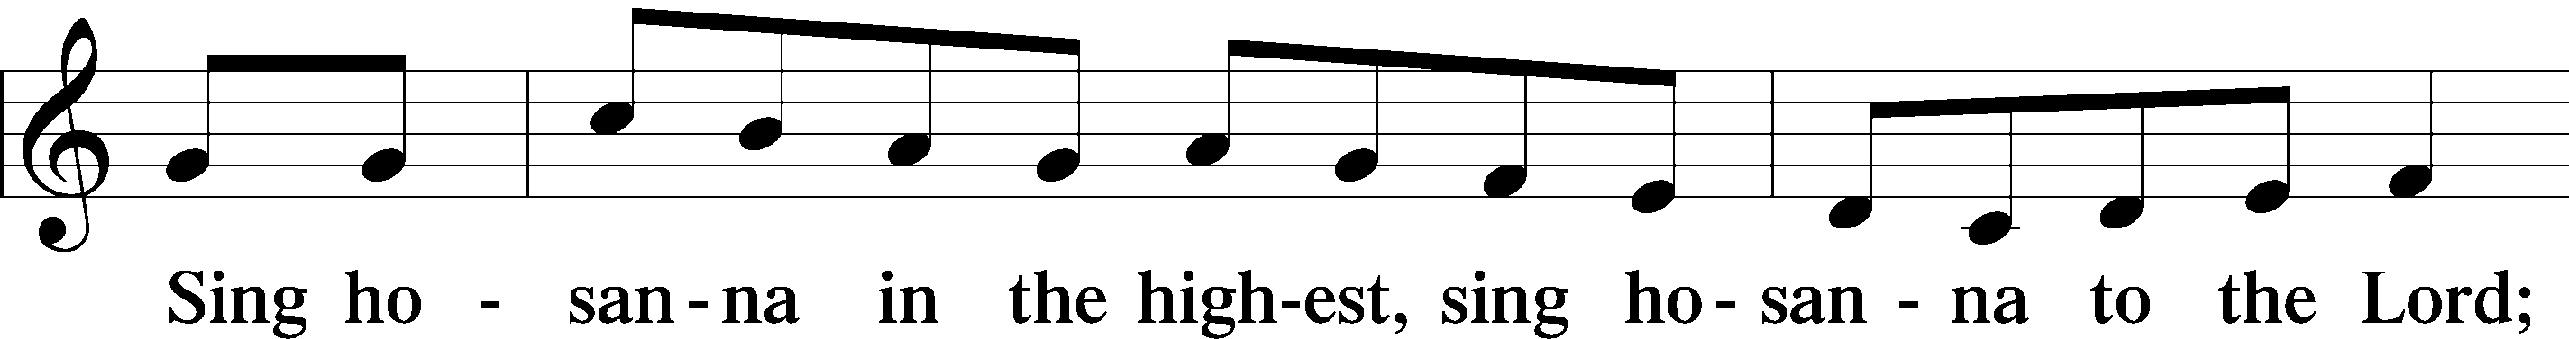
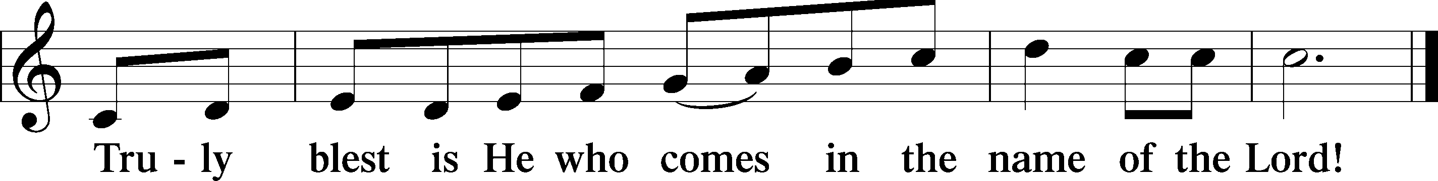

PRAYER OF THANKSGIVING
P Blessed are You, O Lord our God, king of all creation, for You have had mercy on us and given Your only-begotten Son that whoever believes in Him should not perish but have eternal life.
As the glory of Your presence once filled Your ancient temple, so in the incarnation of Your Son, Jesus Christ, You manifested the fullness of Your glory in human flesh.
We give You thanks that in His most Holy Supper You reveal Your glory to us. Grant us faithfully to eat His body and drink His blood so that we may one day behold Your glory face to face.

THE WORDS of our LORD
P Our Lord Jesus Christ, on the night when He was betrayed, took bread, and when He had given thanks, He broke it and gave it to the disciples and said: “Take, eat; this is My T body, which is given for you. This do in remembrance of Me.”
In the same way also He took the cup after supper, and when He had given thanks, He gave it to them, saying: “Drink of it, all of you; this cup is the new testament in My T blood, which is shed for you for the forgiveness of sins. This do, as often as you drink it, in remembrance of Me.”

PAX DOMINI
P The peace of the Lord be with you always.
C Amen.

AGNUS DEI LSB 210
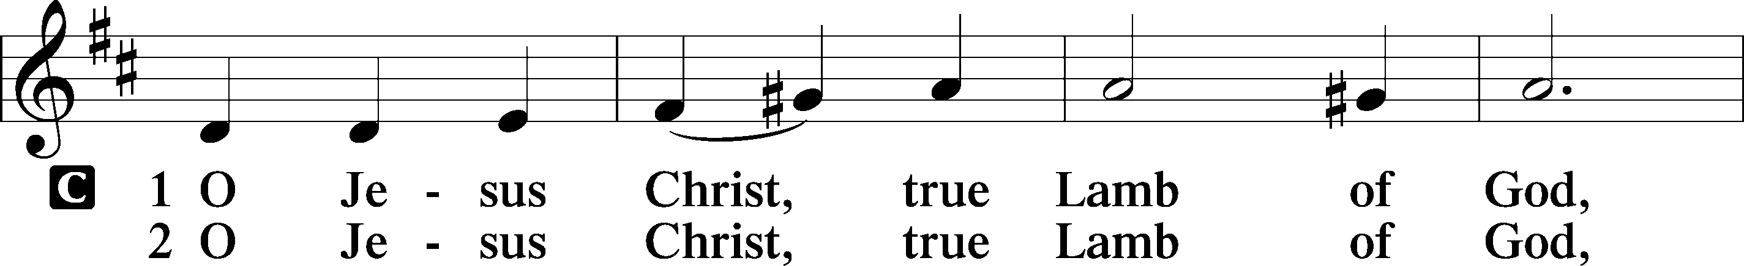
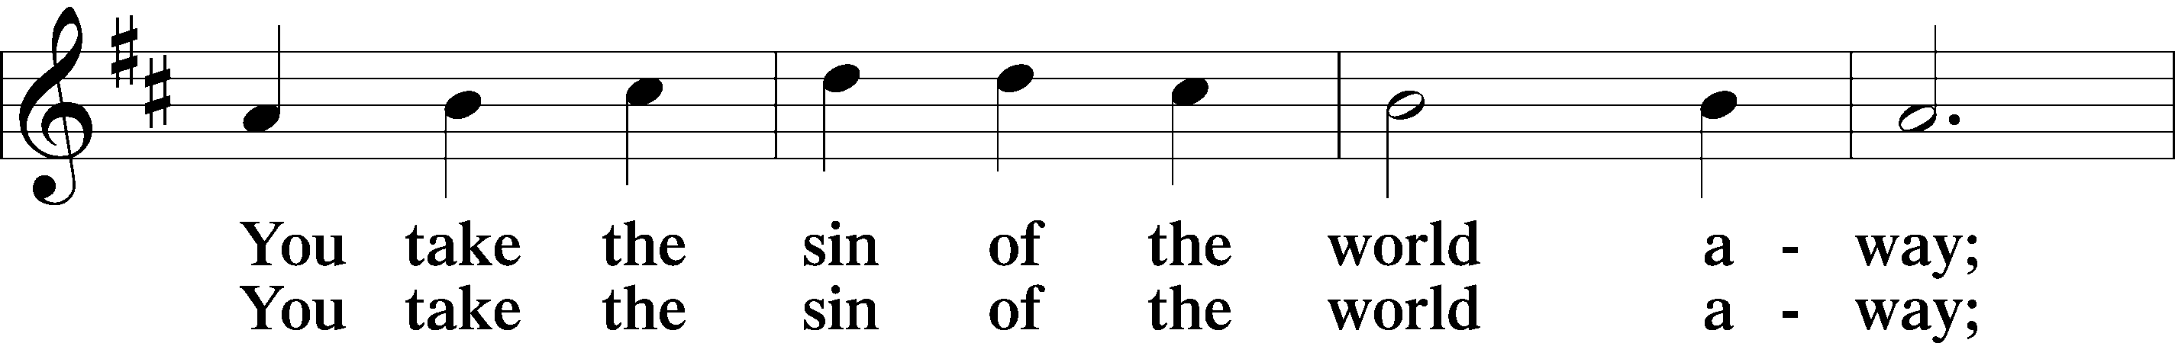
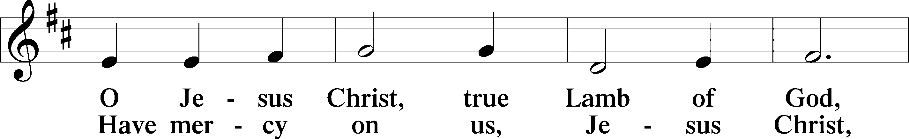
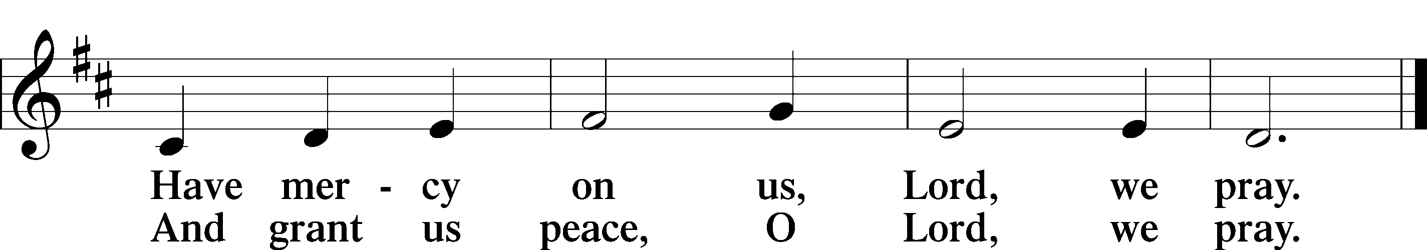

Please be Seated

The pastor and those who assist him receive the body and blood of Christ first, then Communion will be served at the rail. Ushers will help direct you forward via the center aisle; please return to your seats via the side aisles. Gluten-free bread is available for those who need it, as is non-alcoholic grape juice. Simply request either when you come forward to receive Communion.
DISTRIBUTION HYMN
Drawn to the Cross, Which Thou Hast Blessed LSB 560
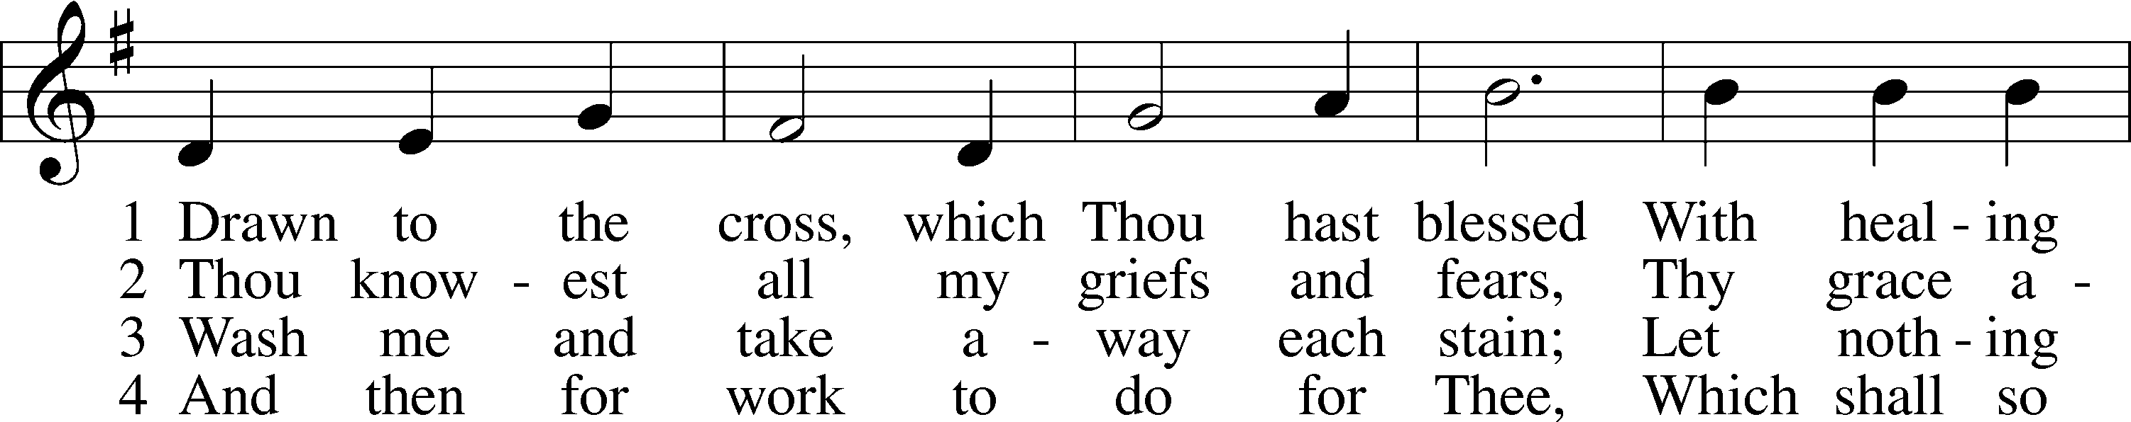
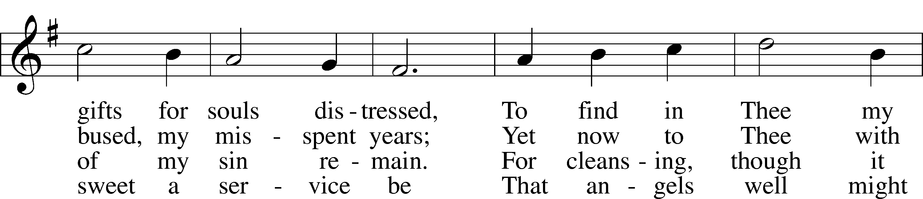
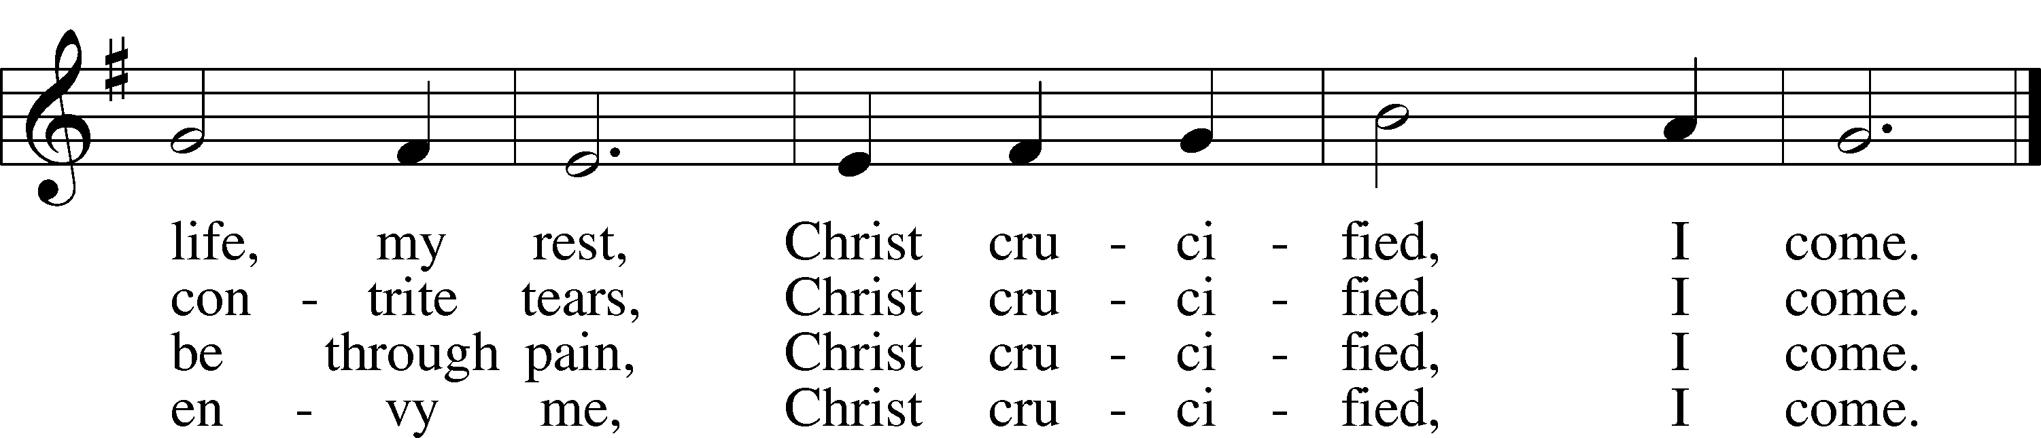

DISTRIBUTION HYMN
God Loved the World So That He Gave LSB 571
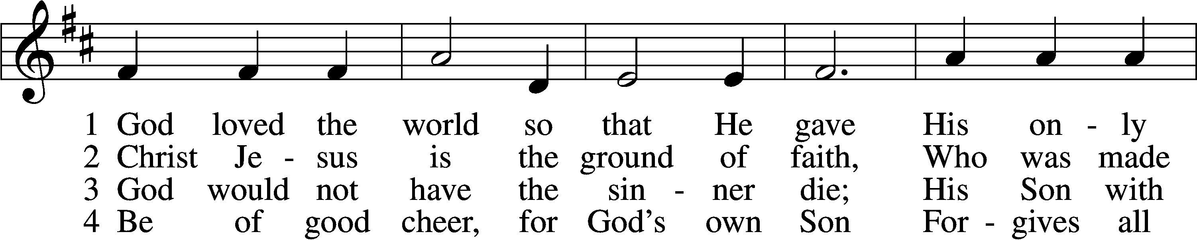
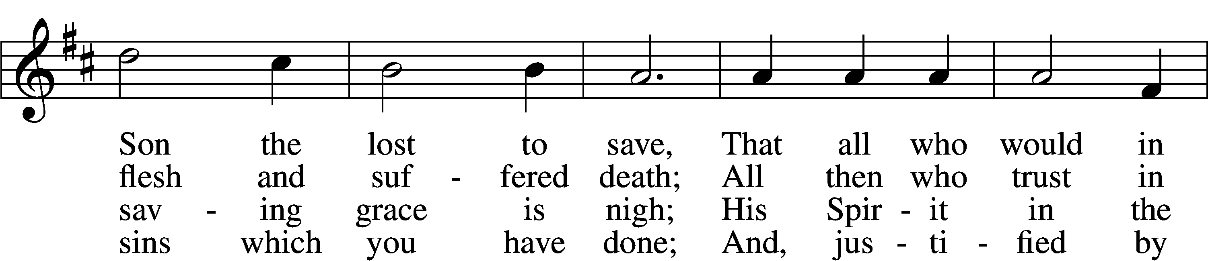
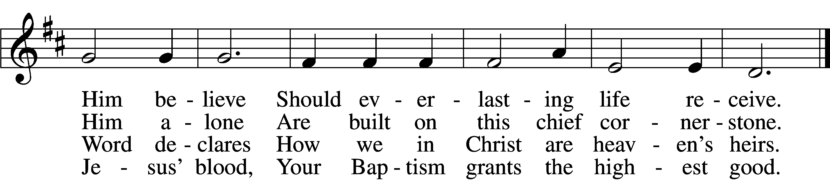

5 If you are sick, if death is near,
This truth your troubled heart can cheer:
Christ Jesus saves your soul from death;
That is the firmest ground of faith.

6 Glory to God the Father, Son,
And Holy Spirit, Three in One!
To You, O blessèd Trinity,
Be praise now and eternally!

Please stand as able

NUNC DIMITTIS LSB 211
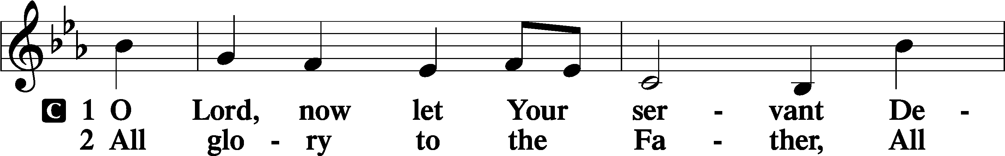
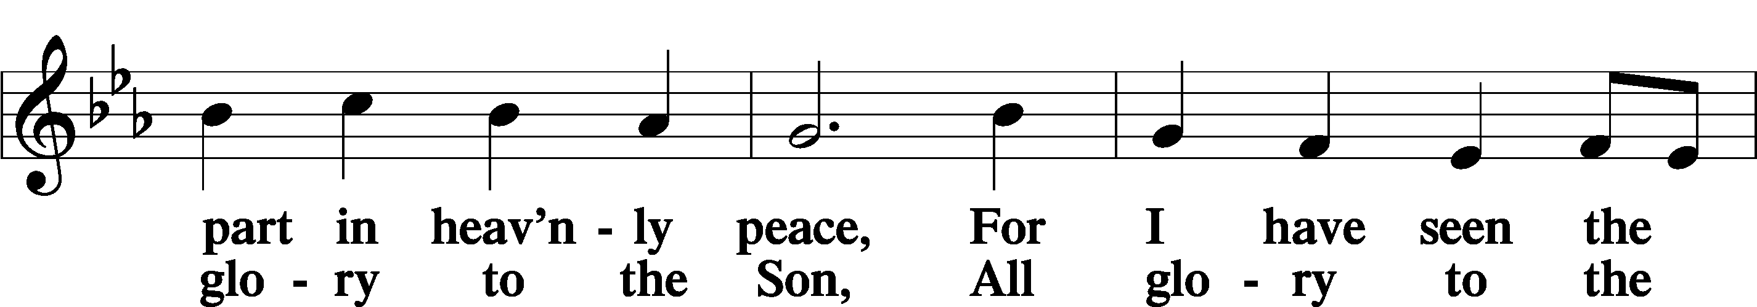
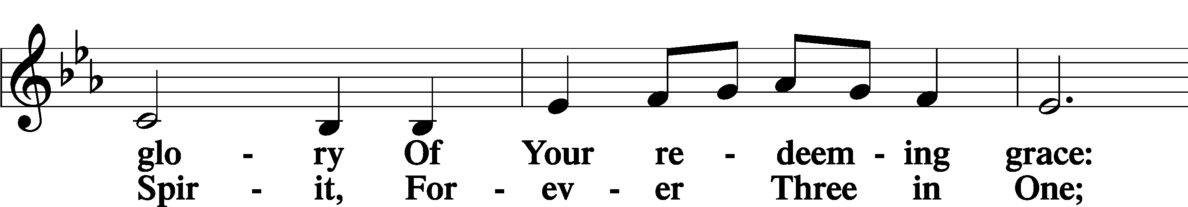
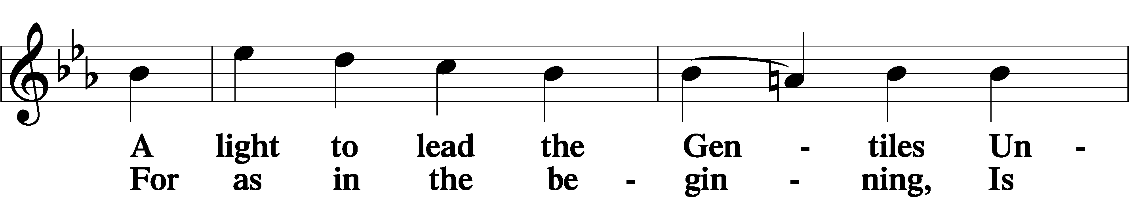
Continued on next page
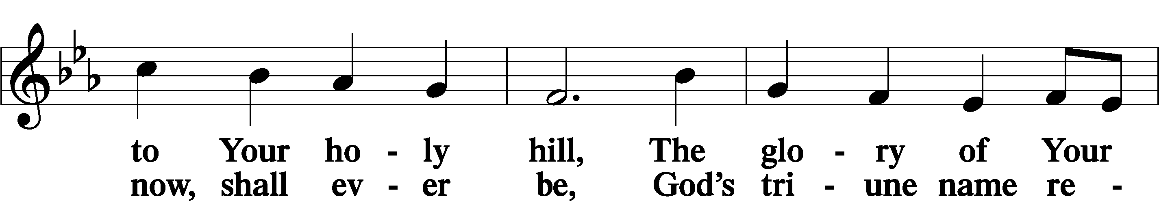
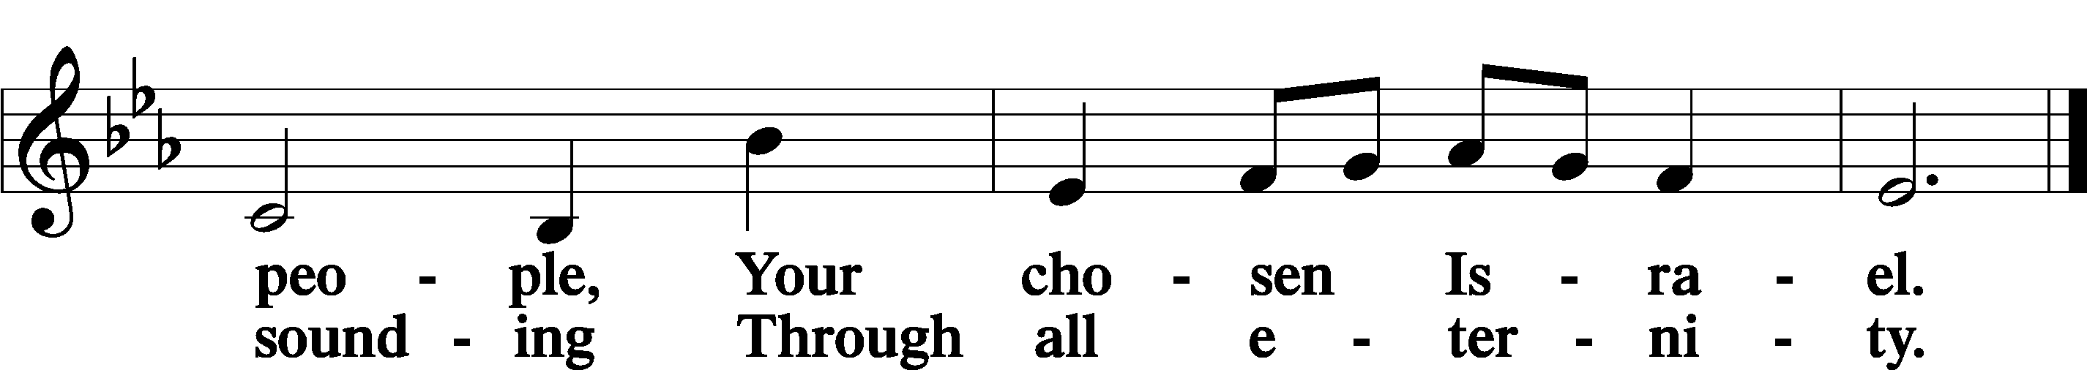

POST COMMUNION COLLECT
P Let us pray.
We give thanks to You, almighty God, that You have refreshed us through this salutary gift, and we implore You that of Your mercy You would strengthen us through the same in faith toward You and in fervent love toward one another; through Jesus Christ, Your Son, our Lord, who lives and reigns with You and the Holy Spirit, one God, now and forever.
C Amen.
BENEDICAMUS LSB 212
P Let us bless the Lord.
C Thanks be to God.
BENEDICTION
P The Lord bless you and keep you.
The Lord make His face shine on you and be gracious to you.
The Lord look upon you with favor and T give you peace.
C Amen.
Please be seated
CLOSING HYMN
Lord, Dismiss Us with Your Blessing LSB 924
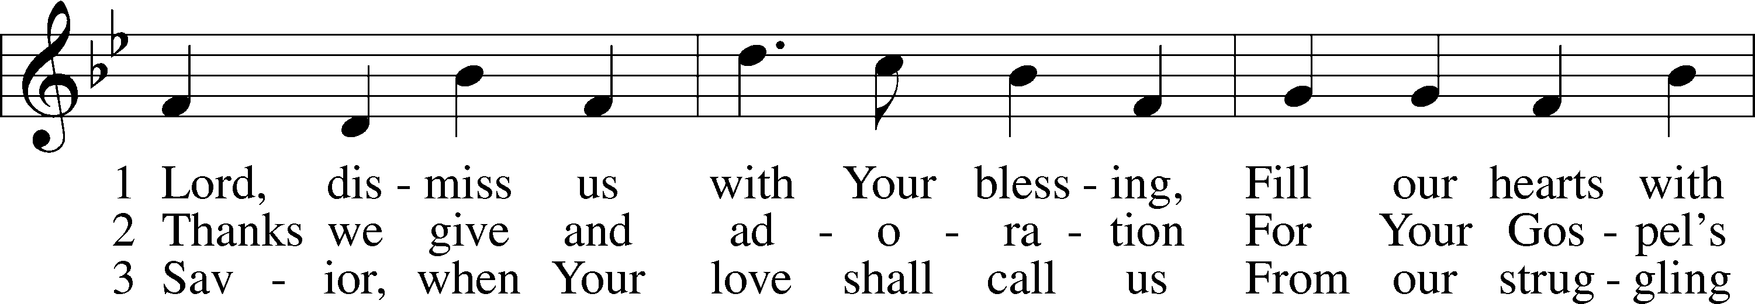
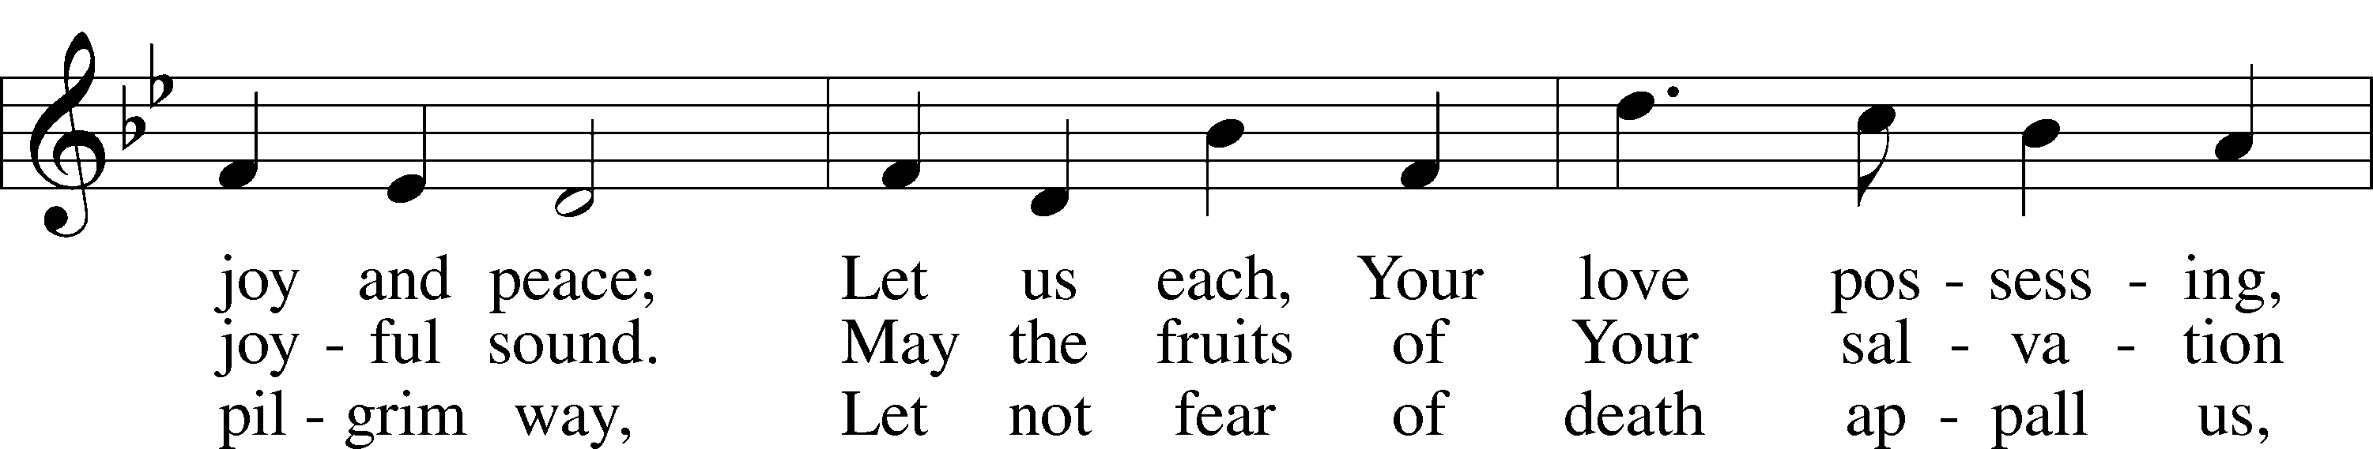
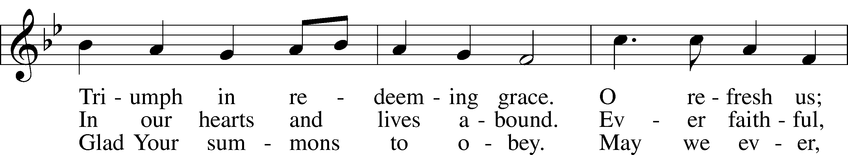
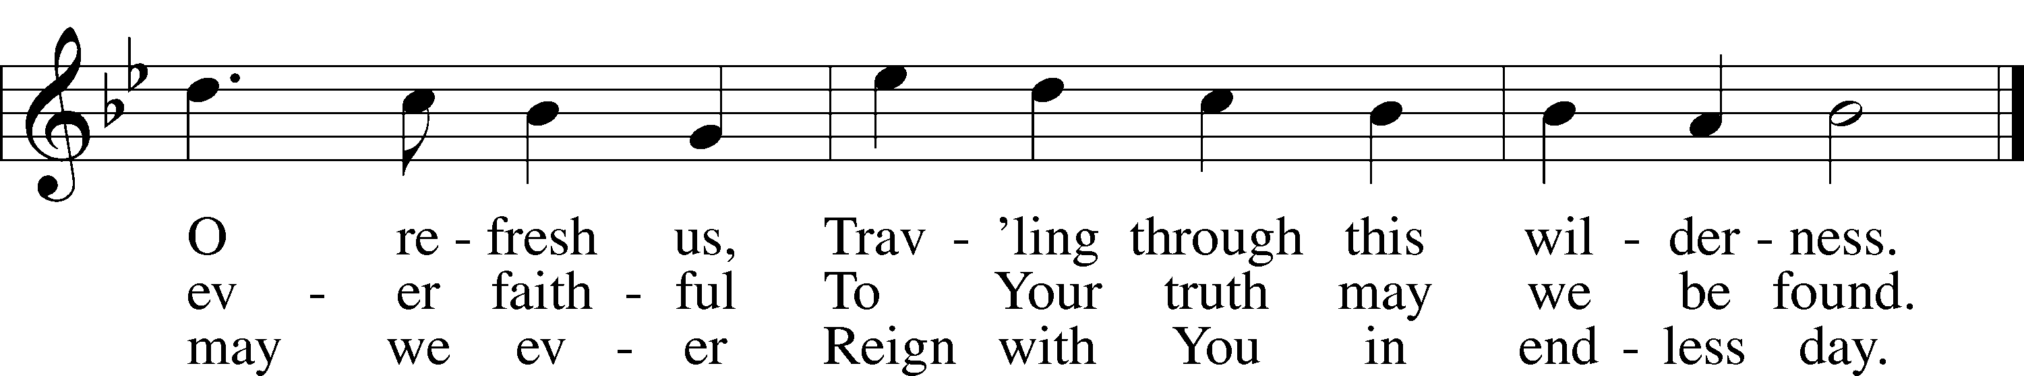

ANNOUNCEMENTS and SENDING WORDS
P We go to live for Jesus!
C We go to share His love!

Acknowledgments
Unless otherwise indicated, Scripture quotations are from the ESV® Bible (The Holy Bible, English Standard Version®), copyright 2001 by Crossway, a publishing ministry of Good News Publishers. Used by permission. All rights reserved. Created by Lutheran Service Builder. Music reproduced in this service is used with permission through: CCLI License No.1776588 and CPH – LSB Service Builder.

SERVING in GODS HOUSE TODAY
Pastor: Rev. Ken Bernthal
Elder: Tom Raithel
Ushers: Mike Goodrich, Ron Tesolin
Greeters: Bob & Kathy Erat
Coffee: Stutzmans
Counters: Brian Techel and Karl Scheiterlein
Altar Care: Ann Mertz
Children’s Talk: Nancy Ely
Piano/Organ: Beaches
Bible Study: Tom Beach
Children’s Sunday School: Nancy Ely, Jean Beach, Sharon Techel
Confirmation Class: Rev. Paul Schneider

PRAYERS
Please contact the office with updates to the prayer list. People will remain on the prayer list for 4 weeks before being removed. If they need to remain on the list, please keep Elaine informed and of any updates. This will help us to have a more accurate list. Thanks for your cooperation.
Those who continue to grieve the passing of loved ones: The Kurt Farhy from Georgia (Kurt passed away Wednesday January 4th). Friends of John & Judi Stutzman and
Jean Siebels niece.
Those with upcoming surgery and medical procedures: Bill Stiles.
Those recovering from surgery and medical procedures: Tanner Beyers., Greg Techel, and, Vicki Sherman (Risas daughter-in -law.).
Those with health concerns: Tiffany Amsdill, Wally Beasinger, Ruth Bennett (Sharron Kato’s Sister), Jackie Bliss, Hope Buchinger, Betsy Cook, Andy Francis, Shirley Hildebrand, Paul Kietzman, Jennifer Martin, Gladys Pickering, Eleanor Raether,
Beth Smith, Judi Stutzman, Sharon Techel, Joann Whitney and Lyle Yingling this is Larry Whitneys daughters friend.
Those diagnosed with cancer: Sue Cavanagh, Leah Eicher, Rachel Frisch, Janice Knoellinger, Leslie Martin, Brian Morgan, and Hope Osantowski. Leanne a friend of Denise Lange’s, and Sheryl Marsh (Shirley Hildebrands daughter).
Those under Hospice Home Care: Ken Williamson, Jim (Joann Whitney’s brother-in law).
BIRTHDAYS: ANNIVERSARIES;
1/25 Heather Appold NONE
1/26 Jackie Bliss

MESSAGES
MEMBER & GUEST CARDS: If you have not filled out a member/guest card, please take the time to fill one out and place it in the plate behind the back pews in our sanctuary.
WEDNESDAY MORNING BIBLE STUDY, 10:00am in the fellowship hall with Pastor Ken Bernthal.

GREETING CARDS If you are in need of some greeting cards, we carry an array of them in the cabinet in the library. The Valentines and Easter cards have been put out. The cost of the cards is posted on the cabinet. The money collected from the cards goes to LWML to help support Missions.
CANCER and FRIENDS SUPPORT GROUP: Will be meeting January 24th. We will be discussing caregiving and radiation. Please remember Cancer & Friends Support Group is not just for people going through treatment, or survivors, we are also here for caregiver, spouse, children, and friends. There are times when we can all use someone to talk to during those difficult times. If there is any subject you would like to discuss with me you call or text or at 989-350-4391. Hope you will join us.
KUT-UPS will be meeting Monday January 23rd, 10am in the fellowship hall.
VALENTINES CANDY BAR BINGO: Our annual Candy Bar Bingo is Friday February 10th at 6pm. All you will need to bring is one candy bar per family. Munchies and beverages will be provided unless you would like to bring your favorite munchie to share. Come relax, kick back and enjoy.
SUPER BOWL SUB SALE: Get your orders in!!! Super Bowl Sub Sale February 12, 2023 again will made by LWML Trinity Lutheran all proceeds will go to Otsego County Food Pantry. Orders need to be in by February 5th so that we can order the product and have it to make the Subs on Sunday the 12th. If you have any questions please feel free to contact Tina at 989-350-3287.
NOISY OFFERING
(We invite you to put your pocket change in the buckets located at the back of the church where the membership cards are located to support our local Food Pantry.)

OFFERING ENVELOPED: If you have not already taken your offering envelopes they are now in your mail boxes. We will be collecting the ones not taken at the end of this month. If you do not need your envelopes please let the office know.

CALL COMMITTEE: Greetings Brothers & Sisters of Trinity,
Please mark your calendars for Sunday, January 29th to meet so that the Mt. Hope & Trinity Call Committee can present information and recommendations to extend a call for the Pastor candidate. We will meet in the Mt. Hope Church Fellowship Hall at 1:00 pm after Sunday service on January 29th. Meeting details are noted below:
Sunday, January 29, 2023
Mt. Hope / Trinity Church Call Committee - Pastor Candidate Presentation
Time: 1:00p to 2:30p
Mt. Hope Lutheran Church - Fellowship Hall
905 I-75 BL, Grayling, MI 49738
Thank you for your consideration and we look forward to meeting with everyone. Should you have any questions, please reach out to any member of the call committee. God's blessings to you this day!

SERVING in GODS HOUSE NEXT WEEK JANUARY 29
Pastor: Rev. Ken Bernthal
Elder: Dave Beyers
Ushers: Jim & Marge Kunisch
Greeters: Ken & Ann Mertz
Coffee: Nancy Ely
Counters: Sharon Kwapis & Janet Arner
Altar Care: Terri Raithel
Children’s Talk: Nancy Ely
Virtual Organist: Bob Erat
Bible Study: Tom Beach
Children’s Sunday School: Nancy Ely, Jean Beach, Sharon Techel
Confirmation Class Pastor Paul Schneider

READINGS FOR NEXT WEEK JANUARY 29th
First Reading: Micha 6:1-8
Second Reading: I Corinthians: 1:18-25
Gospel: Matthew: 5:1-12

THIS WEEK AT TRINITY
January 22 Sunday
9:00 am Worship Service - Holy Communion
Noisy Offering
10:00 am Fellowship & Coffee Hour
10:30 am Sunday Morning Bible Study W/ Dr. Tom Beach
10:30 am Children’s Sunday School.: Nancy Ely, Jean Beach and Sharon
Techel
10:30 am Confirmation Class in Library
January 23 Monday
10:00 pm Kut- Ups (Fellowship Hall)
7:00 pm Choir
January 24 Tuesday
5:30 pm Cancer & Friends Support Group
January 25 Wednesday
10:00 am Wednesday Morning Bible Study W/ Pastor Ken Bernthal
January 26 Thursday
7:00 pm Erats Home Bible Study
January 27 Friday
January 28 Saturday
January 29 Sunday
9:00 am Worship Service - Holy Communion
10:00 am Fellowship & Coffee Hour
10:30 am Sunday Morning Bible Study W/ Dr. Tom Beach
10:30 am Children’s Sunday School.
10:30 am Confirmation Class in Library

