Welcome To
Trinity Lutheran Church
Lutheran Church—Missouri Synod
A Stephen Ministry Congregation

1354 South Otsego Avenue
Gaylord, Michigan 49735
Church Phone: (989) 732-4816

Church Email: secretary@trinitygaylord.com
www.trinitygaylord.com

Office Hours: Monday through Friday 9am – 1pm

OUR PURPOSE
…is to LOVE GOD, LOVE OTHERS, AND SERVE THE WORLD by worshiping the Lord Jesus, bringing our members into Christ-like maturity, and equipping them through Word and Sacrament for their mission and ministry. We go heart to heart into the world with Jesus, sharing His love, caring for one another, praying, and bringing the lost into a relationship with Christ, by the working of the Holy Spirit.

January 15, 2023
Second Sunday after Epiphany
Preacher: Rev. Ken Bernthal

ABOUT OUR WORSHIP
We welcome all who gather here today! We are blessed to celebrate together the mercy, grace, and love we have from God through the death and resurrection of our Lord Jesus Christ.

Children: Families with children are very welcome here. Having children in church is important so they can begin to learn about their faith in Jesus, and it’s good for the whole congregation to see. Please feel comfortable keeping “squirmy” kids in the service. This is where they belong, too!

Pew Cards: Guests and Members, please fill out the Guest/Member card located on the back of the pew in front of you and pass it to the end of the aisle. If you forget you can put it in the offering plate on your way out.

If standing is difficult: Please feel free to remain seated during any portion of the service. Please let an Elder or Usher know if you need communion in your pew seat.

About our celebration of Holy Communion: We celebrate the Lord’s Supper in the confession and glad confidence that, as he says, our Lord gives into our mouths not only bread and wine but his very body and blood to eat and to drink for the forgiveness of sins and to strengthen our union with him and with one another. Our Lord invites to his table those who trust his words, repent of all sin, and set aside any refusal to forgive and love as he forgives and loves us, that they may show forth his death until he comes.

Because those who eat and drink our Lord’s body and blood contrary to that which is stated above do so to their great harm, and also because Holy Communion is a confession of the faith which is confessed at this altar. Anyone who is not yet instructed, in doubt, or who hold a confession differing from that of the Lutheran Church—Missouri Synod, and yet desire to receive the sacrament, are asked first to speak with Pastor. Those not communing are still invited to come forward for a blessing from Pastor, and you may indicate this by crossing your arms over your chest.
TTTTTT
GREETING

P Peace be with you.
C And also with you.

T ORDER OF SERVICE T
(The liturgy is from Divine Service Setting four LSB pg. 203ff)

Please stand as able

OPENING HYMN
Christ Is Our Cornerstone Stand on verse 3 LSB 912
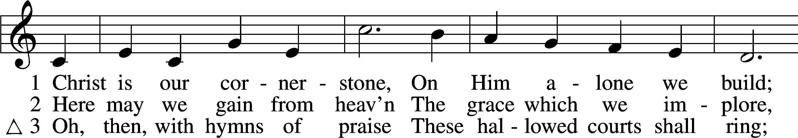
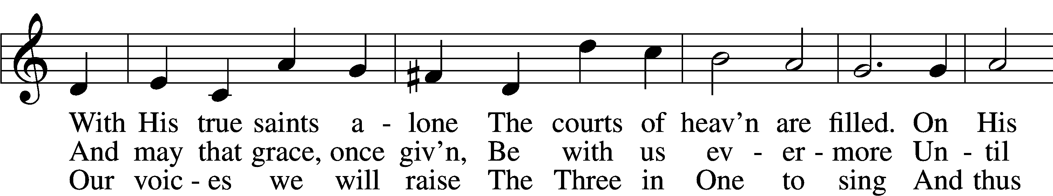
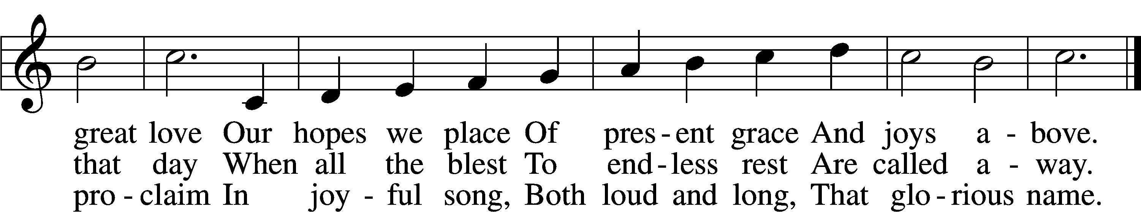

CONFESSION and ABSOLUTION
The sign of the cross may be made by all in remembrance of their Baptism.

P In the name of the Father and of the T Son and of the Holy Spirit.
C Amen.
P Our help is in the name of the Lord,
C who made heaven and earth.
P If You, O Lord, kept a record of sins, O Lord, who could stand?
C But with You there is forgiveness; therefore, You are feared.

P Since we are gathered to hear God’s Word, call upon Him in prayer and praise, let us first consider our unworthiness and confess before God and one another that we have sinned in thought, word, and deed, and that we cannot free ourselves from our sinful condition. Together as His people let us take refuge in the infinite mercy of God, our heavenly Father, seeking His grace for the sake of Christ, and saying: God, be merciful to me, a sinner.
C Almighty God, have mercy upon us, forgive us our sins, and lead us to everlasting life. Amen.
P Almighty God, merciful Father, in Holy Baptism You declared us to be Your children and gathered us into Your one, holy Church, in which You daily and richly forgive us our sins and grant us new life through Your Spirit. Be in our midst, enliven our faith, and graciously receive our prayer and praise; through Your Son, Jesus Christ, our Lord.
C Amen.
T SERVICE OF THE WORD T
INTROIT Psalm 19:1–4a, b; antiphon: v. 14

P Let the words of my mouth and the meditation of my heart be acceptable in your
sight, O Lord, my rock and my redeemer.
C The heavens declare the glory of God,
and the sky above proclaims his handiwork.
P Day to day pours out speech,
and night to night reveals knowledge.
C There is no speech, nor are there words,
whose voice is not heard.
P Their measuring line goes out through all the earth, and their words to the end of the
world. In them he has set a tent for the sun.
A Glory be to the Father and to the Son
and to the Holy Spirit;
as it was in the beginning,
is now, and will be forever. Amen.
P Let the words of my mouth and the meditation of my heart be acceptable in your
sight, O Lord, my rock and my redeemer.

KYRIE LSB 204

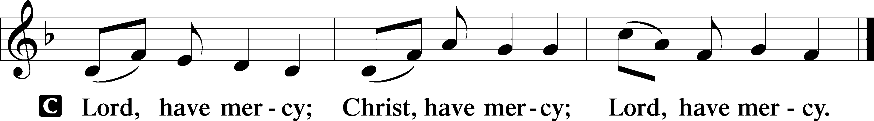

HYMN OF PRAISE
GLORIA IN EXCELSIS LSB 204
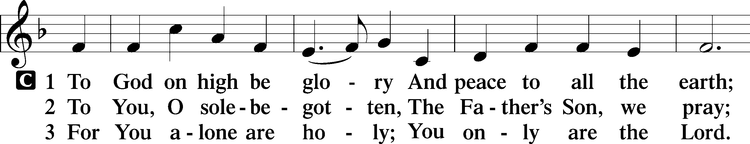
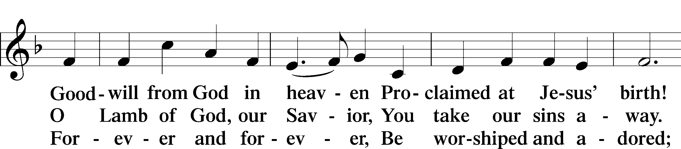
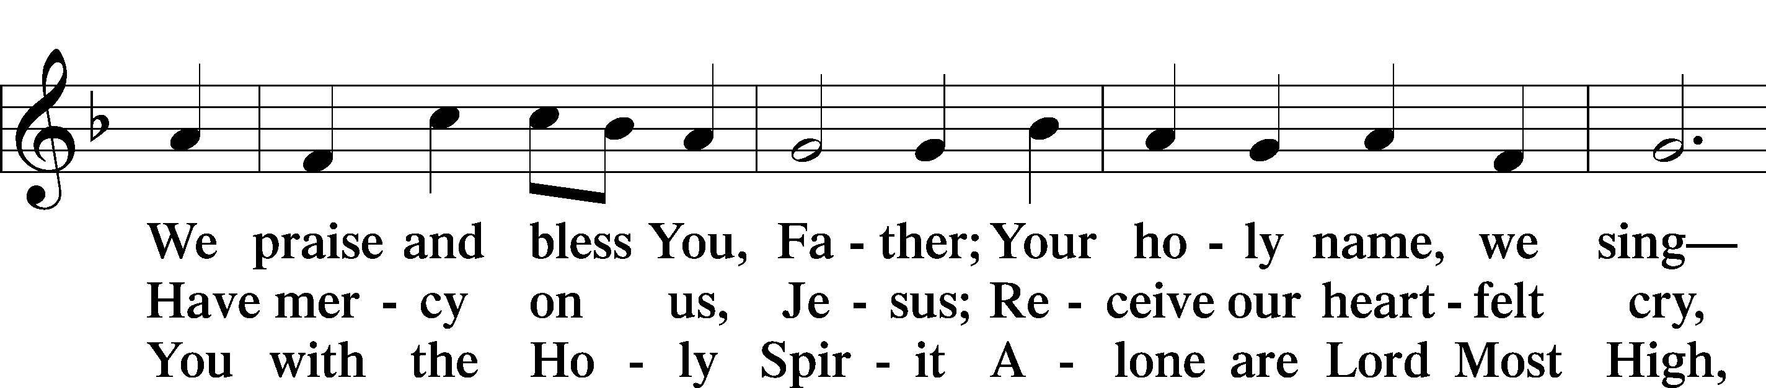
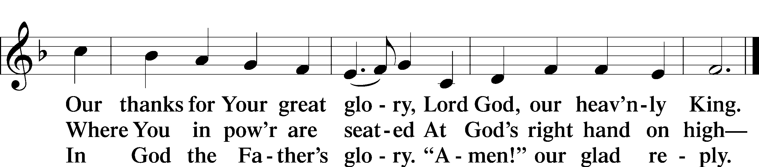

SALUTATION AND COLLECT OF THE DAY

P The Lord be with you.
C And also with you.

P Let us pray.
Almighty and everlasting God, who governs all things in heaven and on earth, mercifully hear the prayers of Your people and grant us Your peace through all our days; through Jesus Christ, Your Son, our Lord, who lives and reigns with You and the Holy Spirit, one God, now and forever.
C Amen.

Please be seated

OLD TESTAMENT READING Isaiah 49:1-7
¹Listen to me, O coastlands,
and give attention, you peoples from afar.
The Lord called me from the womb,
from the body of my mother he named my name.
²He made my mouth like a sharp sword;
in the shadow of his hand he hid me;
he made me a polished arrow;
in his quiver he hid me away.
³And he said to me, “You are my servant,
Israel, in whom I will be glorified.”
⁴But I said, “I have labored in vain;
I have spent my strength for nothing and vanity;
yet surely my right is with the Lord,
and my recompense with my God.”
⁵And now the Lord says,
he who formed me from the womb to be his servant,
to bring Jacob back to him;
and that Israel might be gathered to him—
for I am honored in the eyes of the Lord,
and my God has become my strength—
⁶he says:
“It is too light a thing that you should be my servant
to raise up the tribes of Jacob
and to bring back the preserved of Israel;
I will make you as a light for the nations,
that my salvation may reach to the end of the earth.”
⁷Thus says the Lord,
the Redeemer of Israel and his Holy One,
to one deeply despised, abhorred by the nation,
the servant of rulers:
“Kings shall see and arise;
princes, and they shall prostrate themselves;
because of the Lord, who is faithful,
the Holy One of Israel, who has chosen you.”

P This is the Word of the Lord.
C Thanks be to God.

CHOIR “Trust In the Lord”

EPISTLE 1 Corinthians 1:1–9
¹Paul, called by the will of God to be an apostle of Christ Jesus, and our brother Sosthenes,
²To the church of God that is in Corinth, to those sanctified in Christ Jesus, called to be saints together with all those who in every place call upon the name of our Lord Jesus Christ, both their Lord and ours:
³Grace to you and peace from God our Father and the Lord Jesus Christ.
⁴I give thanks to my God always for you because of the grace of God that was given you in Christ Jesus, ⁵that in every way you were enriched in him in all speech and all knowledge—⁶even as the testimony about Christ was confirmed among you—⁷so that you are not lacking in any spiritual gift, as you wait for the revealing of our Lord Jesus Christ, ⁸who will sustain you to the end, guiltless in the day of our Lord Jesus Christ. ⁹God is faithful, by whom you were called into the fellowship of his Son, Jesus Christ our Lord.

P This is the Word of the Lord.
C Thanks be to God.

Please stand as able

ALLELUIA AND VERSE
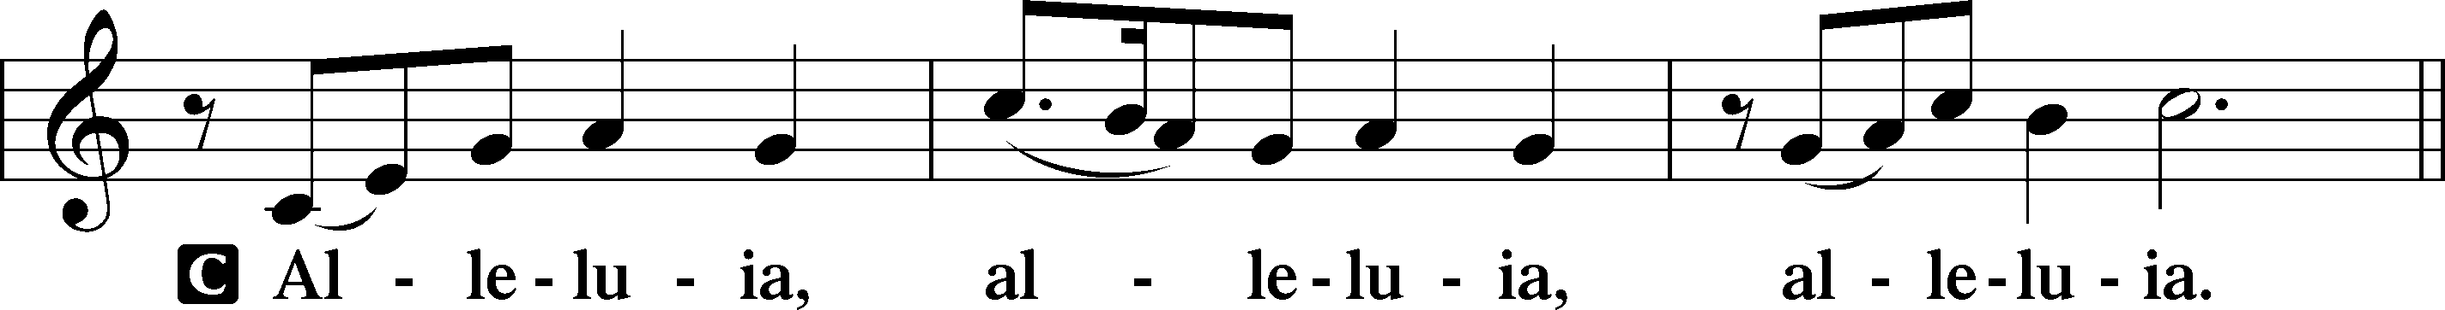
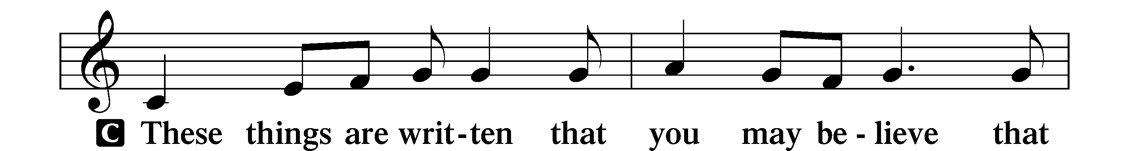
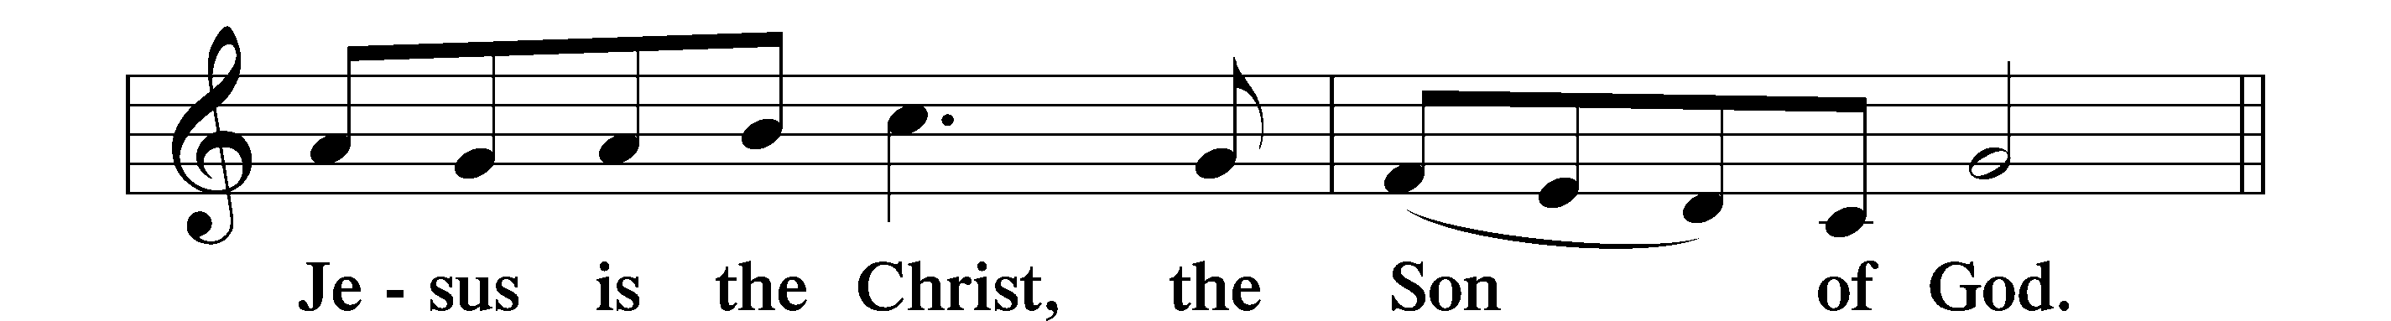
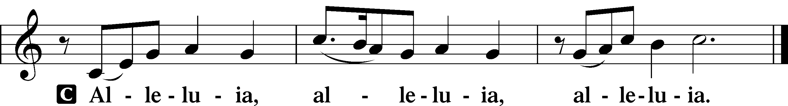

HOLY GOSPEL John 1:29–42a
P The Holy Gospel according to St. John, the first chapter.
C Glory to You, O Lord.

²⁹The next day [John] saw Jesus coming toward him, and said, “Behold, the Lamb of God, who takes away the sin of the world! ³⁰This is he of whom I said, ‘After me comes a man who ranks before me, because he was before me.’ ³¹I myself did not know him, but for this purpose I came baptizing with water, that he might be revealed to Israel.” ³²And John bore witness: “I saw the Spirit descend from heaven like a dove, and it remained on him. ³³I myself did not know him, but he who sent me to baptize with water said to me, ‘He on whom you see the Spirit descend and remain, this is he who baptizes with the Holy Spirit.’ ³⁴And I have seen and have borne witness that this is the Son of God.”
³⁵The next day again John was standing with two of his disciples, ³⁶and he looked at Jesus as he walked by and said, “Behold, the Lamb of God!” ³⁷The two disciples heard him say this, and they followed Jesus. ³⁸Jesus turned and saw them following and said to them, “What are you seeking?” And they said to him, “Rabbi” (which means Teacher), “where are you staying?” ³⁹He said to them, “Come and you will see.” So they came and saw where he was staying, and they stayed with him that day, for it was about the tenth hour. ⁴⁰One of the two who heard John speak and followed Jesus was Andrew, Simon Peter’s brother. ⁴¹He first found his own brother Simon and said to him, “We have found the Messiah” (which means Christ). ⁴²He brought him to Jesus.
P This is the Gospel of the Lord.
C Praise to You, O Christ.

NICENE CREED
C I believe in one God,
the Father Almighty,
maker of heaven and earth
and of all things visible and invisible.
And in one Lord Jesus Christ,
the only-begotten Son of God,
begotten of His Father before all worlds,
God of God, Light of Light,
very God of very God,
begotten, not made,
being of one substance with the Father,
by whom all things were made;
who for us men and for our salvation came down from heaven
and was incarnate by the Holy Spirit of the virgin Mary
and was made man;
and was crucified also for us under Pontius Pilate.
He suffered and was buried.
And the third day He rose again according to the Scriptures
and ascended into heaven
and sits at the right hand of the Father.
And He will come again with glory to judge both the living and the dead,
whose kingdom will have no end.
And I believe in the Holy Spirit,
the Lord and giver of life,
who proceeds from the Father and the Son,
who with the Father and the Son together is worshiped and glorified,
who spoke by the prophets.
And I believe in one holy Christian and apostolic Church,
I acknowledge one Baptism for the remission of sins,
and I look for the resurrection of the dead
and the life T of the world to come. Amen.
Please be seated
ALL GOD’S CHILDREN – TALK

SERMON HYMN
Christ the Eternal Lord LSB 829 sts. 1–3
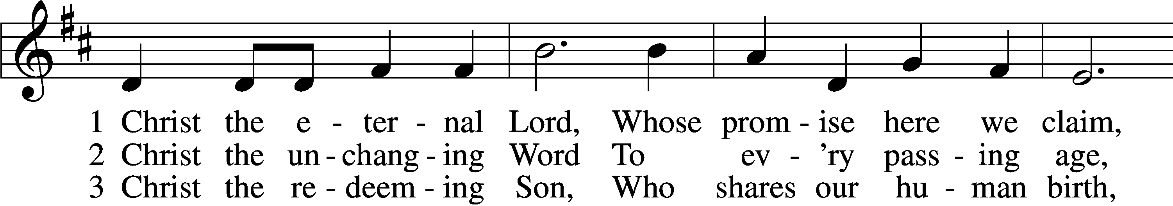
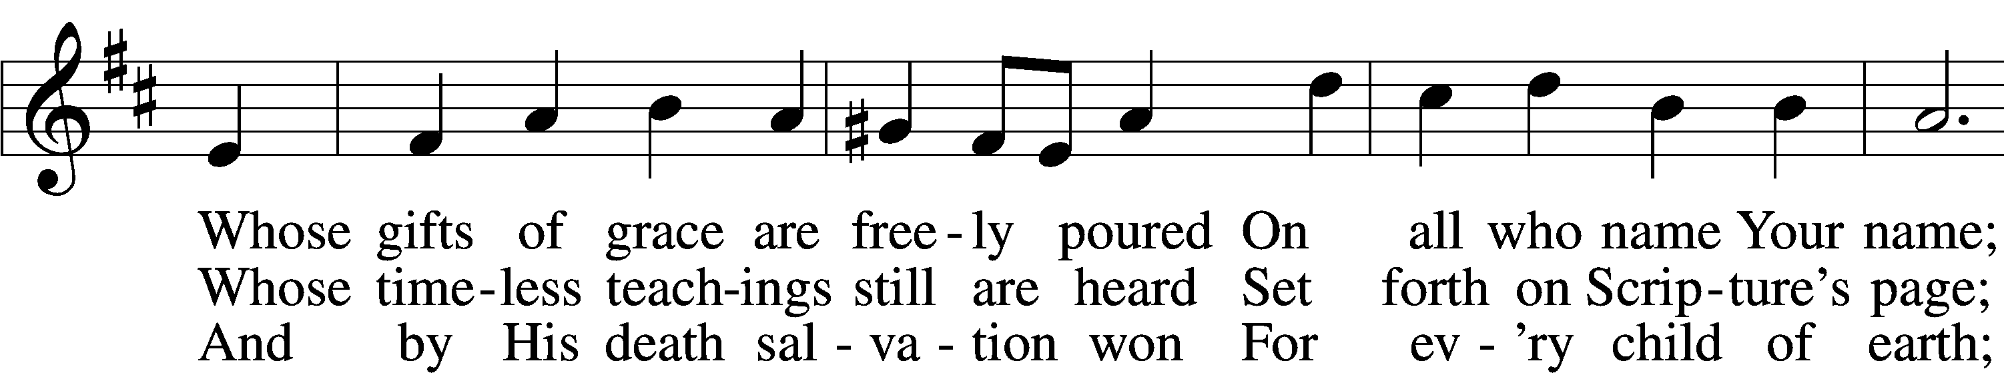
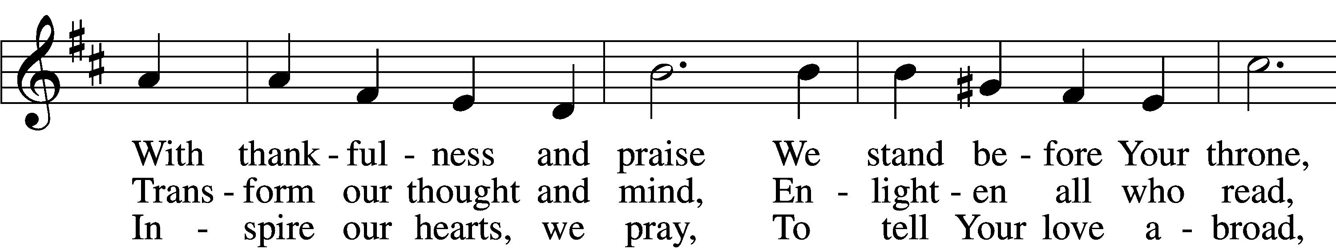
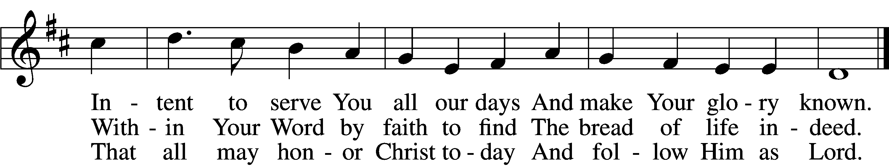

SERMON
Please stand as able

PRAYER of the CHURCH
After each Segment:
P Lord, in Your Mercy,
C Hear our Prayer.
After Final Segment:
P Hear us as we pray in His name and as He has taught us:
LORD’S PRAYER
Our Father who art in heaven,
Hallowed be thy name,
Thy kingdom come,
Thy will be done
On earth as it is in heaven.
Give us this day our daily bread;
And forgive us our trespasses
As we forgive those
Who trespass against us;
And lead us not into temptation,
But deliver us from evil.
For thine is the kingdom
And the power and the glory
Forever and ever. Amen

PREFACE LSB 208
P The Lord be with you.
C And also with you.

P Lift up your hearts.
C We lift them to the Lord.

P Let us give thanks to the Lord our God.
C It is right to give Him thanks and praise.

P It is truly good, right, and salutary that we should at all times and in all places give thanks to You, O Lord, holy Father, almighty and everlasting God, for the countless blessings You so freely bestow on us and all creation. Above all, we give thanks for Your boundless love shown to us when You sent Your only-begotten Son, Jesus Christ, into our flesh and laid on Him our sin, giving Him into death that we might not die eternally. Because He is now risen from the dead and lives and reigns to all eternity, all who believe in Him will overcome sin and death and will rise again to new life. Therefore with angels and archangels and with all the company of heaven we laud and magnify Your glorious name, evermore praising You and singing:

SANCTUS LSB 208
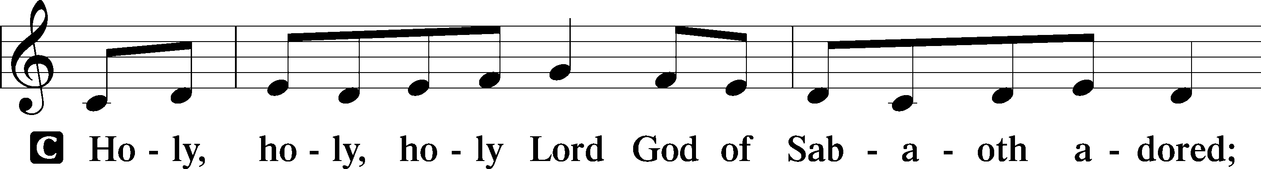
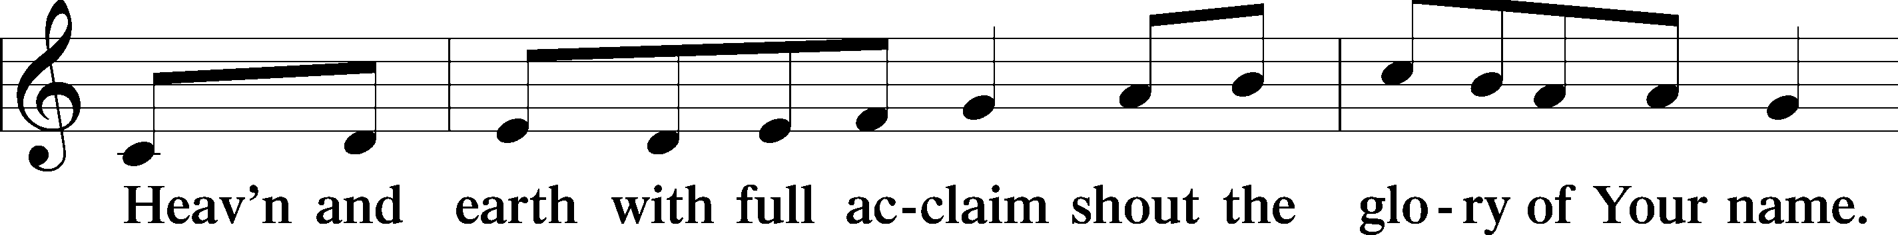
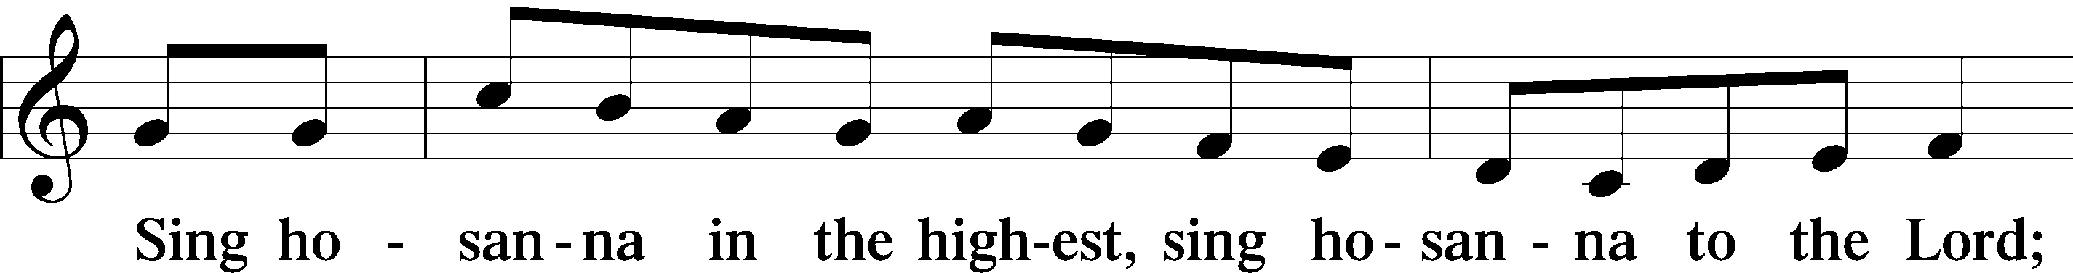
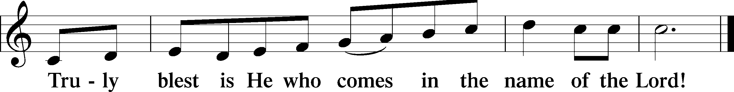

PRAYER OF THANKSGIVING
P Blessed are You, O Lord our God, king of all creation, for You have had mercy on us and given Your only-begotten Son that whoever believes in Him should not perish but have eternal life.
As the glory of Your presence once filled Your ancient temple, so in the incarnation of Your Son, Jesus Christ, You manifested the fullness of Your glory in human flesh.
We give You thanks that in His most Holy Supper You reveal Your glory to us. Grant us faithfully to eat His body and drink His blood so that we may one day behold Your glory face to face.

THE WORDS of our LORD
P Our Lord Jesus Christ, on the night when He was betrayed, took bread, and when He had given thanks, He broke it and gave it to the disciples and said: “Take, eat; this is My T body, which is given for you. This do in remembrance of Me.”
In the same way also He took the cup after supper, and when He had given thanks, He gave it to them, saying: “Drink of it, all of you; this cup is the new testament in My T blood, which is shed for you for the forgiveness of sins. This do, as often as you drink it, in remembrance of Me.”
PAX DOMINI
P The peace of the Lord be with you always.
C Amen.

AGNUS DEI LSB 210
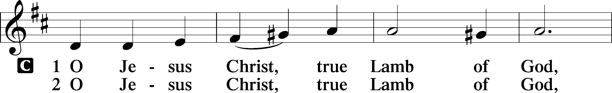
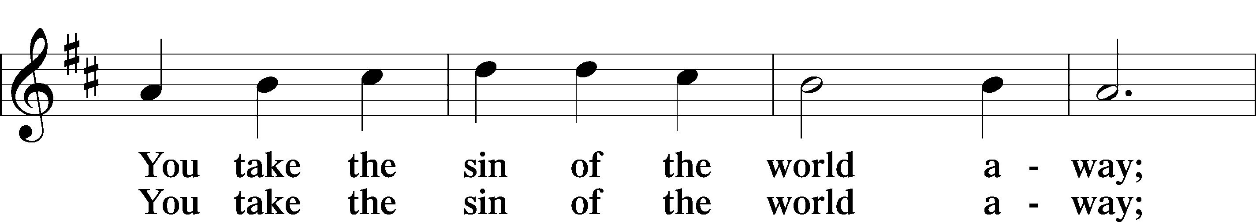
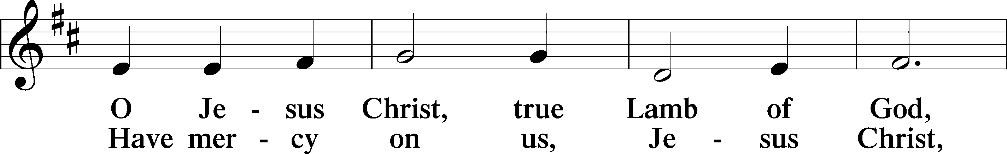
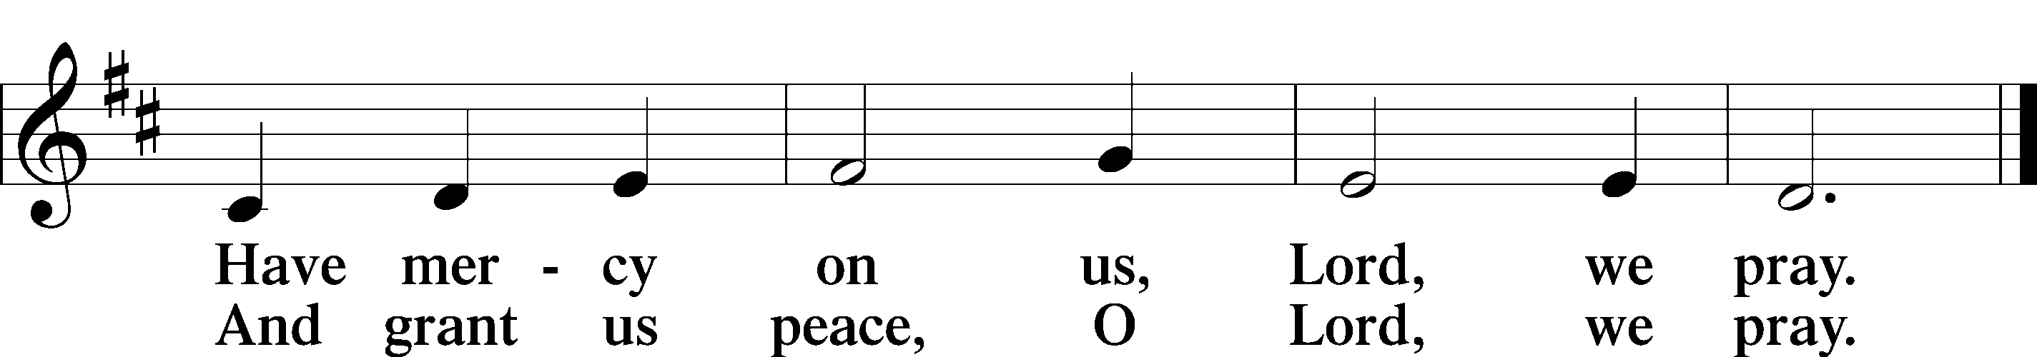

Please be Seated
The pastor and those who assist him receive the body and blood of Christ first, then Communion will be served at the rail. Ushers will help direct you forward via the center aisle; please return to your seats via the side aisles. Gluten-free bread is available for those who need it, as is non-alcoholic grape juice. Simply request either when you come forward to receive Communion.

DISTRIBUTION HYMN
What Wondrous Love Is This LSB 543
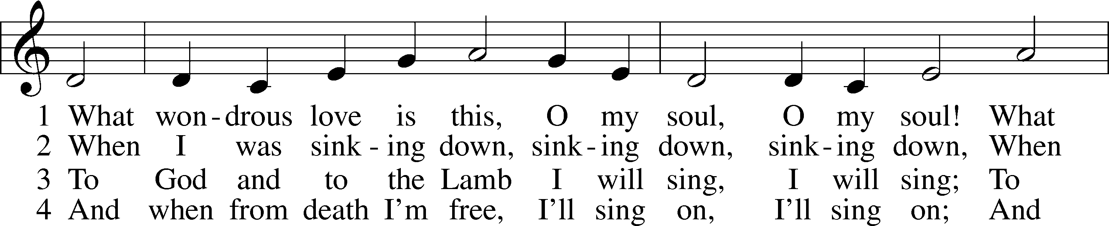
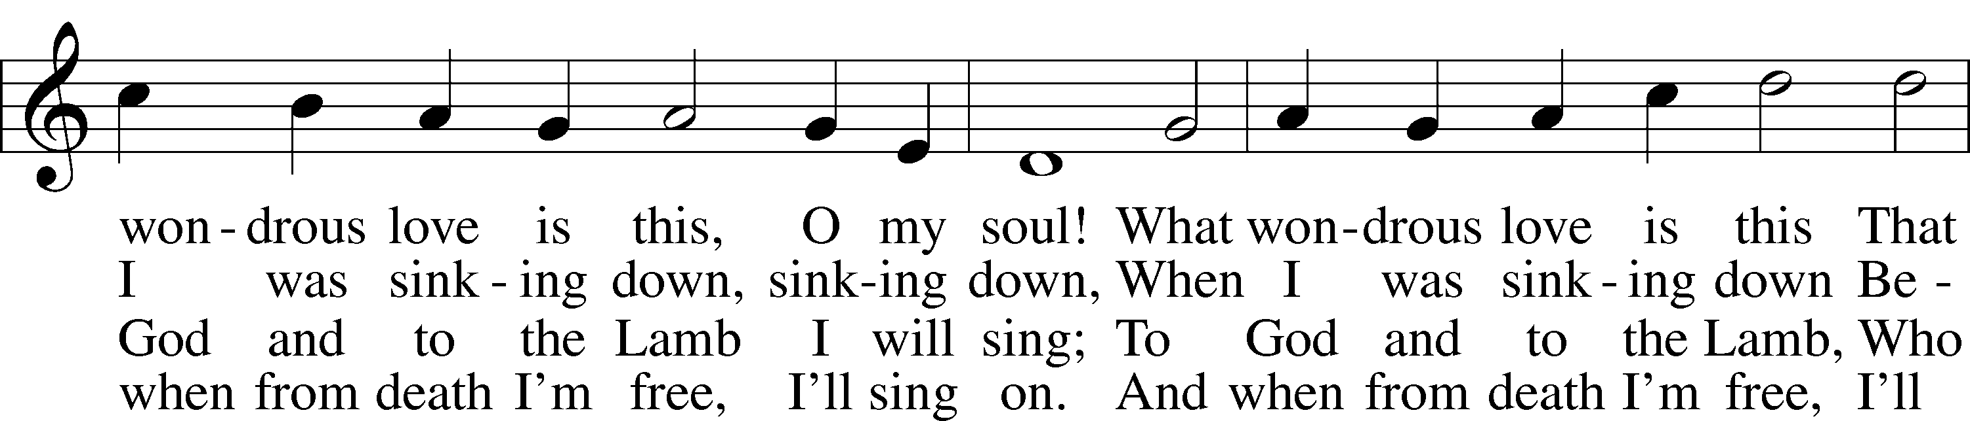
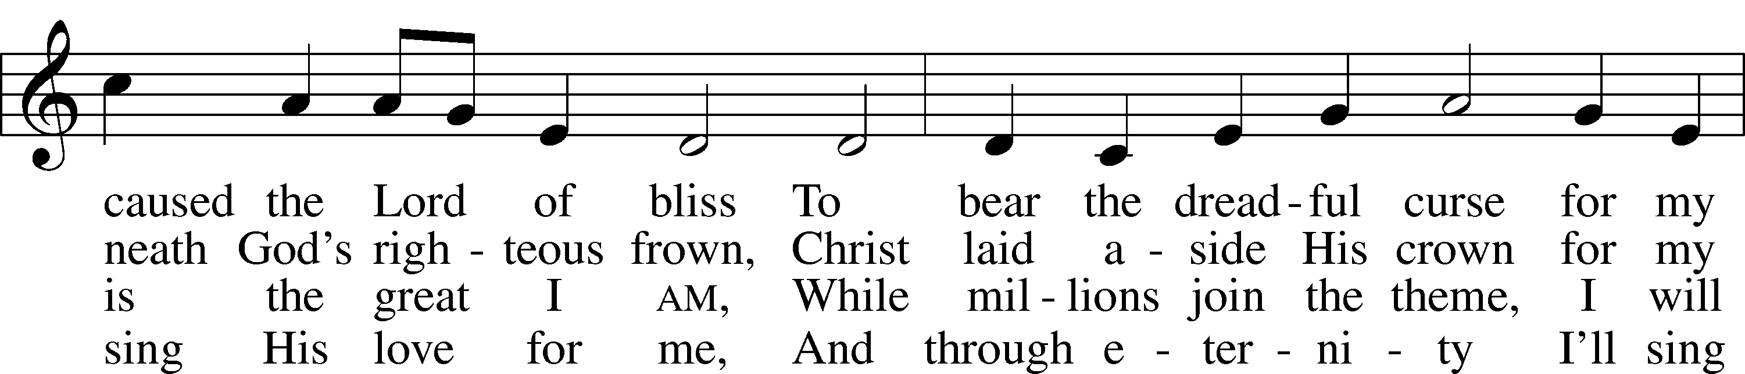
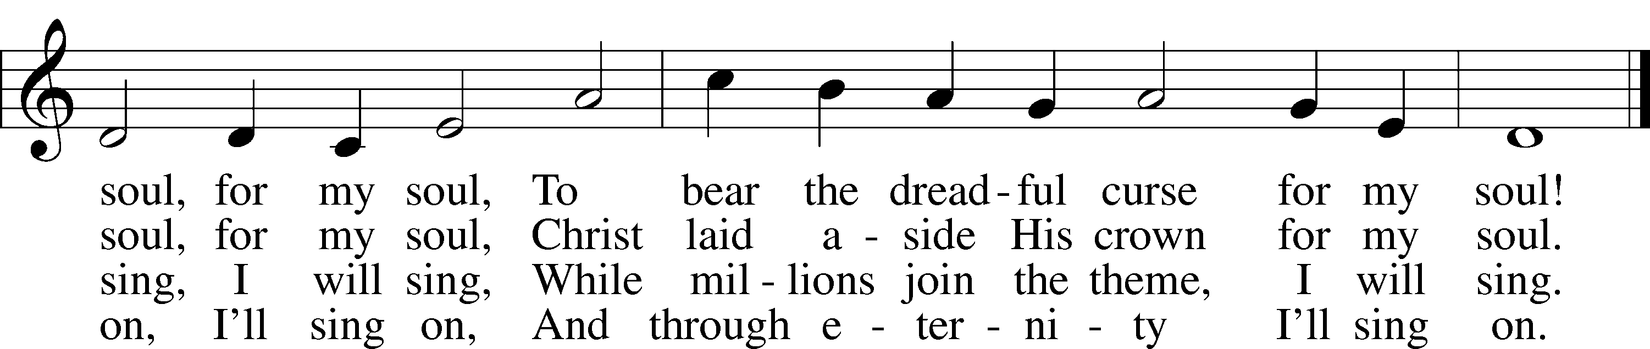

DISTRIBUTION HYMN
Spread the Reign of God the Lord LSB 830
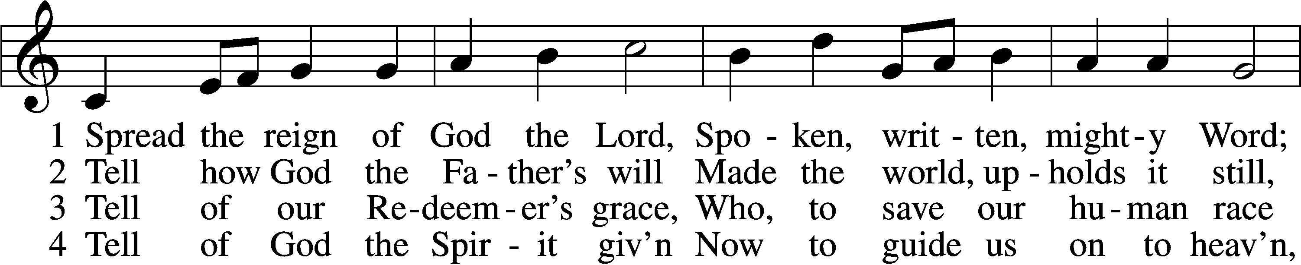
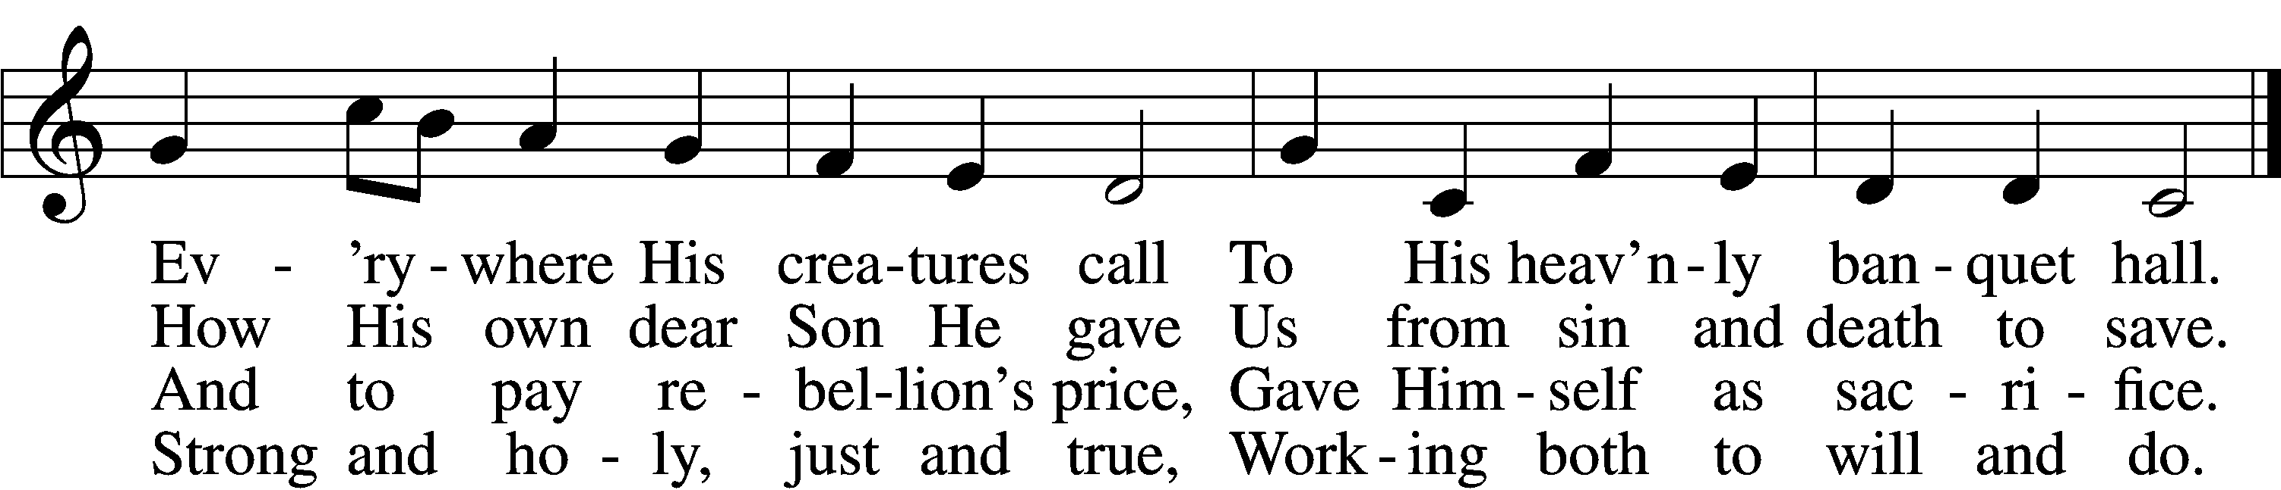

5 Enter, mighty Word, the field;
Ripe the promise of its yield.
But the reapers, oh, how few
For the work there is to do!
6 Lord of harvest, great and kind,
Rouse to action heart and mind;
Let the gath’ring nations all
See Your light and heed Your call.

Please stand as able

NUNC DIMITTIS LSB 211
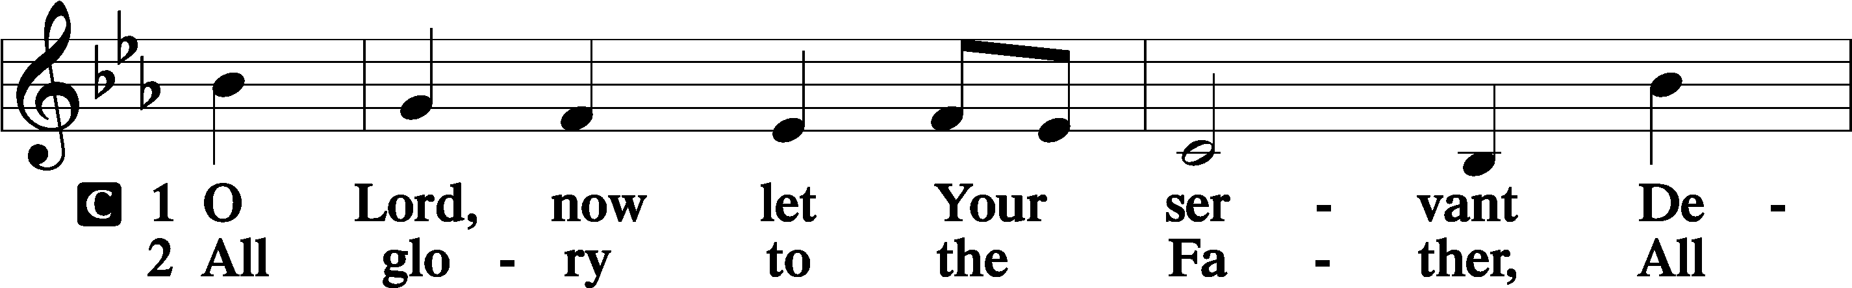
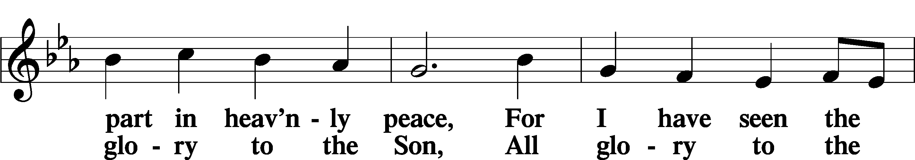
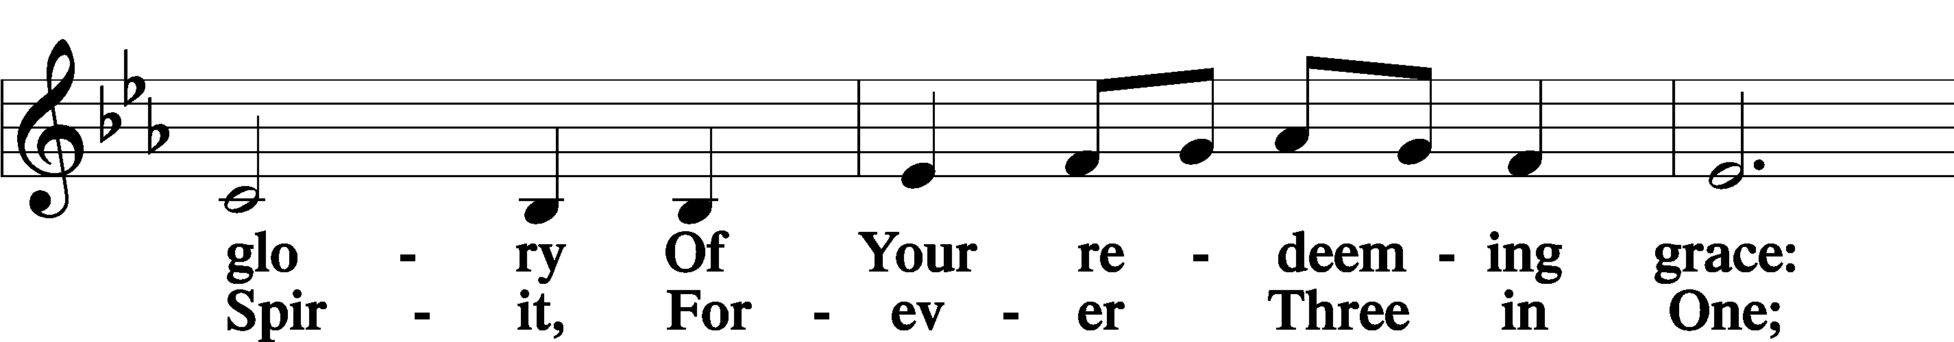
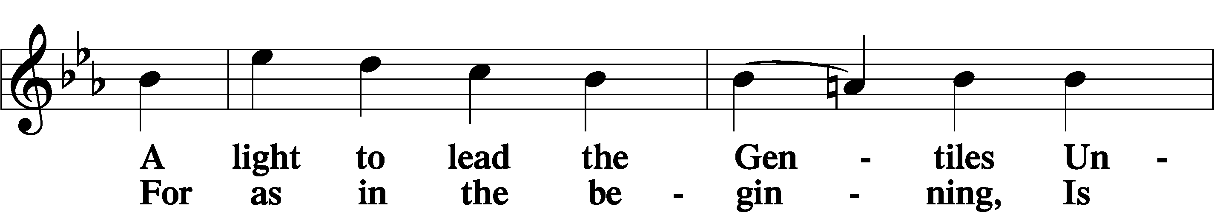
Continued on next page
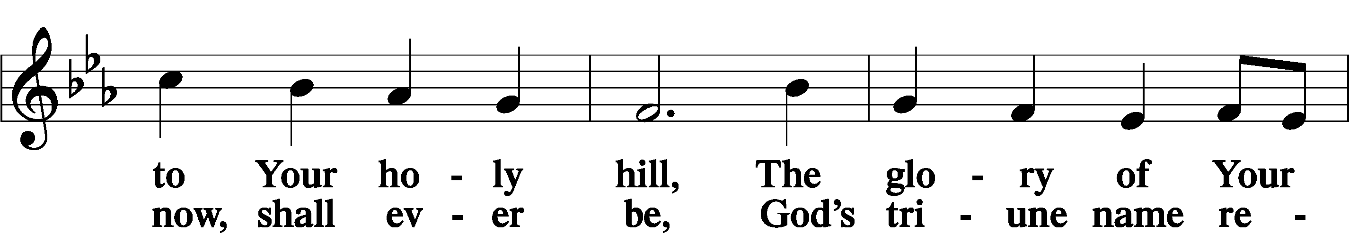
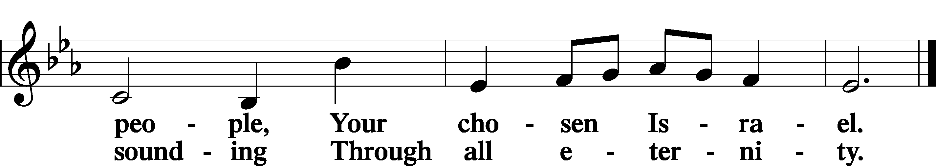
POST COMMUNION COLLECT
P Let us pray.
We give thanks to You, almighty God, that You have refreshed us through this salutary gift, and we implore You that of Your mercy You would strengthen us through the same in faith toward You and in fervent love toward one another; through Jesus Christ, Your Son, our Lord, who lives and reigns with You and the Holy Spirit, one God, now and forever.
C Amen.

BENEDICAMUS LSB 212
P Let us bless the Lord.
C Thanks be to God.
BENEDICTION
P The Lord bless you and keep you.
The Lord make His face shine on you and be gracious to you.
The Lord look upon you with favor and T give you peace.
C Amen.
Please be seated
CLOSING HYMN
Christ the Eternal Lord LSB 829 sts. 4–5
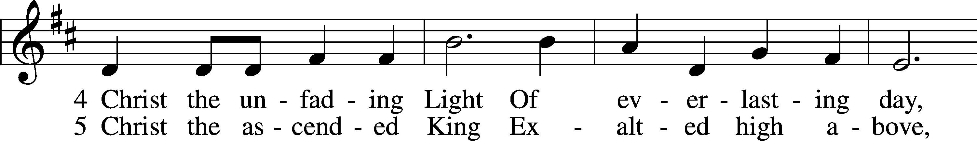
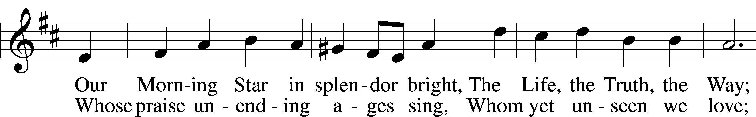
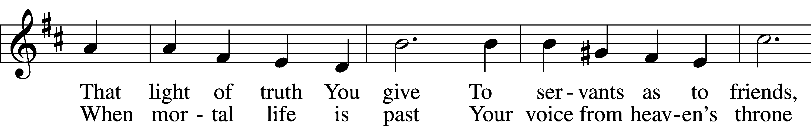
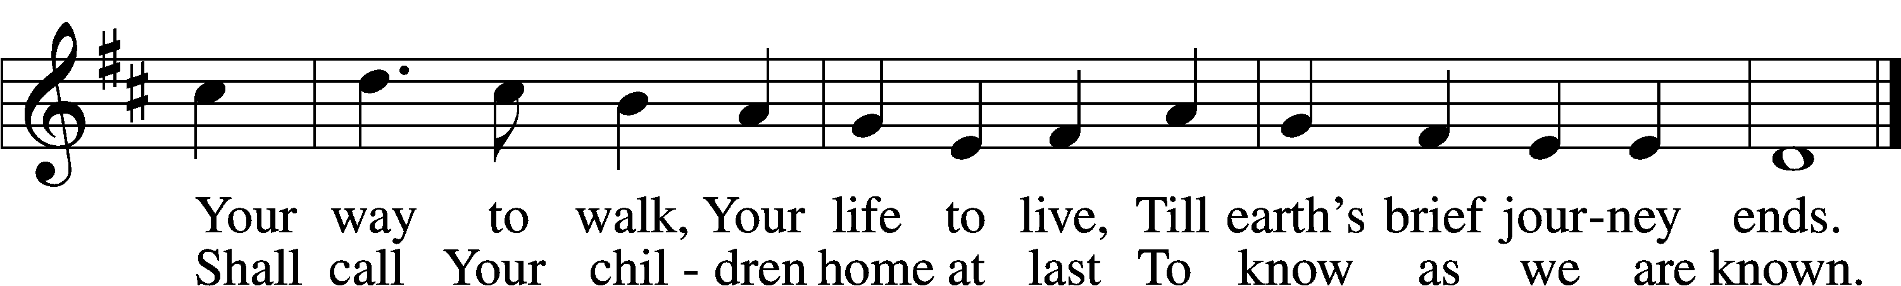
ANNOUNCEMENTS and SENDING WORDS
P We go to live for Jesus!
C We go to share His love!

Acknowledgments
Unless otherwise indicated, Scripture quotations are from the ESV® Bible (The Holy Bible, English Standard Version®), copyright 2001 by Crossway, a publishing ministry of Good News Publishers. Used by permission. All rights reserved. Created by Lutheran Service Builder. Music reproduced in this service is used with permission through: CCLI License No.1776588 and CPH – LSB Service Builder.

SERVING in GODS HOUSE TODAY
Pastor: Rev. Ken Bernthal
Elder: Glen Smith
Ushers: John & Judi Stutzman
Greeters: Wally & Pam Beasinger
Coffee
Counters: Ric Francis, Sandra Smith
Altar Care: Jeanine Boldrey
Children’s Talk: Rev. Pastor Paul Schneider
Virtual Organist: Bob Erat
Bible Study: Tom Beach
Children’s Sunday School: Nancy Ely, Jean Beach, Sharon Techel

PRAYERS
Please contact the office with updates to the prayer list. People will remain on the prayer list for 4 weeks before being removed. If they need to remain on the list, please keep Elaine informed and of any updates. This will help us to have a more accurate list. Thanks for your cooperation.
Those who continue to grieve the passing of loved ones: The Kurt Farhy from Georgia (Kurt passed away Wednesday January 4th). Friends of John & Judi Stutzman.
Those with upcoming surgery and medical procedures: Bill Stiles Shoulder surgery,
Those recovering from surgery and medical procedures: Tanner Beyers and, Greg Techel, Vicki Recovering from surgery. (Risa Shermans daughter-in-law). Wally Beasinger recovering from ear surgery down state on January 10th..
Those with health concerns: Tiffany Amsdill, Ruth Bennett (Sharron Kato’s Sister), Jackie Bliss, Hope Buchinger, Betsy Cook, Shirley Hildebrand, Paul Kietzman, Janice Knoellinger, Jennifer Martin, Eleanor Raether, Beth Smith, Judi Stutzman, Sharon Techel, Joann Whitney and, Lyle Yingling a friend of Larry Whitneys daughter.
Those diagnosed with cancer: Sue Cavanagh, Leah Eicher, Rachel Frisch, Janice Knoellinger, Leslie Martin, Brian Morgan, and Hope Osantowski. Leanne a friend of Denise Lange’s, and Sheryl Marsh (Shirley Hildebrands daughter).
Those under Hospice Home Care: Ken Williamson, Jim (Joann Whitney’s brother-in law).
BIRTHDAYS: ANNIVERSARIES;
NONE 01/19 Donald and Janet Rechlin
01/20 Douglas and Mary Arego
MESSAGES
MEMBER & GUEST CARDS: If you have not filled out a member/guest card, please take the time to fill one out and place it in the plate behind the back pews in our sanctuary.
WEDNESDAY MORNING BIBLE STUDY, 10:00am in the fellowship hall with Pastor Ken Bernthal.
GREETING CARDS If you are in need of some greeting cards, we carry an array of them in the cabinet in the library. The Valentines and Easter cards have been put out. The cost of the cards is posted on the cabinet. The money collected from the cards goes to LWML to help support Missions.
CANCER and FRIENDS SUPPORT GROUP: Will be meeting January 24th . We will be discussing caregiving and radiation. Please remember Cancer & Friends Support Group is not just for people going through treatment, or survivors, we are also here for caregiver, spouse, children, and friends. There are times when we can all use someone to talk to during those difficult times. If there is any subject you would like to discuss with me you call or text or at 989-350-4391. Hope you will join us.
KUT-UPS will be meeting Monday January 23rd, 10am in the fellowship hall.
LWML will be meeting at a special time for the winter months-We will meet at 3:00 PM on Tuesday, January 17 and end with a soup supper at 5 PM. If you are working and can't make it at 3:00, feel free to come at 5 for dinner and fellowship. Our special program this month will be a screening of LCMS's short movie "The First Rosa" about the life and ministry of Dr. Rosa Young, who rose from poverty in the post construction south to be a champion for Education, eventually starting schools, churches and even a Concordia University for underserved black Americans. We will then discuss how Rosa followed Martin Luther's three ways God works in the life of a believer (Prayer, Meditation and Trial).
VALENTINES CANDY BAR BINGO: Our annual Candy Bar Bingo is Friday February 10th at 6pm. All you will need to bring is one candy bar per family. Munchies and beverages will be provided unless you would like to bring your favorite munchie to share. Come relax, kick back and enjoy.
SUPER BOWL SUB SALE: Get your orders in!!! Super Bowl Sub Sale February 12, 2023 again will made by LWML Trinity Lutheran all proceeds will go to Otsego County Food Pantry. Orders need to be in by February 5th so that we can order the product and have it to make the Subs on Sunday the 12th. If you have any questions please feel free to contact Tina at 989-350-3287.
GAYLORD RIGHT TO LIFE Trinity and Mt. Hope you are invited to the Gaylord March for Life, Thursday January 19, 2023, St. Mary School Gym 321 N. Otsego Ave. 12:30pm Light Refreshments, 1:00 pm Program, 1:45 pm March to City Hall.
FOOD PANTRY: Reminder to bring Non Perishable food items for the Food Pantry Basket NEXT SUNDAY January 22, 2023.
NOISY OFFERING and food collection every 4th Sunday.
CONFIRMATION CLASS begins Sunday January 22, 2023 after church in the Library. Any 7 or 8 grade want to join please call Pastor Paul Schneider.
ANNUAL REPORT: It is that time again, I will be needing each groups reports in by January 24. All reports have to be sent in by email no hand written ones. Thank You
ANNUAL VOTERS MEETING: Congregational meeting will be Sunday, February 12th in the Fellowship Hall at 10:30 am.

SERVING in GODS HOUSE NEXT WEEK JANUARY 22
Pastor: Rev. Ken Bernthal
Elder: Tom Raithel
Ushers: Mike Goodrich, Ron Tesolin
Greeters: Bob & Kathy Erat
Coffee: Stutzmans
Counters: Brian Techel and Karl Scheiterlein
Altar Care: Ann Mertz
Children’s Talk: Nancy Ely
Piano/ Organ: Beaches
Bible Study: Tom Beach
Children’s Sunday School: Nancy Ely, Jean Beach, Sharon Techel

READINGS FOR NEXT WEEK JANUARY 22nd
First Reading: Isaiah 9:1-4
Second Reading: I Corinthians: 1:10-18
Gospel: Matthew: 4:12-17

THIS WEEK AT TRINITY
January 15 Sunday
9:00 am Worship Service - Holy Communion
10:00 am Fellowship & Coffee Hour
10:30 am Sunday Morning Bible Study W/ Dr. Tom Beach
10:30 am Children’s Sunday School.: Nancy Ely, Jean Beach and Sharon Techel
January 16 Monday
7:00 pm Choir
NEWSLETTER DEADLINE
January 17 Tuesday
3:00 pm LWML Dinner Meeting (Fellowship Hall)
January 18 Wednesday
10:00 am Wednesday Morning Bible Study W/ Pastor Ken Bernthal
January 19 Thursday
January 20 Friday
January21 Saturday
January 22 Sunday
9:00 am Worship Service - Holy Communion
Noisy Offering
10:00 am Fellowship & Coffee Hour
10:30 am Confirmation Class In the Library
10:30 am Sunday Morning Bible Study W/ Dr. Tom Beach
10:30 am Children’s Sunday School. Nancy Ely, Jean Brach and Sharon Techel.

